STAMP User’s Guide v2

Statistical Analysis of Metagenomic (and other) Profiles

Donovan Parks

June 25, 2014

1. Introduction 2

2. Contact information 2

3. Citing STAMP and statistical techniques 2

4. Installation 2

4.1 Precompiled binaries for Microsoft Windows 2

4.2 Source code 3

4.3 Unit tests: Verifying the installation 3

5. Constructing and obtaining metagenomic profiles 3

5.1 Creating your own metagenomic profiles 3

5.2 Creating a metadata file 4

5.3 Obtaining profiles from MG-RAST 4

5.4 Obtaining profiles from BIOM files 4

5.5 Obtaining profiles from IMG/M 5

5.6 Obtaining profiles from CoMet or RITA 5

6. Guidelines on sample size 6

7. Analyzing metagenomic profiles 6

7.1 Analyzing multiple groups 7

7.2 Analyzing two groups 13

7.3 Analyzing two samples 16

8. Global preferences 21

9. Custom statistical techniques and plots 21

9.1 Creating a custom plot 21

9.2 Making a plugin publicly available 23

References 24

# Introduction

STAMP is a software package for analyzing metagenomic (and other!) profiles, such as taxonomic profiles indicating the number of marker genes assigned to different taxonomic units or functional profiles indicating the number of sequences assigned to different subsystems or pathways. It aims to promote ‘best practices’ in selecting statistical techniques and in reporting results by encouraging the use of effect sizes and confidence intervals for assessing biological importance. A user-friendly, graphical interface permits easy exploration of statistical results and generation of publication-quality plots for inferring the biological relevance of features in a metagenomic profile. STAMP is open-source, extensible via a plugin framework, and available for all major platforms.

# Contact information

STAMP is in active development and we are interested in discussing all potential applications of this software. We encourage you to send us suggestions for new features. Suggestions, comments, and bug reports can be sent to Donovan Parks (donovan.parks [at] gmail.com). If reporting a bug, please provide as much information as possible and a simplified version of the data set which causes the bug. This will allow us to quickly resolve the issue.

# Citing STAMP and statistical techniques

If you use STAMP in your research, please cite:

Parks, D.H. and Beiko, R.G (2010*). Identifying biologically relevant differences between metagenomic communities.* *Bioinformatics*, **26**, 715-721.

If you make use of White’s non-parametric t-test, please cite:

White, J.R., Nagarajan, N., and Pop, M. (2009). Statisticalmethods for detecting differentially abundant features in clinical metagenomic samples. *PLoS Comput Biol*, **5**, e1000352.

Citations for other statistics are given in Tables 1, 2, and 3.

# Installation

## 4.1 Precompiled binaries for Microsoft Windows

A precompiled binary is available for Microsoft Windows. This binary has been tested under Windows XP and Windows 7, but should also work under Windows Vista. The precompiled binary is available from the STAMP website:

<http://kiwi.cs.dal.ca/Software/STAMP>

If you have a pristine copy of Microsoft Windows installed, you may need to install the Visual C++ 2008 Redistributable Package:

[Windows XP or x86 (32-bit) versions of Windows Vista or 7](http://www.microsoft.com/downloads/details.aspx?FamilyID=9b2da534-3e03-4391-8a4d-074b9f2bc1bf&displaylang=en)

[x64 (64-bit) versions of Windows Vista or 7](http://www.microsoft.com/downloads/details.aspx?familyid=BA9257CA-337F-4B40-8C14-157CFDFFEE4E&displaylang=en)

This package contains a number of commonly required runtime components which you likely already have via other installed software. STAMP will fail with a message indicating the "configuration is incorrect" if you require this package.

## 4.2 Source code

Running from source is the best way to fully exploit and contribute to STAMP. It is relatively simple to setup STAMP from source on Microsoft Windows, Apple OS X, or Linux. Instructions on installing STAMP from source are available on our wiki:

<http://kiwi.cs.dal.ca/Software/Quick_installation_instructions_for_STAMP>

## 4.3 Unit tests: Verifying the installation

A set of unit tests are available to verify that STAMP and all 3rd-party libraries are installed correctly. These unit tests verify the numerical accuracy of the statistical tests, effect size measures, confidence interval methods, and multiple test correction methods provided within STAMP. To execute the unit tests, move to the main STAMP directory and enter the following command:

python STAMP_test.py –v

If any of these tests fail, STAMP should not be used. Please contact the authors so we can try to resolve the situation.

## 4.4 Contributing to STAMP

STAMP is open source software released under the GNU GPL v3 license. If you wish to contribute to STAMP, you can find the development branch of STAMP on GitHub:

<https://github.com/dparks1134/STAMP>

# 5. Constructing and obtaining metagenomic profiles

## 5.1 Creating your own metagenomic profiles

STAMP reads text files in tab-separated values (TSV) format. This file can contain hierarchical and profile information for two or more samples. The first row of the file contains the header for each column. Columns indicating the hierarchical structure of a feature must be placed from the highest to lowest level in the hierarchy. There are no restrictions on the depth of the hierarchy*. Hierarchies can be multifuricating, but must form a strict tree structure*. The number of reads assigned to each leaf node in the hierarchy must be specified for each sample. Reads that have an unknown classification at any point in the hierarchy should be marked as unclassified (case insensitive) and can subsequently be processed in a number of different ways (see Section 6.1). To allow for different normalization methods, these read counts may be integers or any real number. An example input files is given below:

|  |  |  |  |  |
| --- | --- | --- | --- | --- |
| Hierarchical Level 1 | Hierarchical Level 2 | Sample 1 | Sample 2 | Sample 3 |
| Category A | Subcategory A1 | 0 | 4.4 | 4 |
| Category A | Subcategory A1 | 3 | 5 | 5 |
| Category A | Subcategory A2 | 4.8 | 3.5 | 2 |
| Category B | Subcategory B1 | 2 | 32 | 6.5 |
| Category C | Subcategory C1 | 1 | 2 | 2 |
| Category C | Subcategory C1 | 7.2 | 6 | 4 |

## 5.2 Creating a metadata file

STAMP allows additional data associated with each sample to be defined through a metadata file. Like a STAMP profile, a metadata file is a tab-separated values (TSV) file. The first column of this file indicates the name of each sample and should correspond to an entry in the corresponding STAMP profile. Additional columns can specify any other data relevant to the samples being considered. Within STAMP, these additional columns can be used to define groups (*i.e.*, collections of one or more profiles) over which statistics can be calculated. For example, a metadata file for the example profile above could have the structure:

|  |  |  |  |  |
| --- | --- | --- | --- | --- |
| Sample Id | Location | Phenotype | Gender | Sample Size |
| Sample 1 | Canada | Obese | Female | 4000 |
| Sample 2 | Canada | Lean | Male | 2000 |
| Sample 3 | Italy | Lean | Female | 3000 |

## 5.3 Obtaining profiles from MG-RAST

STAMP provides support for analyzing MG-RAST taxonomic or functional profiles. Visit the MG-RAST website (Meyer *et al.*, 2008; http://metagenomics.nmpdr.org) and browse the list of pubic metagenomes. Profiles for multiple samples can be obtained and downloaded as tab-separated values (tsv) file using the table data visualization. To work with MG-RAST profiles, they must be converted into a STAMP-compatible profile. From within STAMP, select the Create STAMP profile from...->MG-RAST profile command from the File menu. This opens up the Create profile dialog box. Click on the Load profile button and select the MG-RAST profile you wish to convert. If desired, you can customize the headings of each hierarchical level by clicking on the Customize headings button. Click the Create STAMP profile button and save the STAMP profile to a suitable location. If you wish to give the samples more descriptive names, you can manually edit the resulting STAMP profile in a text editor.

## 5.4 Obtaining profiles from BIOM files

BIOM is emerging as a standard format for specifying both taxonomic and functional profiles. The BIOM file format provides substantial flexibility allowing it to be tailor to many applications. Unfortunately, this also adds to the complexity on interpreting these files. STAMP profiles can be generated from BIOM files using the Create STAMP profile from...->BIOM profile command from the File menu. This opens a Create profile dialog box where the BIOM file can be specified along with a *Metadata field*. The *Metadata field* specifies what information should be taken from the BIOM file to create a STAMP profile. The drop-down box provides default choices for popular programs including QIIME (Caporaso *et al.*, 2010) and PICRUSt (Langille *et al.*, 2013). The <observation ids> field can be used on most BIOM files to produce a STAMP profile without any higher level hierarchical information. In particular, this can be used to create STAMP profiles from PICRUSt KEGG KO profiles. You may also enter a custom value for the *Metadata field* which allows STAMP to be compatible with forthcoming programs using BIOM as a file format.

## 5.5 Obtaining profiles from IMG/M

Metagenomic profiles can be obtained from the JGI IMG/M web portal (Markowitz *et al.*, 2008; http://img.jgi.doe.gov/m). Profiles for multiple samples can be created using the services at IMG/M and downloaded as a single file. STAMP works directly with IMG/M’s abundance profiles obtained by clicking on the Compare Genomesmenu item, followed by Abundance Profile*,* andfinallyOverview (All Functions). Select the Matrix output type with the Gene countor Estimated gene copies option along with all metagenomes you are interested in. Hit *GO* and download the resulting tab-delimited file. This file can be directly read by STAMP. Although this file has the extension xls, it is in fact a simple tab-separated values file and you may wish to change the extension to tsv.

COG profiles from IMG/M do not contain information about which COG category or higher level class a COG belongs to. STAMP can add this information to an IMG/M COG profile. This is done in the Assign COG categories to IMG/M profile dialog accessible through the File menu. Some COGs are associated with multiple COG categories. For example, COG0059 is assigned to COG categories E and H. You can elect to treat multi-code COGs as unique features (*i.e.*, there should be a COG code named EH) or to assign sequences associated with a multi-code COG to each individual COG category (*i.e.*, a sequence assigned to COG0059 will add a single count to COG categories E and H).

You can create your own COG profiles and have STAMP assigned higher level COG information to your profile. The example file Assign_COGs_Example.tsv demonstrates the required file format for using the Assign COG categories to IMG/M profile feature of STAMP.

## 5.6 Obtaining profiles from CoMet or RITA

STAMP can process the functional profiles produced by CoMet (Lingner *et al*., 2011) or the taxonomic profiles produced by RITA (MacDonald *et al*., 2011). These web servers are available at:

CoMet: http://comet.gobics.de

RITA: http://ratite.cs.dal.ca/rita

Like MG-RAST profiles, these profiles must be converted into STAMP-compatible profiles using the appropriate Create STAMP profile from... command within the File menu. STAMP combines multiple CoMet or RITA profile files into a single STAMP profile file. For RITA profiles, the desired classification groups to use for profile construction can be specified.

# 6. Guidelines on sample size

There is an extensive literature surrounding the number of samples required to detect statistical significance for different hypothesis tests. For excellent introductions to this topic with practical advice, I recommend the recent manuscript by Suresh and Chandrashekara (2012) and the article “Getting the Sample Size Right” by Jeremy Miles (http://www.jeremymiles.co.uk/misc/power/).

My advice is as follows. There is no minimum sample size required for a statistical hypothesis test to be valid, but the assumptions for the test statistic must be met (e.g., approximately normally distributed). Small sample sizes are more likely to violate these assumptions. A small sample size is also less likely to have the *statistical power* required to identify a *small effect size* as statistically significant. Famously, Student’s original paper demonstrating the t-test considered examples with only 4 samples in each group. In these examples, 4 samples were sufficient due to the accuracy and precision of the underlying data, and the magnitude of the effect size between groups. For example, consider trying to determine if the average weight of an American penny is different than the average weight of an Australian 50 cent piece. I have carried both of these around, and I can assure you that a penny weighs far less than the excessively heavy Australian 50 cent piece! Put another way, *a priori* I know the effect size is large and that fewer samples will be required to detect statistical significance. Furthermore, these coins are manufactured on high precision machines and we can accurately measure the weight of these pieces using a highly accurate scale. Consequently, fewer samples are required to accurately estimate the mean of these coins and the variance around these means will be small. Because of these factors (large effect size, highly precise and accurate measurements, and small variance) a small sample size is sufficient to establish that the mean weight of these coins is statistically different.

In contrast, biological data is noisy. Taxonomic and metabolic profiles are subjected to a lot of variability. Unlike the example above, these profiles have relatively low accuracy and precision. Changing the method used to classify sequences or the underlying reference database will often result in substantial changes to the resulting profiles. This is analogous to changing one inaccurate scale for another. Sample preparation will also influence the resulting profiles. Intuitively, we expect biological replicates to produce similar profiles, but we accept that there will be a lot of variability. We are also often comparing broadly defined groups where we expect the intragroup variability to be substantial, e.g., community profiles of healthy vs sick individuals. Intuitively, a large number of samples will be required to reliably estimate the mean and variance of a group under these conditions. Consequently, more samples per a group are required before it is reasonable to compare the means of these two groups. The exact number of samples required depends on the *effect size* between these groups, the desired *alpha level* for defining statistical significance, and the desired *statistical power* (see Jeremy Miles article).

Effect sizes must also be considered when assessing results. A feature with a statistically significant difference between two groups, regardless of sample size, may not be biologically relevant. When sample sizes are large, even extremely small differences will be statistically significant. However, caution is warranted when effect sizes are small as statistical tests do not account for systematic biases that may exists in the methodology used to generate a taxonomic or metabolic profile. For example, a small increase in Firmicutes in 100 healthy patients vs. 100 sick patients may simply be the result of reference databases containing more Firmicute species found within healthy humans. When sample sizes are small, the reported p-values will often be inaccurate as statistical hypothesis test cannot account for the poor accuracy and precision of the methods used to generate taxonomic and metabolic profiles. In these situations, I believe ‘best practice’ is to use the p-values to identify statistically significant features and then to further filter these results to those with a sufficiently large effect size. It is my opinion that one should never report statistically different features without also indicating the effect size of the difference.

# 7. Analyzing metagenomic profiles

Taxonomic profiles of the gut microbiota of 41 individuals will be used to illustrate how STAMP can be used to analyze metagenomic profiles. These profiles are based on the analysis performed by Arumugam *et al.* (2011) which revealed that these profiles could be assigned to three distinct clusters or enterotypes. STAMP-compatible profiles and metadata for this dataset can be found in the examples/EnterotypesArumugam directory.

## 7.1 Analyzing multiple groups

Setting statistical analysis properties:The enterotypes data can be loaded through the File->Load data… dialog. Make sure to specify both the profile (Enterotypes.profile.spf) and group metadata (Enterotypes.metadata.tsv) files before hitting OK to continue. Here we will group the data by the three enterotypes specified by Arumugam *et al.* (2011). Profiles are assigned to groups through the Group legend window. To open this window, select View->Group legend. The Group legend window can be left as a floating window or docked in different positions (Figure 1). For this analysis, dock the window on the right (Figure 1b) and select Enterotype from the Group field combobox. This indicates that we wish to group the data by enterotypes. If you open the file Enterotypes.metadata.tsv you can see that Enterotype is simply a column in this file. A large number of enterotypes have been defined. To replicate the analysis by Arumugam *et al.* uncheck all groups except Enterotype 1, Enterotype 2, and Enterotype 3 (Figure 2). Unchecking a group causes it to be ignored when calculating statistics and generating plots.

Notice that all statistics and plots are automatically updated as you uncheck each group. In general, STAMP automatically regenerates all statistics and plots as needed. For large datasets this can be inconvenient. To prevent automatic updating of results, click the Recalculate statistics and plot button in the lower, right of the main window. Once you have modified all desired properties (*e.g.*, selected specific groups, changed desired statistical properties, or set appropriate filtering constraints) click the Recalculate statistics and plot button to regenerate results.

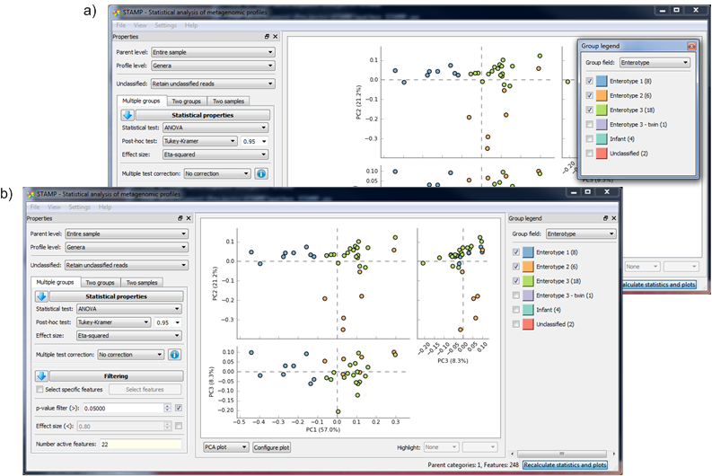

Figure 1: Example of a floating (a) and docked (b) group legend. All windows available from the View menu can be left as floating or docked in different positions within the main window.

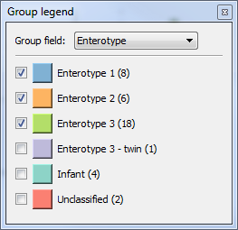

Figure 2: Group legend specifying that profiles should be grouped according to their Enterotype. Unchecked groups have been removed from the analysis.

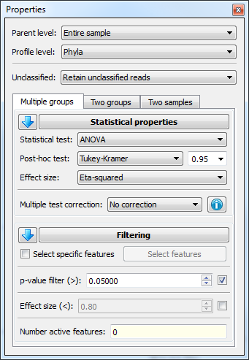Statistical properties are set through the Properties window. By default, this window is docked on the right. However, it can be detached from this position and docked in different locations just like the Group legend window. Windows can be selectively shown and hidden using their corresponding entry in the View menu. The Properties window allows you to set a number of properties related to performing multiple group tests. These are described below (Figure 3):

*Parent level:* the proportion of sequences assigned to a feature will be calculated relative to the total number of sequences assigned to its parent category. The default is to calculate proportions relative to all assigned sequences in the sample. For this tutorial, keep the parent level at the default value of Entire sample.

*Profile level:* the hierarchical level at which to construct the profile. This allows data to be explored at different depths in the hierarchy. For this tutorial, change the profile level to Genera.

*Unclassified*: specifies how unclassified sequences are to be handled. Any reads assigned to a feature with the name unclassified (case insensitive) are deemed to be unclassified. Unclassified sequences can either be retained in the profile (Retain unclassified reads), removed from the profile (Remove unclassified reads), or removed from consideration except when calculating a profile (Use only for calculating frequency profiles). These three options for treating unclassified sequences can result in large differences. For both the Retain unclassified reads and Use only for calculating frequency profiles options, the relative proportion of sequences assigned to a feature is proportional to the total number of sequences within the specified parent category. The latter option prevents the unclassified feature for appearing in tables and plots. In contrast, the Remove unclassified reads option results in profiles indicating the relative proportion of sequences within each feature relative to those sequences which were classified at the specified profile level. Since the proportion of unclassified sequences can vary substantially between samples, this can result in vastly different profiles.

*Statistical properties:* the statistical test, post-hoc test along with the confidence interval width, effect size, and multiple test correction method to use can all be specified in this section. A list of methods provided in STAMP for analyzing multiple groups is given in Table 1.

*Filtering*: the filtering section provides a number of filters for identifying features that satisfy a set of criteria (*i.e.,* desired p-value and effect size). The number of features passing the specified filters is indicated at the bottom of this section. In order to allow specific features to be investigated, STAMP also supports selecting subsets of features. Feature selection is performed using the Select features dialog box which is accessed by clicking on the Select features button. Within this dialog individual features or all features within specific parent categories can be selected or removed from consideration. Filtering is performed on these selected features in order to allow investigating specific subsets of features with particular properties. To investigate a subset of features without performing any filtering uncheck all the filters.

Graphical exploration of results: The following plots are provided for exploring the results of a multiple groups analysis:

* *Bar plot:* a bar plot indicating the proportion of sequences assigned to each feature. The feature to plot is selected from a table to the right of the plot (Figure 3). This table can be moved in and out to provide additional space for the plot. Table columns can be sorted to focus on features with low p-values or large effect sizes. Additionally, the table can be limited to those features passing the specified filters by checking the Show only active features checkbox. The example in Figure 3 shows the proportion of *Bacteroides* within each sample and reveals the over-abundance of this genus within Enterotype 1. Arumugam *et al*. (2011) also suggested *Prevotella* and *Ruminococcus* as genera useful for distinguishing between enterotypes.
* *Box plot:* a box plot is similar to a bar plot except the distribution of proportions within a group are indicated using a box-and-whiskers graphic (Figure 4). This provides a more concise summary of the distribution of proportions within a group. The box-and-whiskers graphics show the median of the data as a line, the mean of the data as a star, the 25th and 75th percentiles of the data as the top and bottom of the box, and uses whiskers to indicate the most extreme data point within 1.5*(75th – 25th percentile) of the median. Data points outside of the whiskers are shown as crosses.
* *PCA plot:* a principal component analysis (PCA) plot of the samples. Clicking on a marker within the plot indicates the sample represented by the marker.
* *Post-hoc plot*: the null hypothesis of a multiple group statistic test (*i.e.*, ANOVA or Kruskal-Wallis) is that the means of all groups are equal. Given a p-value sufficiently small to suggest this null hypothesis should be rejected, we can only conclude that the means of all groups are not equal. If we wish to identify which pairs of groups may differ from each other a post-hoc test must be performed. A post-hoc plot shows the results of such a test. It provides a p-value and effect size measure for each pair of groups (Figure 5). In the case of *Bacteroides*, the mean abundance in Enterotype 1 is found to differ significantly from the mean abundance in Enterotypes 2 and 3. (p ≤ 0.001) In contrast, the mean abundance in Enterotypes 2 and 3 do not differ significantly (p ≥ 0.1).

Each of these plots provides a number of customization options. To customize a plot, click the Configure plot button below the plot. Plots can also be sent to a new window using the Send plot to window command under the View menu. This allows multiple plots to be viewed at once. Plots can be saved in raster (PNG) and vector (PDF, PS, EPS, SVG) formats (File->Save plot…). For raster formats the desired resolution can be specified.

Tabular view of results: the results of a multiple groups analysis are tabulated in a Multiple group statistics table. This table is accessed through the View->Multiple group statistics table menu item. The resulting table can be docked or left as a floating window. Columns can be sorted to help identify patterns of interest. Results can be limited to only the active features (those passing the specified filters) by checking the Show only active features checkbox. The table can be saved to file using the Save button. Tables are saved as text files in tab-separated values format which can be read by any text editor and most spreadsheet programs.

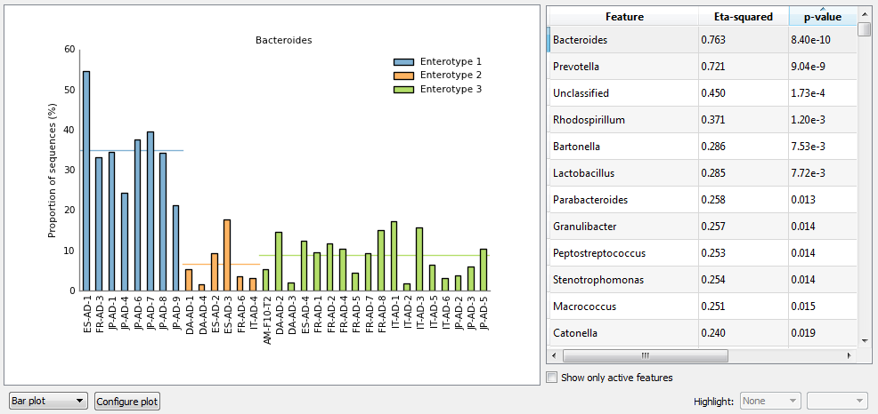

Figure 3. Bar plot showing the relative proportion of *Bacteriodes* within 32 gut microbiota samples. Samples are coloured according to the enterotype to which they have been assigned. The table on the right provides a list of features (genera) which can be plotted. It has been sorted by increasing order of p-values. *Bacteriodes* has the smallest p-value of all genera.

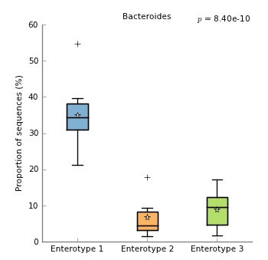

Figure 4. Box plot showing the distribution in the proportion of *Bacteriodes* assigned to samples from three enterotypes. Boxes indicate the IQR (75th to 25th of the data). The median value is shown as a line within the box and the mean value as a star. Whiskers extend to the most extreme value within 1.5*IQR. Outliers are shown as crosses.

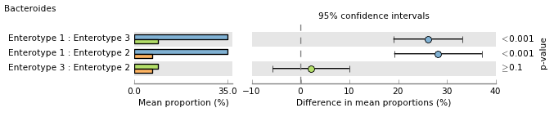

Figure 5. Post-hoc plot for *Bacteriodes* indicating 1) the mean proportion of sequences within each enterotype, 2) the difference in mean proportions for each pair of enterotypes, and 3) a p-value indicating if the mean proportion is equal for a given pair.

|  |  |  |
| --- | --- | --- |
| Statistical hypothesis tests | Comments | References |
| ANOVA | An analysis of variance (ANOVA) is a method for testing whether or not the means of several groups are all equal. It can be seen as a generalization of the t-test to more than two groups. | Bluman, 2007 |
| Kruskal-Wallis H-test | A non-parametric method for testing whether or not the median of several groups are all equal. It considers the rank order of each sample and not the actual proportion of sequences associated with a feature. This has the benefit of not assuming the data is normally distributed. Each group must contain at least 5 samples to apply this test. | Bluman, 2007 |
| Post-hoc tests |  |  |
| Games-Howell | Used to determine which means are significantly different when an ANOVA produces a significant p-value. This post-hoc test is designed for use when variances and group sizes are unequal. It is preferable to Tukey-Kramer when variances are unequal and group sizes are small, but it more computationally expensive. |  |
| Scheffè | A general post-hoc test for considering all possible contrasts unlike the Tukey-Kramer method which considers only pairs of means. Currently, STAMP only considers pairs of means so the Tukey-Kramer method is preferred. In general, this test is highly conservative. |  |
| Tukey-Kramer | Used to determine which means are significantly different when an ANOVA produces a significant p-value. It considers all possible pairs of means while controlling the familywise error rate (*i.e.*, accounting for multiple comparisons). In general, we recommend using the Games-Howell post-hoc test when reporting final results and the Tukey-Kramer method for exploratory analysis since it is less computationally intensive. The Tukey-Kramer may also be preferred as it is more widely used and known amongst researchers. | Bluman, 2007 |
| Welch’s (uncorrected) | Simple performs Welch’s t-test on each possible pair of means. No effort is made to control the familywise error rate. |  |
| Multiple test correction methods |  |  |
| Benjamini-Hochberg FDR | Initial proposal for controlling false discovery rate instead of the familywise error. Step-down procedure. | Benjamini and Hochberg, 1995 |
| Bonferroni | Classic method for controlling the familywise error. Often criticized as being too conservative. | Adbi, 2007 |
| Šidák | Less common method for controlling the familywise error rate. Uniformly more powerful than Bonferroni, but requires the assumption that individual tests are independent. | Adbi, 2007 |
| Storey’s FDR | Recent method used to control the false discovery rate. More powerful than the Benjamini-Hochberg method. Requires estimating certain parameters and is more computationally expensive than the Benjamini-Hochberg approach. | Storey and Tibshirani, 2003 Storey *et al.*, 2004 |

Table 1. Multiple group statistical techniques available in STAMP. Our recommendations are indicated in bold.

## 7.2 Analyzing two groups

Setting statistical analysis properties:To analyze a pair of groups, click on the Two groups tab in the Properties window. Whether analyzing multiple groups or a pair of groups, groupings are determined by the value of the Group field combobox in the Group legend window. In this section, we will consider if there are compositional differences in the gut microbiota of males and females by setting the Group field to Gender.

Statistical properties are set through the Properties window. The settings for *Parent level, Profile level*, and the treatment of *Unclassified* sequences apply uniformly to all analyses (*i.e.*, multiple groups, two groups, and two samples). Analysis specific properties are given below the analysis type tabs in the Properties window.

*Profile*: The profile section is used to specify which pair of groups will be analyzed. In this case, we have only two groups (male and female) so we do not need to change these values. The colour associated with the two groups can also be changed by clicking on the colour button next to these groups. Group 2 can also be set to <All other samples> in which case all samples not contained in group 1 are used to form the second group. This is useful for comparing a specific set of samples to all other samples within a study.

*Statistical properties:* the statistical test, confidence interval method and width, and multiple test correction method to use can all be specified in this section. A one or two-sided statistical hypothesis tests can be performed although generally a two-sided test should be used for the reasons discussed in Rivals *et al.* (2007). A list of methods provided in STAMP for analyzing two groups is given in Table 2.

*Filtering*: the filtering section provides a large number of filters for identifying features that satisfy a set of criteria with the number of features passing the specified filters indicated at the bottom of the section. Attention can be focused on a specific subset of features using the Select features dialog. The provided filters are as follows:

* *p-value filter*: all features with a p-value greater than the specified value are removed
* *Sequence filter*: allows features that have been assigned fewer than the specified number of sequences to be removed. Filtering can be applied to the sample within the two groups having either the maximum or minimum number of sequences for a given feature. Alternatively, filtering can be applied independently to the samples within each group and features filtered if the samples within either group contain an insufficient number of sequences.
* *Parent sequence filter:* same as the sequence filter except applied to the sequence counts within parental categories.
* *Effect size* *filters*: allows features with small effect sizes to be removed. Filtering can be performed on two different effect size statistics. This allows one to filter on both an absolute (i.e., difference between proportions) and relative (i.e., ratio of proportions) measure of effect size. These filters can be applied so features failing either condition (logical OR operator) or both conditions (logical AND operator) are filtered. These effect size filters are applied to the mean proportions over all samples within a group.

Graphical exploration of results: The following plots are provided for exploring the results of a two groups analysis:

* *Bar plot:* a bar plot indicating the proportion of sequences assigned to each feature. The feature to plot is selected from a table to the right of the plot.
* *Box plot:* a box plot is similar to a bar plot except the distribution of proportions within a group are indicated using a box-and-whiskers graphic. This provides a more concise summary of the distribution of proportions within a group. The box-and-whiskers graphics show the median of the data as a line, the mean of the data as a star, the 25th and 75th percentiles of the data as the top and bottom of the box, and uses whiskers to indicate the most extreme data point within 1.5*(75th – 25th percentile) of the median. Data points outside of the whiskers are shown as crosses.
* *PCA plot:* a principal component analysis (PCA) plot of the samples. Clicking on a marker within the plot indicates the sample represented by the marker.
* *Scatter plot*: indicates the mean proportion of sequences within each group which are assigned to each feature. This plot is useful for identifying features that are clearly enriched in one of the two groups. The spread of the data within each group can be shown in various ways (*e.g.*, standard deviation, minimum and maximum proportions).
* *Extended error bar*: indicates the difference in mean proportion between the two groups along with the associated confidence interval of this effect size and the p-value of the specified statistical test. In addition, a bar plot indicates the mean proportion of sequences assigned to a feature in each group. We believe this is the minimal amount of information required to reason about the biological relevance of a feature. Figure 6 gives an extended error bar plot for the enterotype data.

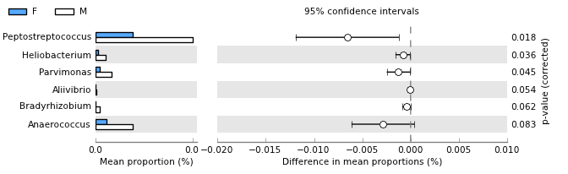

Figure 6: Extended error bar plot indicating all genera where Welch’s t-test produces a p-value > 0.1. All genera are overabundant within the gut microbiota of males (M) compared to females (F).

Tabular view of results: the results of a two groups analysis are tabulated in a Two group statistics table. This table is accessed through the View->Two group statistics table menu item.

|  |  |  |
| --- | --- | --- |
| Statistical hypothesis tests | Comments | References |
| t-test (equal variance) | Student’s t-test which explicitly assumes the two groups have equal variance. When this assumption can be made, this test is more powerful than Welch’s t-test. | Bluman, 2007 |
| Welch’s t-test | A variation of Student’s t-test that is intended for use when the two groups cannot be assumed to have equal variance. | Bluman, 2007 |
| White’s non-parametric t-test | Non-parametric test proposed by White *et al*. for clinical metagenomic data. This test uses a permutation procedure to remove the normality assumption of a standard t-test. In addition, it uses a heuristic to identify sparse features which are handled with Fisher’s exact test and a pooling strategy when either group consists of less than 8 samples. See White *et al*., 2009 for details.  For large datasets this test can be computationally expensive. It may help to reduce the number of replicates performed which can be set in the Preferences->Settings dialog. | White *et al.*, 2009 |
| Confidence interval methods |  |  |
| DP: t-test inverted | Only available when using the equal variance t-test. Provides confidence intervals by inverting the equal variance t-test. |  |
| DP: Welch’s inverted | Only available when using Welch’s t-test. Provides confidence intervals by inverting Welch’s t-test. |  |
| DP: bootstrap | Only available when using White’s non-parametric t-test. Provides confidence intervals using a percentile bootstrapping method. If White’s non-parametric t-test defaults to using Fisher’s exact test, confidence intervals are obtained using the Asymptotic with CC approach (see Table 3). |  |
| Multiple test correction methods |  |  |
| Benjamini-Hochberg FDR | Initial proposal for controlling false discovery rate instead of the familywise error. Step-down procedure. | Benjamini and Hochberg, 1995 |
| Bonferroni | Classic method for controlling the familywise error. Often criticized as being too conservative. | Adbi, 2007 |
| Šidák | Less common method for controlling the familywise error rate. Uniformly more powerful than Bonferroni, but requires the assumption that individual tests are independent. | Adbi, 2007 |
| Storey’s FDR | Recent method used to control the false discovery rate. More powerful than the Benjamini-Hochberg method. Requires estimating certain parameters and is more computationally expensive than the Benjamini-Hochberg approach. | Storey and Tibshirani, 2003 Storey *et al.*, 2004 |

Table 2. Two group statistical techniques available in STAMP. Our recommendations are indicated in bold. DP = difference between mean proportions.

## 7.3 Analyzing two samples

Setting statistical analysis properties:To analyze a pair of samples, click on the Two samples tab in the Properties window. In this section, we will consider if there are compositional differences in the gut microbiota between two twins, AM-F10-T1 and AM-F10-T2.

*Profile*: The profile section is used to specify which pair of samples will be analyzed. Set the Sample 1 and Sample 2 comboboxes to AM-F10-T1 and AM-F10-T2, respectively. The colour associated with these two samples can be changed by clicking on the colour button next to the samples.

*Statistical properties:* the statistical test, confidence interval method and width, and multiple test correction method to use can all be specified in this section. A one or two-sided statistical hypothesis tests can be performed although generally a two-sided test should be used for the reasons discussed in Rivals *et al.* (2007). To assess biological importance it is often useful to consider both an absolute effect size statistic such as the different between proportions and a relative statistic such as the ratio of proportions. For the difference between proportions we recommend using the Newcombe-Wilson method for calculating CIs and for the ratio of proportions we recommend the standard asymptotic approach (Parks and Beiko, 2009; Newcombe, 1998). CIs are typically created for a nominal coverage of 95% and in general there is little reason to deviate from this convention. A list of methods provided in STAMP for analyzing two samples is given in Table 3.

*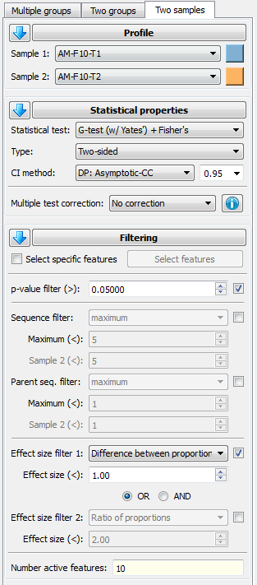Filtering*: the filtering section provides a large number of filters for identifying features that satisfy a set of criteria with the number of features passing the specified filters indicated at the bottom of the section. Attention can be focused on a specific subset of features using the Select features dialog. The provided filters are as follows:

* *p-value filter*: all features with a p-value greater than the specified value are removed
* *Sequence filter*: allows features that have been assigned fewer than the specified number of sequences to be removed. Filtering can be applied to the maximum or minimum number of sequences assigned to a feature within the two samples. Alternatively, features can be filtered by sequence count using an independent threshold for each sample.
* *Parent sequence filter:* same as the sequence filter except applied to the sequence counts within parental categories.
* *Effect size* *filters*: allows features with small effect sizes to be removed. Filtering can be performed on two different effect size statistics. This allows one to filter on both an absolute (*i.e.*, difference between proportions) and relative (*i.e.*, ratio of proportions) measure of effect size. These filters can be applied so features failing either condition (logical OR operator) or both conditions (logical AND operator) are filtered.

Graphical exploration of results: STAMP contains several statistical plots to help investigate the results of a two sample analysis and to identify features that are of biological relevance:

* *Profile bar plot:* a bar plot indicating the proportion of sequences assigned to each feature. It is recommended for investigating higher hierarchical levels of a profile where the number of features is relatively small. Confidence intervals for each proportion are calculated using the Wilson score method (Newcombe, 1998b). Figure 7 gives a profile bar plot of the two twin gut microbiota profiles.
* *Scatter plot:* indicates the proportion of sequences assigned to each feature in a colour coded scatter plot. This plot is useful for identifying features that are clearly enriched in one of the two samples. Confidence intervals for each proportion can be displayed and are calculated using the Wilson score method (Newcombe, 1998b). A notable benefit of this plot is that it can be applied to metagenomes which have a large number of features. Figure 8 gives a profile scatter plot of the two twin gut microbiota profiles.
* *Sequence histogram:* gives a general overview of the number of sequences assigned to each feature.
* *Bar plot:* the bar plot can be used to look at any statistic in detail for the set of active features (*i.e.*, effect size, p-value, corrected p-value, number of sequences assigned to a feature in each sample, or the relative proportion of sequences assigned to a feature in each sample).
* *Extended error bar plot:* indicates the p-value along with the effect size and associated confidence interval for each active feature. In addition, a bar plot indicates the proportion of sequences assigned to a feature in each sample. We believe this is the minimal amount of information required to reason about the biological relevance of a feature. Figure 9 contain an extended error bar plots for the two twin gut microbiota profiles.
* *Multiple comparison plot:* a multiple comparison plot can be used to analyze the results of applying a multiple test correction technique.
* *p-value histogram*: a p-value histogram shows the distribution of p-values in a metagenomic profile.

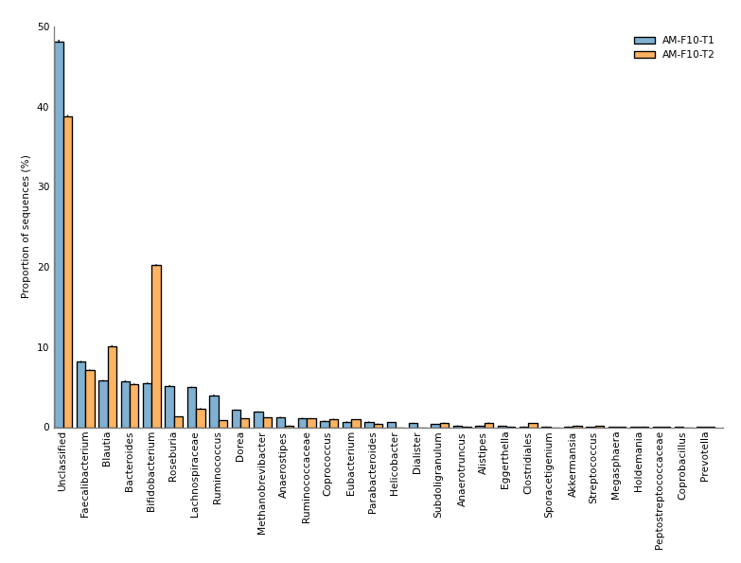

Figure 7. Profile bar plot showing the relative proportion of the 30 most abundant genera in the gut microbiota of a pair of twins.

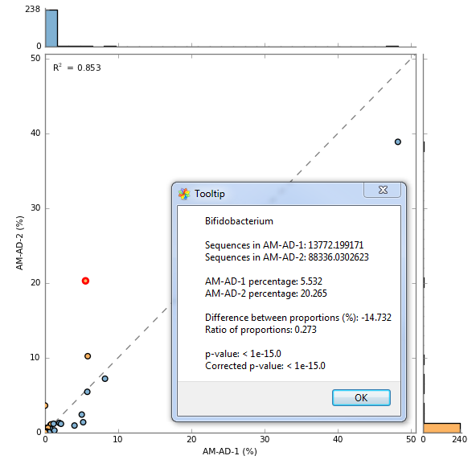

Figure 8. Profile scatter plot indicating the relative proportion of all 248 genera within the gut microbiota of a pair of twins. Detailed information for the point highlighted in red is shown in a Tooltip dialog. Detailed information about any point can be obtained by clicking on it. Points on either side of the grey dashed y = x line are enriched in one of the two samples. A statistical hypothesis test is required to determine if the observed difference is large enough to safely discount it being a sampling artifact. This plot illustrates that the majority of genera within the gut microbiota are present in low proportions (i.e., < 5%) and are similar in our two samples.

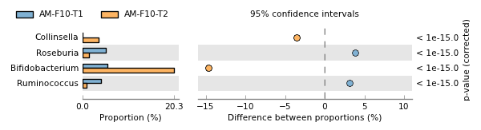

Figure 9. Extended error bar plot for the four genera that have a difference between proportions of at least 3% and a ratio of proportions of at least 2.

Tabular view of results: the results of a two sample analysis are tabulated in a Two sample statistics table. This table is accessed through the View->Two sample statistics table menu item.

|  |  |  |
| --- | --- | --- |
| Statistical hypothesis tests | Comments | References |
| Bootstrap | A rough non-parametric approximation to Barnard’s exact test. Assumes sampling with replacement. | Manly, 2007 |
| Chi-square | Large sample approximation to Fisher’s exact test. Generally liberal compared to Fisher’s. | Cochran, 1952 Agresti, 1992 |
| Chi-square with Yates’ | Large sample approximation to Fisher’s exact test which has been corrected to account for the discrete nature of the distribution it is approximating. Generally conservative compared to Fisher’s. | Yates, 1934 |
| Difference between proportions | Z-test. Large sample approximation to Barnard’s exact test. | Agresti, 1990 |
| Fisher’s exact test1 | Conditional exact test where p-values are calculated using the ‘minimum-likelihood’ approach. Computationally efficient even for large metagenomic samples. Widely used and understood. | Agresti, 1990 Rivals *et al.*, 2007 |
| G-test | Large sample approximation to Fisher’s exact test. Often considered more appropriate than the Chi-square approximation. Generally liberal compared to Fisher’s. | Agresti, 1990 |
| G-test with Yates’ | Large sample approximation to Fisher’s exact test which has been corrected to account for the discrete nature of the distribution it is approximating. Generally conservative compared to Fisher’s. | Yates, 1934 |
| G-test (w/Yates’) + Fisher’s | Applied Fisher’s exact test if any entry in the contingency table is less than 20. Otherwise, the G-test with Yates’ continuity correction is used. For clarity, we recommend reporting final results using just Fisher’s exact test. However, it is far more efficient to explore the data using this hybrid statistical test. | Agresti, 1990 Rivals *et al.*, 2007  Yates, 1934 |
| Hypergeometric1 | Conditional exact test where p-values are calculated using the ‘doubling’ approach. More computationally efficient than the ‘minimum-likelihood’ approach, but the latter approach is more commonly used by statistical packages (i.e., R and StatXact). Our results suggest the doubling approach is generally more conservative than the minimum-likelihood approach. | Rivals *et al.*, 2007 |
| Permutation | Approximation to Fisher’s exact test. Assumes sampling without replacement. | Manly, 2007 |
| Confidence interval methods |  |  |
| DP: Asymptotic | Standard large sample method. | Newcombe, 1998 |
| DP: Asymptotic with CC | As above, with a continuity correction to account for the discrete nature of the distribution being approximated. | Newcombe, 1998 |
| DP: Newcombe-Wilson | Method recommended by Newcombe in a comparison of seven asymptotic approaches. | Newcombe, 1998 |
| OR: Haldane adjustment | Standard large sample method with a correction to handle degenerate cases. | Bland, 2000; Lawson, 2004; Agresti, 1999 |
| RP: Asymptotic | Standard large sample method. | Agresti, 1990 |
| Multiple test correction methods |  |  |
| Benjamini-Hochberg FDR | Initial proposal for controlling false discovery rate instead of the familywise error. Step-down procedure. | Benjamini and Hochberg, 1995 |
| Bonferroni | Classic method for controlling the familywise error. Often criticized as being too conservative. | Adbi, 2007 |
| Šidák | Less common method for controlling the familywise error rate. Uniformly more powerful than Bonferroni, but requires the assumption that individual tests are independent. | Adbi, 2007 |
| Storey’s FDR | Recent method used to control the false discovery rate. More powerful than the Benjamini-Hochberg method. Requires estimating certain parameters and is more computationally expensive than the Benjamini-Hochberg approach. | Storey and Tibshirani, 2003 Storey *et al.*, 2004 |

Table 3. Two sample statistical techniques available in STAMP. Our recommendations are indicated in bold. CC = continuity correction, DP = difference between proportions, OR = odds ratio, RP = ratio of proportions. 1Use of Fisher’s exact test to imply a ‘minimum-likelihood’ approach and hypergeometric to imply a ‘doubling’ approach to calculating a p-value is commonly, but not universally, used.

# 8. Global preferences

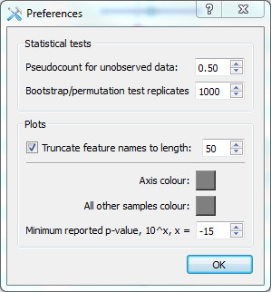Global user preferences can be set in the Preferences dialog available from the Setttings menu. Within this dialog the pseudocount to add to the unobserved data can be set. Pseudocounts are only added when a sample has a count of zero and the statistical method is degenerate for such boundary cases. The only exception to this is the Haldane odds ratio confidence interval method which adds the pseudocount to all table entries regardless of their initial value. The default value of 0.5 should be changed with caution. The number of replicates to construct when performing a bootstrap or permutation test is also set through this dialog. This setting also influences the number of replicates conducted by White’s non-parametric t-test.

Global options relevant to the generation of plots can also be set through this dialog. Feature names within metagenomic profiles are often relatively long. This can make producing plots suitable for journal publication difficult. The Preferences dialog allows feature names to be truncated to a specific length. Colour of plot axes and the group comprising ‘all other samples’ (see Section 6.2) can also be set. Finally, p-values below a specified value can be reported using a ‘≤’ notation to aid clarity.

# 9. Custom statistical techniques and plots

STAMP uses a plugin architecture in order to allow new statistical hypothesis tests, effect size statistics, CI methods, multiple comparison procedures, or plots to be easily incorporated into the software. Plugins are written in Python and must implement a pre-defined interface as specified in an abstract base class. To have a plugin load into STAMP it simply needs to be placed in the relevant plugin folder located at /STAMP/library/plugins/. All statistical techniques and plots available in STAMP have been implemented as plugins and can be consulted as examples.

### 9.1 Creating a custom plot

Here we will create a minimal two sample statistical plot plugin which displays a scatter plot of the relative abundance of all active features (see STAMP/library/plugins/samples/plots/examples/MyScatterPlot.py). This will be nearly identical to the exploratory scatter plot that indicates the relative abundance of all features. To begin, create a file named MyScatterPlot.py in /STAMP/library/plugins/samples/plots. It is important that you place new plugins into the correct plugins folder. To adhere to the required interface for a statistical plot you must create a new class which is derived from AbstractSamplePlotPlugin:

class **MyScatterPlot**(AbstractSamplePlotPlugin):

def **__init__**(*self*, preferences, parent=None):

AbstractSamplePlotPlugin.__init__(*self*, preferences, parent)

*self*.preferences = preferences

*self*.name = *'My scatter plot'*

*self*.figWidth = 6.0

*self*.figHeight = 6.0

*self*.sampleName1 = *''*

*self*.sampleName2 = *''*

The __init__ function takes two parameters. The preferences parameter indicates global user preferences and the parent parameter indicates the parent window for your plot. You will generally want to save these preferences in a class variable for later use. The only required class variable is name which indicates what your plot will be called within STAMP. In the initialization function it is generally useful to initialize all class variables to known default values.

The only other required function is plot. This function takes two parameters, profile and statsResults, which provides details about the profiles for the two samples and the results of all calculated statistics, respectively. Please consult the other plugins for details on how to use these two parameters. The plot function below creates a scatter plot with each data point coloured to reflect the sample it is most abundant in.

def **plot**(*self*, profile, statsResults):

# Colour of plot elements

profile1Colour = str(*self*.preferences[*'Sample 1 colour'*].name())

profile2Colour = str(*self*.preferences[*'Sample 2 colour'*].name())

# Set sample names

if *self*.sampleName1 == *''* and *self*.sampleName2 == *''*:

*self*.sampleName1 = statsResults.profile.sampleNames[0]

*self*.sampleName2 = statsResults.profile.sampleNames[1]

# Get data to plot

field1 = statsResults.getColumn(*'RelFreq1'*)

field2 = statsResults.getColumn(*'RelFreq2'*)

# Set figure size

*self*.fig.clear()

*self*.fig.set_size_inches(*self*.figWidth, *self*.figHeight)

axesScatter = *self*.fig.add_subplot(111)

# Set visual properties of all points

colours = []

for i in xrange(0, len(field1)):

if field1[i] > field2[i]:

colours.append(profile1Colour)

else:

colours.append(profile2Colour)

# Create scatter plot

axesScatter.scatter(field1, field2, c=colours)

# Update plot

*self*.updateGeometry()

*self*.draw()

For a plot to be sent to a new window the mirrorProperties function needs to be implemented. To create a configuration dialog box for your plot the configure function must be implemented. We have been making use of Qt Designer to create configuration dialogs which comes bundled with PyQt4. A useful exercise is to extend this simple scatter plot so it contains all the functionality of the exploratory scatter plot (/STAMP/library/plugins/samples/plots/ScatterPlot.py).

### 9.2 Making a plugin publicly available

If you have created a plugin and would like to make it publicly available, we are happy to host it on the STAMP website. Plugins that will be of general use to STAMP users will be included in future releases (with your permission) and attributed to you. To have a plugin hosted on the STAMP website send an email to Rob Beiko (beiko [at] cs.dal.ca).

# References

Adbi 2007Adbi, H. (2007) *Encyclopedia of Measurement and Statistics.* Thousand Oaks, CA: Sage.

Agresti 1990Agresti, A. (1990) *Categorical data analysis.*, New York : Wiley.

Agresti 1992Agresti, A. (1992) A survey of exact inference for contingency tables. *Statist Sci*, **7**, 131–153.

Agresti 1999Agresti, A. (1999) On logit confidence intervals for the odds ratio with small samples. *Biometrics*, **55**, 597–602.

Arumugam, M. *et al.* (2011) Enterotypes of the human gut microbiome. *Nature*, **473**, 174-180.

Benjamini and Hochberg 1995Benjamini, Y. and Hochberg, Y. (1995) Controlling the false discovery rate: a practical and powerful approach to multiple testing. *J Roy Stat Soc B*, **57**, 289–300.

Bland and Altman 2000Bland, J. M. and Altman, D. G. (2000) The odds ratio. *BMJ*, **320**, 1468.

Bluman, A.G. (2007) *Elementary statistics: A step by step approach (6th edition)*, McGraw Hill Higher Education, New York, New York.

Caporaso *et al.* (2010) **QIIME allows analysis of high-throughput community sequencing data.** Nature Methods, doi:10.1038/nmeth.f.303

Cochran 1952Cochran, W. (1952) The chi-square test of goodness of fit. *Ann Math Stat*, **23**, 315–45.

Kumar and Dudley 2007Kumar, S. and Dudley, J. (2007) Bioinformatics software for biologists in the genomics era. *Bioinformatics*, **23**, 1713–1717.

Langille, M.G.I. *et al*. (2013) **Predictive functional profiling of microbial communities using 16S rRNA marker gene sequences.**Nature Biotechnology, 1-10.

Lawson 2004Lawson, R. (2004) Small sample confidence intervals for odds ratio. *Commun Stat Simulat*, **33**, 1095–1113.

Lingner, T. *et al.* (2011) CoMet – a web server for comparative functional profiling of metagenomes. *Nucleic Acids Res*, **39 (suppl 2)**, W518-W523.

MacDonald, N.J. *et al*. (2011) RITA: rapid identification of high-confidence taxonomic assignments for metagenomic data. (in preparation)

Manly 2007Manly, B. F. J. (2007) *Randomization, bootstrap and Monte Carlo methods in biology*, Physica Verlag, An Imprint of Springer-Verlag GmbH.

Markowitz et al. 2008Markowitz, V. M. *et al.* (2008) IMG/M: a data management and analysis system for metagenomes. *Nucleic Acids Res*, 36 (Database issue), D534–D538.

Meyer et al. 2008Meyer, F. *et al.* (2008) The metagenomics rast server - a public resource for the automatic phylogenetic and functional analysis of metagenomes. *BMC Bioinformatics*, **9**, 386.

Newcombe 1998Newcombe, R. G. (1998) Interval estimation for the difference between independent proportions: comparison of eleven methods. *Stat Med.,* **17**, 873–890.

Newcombe, R.G. (1998b) Two-sided confidence intervals for the single proportion; comparison of several methods. *Stat Med.*, **17**, 857-872.

Overbeek et al. 2005Overbeek, R. *et al.* (2005) The subsystems approach to genome annotation and its use in the project to annotate 1000 genomes. *Nucleic Acids Res*, **33**, 5891–5702.

Rivals, I. *et al.* (2007) Enrichment or depletion of a GO category within a class of genes: which test? *Bioinformatics*, **23**, 401-407.

Storey et al. 2004Storey, J. D. *et al.* (2004) Strong control, conservative point estimation, and simultaneous conservative consistency of false discovery rates: A unified approach. *J Roy Stat Soc B*, **66**, 187–205.

Storey and Tibshirani 2003Storey, J. D. and Tibshirani, R. (2003) Statistical significance for genome wide studies. *Proc Natl Acad Sci USA*, **100**, 9440–9445.

Suresh, K.P. and Shandrashekara, S. (2012). Sample size estimation and power analysis for clinical research studies. *J Hum Reprod Sci*, **5**, 7-13.

White, J.R., Nagarajan, N., and Pop, M. (2009) Statisticalmethods for detecting differentially abundant features in clinical metagenomic samples. *PLoS Comput Biol*, **5**, e1000352.

Yates, F. (1934) Contingency table involving small numbers and the χ2 test. *Supplement to the Journal of the Royal Statistical Society*, **1**, 217-235.