DSP Final Exam. Class:電通三乙_, Student ID:05050032_, Name:陳韋澔

1. The z-transform of *x*(*n*) is  (a) Determine the z-transform of the sequence, where * denotes convolution. (b) Indicate its region of convergence (ROC).
2. The z-transDetermine the z-transform of the following sequences. Indicate the ROC for each sequence.
   1. *x*(*n*)={3, 2, 1, -2, -3}
   2. 
3. A linear, causal, and time-invariant system:

*y*(*n*)*=*2*x*(*n*)*+*0.9*y*(*n-*1)

Determine

1. the impulse response *h*(*n*)
2. the system function H(z)
3. the pole-zero plot

b=[2 0];

a=[1 -0.9];

[R,P,C]=residuez(b,a);

zplane(b,a)

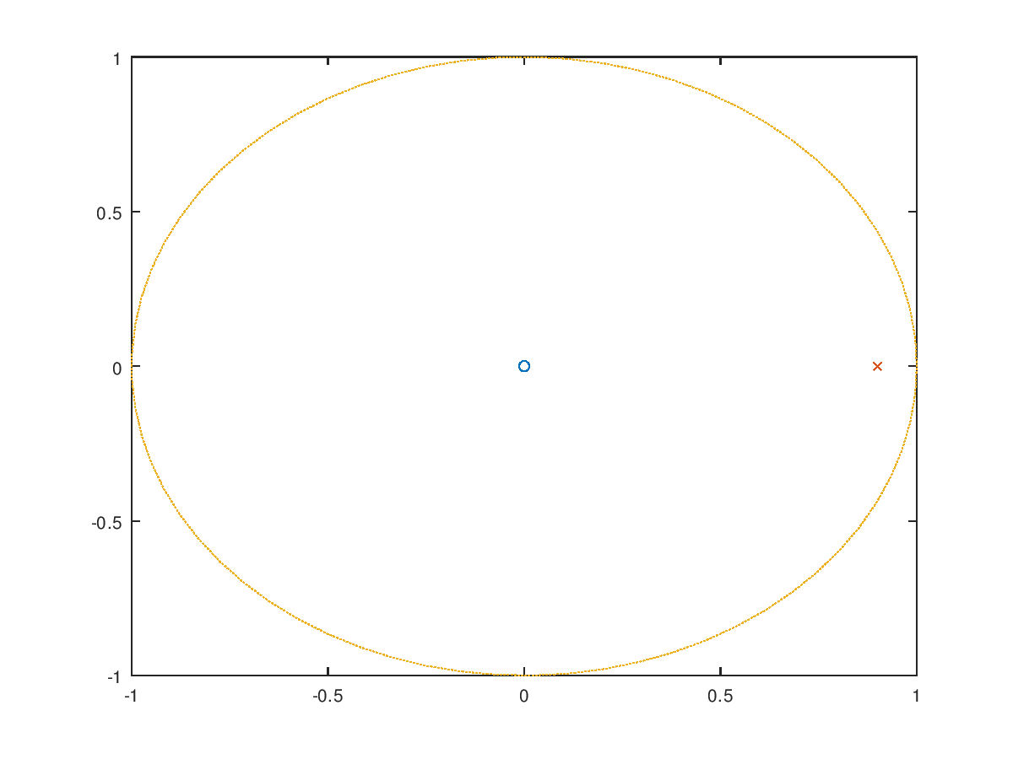

1. Compute the DFS coefficients of the following periodic sequences using the DFS definition

.

1. Compute the DFS coefficients of the following periodic sequences using Octave.

.

close all; clear all;

x=[2 0 0 0 -1 0 0 0];N=8;

x=dft1(x,N);n=0:7;

magx=abs(x);

phcx=angle(x);

subplot(2,1,1);stem(n,magx);

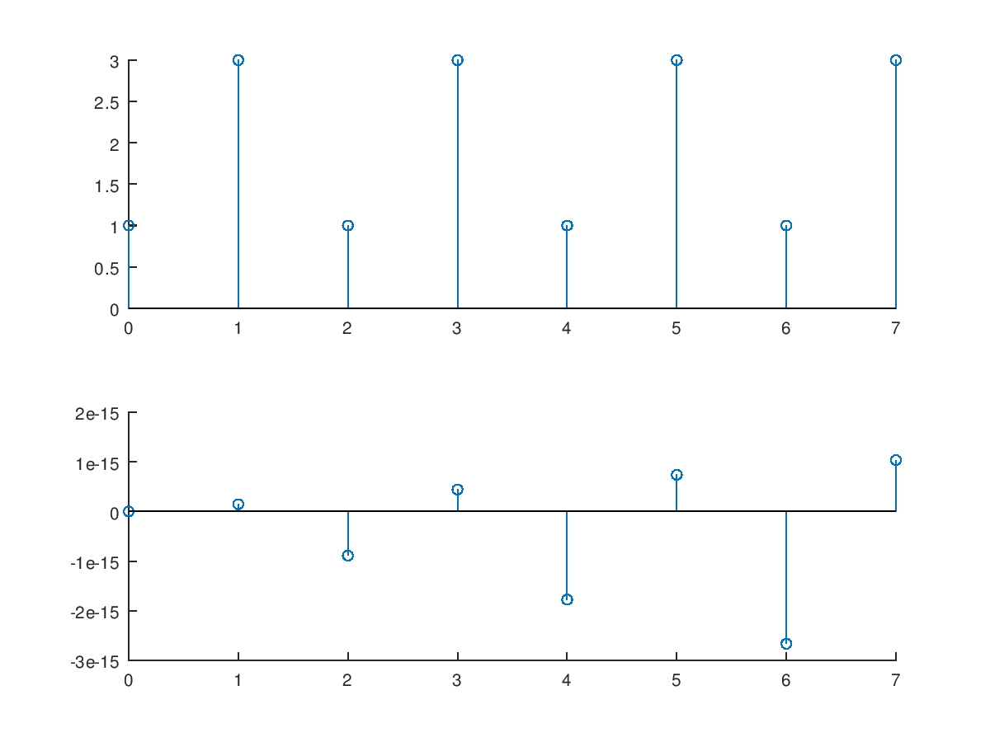subplot(2,1,2);stem(n,phcx);

1. Plot the DFT (a) magnitude and (b) angle of the following sequence (N=100, ω: 0~π).

*x*(*n*)={1, 2, 3, 4, 3, 2, 1}

close all; clear all;

w=[0:500]*pi/500;

X=2*cos(3*w)+4*cos(2*w)+6*cos(w)+4;

mag=abs(X); pha=angle(X);

subplot(211); plot(w/pi,mag);

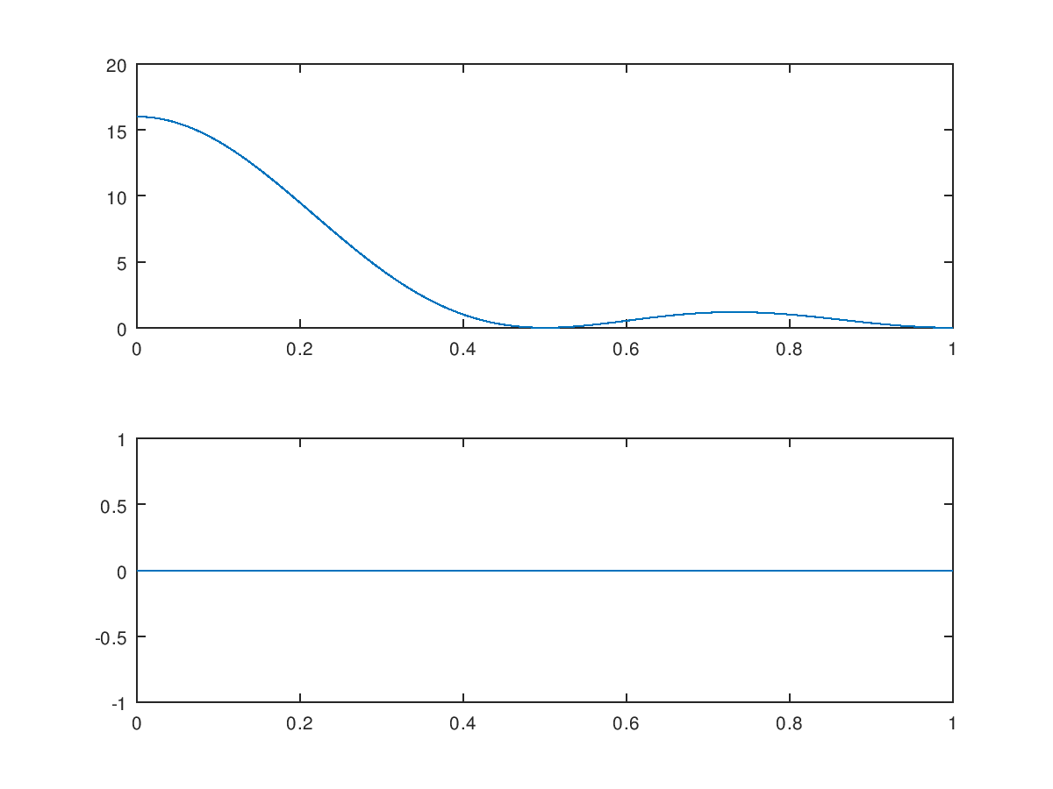subplot(212); plot(w/pi,pha);

1. Let *x*(*n*) be a 4-point sequence:



(a) Compute the discrete-time Fourier transform (DTFT)and plot its magnitude and phase.

(b) Compute and plot the 8-point DFT of *x*(*n*).

(c) Compute and plot the 16-point DFT of *x*(*n*).

(a) plot its magnitude and phase.

close all; clear all;

w=[0:1:5]*(2*pi/5);

x=(1-exp(-j*4*w))./(1-exp(-j*w));

magx=abs(x);

phcx=angle(x);

subplot(2,1,1);stem(w/pi,magx);

subplot(2,1,2);stem(w/pi,phcx);

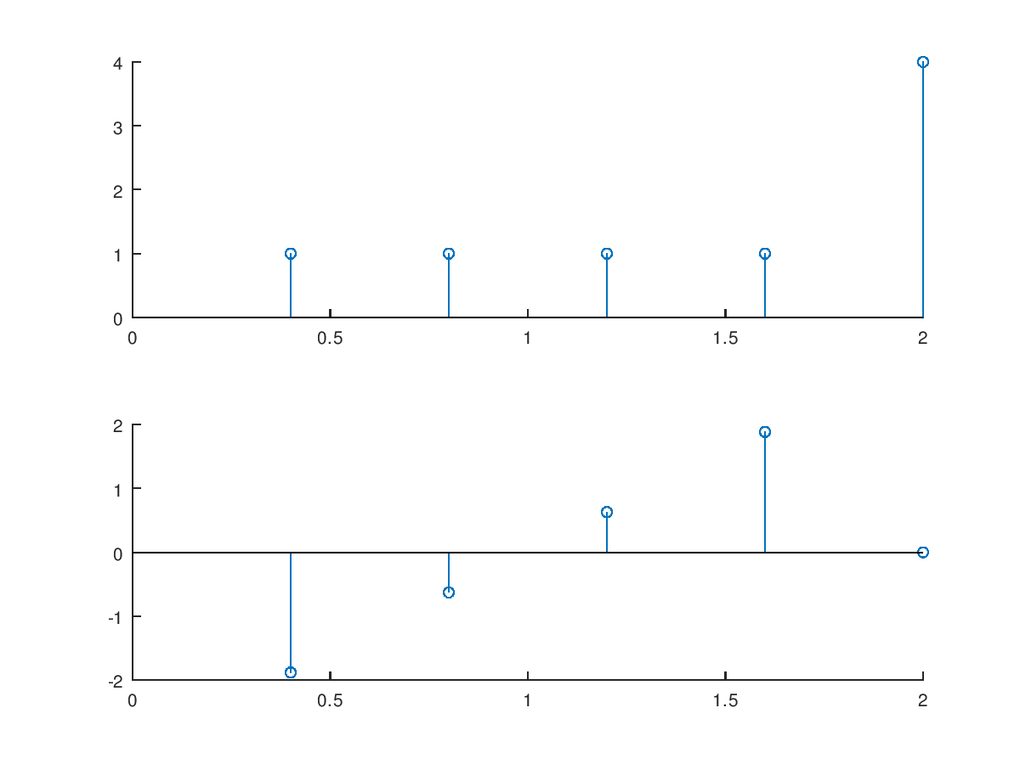

(b) Compute and plot the 8-point DFT of *x*(*n*).

close all; clear all;

x=[1 1 1 1 0 0 0 0];N=8;

x=dft1(x,N);n=0:7;

magx=abs(x);

phcx=angle(x);

subplot(2,1,1);stem(n,magx);

subplot(2,1,2);stem(n,phcx);

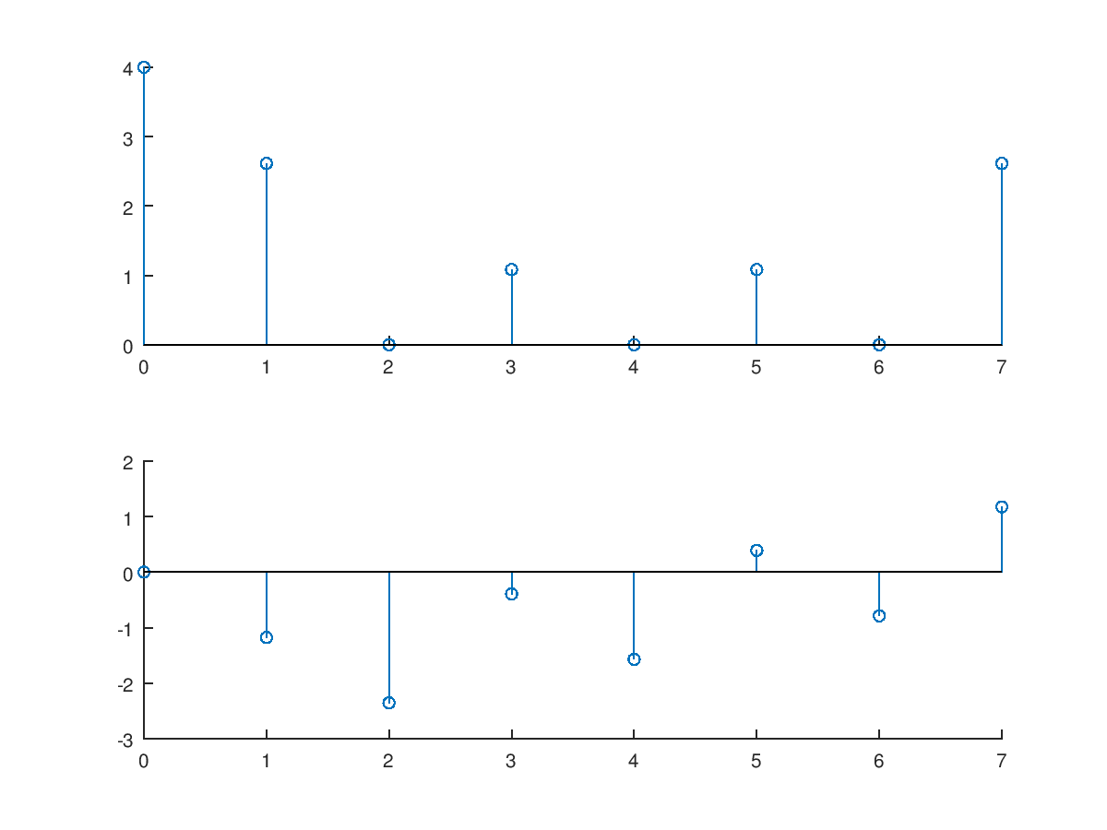

(c) Compute and plot the 16-point DFT of *x*(*n*).

close all; clear all;

x=[1 1 1 1 0 0 0 0 0 0 0 0 0 0 0 0];N=16;

x=dft1(x,N);n=0:15;

magx=abs(x);

phcx=angle(x);

subplot(2,1,1);stem(n,magx);

subplot(2,1,2);stem(n,phcx);

