1. Ex 3.13 Determine the freq response of the system h(n)=(0.9)^n*u(n). Plot the magnitude and the phase responses

程式碼:

|  |
| --- |
| w = [0:1:500]*pi/500;  H = exp(j*w) ./ (exp(j*w) - 0.9*ones(1,501));  magH = abs(H); angH = angle(H);  subplot(2,1,1); plot(w/pi,magH); grid;  xlabel(' frequency in pi units ');  ylabel('|H|');  title('Magnitude Response');  subplot(2,1,2); plot(w/pi,angH/pi); grid  xlabel(' frequency in pi units ');  ylabel('Phase in pi Radians');  title('Phase Response'); |

結果:

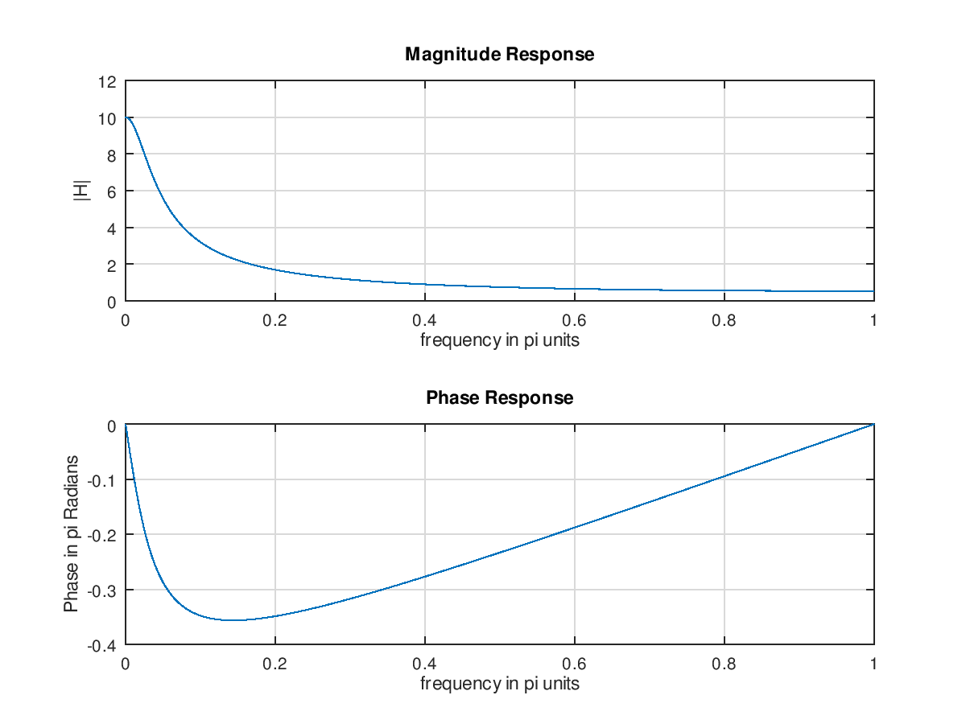

1. Ex 3.15 An LTI system: y(n)=0.8y(n-1)+x(n)

程式碼:

|  |
| --- |
| subplot(1,1,1)  b = 1; a = [1,-0.8];  n=[0:100];x = cos(0.05*pi*n);  y = filter(b,a,x);  subplot(2,1,1); stem(n,x);  xlabel('n'); ylabel('x(n)'); title('Input sequence')  subplot(2,1,2); stem(n,y);  xlabel('n'); ylabel('y(n)'); title('Output sequence') |

結果:

