1. Ex 3.3 Determine the DTFT of ex 3.1 at 501 equispaced points between [0, pi]

|  |
| --- |
| w = [0:1:500]*pi/500;  X = exp(j*w) ./ (exp(j*w) - 0.5*ones(1,501));  magX = abs(X); angX = angle(X);  realX = real(X);imagX = imag(X);  subplot(2,2,1); plot(w/pi,magX); grid  xlabel('frequency in pi units');  title('Magnitude Part'); ylabel('Magnitude')  subplot(2,2,3); plot(w/pi,angX); grid  xlabel(' frequency in pi units ');  title('Angle Part'); ylabel('Radians')  subplot(2,2,2); plot(w/pi,realX); grid  xlabel(' frequency in pi units ');  title('Real Part'); ylabel('Real')  subplot(2,2,4); plot(w/pi,imagX); grid  xlabel(' frequency in pi units ');  title('Imaginary Part'); ylabel('Imaginary') |

結果:

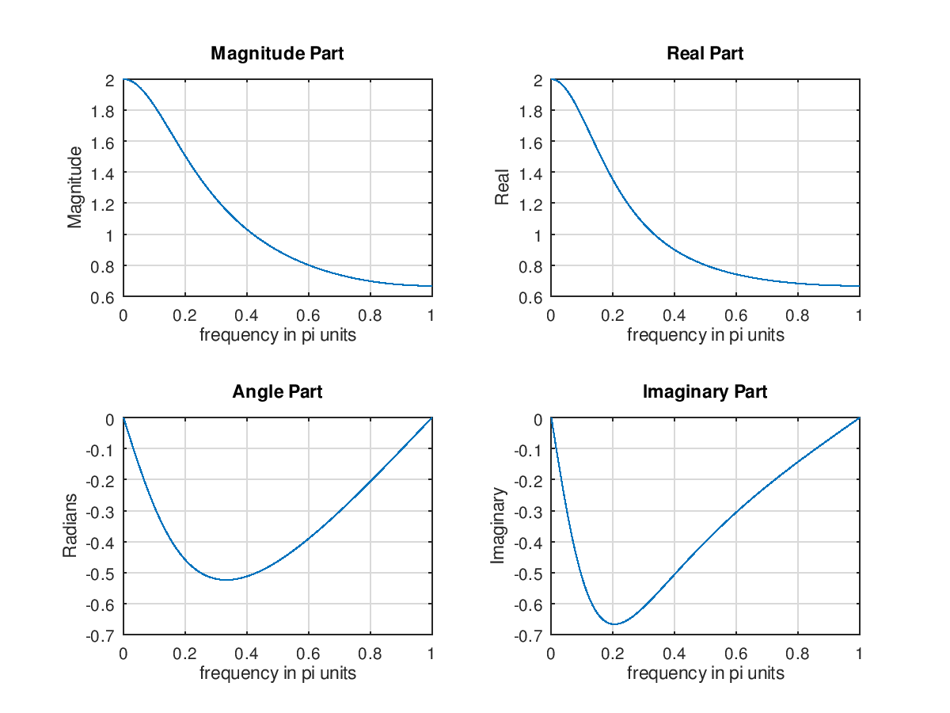

1. Ex 3.4 Determine the DTFT of *x*(n)={1,2,3,4,5}by MATLAB

|  |
| --- |
| n=-1:3; x=1:5;  k=0:500; w=(pi/500)*k;  X=x*(exp(-j*pi/500)).^(n'*k);  magX=abs(X); angX=angle(X);  realX = real(X); imagX = imag(X);  subplot(2,2,1); plot(k/500,magX); grid;  xlabel('frequency in pi unit');  title('Magnitude Part');  subplot(2,2,3); plot(k/500,angX); grid;  xlabel('frequency in pi unit');  title('Magnitude Part');  subplot(2,2,2); plot(k/500,realX); grid;  xlabel('frequency in pi unit');  title('Magnitude Part');  subplot(2,2,4); plot(k/500,imagX); grid;  xlabel('frequency in pi unit');  title('Magnitude Part'); |

結果:

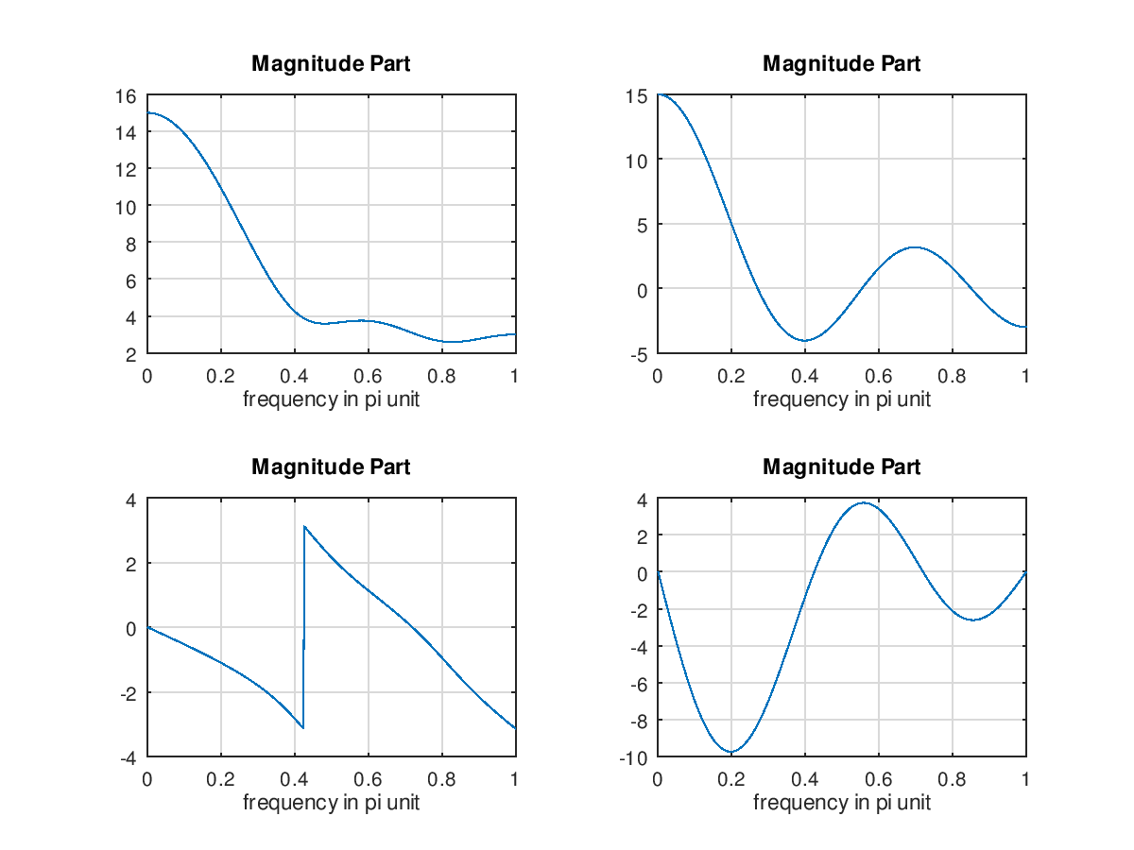

1. Ex 3.5 Find the DTFT of x(n)=(0.9exp(j*pi/3))^n, 0<=n<=10 and investigate its periodicity

|  |
| --- |
| n = 0:10; x = (0.9*exp(j*pi/3)).^n;  k = -200:200; w = (pi/100)*k;  X = x * (exp(-j*pi/100)) .^ (n'*k);  magX = abs(X); angX =angle(X);  subplot(2,1,1); plot(w/pi,magX);grid  xlabel('frequency in units of pi');  ylabel('|X|')  title('Magnitude Part')  subplot(2,1,2); plot(w/pi,angX/pi);grid  axis([-2,2,-1,1])  xlabel(' frequency in units of pi ');  ylabel('radians/pi')  title('Angle Part') |

結果:

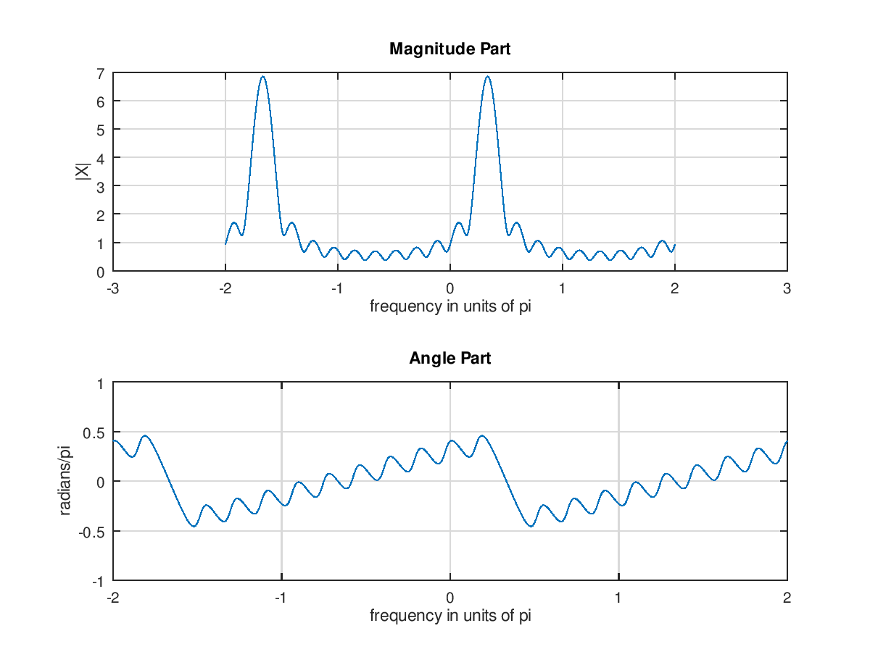

1. Find the DTFT of x(n)=(0.9)^n, -10<=n<=10 and investigate its periodicity

|  |
| --- |
| n = -10:10; x = (0.9).^n;  k = -200:200; w = (pi/100)*k;  X = x * (exp(-j*pi/100)) .^ (n'*k);  magX = abs(X); angX =angle(X);  subplot(2,1,1); plot(w/pi,magX);grid  xlabel('frequency in units of pi');  ylabel('|X|')  title('Magnitude Part')  subplot(2,1,2); plot(w/pi,angX/pi);grid  axis([-2,2,-1,1])  xlabel(' frequency in units of pi ');  ylabel('radians/pi')  title('Angle Part') |

結果:

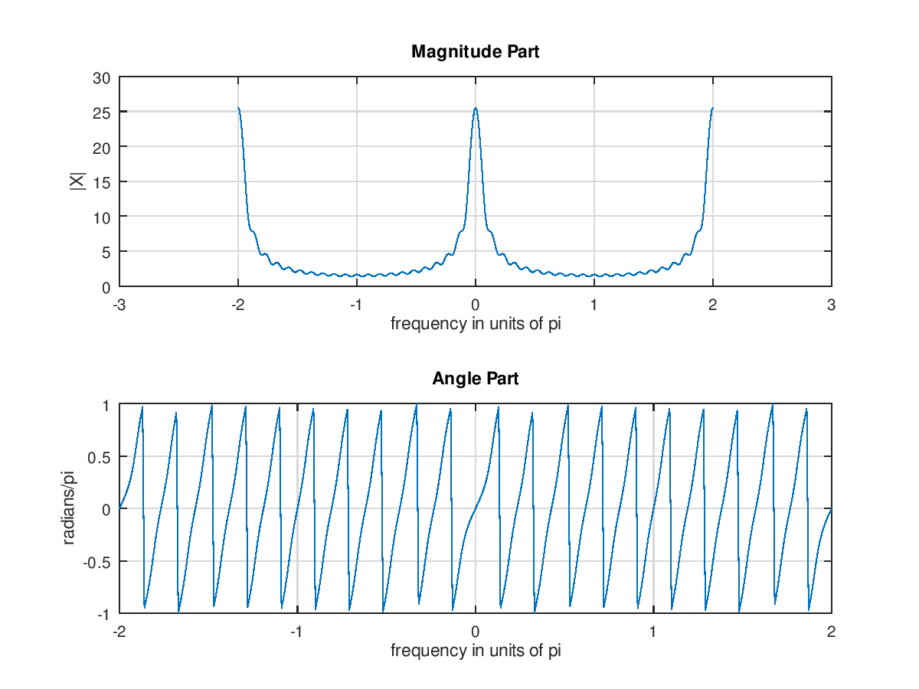

1. 3.3. Find the DTFT of x(n)=(0.9)^|n|, -pi<=w<=pi and investigate its periodicity

|  |
| --- |
| w=[-300:300]*pi/300;  H = 0.19*ones(size(w))./(1.81-1.8*cos(w));  magH=abs(H);  phaH=angle(H)*180/pi;  subplot(2,1,1);  plot(w/pi,magH,'LineWidth',1.5);  axis([-1 1 0 20])  subplot(2,1,2);  plot(w/pi,phaH,'LineWidth',1.5);  axis([-1 1 -180 180]) |

結果:

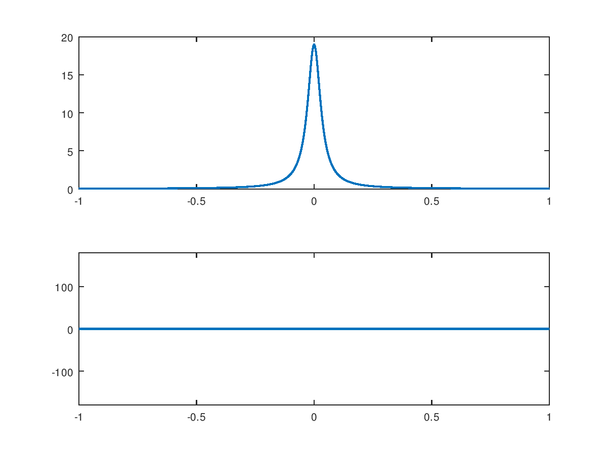

1. 3.11 Find the DTFT of x(n)=2*(0.5)^n(+2), and investigate its periodicity

|  |
| --- |
| W1 = linspace(0,pi,501);  x1 = 8*exp(j*2*W1)./(1-0.5*exp(-j*W1));  magX1 = abs(x1);  phaX1 = angle(x1);  subplot(2,1,1);  plot(W1/pi,magX1,'LineWidth',1.5);  axis([0 1 0 20]);  subplot(2,1,2);  plot(W1/pi,phaX1*180/pi,'LineWidth',1.5);  axis([0 1 -200 200]); |

結果:

