DSP 2019/2/23

2.5

題目:x(n)=[……….-2,-1,0,1,2………..]，plot5個週期

參考範例ch2-p.22-exe2.1

程式碼:

|  |
| --- |
| n=[-10:14];  x=[-2,-1,0,1,2];  xtilde=x' * ones(1,5);  xtilde=(xtilde(:))';  subplot(2,2,4);stem(n,xtilde);  title('Sequence in Problem 2.1d')  xlabel('n'); ylabel('xtilde(n)'); |

結果:

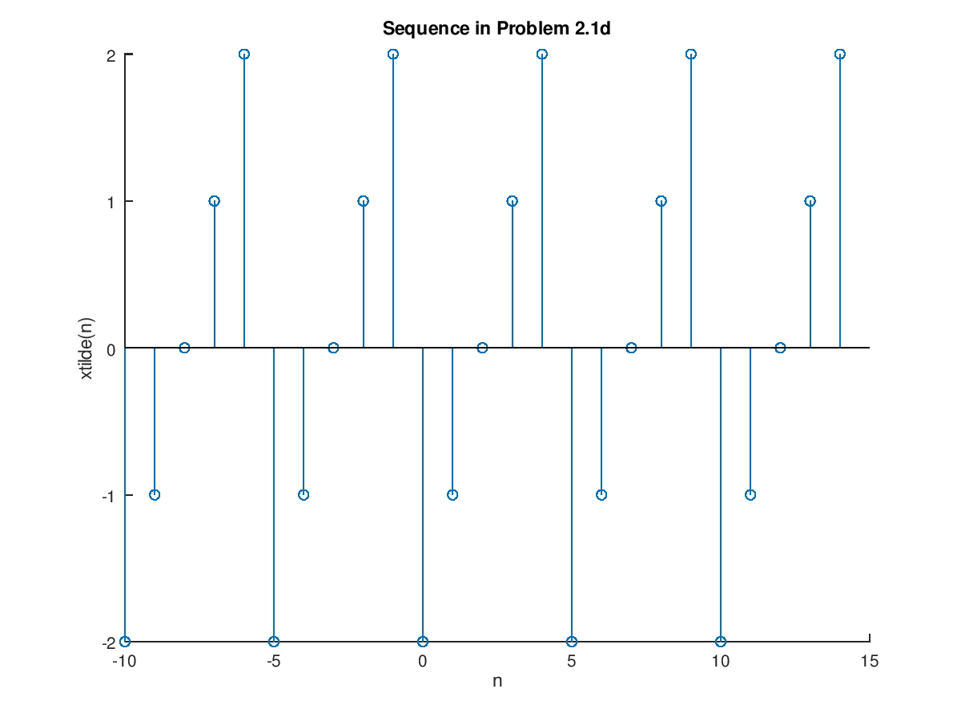

2.6

題目:x(n)=[2,4,-3,1,-5,4,7]，plot5 x(n)=2x(n-3)+ 3x(n+4)-x(n))

參考範例ch2-p.24-exe2.2 ＊ sigadd最多只能加兩項

程式碼:

|  |
| --- |
| n = -3:3;  x = [2,4,-3,1,-5,4,7];  [x11,n11] = sigshift(x,n,3);  [x12,n12] = sigshift(x,n,-4);  [x1,n1] = sigadd(2*x11,n11,3*x12,n12);  [x2,n2] =sigadd(x1,n1,-x,n);  stem(n2,x2);  title('Sequence in Problem 2.2a')  xlabel('n'); ylabel('x2(n)'); |

結果:

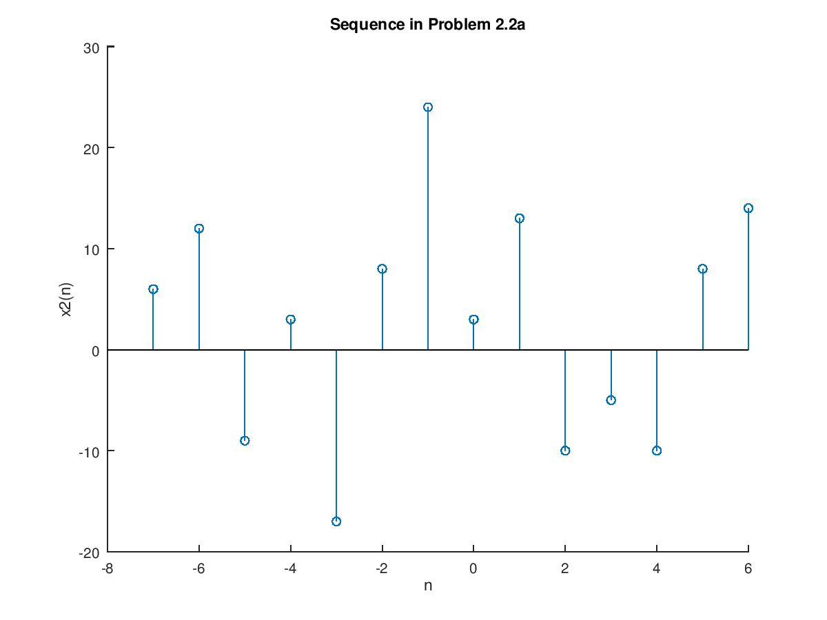

2.7判斷使否為線性(Linear)

1. y(n)=T[x(n)]=3x^2(n) 非線性

2.y(n)=2x(n-2)+5 非線性

3.y(n)=x(n+1)-x(n-1) 線性