close all;clear all;

Ac=1;

fc=10^4;

t=10^-7:10^-7:0.003;

fm=10^3;

vm=cos(2*pi*fm.*t);

freq_de=0.25;

v=Ac*cos(2*pi*fc.*t+freq_de*sin(2*pi*fm.*t));

subplot(2,1,1);

plot(t,vm);

subplot(2,1,2);

plot(t,v);

freq _de=0.25 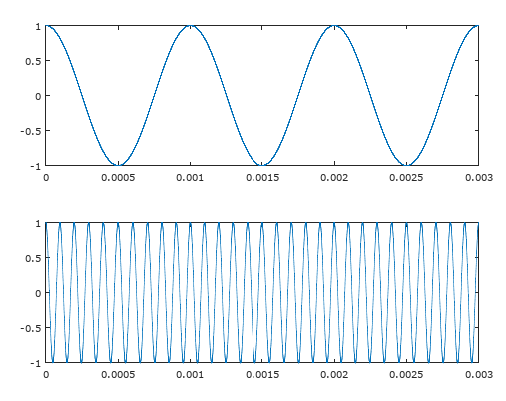

freq _de=5 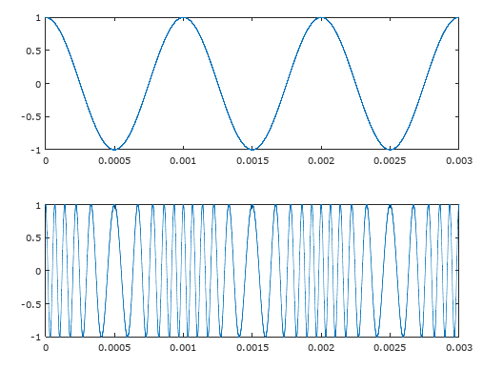

freq _de=25 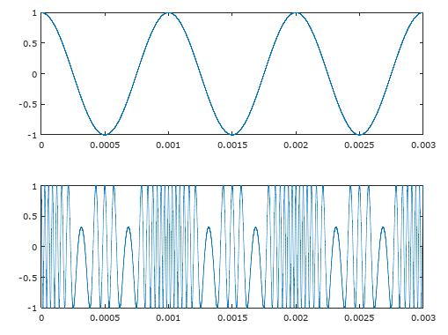

freq _de=50 