電通二乙微處理器實驗 實驗結報

實驗名稱 | Lab04-四合一七段顯示器
組別 | 13 | 組員 | 05050032陳韋澔

- 實驗目的
了解七段顯示器顯示原理
- 共陰極與共陽極七段顯示器之不同?
- 如何讓七段顯示器顯示0-F?
- 如何控制四合一七段顯示器?
- 如何讓四合一七段顯示器顯示四位數字?
- 實驗步驟1
Arduino 接好四合一七段顯示器之電路
四合一七段顯示器每隔0.3秒會跳一個數字，從0000->0059->0100跳至2359後歸零
- 實驗步驟2
於PIN6按鍵，按下後歸零顯示
- 實驗步驟3
合併歸零及倒數計時
於PIN6按鍵，按下後歸零顯示
於PIN17接一個按鍵，按下倒數計時
- 程式碼1
#include "SevSeg.h"

SevSeg sevseg; //Instantiate a seven segment controller object

void setup() {

byte numDigits = 4;

byte digitPins[] = {2,3,4,5};

byte segmentPins[] = {8, 9, 10, 11, 12, 13,14,15};

bool resistorsOnSegments = false;

byte hardwareConfig = COMMON_CATHODE;

sevseg.begin(hardwareConfig, numDigits, digitPins, segmentPins, resistorsOnSegments);

sevseg.setBrightness(90);

}

void loop() {

static unsigned long timer = millis();

static int deciSeconds = 0;

sevseg.setNumber(deciSeconds, 3);

if (millis() - timer >=50) {

deciSeconds++;

timer += 50;

if (deciSeconds%100 == 59)

deciSeconds+=41;

else

deciSeconds+=1;

if (deciSeconds == 2400)

deciSeconds=0;

}

sevseg.refreshDisplay(); // Must run repeatedly

}

- 程式碼2
#include "SevSeg.h"

SevSeg sevseg; //Instantiate a seven segment controller object

byte sw=digitalRead(6);

void setup() {

byte numDigits = 4;

byte digitPins[] = {2,3,4,5};

byte segmentPins[] = {8, 9, 10, 11, 12, 13,14,15};

bool resistorsOnSegments = false;

byte hardwareConfig = COMMON_CATHODE;

sevseg.begin(hardwareConfig, numDigits, digitPins, segmentPins, resistorsOnSegments);

sevseg.setBrightness(90);

}

void loop() {

static unsigned long timer = millis();

static int deciSeconds = 0;

sevseg.setNumber(deciSeconds, 3);

if(sw){

if (millis() - timer >=50) {

deciSeconds++;

timer += 50;

if (deciSeconds%100 == 59)

deciSeconds+=41;

else

deciSeconds+=1;

if (deciSeconds == 2400)

deciSeconds=0;

}

}

else

sevseg.setNumber(0000, 3);

sevseg.refreshDisplay(); // Must run repeatedly

}

- 程式碼3
#include "SevSeg.h"

SevSeg sevseg; //Instantiate a seven segment controller object

void setup() {

byte numDigits = 4;

byte digitPins[] = {2, 3, 4, 5};

byte segmentPins[] = {8,9,10,11,12,13,14,15};

bool resistorsOnSegments = false; // 'false' means resistors are on digit pins

byte hardwareConfig = COMMON_CATHODE; // See README.md for options

sevseg.begin(hardwareConfig, numDigits, digitPins, segmentPins, resistorsOnSegments);

sevseg.setBrightness(90);

pinMode(6,INPUT);

pinMode(17,INPUT);

}

void loop()

{

static unsigned long timer = millis();

static int deciSeconds = 0;

boolean val=digitalRead(6);

boolean Pin17=digitalRead(17);

if(val)

{

sevseg.setNumber(0000, 3);

sevseg.refreshDisplay();

if(Pin17==HIGH)

deciSeconds=2400;

else

deciSeconds=0;

}

else if(Pin17==HIGH)

{

sevseg.setNumber(deciSeconds, 3);

if (millis() - timer >= 300)

{

timer += 300;

deciSeconds--;

if (deciSeconds%100 == 59)

{

deciSeconds=deciSeconds-59;

}

else

{

deciSeconds=deciSeconds-1;

}

}

if (deciSeconds == 0)

deciSeconds =2400 ;

sevseg.refreshDisplay(); // Must run repeatedly

}

else

{

sevseg.setNumber(deciSeconds, 3);

if (millis() - timer >= 300)

{

timer += 300;

deciSeconds++;

if (deciSeconds%100 == 59)

{

deciSeconds=deciSeconds+41;

}

else

{

deciSeconds=deciSeconds+1;

}

if (deciSeconds == 2400)

deciSeconds =0 ;

}

sevseg.refreshDisplay(); // Must run repeatedly

}

}

- 實驗結果及分析
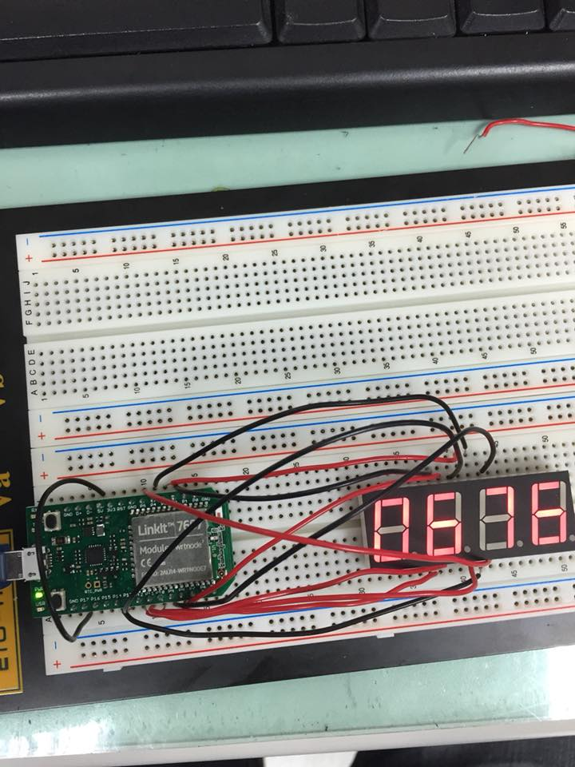
正常會正數，按下按鍵會歸零，PIN17接5V會倒數
- 心得討論
我們直接就接四合一，雖然程式碼設定比一顆簡單，但是迴圈卻麻煩許多，幸好最後有做出來，成就感十足呢

