Engineering Application Software quiz 2 Class: 無 Name: 測試 Student ID:寫好玩

作答時請注意下列規則, 否則不予計分: (a)圖形請用**複製貼上**,勿用螢幕截圖方式(b)程式與執行結果請**複製文字後貼上**(c ) Octave有些指令之名稱或用法與Matlab不同, 請以**Octave指令**作答.

1. The current I flowing in a series RLC circuit is given by



where R=100Ω, L=0.1mH, and C=0.25nF. Plot both the magnitude and phase angle of the current as a function of frequency on two sub-plots of a single figure. Use log-linear scales. (f=100k~10M Hz, Δf=50k Hz)

clear all;

close all;

f=100000:50000:10000000;

vs=120;

c=0.25e-9;

l=0.1e-3;

r=100;

w=2*pi*f;

%Calculate output current

io=vs./(r+j*2*pi*f*l-j./(2*pi*f*c));

%Calculate phase

phase=angle(io)*180/pi;

%plot

subplot(2,1,1);

semilogx(f,abs(io),'LineWidth',2);

grid on;

subplot(2,1,2);

semilogx(f,phase,'LineWidth',2);

grid on;

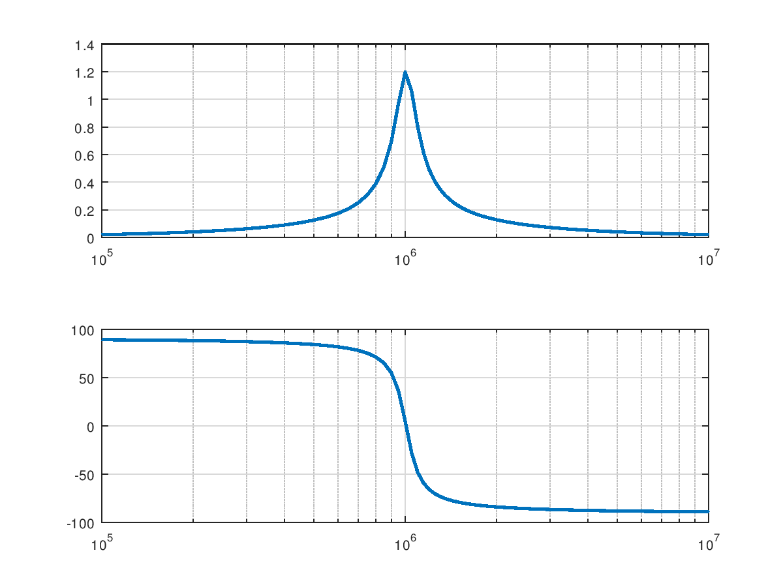

1. Plot the function for using function plot3, where the three dimensions to plot are the real part of the function, the imaginary part of the function, and time.

clear all;

close all;

t=0:0/05:10;

y=10*exp((-0.2+j*pi)*t);

plot(t,real(y),'b');

hold on;

plot(t,imag(y),'r');

hold off;

theta = 0:0.05:10;

x= exp(theta)

x= cos(theta) + i*sin(theta)

plot3(real(x),imag(x),theta)

grid on;

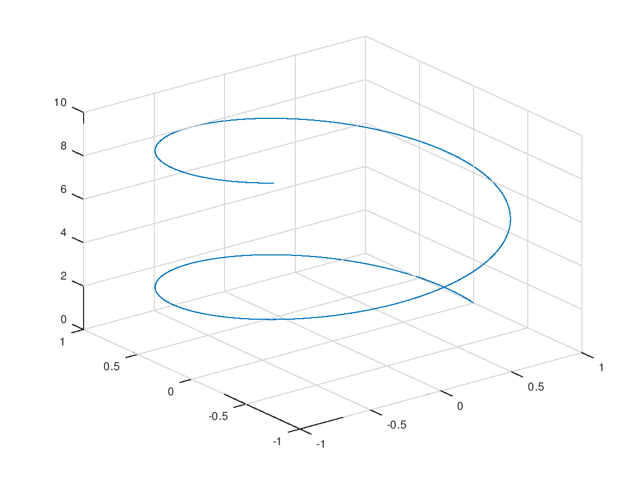

1. Create (a) mesh plot, (b) surface plot, and (c) contour plot of the function for the interval -1<*x*<1 and -2π<*y*<2π. In each case, plot the real part of *z* versus *x* and *y*.

clear all;

close all;

%z=e^{x+iy}

%-1<=x<=1 -2*pi<=y<=2*pi

[x,y]=meshgrid(-1:0.05:1,-2*pi:pi/20:2*pi);

%Calculate function

z=exp(x+i.*y);

%Create mesh plot

figure(1);

mesh(x,y,real(z));

title('\bfMesh plot of real(\itz\rm\bf),where \it z=e^{x+iy}');

xlabel('\bfx');

ylabel('\bfy');

zlabel('\bfz');

%Create surface plot

figure(2);

surf(x,y,real(z));

title('\bfSurface plot of real(\itz\rm\bf),where \it z=e^{x+iy}');

xlabel('\bfx');

ylabel('\bfy');

zlabel('\bfz');

figure(3)

contour(x,y,real(z));

title('\bfContour plot of real(\itz\rm\bf),where \it z=e^{x+iy}');

xlabel('\bfx');

ylabel('\bfy');

zlabel('\bfz');

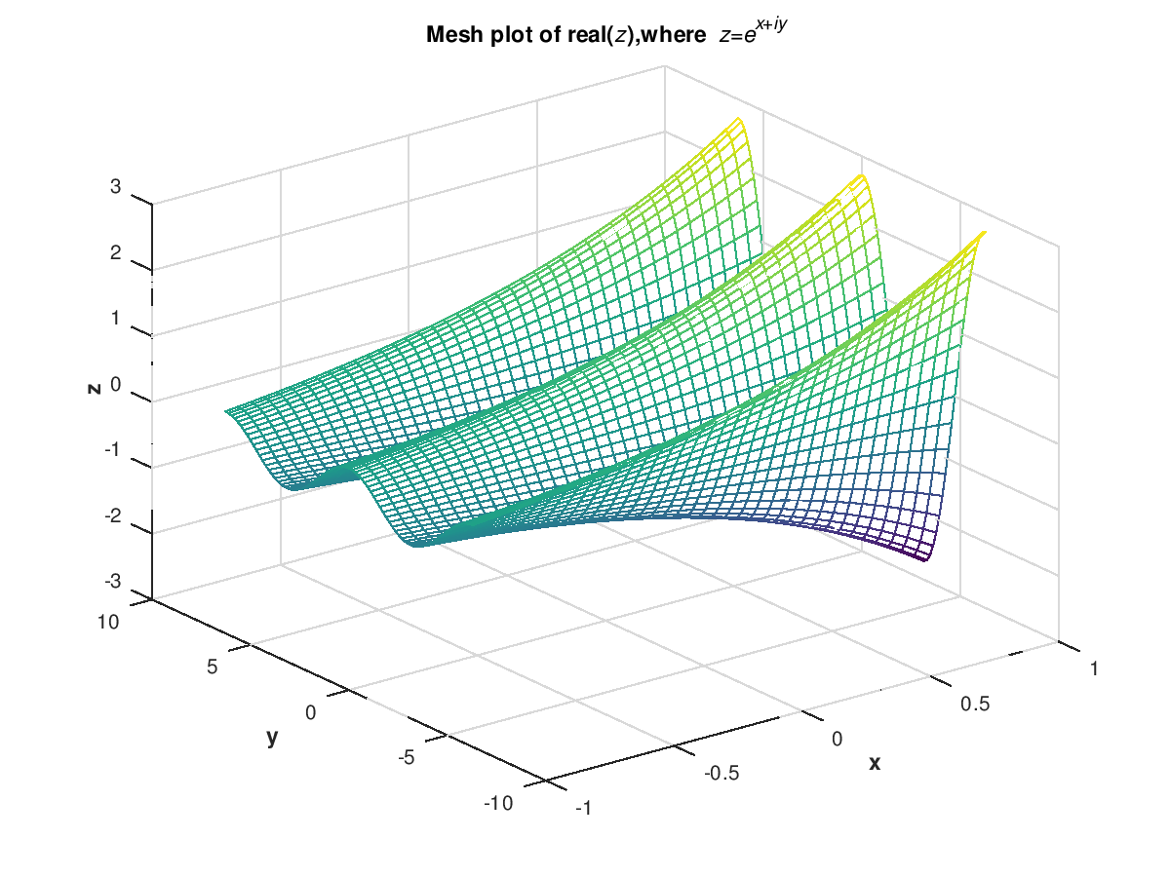

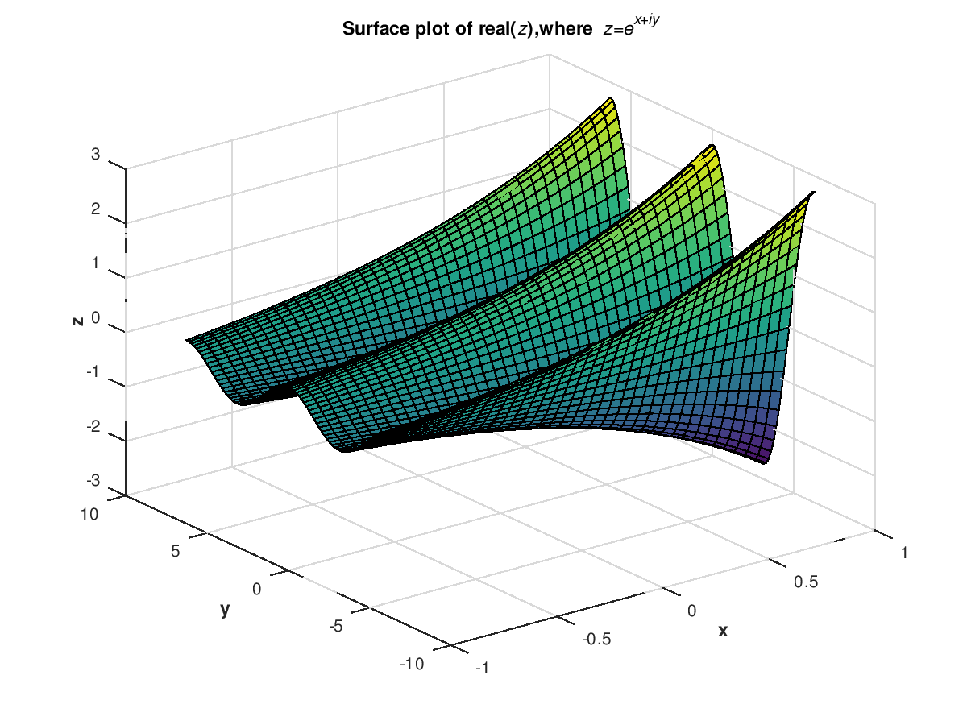

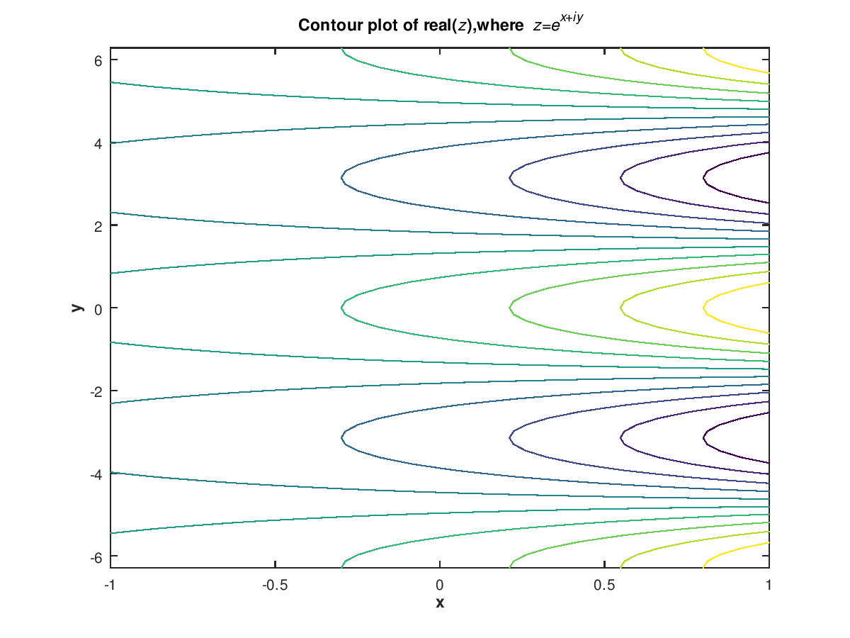

1. Execute the following instructions to read an image data:

>> a=imread(‘girl.bmp’);

>>imshow(a);

As you can see in the workspace that the size of a is 256x256x3. a(: ,: ,1), a (: ,: ,2), and a(: ,: ,3 ) A, B, and C contain red, green, and blue components of this image, respectively. Please modify this image such that the intersection between rows 100 to 150 and columns 150 to 200 will appear in red color.

a=imread('girl.bmp');

a(150:200,100:150,1)=ones(51,51)*255; %在51*51範圍 %紅 1

a(150:200,100:150,2)=zeros(51,51); %綠 2

a(150:200,100:150,3)=zeros(51,51); %藍 3

imshow(a);

1. Function dir returns the contents of a specified directory. The dir command returns a structure array with four fields, as shown here:

>> d=dir(‘chap7’)

d=

36x1 struct array with fields:

name

date

bytes

isdir

where name contains the name of each file, date contains the last modification date for the file, bytes contains the size of the file in bytes, and isdir is 0 for conventional files and 1 for directories.

Write a function that accepts a directory name and path name and returns the total size of all files in the directory in bytes.

function b=dir_sige(dir_name)

files=dir(dir_name),b=0;

for i=1:length(files)

if ~files(i).isdir

b=b+files(i).bytes;

end

end

end

主程式:

dir_name=input('輸入目錄名:','s');

b=dir_sige(dir_name)

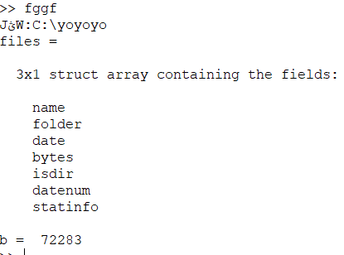

1. Calculate and plot the output *v* of the following differential equation:

$$\frac{dv(t)}{dt}+v\left(t\right)=\left\{\begin{matrix}-v-2t & 0≤t≤5 \\ -v+3t^{2} & otherwise\end{matrix}\right.$$

%fun1函式

function vp=fun1(t,v)

if t>=0 & t<=5

vp=-v+2*t;

else

vp=-v+3t^2;

endif

endfunction

%主程式

clear all;

close all;

[t,y]=ode45(@fun1,[0 10],0);

plot(t,y);

grid on;

