Engineering Application Software Quiz 1 Class: 電通三乙 Name: 李易軒 Student id:05050084

- The distance traveled by a ball falling in the air is given by the equation
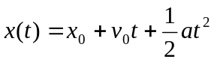
where .
- Use MATLAB to calculate and plot the position of the ball for the range: 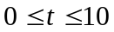 sec.
t=0:1:10;
x0=10e-3;
vo=15e-3;
a=-9.81e-3;
x=x0+vo*t+1/2*a*t.^2;
plot(t,x)
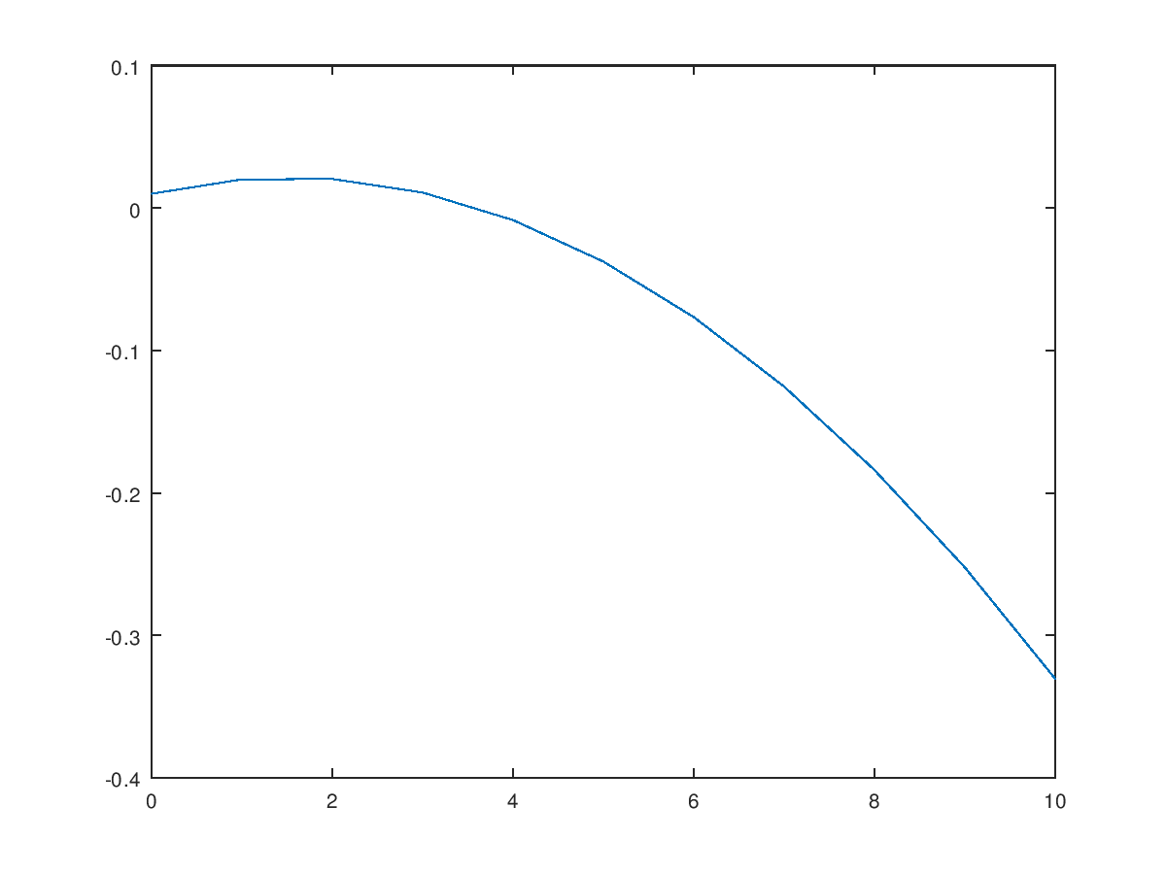
- From the displayed figure, estimate x(5)=?
t=input('');
x0=10;
vo=15;
a=-9.81;
x=x0+vo*t+1/2*t.^2;
fprintf('x(%d)=%f',t,x)
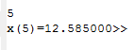
- Write a program to solve for the roots of a quadratic equation: ax²+bx+c=0. Prompt the user for the coefficients a, b, and c . You must consider the three different cases: distinct real roots, repeated roots, and complex roots. Try all cases with your program.

- The average (rms) voltage across the resistive load varies as a function of frequency according to the following equation.
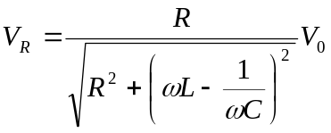
where 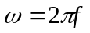and f is the frequency in hertz. Assume that L=0.1mH, C=0.25nF, R=50Ω, and =10mV. Plot the (rms) voltage on the resistive load 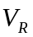 as a function of frequency f. (Create an array of frequencies centered on 1 MHz)
f=1000000;
w=2*pi*f;
L=0.1e-3;
C=0.25e-9;
R=50;
Vo=10;
VR=R/sqrt(R^2+(w*L-1/(w*C))^2)*Vo;
fprintf('VR=%f',VR);
fprintf('\n');
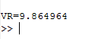
- A function is defined by the equation
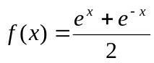
- Write a program to calculate f(x) where the value of x is supplied by the user.
x=input('');
f=(e.^x+e.^-x)/2;
fprintf('f(%d)=%f',x,f)
fprintf('\n')
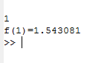
- Use the program to calculate f(3)
x=3;
f=(e.^x+e.^-x)/2;
fprintf('f(%d)=%f',x,f)
fprintf('\n')
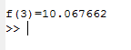
- Plot f(x) for x=-3:3
x=-3:3
f=(e.^x+e.^-x)/2;
plot(x,f)
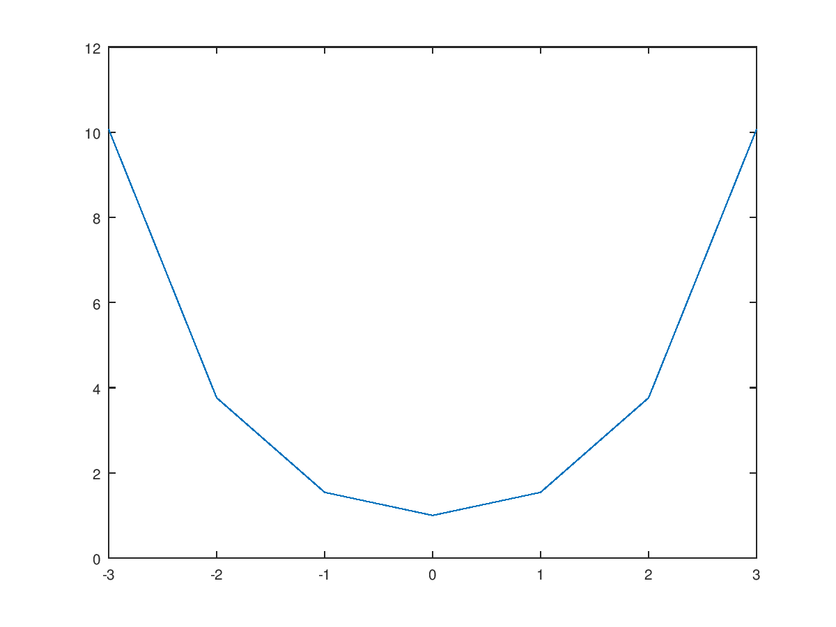
- The gain G of a certain microwave dish antenna can be expressed as a function of angle by the equation:
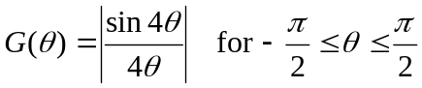
whereis measured in radians. Plot this gain function on a polar plot.
a=-pi/2:pi/2;
G=abs(sin(4.*a)/4.*a);
plot(a,-G)
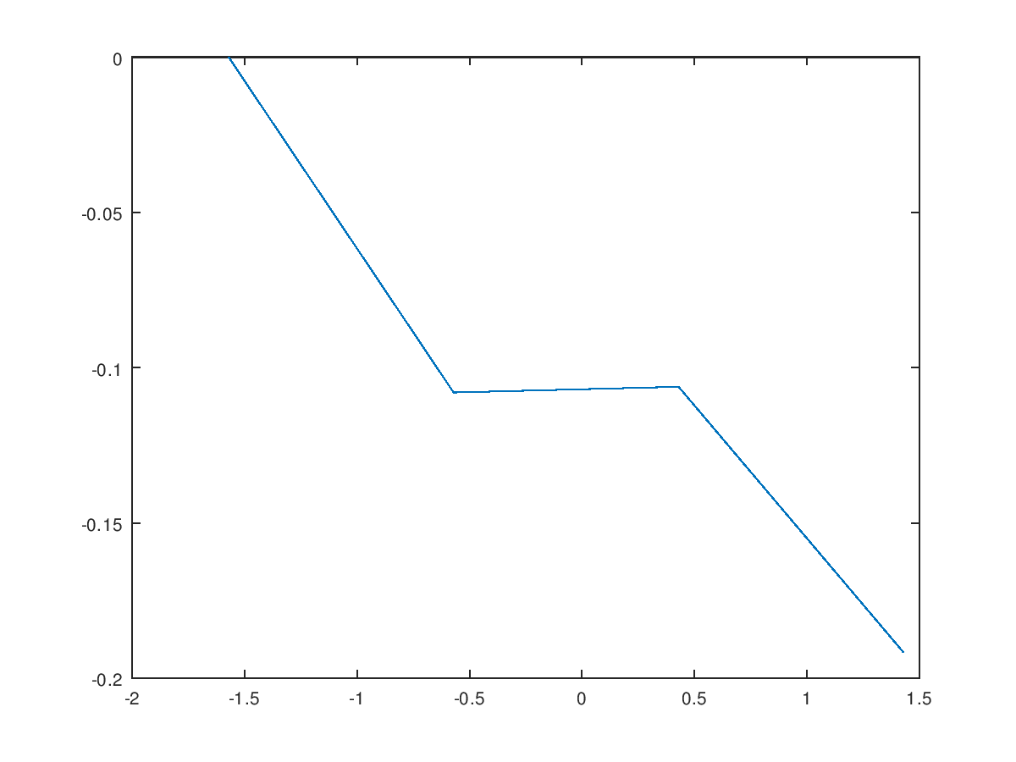
- A high-pass filter has the following transfer function:
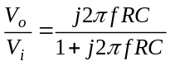
where 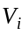 and 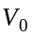 denote the input and output voltages, respectively; 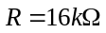and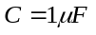. Write a program to generate the following Bode plot. Note that the Bode plot must include titles, xlabels, and ylabels.
R=16000;
C=1e-6;
f=0:0.000001:0.0001;
Vo=j*2*pi.*f*R*C;
Vi=1+j*2*pi.*f*R*C;
s=Vo/Vi;
plot(f,s)
