Engineering Application Software, Midterm Exam Class:電通三甲 Name:戴寧 Student ID:04050432

- Assume that the complex function f(t) is defined by the equation:
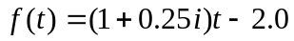
where 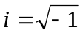. Plot the amplitude and phase of function f for 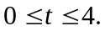 Note that the plot must include titles, xlabels, and ylabels.
List your MATLAB program.
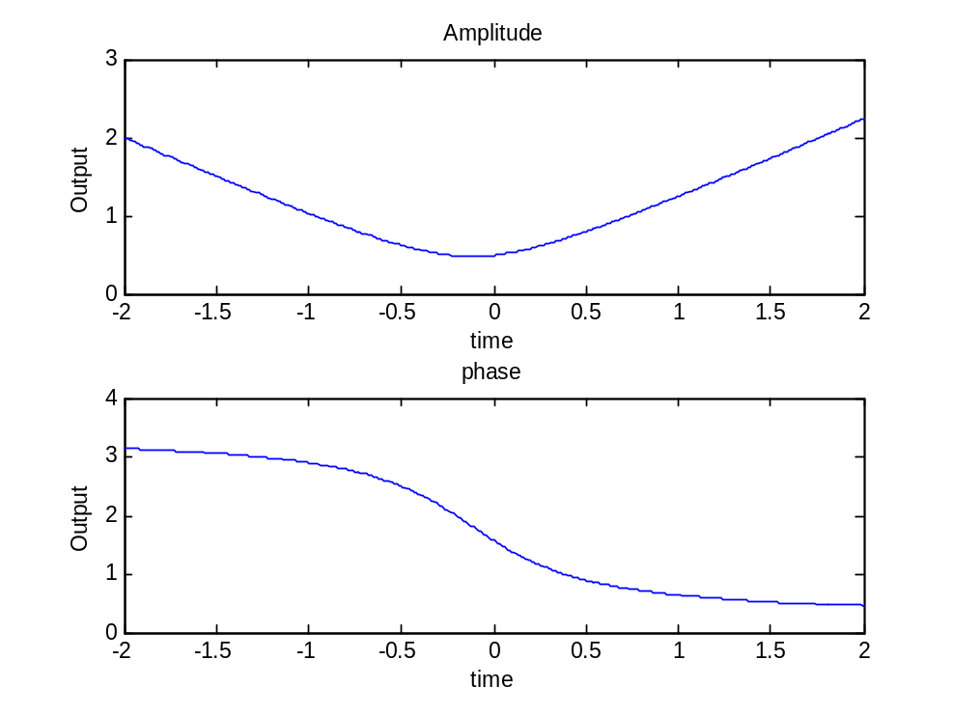
clear all;close all;
i=sqrt(-1);
t=0:0.01:4;
f=(1+0.25*i)*t-2.0;
amp=abs(f);
pha=angle(f);
subplot(2,1,1);
plot(f,amp);
title('Amplitude');
xlabel('time');
ylabel('Output');
subplot(2,1,2);
plot(f,pha);
title('phase');
xlabel('time');
ylabel('Output');
- (A high-pass filter has the following transfer function:
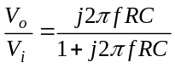
where 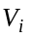 and 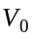 denote the input and output voltages, respectively; 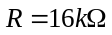and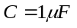. Write a program to generate the following Bode plot. Note that the Bode plot must include titles, xlabels, and ylabels.
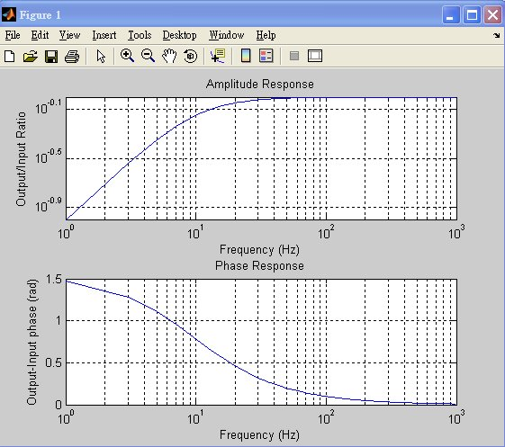
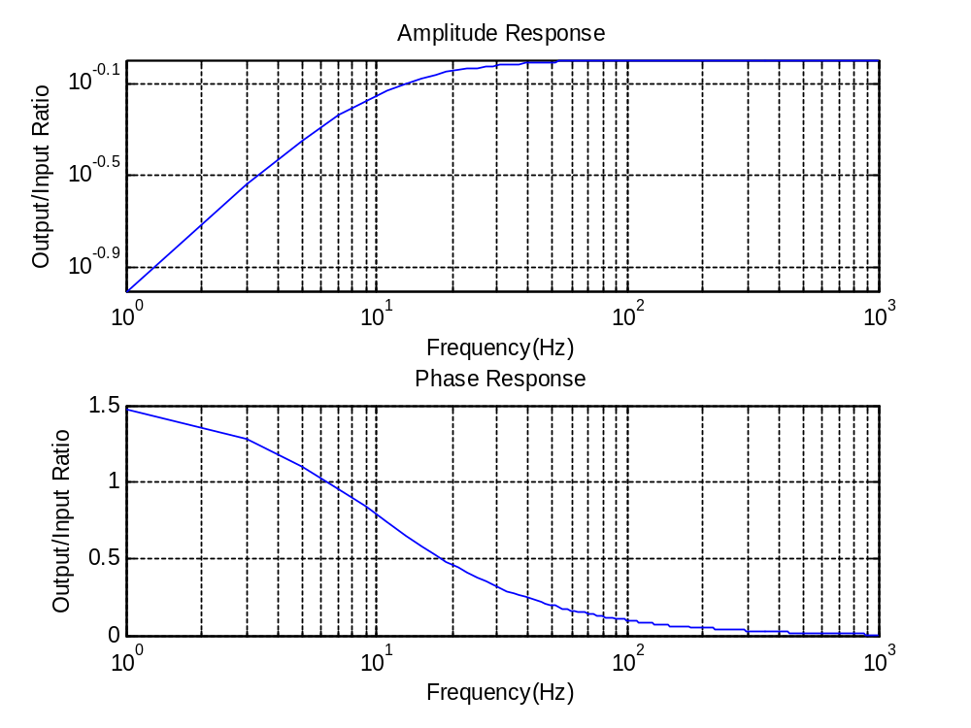
close all;clear all;
r=16000;
c=0.1^6;
f=1:2:1000;
v=(j*2*pi.*f*r*c)./(1+(j*2*pi.*f*r*c));
amp=abs(v);
pha=angle(v);
subplot(2,1,1);
loglog(f,amp);
grid on;
title('Amplitude Response');
xlabel('Frequency(Hz)');
ylabel('Output/Input Ratio');
subplot(2,1,2);
semilogx(f,pha);
grid on;
title('Phase Response');
xlabel('Frequency(Hz)');
ylabel('Output/Input Ratio')

- The harmonic mean of a set of numbers fromthrough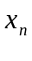is given by the equation:
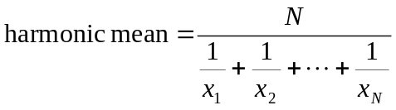
- Write a MATLAB program that will accept an arbitrary number of positive input values and calculate the harmonic mean of the numbers. Use a while loop to get the input values, and terminate the inputs when a user enters a negative number.
clear all;close all;
a=input('Enter first number:');
prod=0;
nvals=0;
while (a>0)
prod=prod+(1/a);
nvals=nvals+1;
a=input('Enter next number:');
end
har=nvals/prod;
fprintf('=%f\n',har);
- Test your program by the four input numbers 10, 5, 2, and 5. Show results.
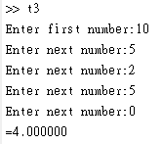

- Write a MATLAB program to evaluate the function
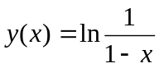
for any user-specified value of x, where x is a number < 1.0. If the value of x is legal, calculate y(x). If not, write a suitable error message and quit. (Build-in function log(x) calculates the natural logarithm of x)
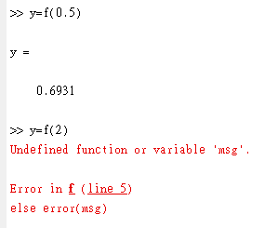
function y=f(x)

if x<=1;
y=log(1/(1-x));
else error(msg)
end
end

- Create a function of the following form:
result= area_or_volume(radius, height)
The function area_or_volume will return a result according to the number of input arguments. If the number of input arguments is two, it will return the volume of a cylinder by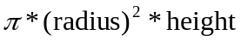. If the number of input arguments is one, it will return the area of a circle by 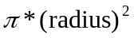.
For example,
>>result= area_or_volume(2, 3)
>>result =
37.6991
>>result= area_or_volume(2)
>>result =
12.5664
If the number of input arguments is illegal, it should output an error message.
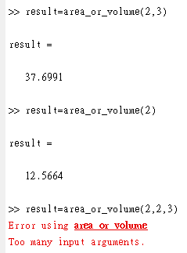
function result=area_or_volume(radius,height)
msg=nargchk(1,2,nargin);
error(msg)
if nargin==1;
height=1;
end;
result=pi*radius^2*height;
end

- (a) Write a function that attempts to locate the maximum and minimum values of an arbitrary function f(x) over a certain range.
The function should have the following input arguments:

first_value = the start of the interval to search(搜尋的區間起始值)
last_value = the end of the interval to search (搜尋的區間終值)
num_steps = the number of steps to use in search (搜尋的點數)
func = the function to evaluate (要搜尋的函數)

The function should have the following output arguments:

xmin = location of smallest value found (最小值的座落位置)
min_value = smallest value found (找出的最小值)
xman = location of largest value found (最大值的座落位置)
max_value = largest value found (找出的最大值)
function [xmin,min_value,xmax,max_value]=fun(first_value,last_value,num_steps,func)
msg=nargchk(4,4,nargin);
error(msg);
dx=(last_value-first_value)/(num_steps-1);
x=first_value:dx:last_value;
y=feval(func,x);
[max_value,ymax]=max(y);
[min_value,ymin]=min(y);
xmax=x(ymax);
xmin=x(ymin);
end

- Use the function obtained in (a) to search the minimum and maximum of the sin function in 100 steps over the range 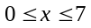

[xmin,min_value,xmax,max_value]=fun(0,7,100,'f');
fprintf('f在=%f時有極小值%f\n',xmin,min_value);
fprintf('f在=%f時有極大值%f\n',xmax,max_value);
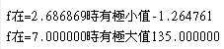

- The current I flowing in a series RLC circuit is given by
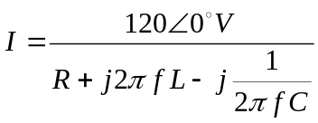
where R=100Ω, L=0.1mH, and C=0.25nF. Plot both the magnitude and phase angle of the current as a function of frequency on two sub-plots of a single figure. Use log-linear scales. (f=100k~10M Hz, Δf=50k Hz)
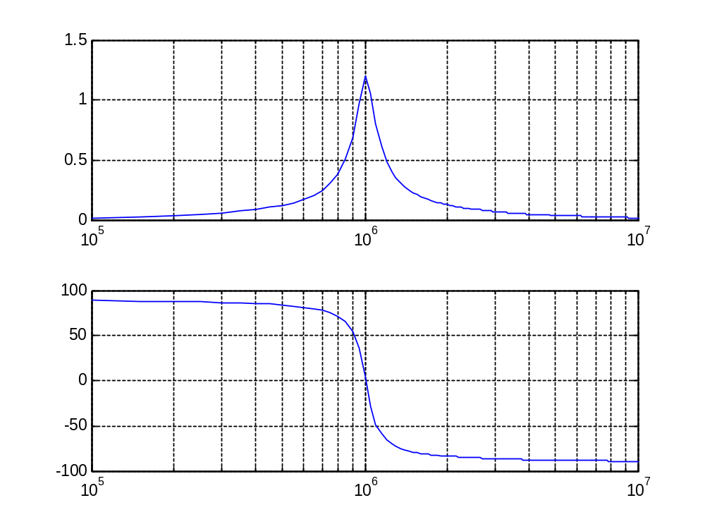
clear all;close all;
R=100;
L=0.1e-3;
C=0.25e-9;
f=[100000:50000:10000000];
V=120;
w=2*pi*f;
I=V./(R+j*w*L-j./(w*C));
pha=angle(I)*(180/pi);
subplot(211);
semilogx(f,abs(I));grid on;
subplot(212);
semilogx(f,pha); grid on;

