Engineering Application Software, Midterm Exam Class:電通三乙Name:李易軒Student ID:05050084

- (a) Plot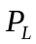as a function of the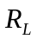.
close all;
clear all;
Rs=50;
V=120;
Rl=1:1:100;
I=V./(Rs+Rl);
P=(I.^2).*Rl;
plot(Rl,P);
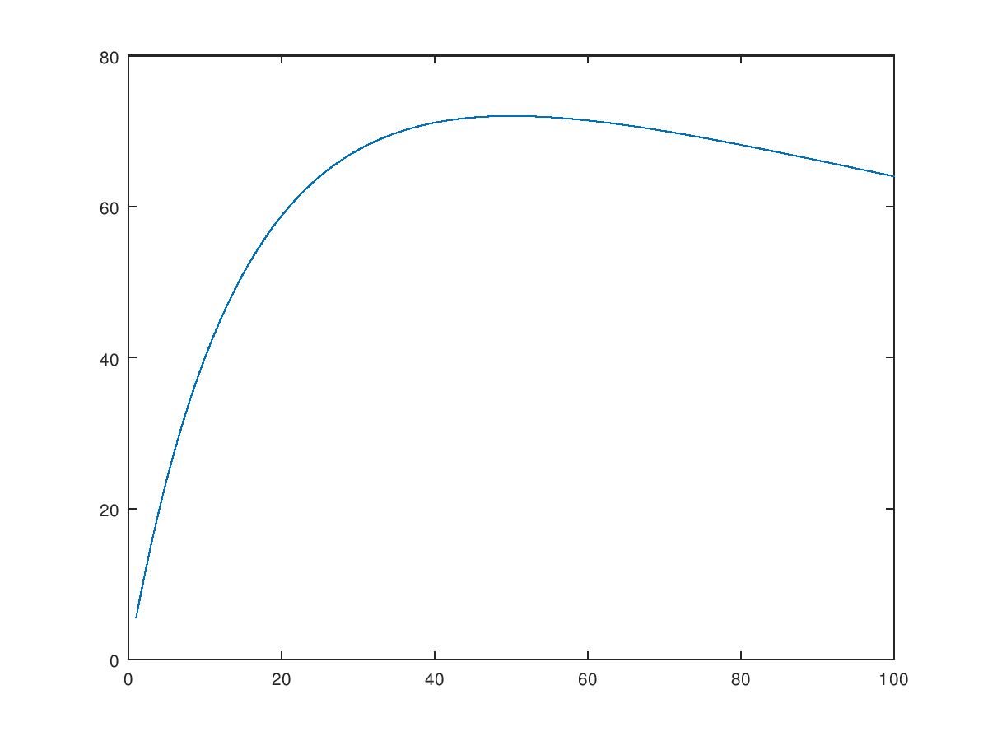

(b) Find the value of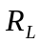that will result in the maximum possible power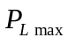. That is, 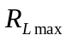=?=?
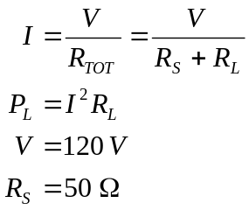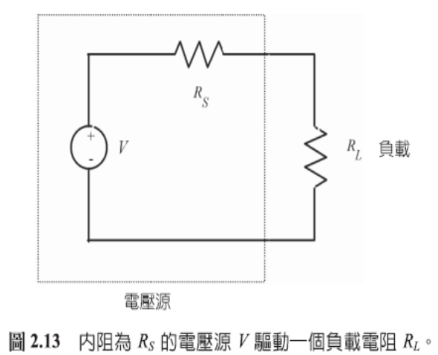
function pl=findpl(rl);
for j=0:rl
j=j+1
rs=50;
v=120;
i=v/(rs+j);
pl=(i^2)*j
end
end
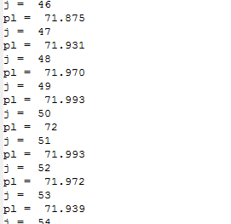
=50 =72

- The distance between two points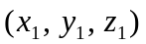and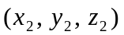is given by the equation
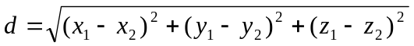
  - Write a program to calculate the distance between two points specified by the user.
  - Use the program to calculate the distance between the points (-3, 2, 5) and (3, -6, -5)
x1 = input('x1= ');
y1 = input('y1= ');
z1 = input('z1= ');
x2 = input('x2= ');
y2 = input('y2= ');
z2 = input('z2= ');

d = sqrt((x1-x2)^2+(y1-y2)^2+(z1-z2)^2);
fprintf('d= %f',d);
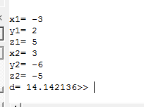

- (a) Write a program to evaluate a function f (x, y) for any two user-specified values x and y.

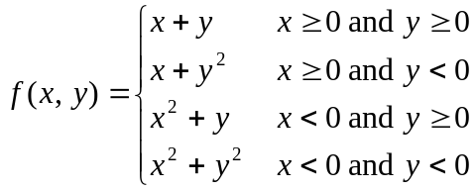
(b) Execute the program with the four sets of input values (x, y)=(2, 3), (2, -3), (-2, 3), and (-2, -3).
close all;
clear all;
x = input('enter x:');
y = input('enter y:');
if x >= 0 && y >= 0
fun = x + y ;
elseif x >= 0 && y < 0
fun = x + y^2 ;
elseif x < 0 && y >= 0
fun = x^2 + y;
else
fun = x^2 + y^2 ;
end;
disp(['f(x,y) = ' num2str(fun)]);
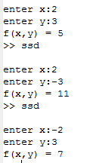

- The arithmetic, and geometric mean of a set of numbers fromthrough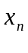are given by the equations
- Write a MATLAB program that will accept an arbitrary number of positive input values and calculate both the arithmetic mean and the geometric mean of the numbers. Use a while loop to get the input values, and terminate the inputs when a user enters a negative number.

- Test your program by the four input numbers 10, 5, 2, and 5. Show results.

prod =1;
nvals=0;
sum_x=0;
%Read the first number
x=input('Enter first number:');

%Read the remaining numbers
while x>0
prod=prod*x;
nvals=nvals+1;
sum_x=sum_x+x;
x=input('Enter next number: ');
end
g=prod^(1/nvals);
x_bar=sum_x/nvals;
fprintf('The arithmetic mean is %.4f\n',x_bar);
fprintf('The geometric mean is %.4f\n',g);
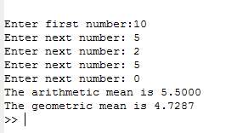

- The current flowing through the semiconductor diode is given by the equation
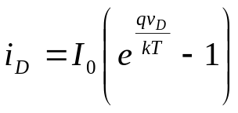
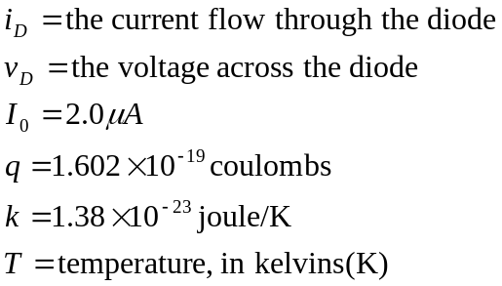
Create a plot of 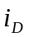vs.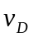 for Repeat this process for the following temperatures: 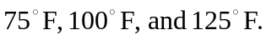

close all;
clear all;
Io=2e-6;
q=1.602e-19;
k=1.38e-23;
vD=-1:0.01:0.6;

T=input('T=');
iD=Io*(exp((q*vD)/(k*T))-1);
plot(vD,iD);
hold on

T=input('T=');
iD=Io*(exp((q*vD)/(k*T))-1);
plot(vD,iD,'r');
hold on

T=input('T=');
iD=Io*(exp((q*vD)/(k*T))-1);
plot(vD,iD,'k-');
hold off
figure
subplot(1,3,1),plot(vD,iD,'r');
subplot(1,3,2),plot(vD,iD,'b');
subplot(1,3,3),plot(vD,iD,'g');
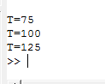
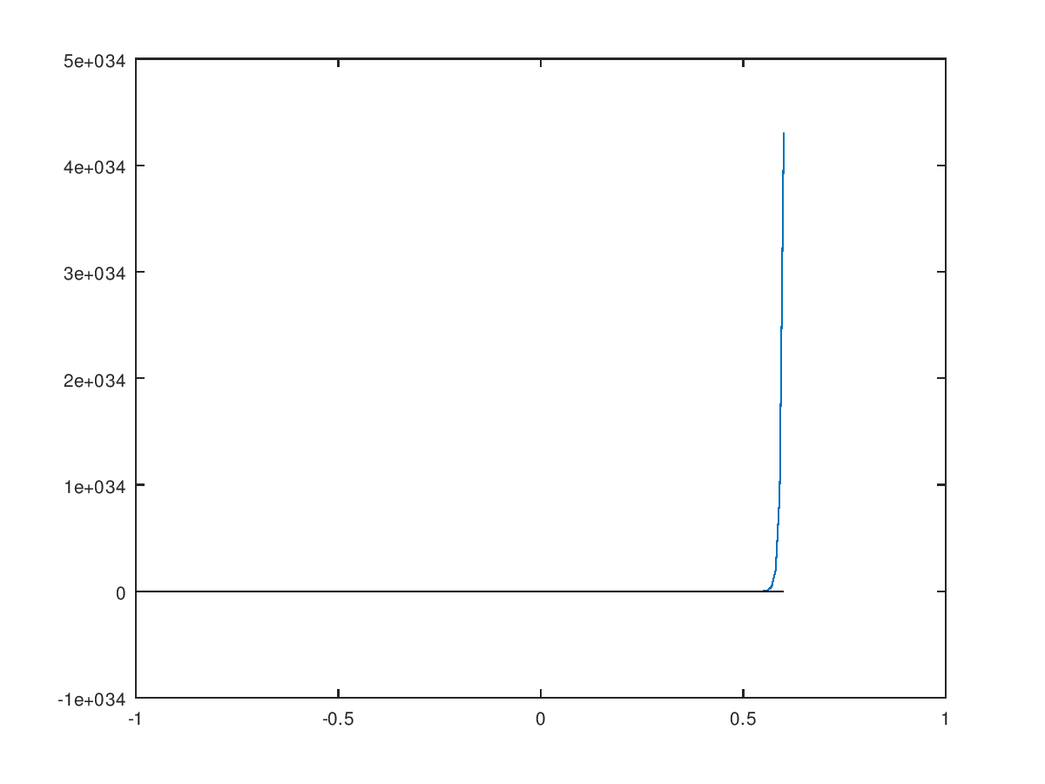
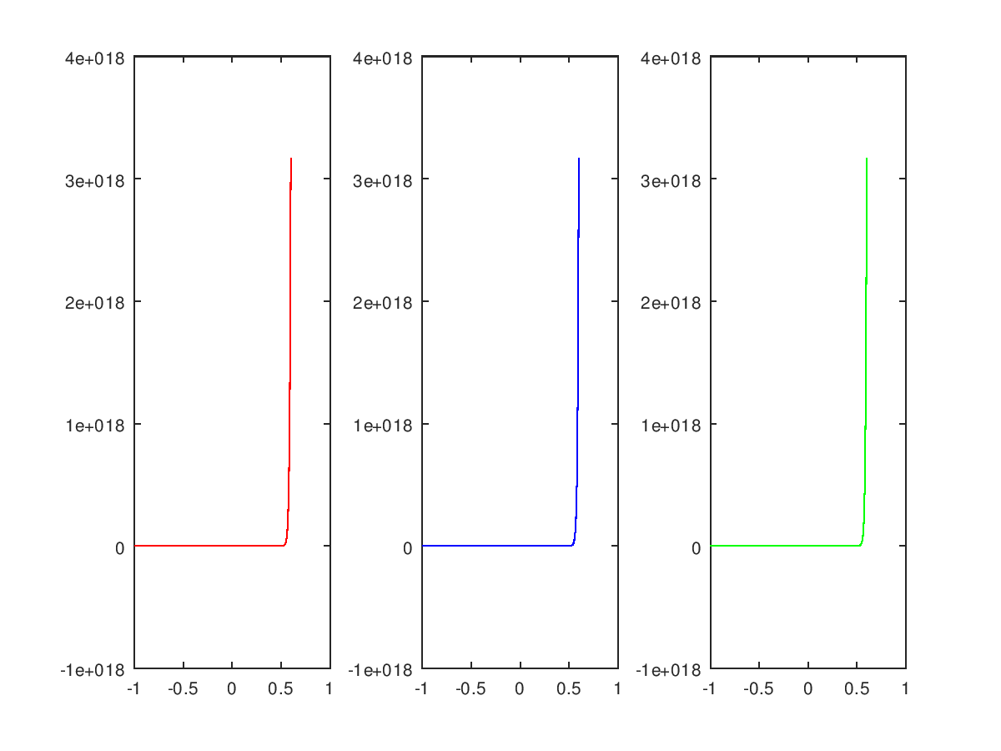
- The gravitational force F between two bodies of massesand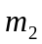is given by the equation
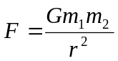
where G is the gravitation constant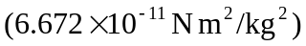, and are the masses of the bodies in kilograms, and r is the distance between the two bodies.
- Write a function to calculate the gravitational force F between two bodies given their masses and the distance between them. (If the number of input arguments is illegal, it should output an error message)
- Test your function by determine the force on an 800 kg satellite in orbit 38,000 km above the earth. (The mass of the earth is 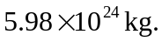)

function force =gravity(range,m1,m2)
gravc=6.672E-11;
force =gravc.*m1.*m2./range.^2;
end
