電通二乙微處理器實驗 實驗結報

實驗名稱 | MCS Cloud
組別 | 20 | 組員 | 李易軒

- 實驗目的
利用7697連接wifi再用網頁控制
- 實驗步驟
1. 控制LED並檢視狀態
2. 將 A0 電阻值上傳
- 程式碼
1.
#include <LWiFi.h>
#include "MCS.h"

char _lwifi_ssid[] = "7700";
char _lwifi_pass[] = "0976706131";
MCSDevice mcs("DkrxOE0V","EkrpjkW6AUJT7Pn9");
MCSControllerOnOff led("05050084");
MCSDisplayOnOff remote("050500841");
#define LED_PIN 7
void setup()
{
Serial.begin(9600);

Serial.println("Connect to Wifi");
while (WiFi.begin(_lwifi_ssid, _lwifi_pass) != WL_CONNECTED) {
Serial.println("Wifi Reconnecting..");
delay(1000);
}

Serial.println("Connect to MCS...");
while (!mcs.connected()) {
Serial.println("MCS Reconnecting..");
mcs.connect();
}
Serial.println("MCS Connected!");
mcs.addChannel(led);
mcs.addChannel(remote);
pinMode(7, OUTPUT);
}

void loop()
{
while (!mcs.connected()) {
mcs.connect();
if (mcs.connected()) {
Serial.println("MCS Reconnect");
}
}

//digitalWrite(7,LED.value() ? HIGH : LOW);

mcs.process(1000);

if (led.value() == 1) {
digitalWrite(7, HIGH);

} else {
digitalWrite(7, LOW);

}

delay(200);
}
2.
#include <LWiFi.h>
#include "MCS.h"

char _lwifi_ssid[] = "7700";
char _lwifi_pass[] = "0976706131";
MCSDevice mcs("DkrxOE0V","EkrpjkW6AUJT7Pn9");

MCSDisplayInteger Temp("050500842");

void setup()
{
Serial.begin(9600);

Serial.println("Connect to Wifi");
while (WiFi.begin(_lwifi_ssid, _lwifi_pass) != WL_CONNECTED) {
Serial.println("Wifi Reconnecting..");
delay(1000);
}

Serial.println("Connect to MCS...");
while (!mcs.connected()) {
Serial.println("MCS Reconnecting..");
mcs.connect();
}
Serial.println("MCS Connected!");

mcs.addChannel(Temp);

}
- 實驗結果及分析
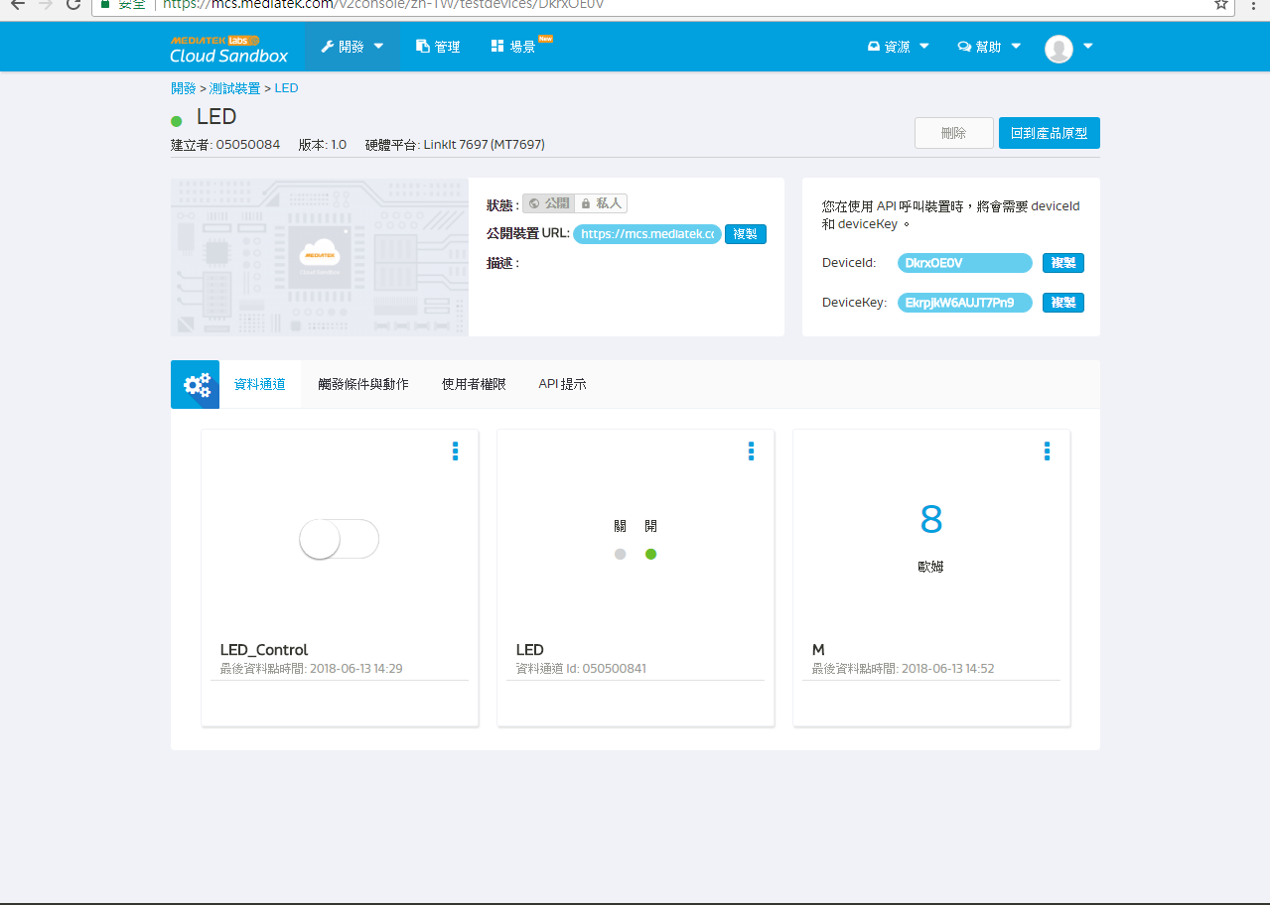
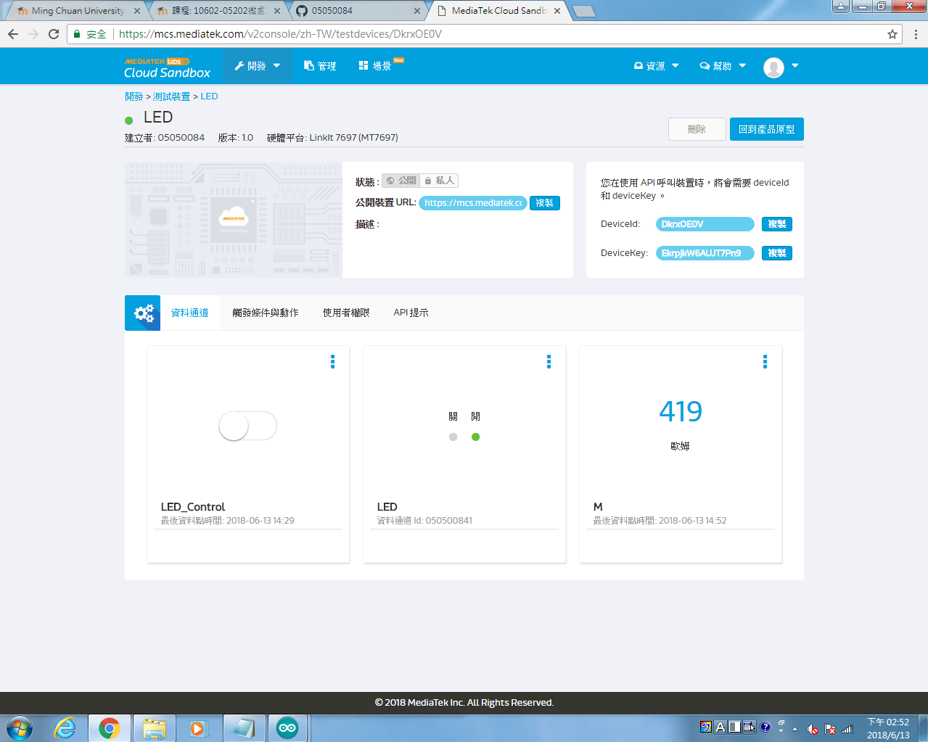

- 心得討論
這次實驗了解7697連接wifi的應用，來用網頁操作7697，覺得有趣。

