**Python程式設計**

**範圍： list、tuple的應用**

**銘傳大學電腦與通訊工程系**

|  |  |
| --- | --- |
| 班 級 | 電通四乙 |
| 姓 名 | 李易軒 |
| 學 號 | 05050084 |
| 成 績 | 應繳作業共 10 題，每題10分，滿分為100分  共完成 10 題，應得 100 分 |
| 授課教師 | 陳慶逸 |

※直接將你的程式碼貼在指定的欄位裡，並且執行題目要求的輸入參數(每一題都有5個不同的輸入參數要執行)，再將執行結果擷圖貼在指定的位置。

※請確實填寫自己寫完成題數，並且計算得分。填寫不實者(如上傳與作業明顯無關的答案，或是計算題數有誤者)，本次作業先扣50分。

EX 1: 試以串列解析式語法來改寫下面的兩個以for-loop所寫的程式：

1. 新串列的內容為原串列的所有元素都乘上2的結果：

For-loop迭代作法：

|  |
| --- |
| **num = [1, 2, 3, 4, 5]**  **doubledOddNum = []**  **for n in num:**  **doubledOddNum.append(n * 2)**  **print(doubledOddNum) #[2, 4, 6, 8, 10]** |

串列解析式語法：

|  |
| --- |
| **doubledOddNum = [x*2 for x in range(1,6)]**  **print(doubledOddNum)** |

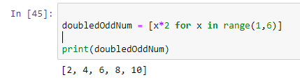

(2) 新串列的內容為原串列的所有奇數值元素都乘上2的結果：

For-loop迭代作法：

|  |
| --- |
| **num = [1, 2, 3, 4, 5]**  **doubledOddNum = []**  **for n in num:**  **if n % 2 == 1:**  **doubledOddNum.append(n * 2)**  **print(doubledOddNum) #[2, 6, 10]** |

串列解析式語法：

|  |
| --- |
| **num=[1,2,3,4,5]**  **doubledOddNum = [x*2 for x in num[::2] ]**  **print(doubledOddNum)** |

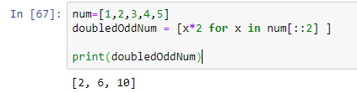

EX 2: 試寫一個Python程式來產生一個3x4x6的三維陣列。

輸出如下:

[[['0', '0', '0', '0', '0', '0'], ['0', '0', '0', '0', '0', '0'], ['0', '0', '0', '0', '0', '0'], ['0', '0', '0', '0', '0', '0']], [['0', '0', '0', '0', '0', '0'], ['0', '0', '0', '0', '0', '0'], ['0', '0', '0', '0', '0', '0'], ['0', '0', '0', '0', '0', '0']], [['0', '0', '0', '0', '0', '0'], ['0', '0', '0', '0', '0', '0'], ['0', '0', '0', '0', '0', '0'], ['0', '0', '0', '0', '0', '0']]]

|  |
| --- |
| **list1 = [[['0' for i in range(6)] for j in range(4)]for m in range(3)]**  **print(list1)** |

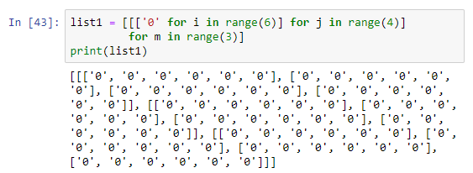

EX 3: 若有一串列a = [[1, 2, 3, 4], [5, 6], [7, 8, 9]]，試計算此串列裡所有元素的總和。

|  |
| --- |
| **a = [[1, 2, 3, 4], [5, 6], [7, 8, 9]]**  **print(sum(a[0]+a[1]+a[2]))** |

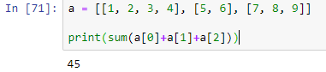

EX 4: 若串列A = [ [1, 2, 3, 0], [4, 5, 6, 0], [7, 8, 9, 0] ]，串列B = [ [2, 4, 6, 0], [1, 3, 5, 0], [0, -1, -2, 0] ]；試產生一個相同尺寸的串列C，且其內容為A + B (矩陣相加)的結果。

|  |
| --- |
| **A = [ [1, 2, 3, 0], [4, 5, 6, 0], [7, 8, 9, 0] ]**  **B = [ [2, 4, 6, 0], [1, 3, 5, 0], [0, -1, -2, 0] ]**  **s=[[0]*4,[0]*4,[0]*4]**  **for i in range(3):**  **for j in range(4):**  **s[i][j]=A[i][j]+B[i][j]**  **print(s)** |

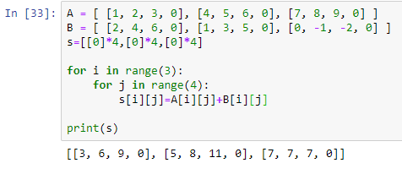

EX 5: 試寫一個Python程式，它能移除輸入之串列中所有的偶數數值。

例如:

輸入: [7, 8, 120, 25, 44, 20, 27]

輸出: [7, 25, 27]

|  |
| --- |
| **a=[7,8,12,25,44,2,27]**  **s=[a for a in a if a%2!=0]**  **print(s)** |

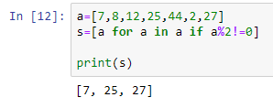

EX 6: 試撰寫一個Python函式tuplexEdit(tuplex)，並利用資料型別轉換的作法，刪除所傳遞進來之tuple從前面算過來第4個項目，以及從末端算過來第4個項目的內容(假設tuple的長度均超過10)，並回傳更改後的tuple內容。

例如:

|  |  |
| --- | --- |
| **輸入** | **執行結果** |
| **print(tuplexEdit(("E", "m", "b", "e", "d", "e", "d", "S", "y", "s", "t", "e", "m")))** | **('E', 'm', 'b', 'd', 'e', 'd', 'S', 'y', 't', 'e', 'm')** |
| **print(tuplexEdit(("1", "2", "3", "4", "5", "6", "7", "8", "9", "10", "11", "12", "13")))** | **('1', '2', '3', '5', '6', '7', '8', '9', '11', '12', '13')** |

我的作答：

**請在下面欄位貼上程式碼：**

|  |
| --- |
| **def tuplexEdit(tuplex):**  **s=list(tuplex)**  **s.pop(3)**  **s.pop(-4)**    **return s** |

**請依下面要求輸入參數，並將執行結果擷圖:**

|  |  |
| --- | --- |
| **print(tuplexEdit(("E", "m", "b", "e", "d", "e", "d", "S", "y", "s", "t", "e", "m")))** | ('E', 'm', 'b', 'd', 'e', 'd', 'S', 'y', 't', 'e', 'm') |
| **print(tuplexEdit(("1", "2", "3", "4", "5", "6", "7", "8", "9", "10", "11", "12", "13")))** | ('1', '2', '3', '5', '6', '7', '8', '9', '11', '12', '13') |
| **print(tuplexEdit((7, 5, 4, 41, 2, 5, 6, 2, "y", "4", "3", 1)))** | (7, 5, 4, 2, 5, 6, 2, '4', '3', 1) |
| **print(tuplexEdit(("P", "y", "t", "h", "o", "n", "w", "o", "r", "k")))** | ('P', 'y', 't', 'o', 'n', 'o', 'r', 'k') |
| **print(tuplexEdit(("m", "a", "t", "l", "a", "b", "d", "i", "y", "s")))** | ('m', 'a', 't', 'a', 'b', 'i', 'y', 's') |

**執行結果擷圖：**

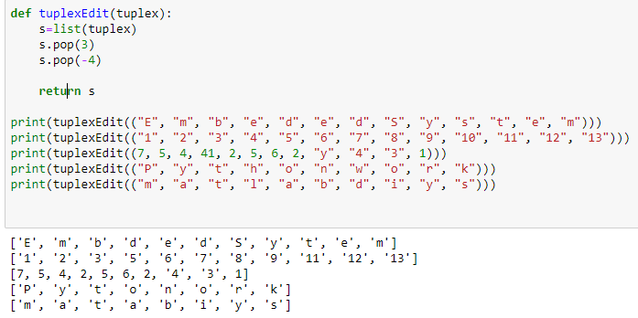

EX 7: 試撰寫一個Python函式tuplexcount(tuplex)，它能計算傳遞進來的tuple之每一個項目出現的次數 ，並儲存成一個list回傳內容。

例如:

|  |  |
| --- | --- |
| **輸入** | **執行結果** |
| **print(tuplexcount(("E", "m", "b", "b", "E")))** | [2, 1, 2, 2, 2] |
| **print(tuplexcount(("1", "3", "3", "4", "4", "6", "7", "3")))** | [1, 3, 3, 2, 2, 1, 1, 3] |

我的作答：

**請在下面欄位貼上程式碼：**

|  |
| --- |
| **def tuplexcount(tuplex):**  **s=list(tuplex)**  **a=[]**  **for i in range(len(tuplex)):**  **b=s.count(tuplex[i])**  **a.append(b)**  **return a** |

**請依下面要求輸入參數，並將執行結果擷圖:**

|  |  |
| --- | --- |
| **print(tuplexcount(("E", "m", "b", "b", "E")))** | [2, 1, 2, 2, 2] |
| **print(tuplexcount(("1", "3", "3", "4", "4", "6", "7", "3")))** | [1, 3, 3, 2, 2, 1, 1, 3] |
| **print(tuplexcount((7, 5, 4, 4, 2, 7, 7, 2, "y", "4", "3", 5)))** | [3, 2, 2, 2, 2, 3, 3, 2, 1, 1, 1, 2] |
| **print(tuplexcount(("P", "y", "t", "h", "o", "n", "w", "o", "r", "k")))** | [1, 1, 1, 1, 2, 1, 1, 2, 1, 1] |
| **print(tuplexcount(("m", "a", "t", "l", "a", "b", "d", "i", "y", "s")))** | [1, 2, 1, 1, 2, 1, 1, 1, 1, 1] |

**執行結果擷圖：**

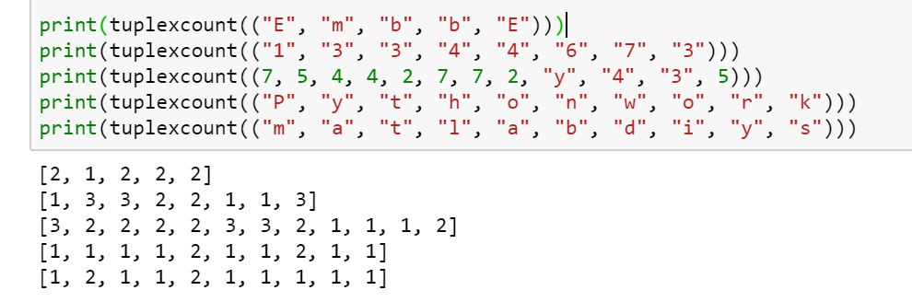

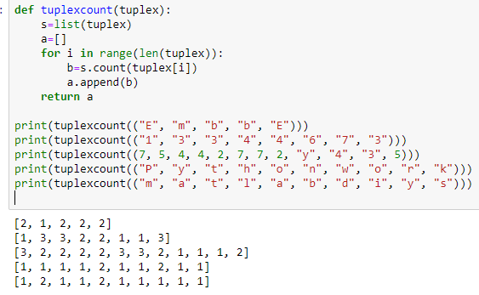

EX 8: 試撰寫一個Python函式lsttuple(lst)，其傳遞進來的list裡是由tuple所構成的內容。函式的功能是將所傳遞進來的list裡每一筆tuple的末端值更改為100，並且回傳。

例如:

|  |  |
| --- | --- |
| **輸入** | **執行結果** |
| **print(lsttuple([(10, 20, 40), (40, 50, 60), (70, 80, 90)]))** | [(10, 20, 100), (40, 50, 100), (70, 80, 100)] |
| **print(lsttuple([(20, 20), (400, 150), (70, 80), (2, 3)]))** | [(20, 100), (400, 100), (70, 100), (2, 100)] |

我的作答：

**請在下面欄位貼上程式碼：**

|  |
| --- |
| **def lsttuple(lst):**  **a=[]**  **for i in range(len(lst)):**  **s=list(lst[i])**  **b=len(lst[i])-1**  **s.remove(lst[i][b])**  **s.insert(lst[i][b],100)**  **a.append(s)**  **return a** |

**請依下面要求輸入參數，並將執行結果擷圖:**

|  |  |
| --- | --- |
| **print(lsttuple([(10, 20, 40), (40, 50, 60), (70, 80, 90)]))** | **[(10, 20, 100), (40, 50, 100), (70, 80, 100)]** |
| **print(lsttuple([(20, 20), (400, 150), (70, 80), (2, 3)]))** | **[(20, 100), (400, 100), (70, 100), (2, 100)]** |
| **print(lsttuple([(100, 20), (140, 350, 60)]))** | **[(100, 100), (140, 350, 100)]** |
| **print(lsttuple([(210, 220, 33, 333), (400, 150, 77), (1170, 180)]))** | **[(210, 220, 33, 100), (400, 150, 100), (1170, 100)]** |
| **print(lsttuple([(200,), (400, 150, 77, 1170, 180)]))** | **[(100,), (400, 150, 77, 1170, 100)]** |

**執行結果擷圖：**

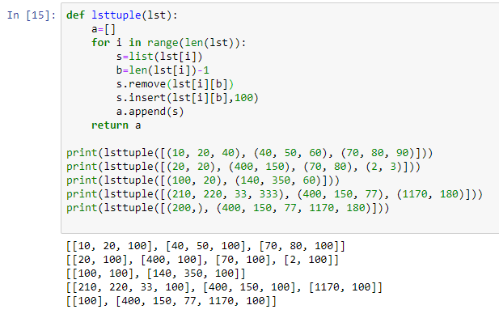

EX 9: 同EX3的題目，試以串列解析式語法撰寫一個Python函式lsttuple(lst)，其傳遞進來的list裡是由tuple所構成的內容。函式的功能是將所傳遞進來的list裡每一筆tuple的末端值更改為100，並且回傳。

例如:

|  |  |
| --- | --- |
| **輸入** | **執行結果** |
| **print(lsttuple([(10, 20, 40), (40, 50, 60), (70, 80, 90)]))** | [(10, 20, 100), (40, 50, 100), (70, 80, 100)] |
| **print(lsttuple([(20, 20), (400, 150), (70, 80), (2, 3)]))** | [(20, 100), (400, 100), (70, 100), (2, 100)] |

我的作答：

**請在下面欄位貼上程式碼：**

|  |
| --- |
| **def lsttuple(lst):**  **a=[]**  **for i in range(len(lst)):**  **s=list(lst[i])**  **b=len(lst[i])-1**  **s.remove(lst[i][b])**  **s.insert(lst[i][b],100)**  **a.append(s)**  **return a** |

**請依下面要求輸入參數，並將執行結果擷圖:**

|  |  |
| --- | --- |
| **print(lsttuple([(10, 20, 40), (40, 50, 60), (70, 80, 90)]))** | **[(10, 20, 100), (40, 50, 100), (70, 80, 100)]** |
| **print(lsttuple([(20, 20), (400, 150), (70, 80), (2, 3)]))** | **[(20, 100), (400, 100), (70, 100), (2, 100)]** |
| **print(lsttuple([(100, 20), (140, 350, 60)]))** | **[(100, 100), (140, 350, 100)]** |
| **print(lsttuple([(210, 220, 33, 333), (400, 150, 77), (1170, 180)]))** | **[(210, 220, 33, 100), (400, 150, 100), (1170, 100)]** |
| **print(lsttuple([(200,), (400, 150, 77, 1170, 180)]))** | **[(100,), (400, 150, 77, 1170, 100)]** |

**執行結果擷圖：**



EX 10:試撰寫一個Python函式lsttupleL(lst)，函式的功能是將所傳遞進來的list裡的空tuple (empty tuple)刪除後回傳。

例如:

|  |  |
| --- | --- |
| **輸入** | **執行結果** |
| **print(lsttupleL([(), (), ('',), ('a', 'b'), ('a', 'b', 'c'), ('d')])) # ('',) is a tuple** | **[('',), ('a', 'b'), ('a', 'b', 'c'), 'd']** |
| **print(lsttupleL([(100, 20), (''), (140, 350, 60)])) # ('') not a tuple, it's a string** | **[(100, 20), '', (140, 350, 60)]** |

我的作答：

**請在下面欄位貼上程式碼：**

|  |
| --- |
| **def lsttupleL(lst):**  **a=[]**  **for i in range(len(lst)):**  **s=list(lst[i])**  **if s or type(lst[i])==str:**  **a.append(s)**  **else:**  **continue**  **return a** |

**請依下面要求輸入參數，並將執行結果擷圖:**

|  |  |
| --- | --- |
| **print(lsttupleL([(), (), ('',), ('a', 'b'), ('a', 'b', 'c'), ('d')])) # ('',) is a tuple** | **[('',), ('a', 'b'), ('a', 'b', 'c'), 'd']** |
| **print(lsttupleL([(20, 20), (), (), (2, 3)]))** | **[(20, 20), (2, 3)]** |
| **print(lsttupleL([(100, 20), (''), (140, 350, 60)])) # ('') not a tuple, it's a string** | **[(100, 20), '', (140, 350, 60)]** |
| **print(lsttupleL([(210, 220, 33, 333), (), (1170, 180)]))** | **[(210, 220, 33, 333), (1170, 180)]** |
| **print(lsttupleL([(200,), ('',)]))** | **[(200,), ('',)]** |

**執行結果擷圖：**

