電通二乙微處理器實驗 實驗結報

實驗名稱 | Lab02走馬燈
組別 | 19 | 組員 | 許揚

- 實驗目的
自訂走馬燈
- 實驗步驟
所有LED亮滅兩次 -> 左移八次 -> 所有LED亮滅兩次 -> 右移八次
- 程式碼

const byte a[]={2,3,4,5,8,9,10,11};
const byte startPin = 2;
const byte endPin = 11;
byte i;
void setup()
{

for (i = 0; i<= 7; i++)
{
pinMode(a[i], OUTPUT);
}
}
void loop()
{
byte i;
byte lightPin = startPin;

for (i=0; i<= 7; i++)
digitalWrite(a[i],LOW);

for (i=0; i< 7; i++)
{
digitalWrite(a[i],HIGH);
delay(100);
digitalWrite(a[i],LOW);
delay(100);

}
for (i=7; i> 0; i--)
{
digitalWrite(a[i],HIGH);
delay(100);

digitalWrite(a[i],LOW);
delay(100);
}
}

- 實驗結果及分析
LED 亮了 也自訂花色成功
- 心得討論

很滿有趣的,過程艱辛,但是值得, 感覺有學到東西
- 修正電路圖

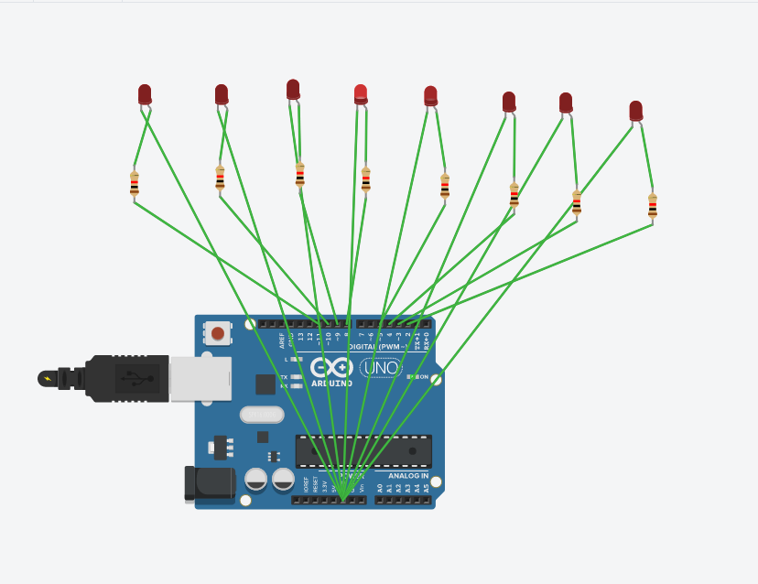
修正程式碼

const byte a[]={12,2,3,4,5,8,9,10,11};
const byte startPin = 2;
const byte endPin = 11;
byte i;
void setup()
{

for (i = 0; i<= 8; i++)
{
pinMode(a[i], OUTPUT);
}
}
void loop()
{

for(i=0;i<2;i++)
{
digitalWrite(a[8],HIGH);
digitalWrite(a[1],HIGH);
digitalWrite(a[2],HIGH);
digitalWrite(a[3],HIGH);
digitalWrite(a[4],HIGH);
digitalWrite(a[5],HIGH);
digitalWrite(a[6],HIGH);
digitalWrite(a[7],HIGH);

delay(1000);

digitalWrite(a[8],LOW);
digitalWrite(a[1],LOW);
digitalWrite(a[2],LOW);
digitalWrite(a[3],LOW);
digitalWrite(a[4],LOW);
digitalWrite(a[5],LOW);
digitalWrite(a[6],LOW);
digitalWrite(a[7],LOW);

delay(1000);

}

byte i;
byte lightPin = startPin;

for (i=0; i<= 8; i++)
digitalWrite(a[i],LOW);

for (i=0; i<= 8; i++)
{
digitalWrite(a[i],HIGH);
delay(100);
digitalWrite(a[i],LOW);
delay(100);

}
for(i=0;i<2;i++)
{
digitalWrite(a[8],HIGH);
digitalWrite(a[1],HIGH);
digitalWrite(a[2],HIGH);
digitalWrite(a[3],HIGH);
digitalWrite(a[4],HIGH);
digitalWrite(a[5],HIGH);
digitalWrite(a[6],HIGH);
digitalWrite(a[7],HIGH);

delay(1000);

digitalWrite(a[8],LOW);
digitalWrite(a[1],LOW);
digitalWrite(a[2],LOW);
digitalWrite(a[3],LOW);
digitalWrite(a[4],LOW);
digitalWrite(a[5],LOW);
digitalWrite(a[6],LOW);
digitalWrite(a[7],LOW);

delay(1000);

}

for (i=8; i> 0; i--)
{
digitalWrite(a[i],HIGH);
delay(100);

digitalWrite(a[i],LOW);
delay(100);
}
}

3.
//low 暗 high 亮
const byte a[]={12,2,3,4,5,8,9,10,11};
const byte startPin = 2;
const byte endPin = 11;
byte i;
void setup()
{
for (i = 0; i<= 8; i++)
{
pinMode(a[i], OUTPUT);
}
pinMode(6, INPUT);
}
void loop()
{
boolean val=(digitalRead(6));
if(val)
{
for(i=1;i<=8;i++)
{
digitalWrite(a[i],HIGH);
delay(100);
digitalWrite(a[i],LOW);
delay(100);
}
for(i=8;i>0;i--)
{
digitalWrite(a[i],HIGH);
delay(100);
digitalWrite(a[i],LOW);
delay(100);
}
}

else
{

for(i=0;i<2;i++)
{
digitalWrite(a[8],HIGH);
digitalWrite(a[1],HIGH);
digitalWrite(a[2],HIGH);
digitalWrite(a[3],HIGH);
digitalWrite(a[4],HIGH);
digitalWrite(a[5],HIGH);
digitalWrite(a[6],HIGH);
digitalWrite(a[7],HIGH);

delay(1000);

digitalWrite(a[8],LOW);
digitalWrite(a[1],LOW);
digitalWrite(a[2],LOW);
digitalWrite(a[3],LOW);
digitalWrite(a[4],LOW);
digitalWrite(a[5],LOW);
digitalWrite(a[6],LOW);
digitalWrite(a[7],LOW);
delay(1000);
}
for(i=1;i<=8;i++)
digitalWrite(a[i],LOW);

for(i=1;i<=8;i++)
{
digitalWrite(a[i],HIGH);
delay(100);
digitalWrite(a[i],LOW);
delay(100);
}
for(i=0;i<2;i++)
{
digitalWrite(a[8],HIGH);
digitalWrite(a[1],HIGH);
digitalWrite(a[2],HIGH);
digitalWrite(a[3],HIGH);
digitalWrite(a[4],HIGH);
digitalWrite(a[5],HIGH);
digitalWrite(a[6],HIGH);
digitalWrite(a[7],HIGH);

delay(1000);

digitalWrite(a[8],LOW);
digitalWrite(a[1],LOW);
digitalWrite(a[2],LOW);
digitalWrite(a[3],LOW);
digitalWrite(a[4],LOW);
digitalWrite(a[5],LOW);
digitalWrite(a[6],LOW);
digitalWrite(a[7],LOW);
delay(1000);
}
for(i=8;i>0;i--)
{
digitalWrite(a[i],HIGH);
delay(100);
digitalWrite(a[i],LOW);
delay(100);
}
}
}

