電通二乙微處理器實驗 實驗結報

實驗名稱 | Lab11 wifi
組別 | 19 | 組員 | 許揚

- 實驗目的
建立wifi

- 步驟
實驗步驟到MCS註冊帳號
建立網頁應用程式（web application）
透過MCS REST API進行溝通
LinkIt 家族開發板、手機、瀏覽器

- 程式碼
#include <LWiFi.h>

#include "MCS.h"

char _lwifi_ssid[] = "Last stardust";

char _lwifi_pass[] = "00000000";

MCSDevice mcs("DkcQ9ldA", "eABE3KyO7NvKJfgW");

MCSControllerOnOff led("05050146");

MCSDisplayOnOff remote("c8763");

void setup()

{

Serial.begin(9600);

Serial.println("Connect to Wifi");

while (WiFi.begin(_lwifi_ssid, _lwifi_pass) != WL_CONNECTED) {

Serial.println("Wifi Reconnecting..");

delay(1000);

}

Serial.println("Connect to MCS...");

while (!mcs.connected()) {

Serial.println("MCS Reconnecting..");

mcs.connect();

}

Serial.println("MCS Connected!");

mcs.addChannel(led);

mcs.addChannel(remote);

pinMode(7, OUTPUT);

}

void loop()

{

while (!mcs.connected()) {

mcs.connect();

if (mcs.connected()) {

Serial.println("MCS Reconnect");

}

}

while(!led.valid())

{

Serial.println("read LED value from MCS...");

led.value(); //¨ú±oMCS¼ÆÈ

}

Serial.print("done, LED value = ");

Serial.println(led.value()); //Åã¥Ü¥X¨Ó

mcs.process(1000);

if (led.value() == 1) {

digitalWrite(7, HIGH);

} else {

digitalWrite(7, LOW);

}

delay(200);

}

- 實驗結果及分析
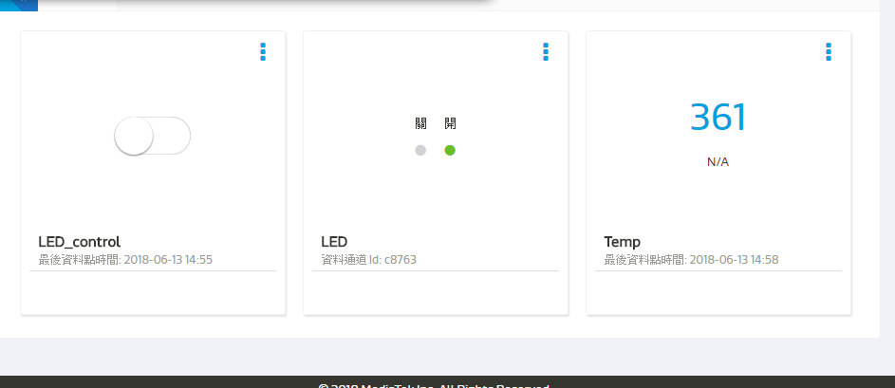
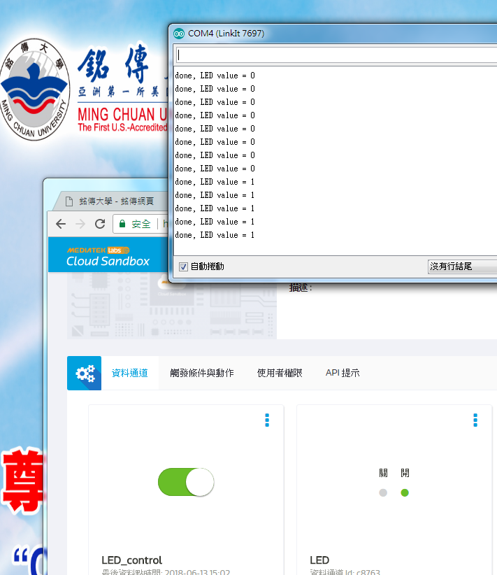
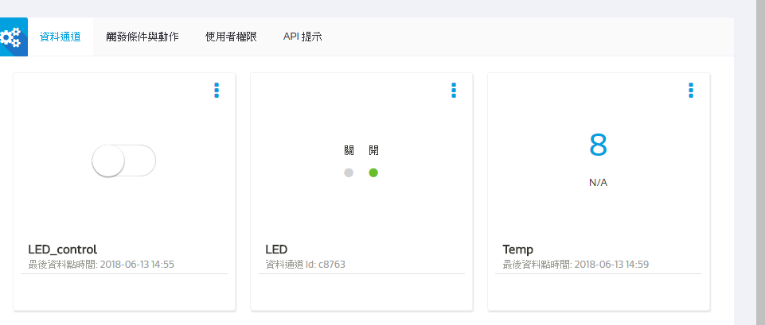
- 心得討論

- 修正程式碼

#include <LWiFi.h>

#include "MCS.h"

char _lwifi_ssid[] = "Last stardust";

char _lwifi_pass[] = "00000000";

MCSDevice mcs("DkcQ9ldA", "eABE3KyO7NvKJfgW");

MCSDisplayInteger Temp("Temp");

void setup()

{

Serial.begin(9600);

Serial.println("Connect to Wifi");

while (WiFi.begin(_lwifi_ssid, _lwifi_pass) != WL_CONNECTED) {

Serial.println("Wifi Reconnecting..");

delay(1000);

}

Serial.println("Connect to MCS...");

while (!mcs.connected()) {

Serial.println("MCS Reconnecting..");

mcs.connect();

}

Serial.println("MCS Connected!");

mcs.addChannel(Temp);

}

void loop()

{

while (!mcs.connected()) {

mcs.connect();

if (mcs.connected()) {

Serial.println("MCS Reconnect");

}

}

mcs.process(1000);

int sensor = analogRead(A0);

Temp.set(sensor);

Serial.println("Add sensor value.");

delay(200);

}

