電通二乙微處理器實驗 實驗結報

實驗名稱
組別 | 18 | 組員 | 張維洋

- 實驗目的
使用Tinkercad 模擬Arduino UNO 電路及程式碼
繪製電路途
觀察Arduino UNO 之輸出
學習將程式碼及實驗報告上傳至Github

- 實驗步驟
創建帳號 -> 連接電路 -> 更改程式碼 -> 將實驗步驟及結報上傳至 Github

- 程式碼
void setup() {
// initialize digital pin LED_BUILTIN as an output.
pinMode(LED_BUILTIN, OUTPUT);
}

void loop() {
digitalWrite(LED_BUILTIN, HIGH); // turn the LED on (HIGH is the voltage level)
delay(1000); // wait for a second
digitalWrite(LED_BUILTIN, LOW); // turn the LED off by making the voltage LOW
delay(1000); // wait for a second
}
- 實驗結果及分析
更改時間觀察出閃爍的時間差

- 心得討論
學習用Github還蠻有趣的
接電路跟寫程式也都是用不太一樣的方式
希望之後可以順利上手

- 修正電路圖
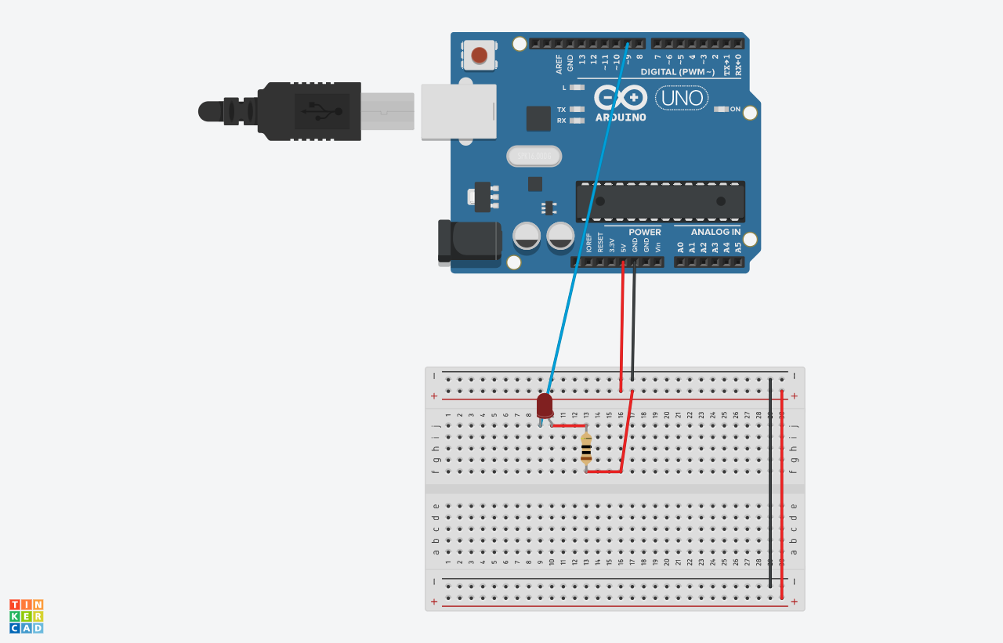
- 修正程式碼
1.
void setup() {
// initialize digital pin LED_BUILTIN as an output.
pinMode(9, OUTPUT);
}

void loop() {
digitalWrite(9, HIGH); // turn the LED on (HIGH is the voltage level)
delay(500); // wait for a second
digitalWrite(9, LOW); // turn the LED off by making the voltage LOW
delay(500); // wait for a second
}

2.
void setup() {
// initialize digital pin LED_BUILTIN as an output.
pinMode(9, OUTPUT);
}

void loop() {
digitalWrite(9, HIGH); // turn the LED on (HIGH is the voltage level)
delay(2000); // wait for a second
digitalWrite(9, LOW); // turn the LED off by making the voltage LOW
delay(2000); // wait for a second
}

