byte LED[8]={2,3,4,5,8,9,10,11};

void setup() {

for (byte i = 0; i< 8; i++) {

pinMode(LED[i], OUTPUT);

}

}

void loop()

{

byte m;

alllight();

alllight();

left();

alllight();

alllight();

right();

}

void left(){

byte i;

for(i=0;i<8;i++)

{

digitalWrite(LED[i],LOW);

if(i>=0)

digitalWrite(LED[i],HIGH);

delay(100);

digitalWrite(LED[i],LOW);

}

}

void right(){

byte i=7;

while(i>=0)

{

digitalWrite(LED[i],LOW);

digitalWrite(LED[i],HIGH);

delay(100);

digitalWrite(LED[i],LOW);

i--;

}

}

void alllight()

{

byte i;

for(i=0;i<8;i++)

{

digitalWrite(LED[i],HIGH);

}

delay(300);

for(i=0;i<8;i++)

{

digitalWrite(LED[i],LOW);

}

delay(300);

}

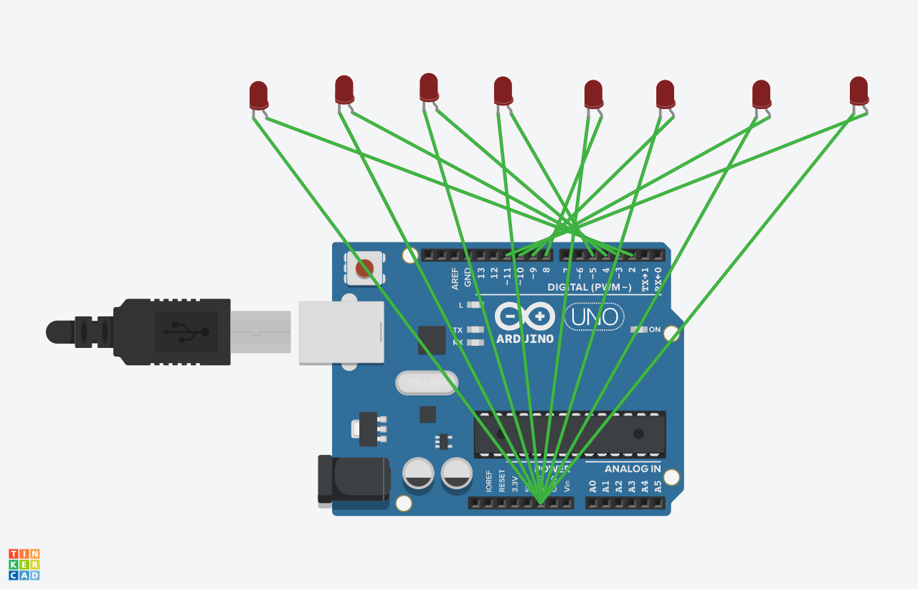

byte LED[8]={2,3,4,5,8,9,10,11};

void setup() {

for (byte i = 0; i< 8; i++) {

pinMode(LED[i], OUTPUT);

}

}

void loop()

{

byte m,i;

alllight();

alllight();

for(m=0;m<=7;m++)

{

left();

}

alllight();

alllight();

for(m=0;m<=7;m++)

{

for(i=7;i<=0;i++)

digitalWrite(LED[i],HIGH);

digitalWrite(LED[i],LOW);

delay(1000);

}

}

void left(){

byte i;

for(i=0;i<8;i++)

{

digitalWrite(LED[i],LOW);

if(i>=0)

digitalWrite(LED[i],HIGH);

delay(100);

digitalWrite(LED[i],LOW);

}

}

void right(){

byte i=7;

while(i>=0)

{

digitalWrite(LED[i],LOW);

digitalWrite(LED[i],HIGH);

delay(100);

digitalWrite(LED[i],LOW);

i--;

}

}

void alllight()

{

byte i;

for(i=0;i<8;i++)

{

digitalWrite(LED[i],HIGH);

}

delay(300);

for(i=0;i<8;i++)

{

digitalWrite(LED[i],LOW);

}

delay(300);

}