電通二乙微處理器實驗 實驗結報

實驗名稱 | 四合一七段顯示器
組別 | 24 | 組員 | 羅楷中

- 實驗目的

- 實驗步驟


-----------------------------------------------------------------------------------



-----------------------------------------------------------------------------------


- 程式碼
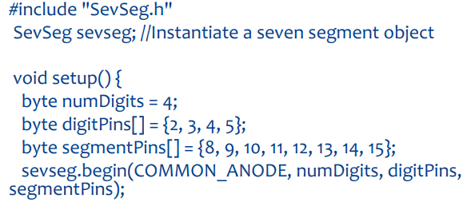

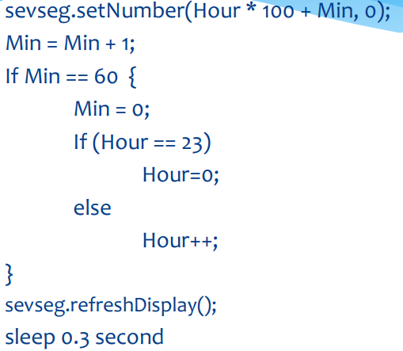

-----------------------------------------------------------------------------------

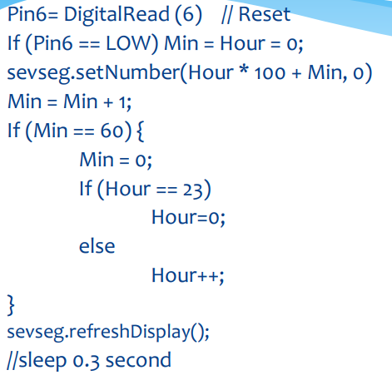

-----------------------------------------------------------------------------------

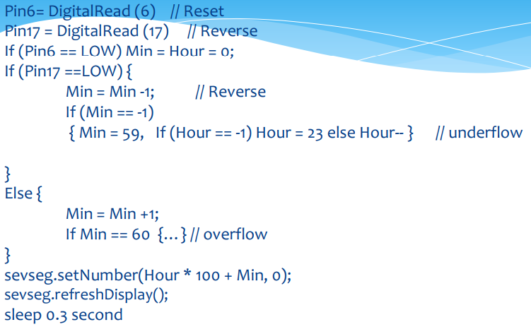
- 實驗結果及分析

要善用ARDUINO內建的一些LIBRARIES的資訊，這真的很方便可以節省很多時間

- 心得討論

這個實驗還真的是有點複雜，但是沒想到這樣簡單的程式就可以做出一個電子鐘
- 修正程式碼
#include "SevSeg.h"
int h=0, m=0;
SevSeg sevseg; //Initiate a seven segment controller object
void setup() {
byte numDigits = 4;
byte digitPins[] = {2,3,4,5};
byte segmentPins[] = {8,9,10,11,12,13,14,15};
sevseg.begin(COMMON_CATHODE, numDigits, digitPins, segmentPins);
sevseg.setBrightness(90);
}
void loop() {
static unsigned long timer = millis();
static int m = 59;
static int h = 23;
if (millis()>=timer)
{
timer += 10;
if(++m>=60)
{
m=0;
if(++h>=24)
h=0;
}
sevseg.setNumber(h*100+m);
}
sevseg.refreshDisplay(); // Must run repeatedly
}

#include "SevSeg.h"

SevSeg sevseg; //Instantiate a seven segment controller object

void setup() {

byte numDigits = 4;

byte digitPins[] = {2, 3, 4, 5};

byte segmentPins[] = {8,9,10,11,12,13,14,15};

bool resistorsOnSegments = false; // 'false' means resistors are on digit pins

byte hardwareConfig = COMMON_CATHODE; // See README.md for options

sevseg.begin(hardwareConfig, numDigits, digitPins, segmentPins, resistorsOnSegments);

sevseg.setBrightness(90);

pinMode(6,INPUT);

}

void loop()

{

static unsigned long timer = millis();

static int deciSeconds = 0;

boolean val=digitalRead(6);

if(val)

{

sevseg.setNumber(0000, 0);

sevseg.refreshDisplay();

deciSeconds=0;

}

else

{

sevseg.setNumber(deciSeconds, 0);

if (millis() - timer >= 300)

{

timer += 300;

deciSeconds++;

if (deciSeconds%100 == 59)

{

deciSeconds=deciSeconds+41;

}

else

{

deciSeconds=deciSeconds+1;

}

if (deciSeconds == 2400)

deciSeconds =0 ;

}

sevseg.refreshDisplay(); // Must run repeatedly

}

}

else

{

deciSeconds=deciSeconds+1;

}

if (deciSeconds == 2400)

deciSeconds =0 ;

}

sevseg.refreshDisplay(); // Must run repeatedly

}

}

#include "SevSeg.h"

SevSeg sevseg; //Instantiate a seven segment controller object

void setup() {

byte numDigits = 4;

byte digitPins[] = {2, 3, 4, 5};

byte segmentPins[] = {8,9,10,11,12,13,14,15};

bool resistorsOnSegments = false; // 'false' means resistors are on digit pins

byte hardwareConfig = COMMON_CATHODE; // See README.md for options

sevseg.begin(hardwareConfig, numDigits, digitPins, segmentPins, resistorsOnSegments);

sevseg.setBrightness(90);

pinMode(6,INPUT);

pinMode(17,INPUT);

}

void loop()
{

static unsigned long timer = millis();

static int deciSeconds = 0;

boolean val=digitalRead(6);

boolean Pin17=digitalRead(17);

if(val)

{

sevseg.setNumber(0000, 0);

sevseg.refreshDisplay();

if(Pin17==HIGH)

deciSeconds=2400;

else

deciSeconds=0;

}

else if(Pin17==HIGH)

{

sevseg.setNumber(deciSeconds, 0);

if (millis() - timer >= 300)

{

timer += 300;

/*deciSeconds--; */

if (deciSeconds%100 == 0)

{

deciSeconds=deciSeconds-41;

}

else

{

deciSeconds=deciSeconds-1;

}

}

if (deciSeconds == 0)

deciSeconds =2400 ;

sevseg.refreshDisplay(); // Must run repeatedly

}

else

{

sevseg.setNumber(deciSeconds, 0);

if (millis() - timer >= 300)

{

timer += 300;

/*deciSeconds++; */

if (deciSeconds%100 == 59)

{

deciSeconds=deciSeconds+41;

}

else

{

deciSeconds=deciSeconds+1;

}

if (deciSeconds == 2400)

deciSeconds =0 ;

}

sevseg.refreshDisplay(); // Must run repeatedly

}

}

