電通二乙微處理器實驗 實驗結報

實驗名稱 | I2C 通訊
組別 | 24 | 組員 | 羅楷中

- 實驗目的
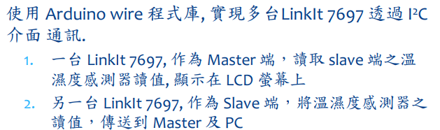
- 實驗步驟
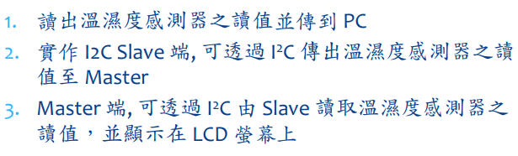
- 程式碼

// Example testing sketch for various DHT humidity/temperature sensors
// Written by ladyada, public domain

#include "DHT.h"

#define DHTPIN 2 // what digital pin we're connected to

#define DHTTYPE DHT11
//#define DHTTYPE DHT21

// Connect pin 1 (on the left) of the sensor to +5V
// NOTE: If using a board with 3.3V logic like an Arduino Due connect pin 1
// to 3.3V instead of 5V!
// Connect pin 2 of the sensor to whatever your DHTPIN is
// Connect pin 4 (on the right) of the sensor to GROUND
// Connect a 10K resistor from pin 2 (data) to pin 1 (power) of the sensor

// Initialize DHT sensor.
// Note that older versions of this library took an optional third parameter to
// tweak the timings for faster processors. This parameter is no longer needed
// as the current DHT reading algorithm adjusts itself to work on faster procs.
DHT dht(DHTPIN, DHTTYPE);

void setup() {
Serial.begin(9600);
Serial.println("DHTxx test!");

dht.begin();
}

void loop() {
// Wait a few seconds between measurements.
delay(2000);

// Reading temperature or humidity takes about 250 milliseconds!
// Sensor readings may also be up to 2 seconds 'old' (its a very slow sensor)
float h = dht.readHumidity();
// Read temperature as Celsius (the default)
float t = dht.readTemperature();
// Read temperature as Fahrenheit (isFahrenheit = true)
float f = dht.readTemperature(true);

// Check if any reads failed and exit early (to try again).
if (isnan(h) || isnan(t) || isnan(f)) {
Serial.println("Failed to read from DHT sensor!");
return;
}

// Compute heat index in Fahrenheit (the default)
float hif = dht.computeHeatIndex(f, h);
// Compute heat index in Celsius (isFahreheit = false)
float hic = dht.computeHeatIndex(t, h, false);

Serial.print("Humidity: ");
Serial.print(h);
Serial.print(" %\t");
Serial.print("Temperature: ");
Serial.print(t);
Serial.print(" *C ");
Serial.print(f);
Serial.print(" *F\t");
Serial.print("Heat index: ");
Serial.print(hic);
Serial.print(" *C ");
Serial.print(hif);
Serial.println(" *F");
}

- 實驗結果及分析
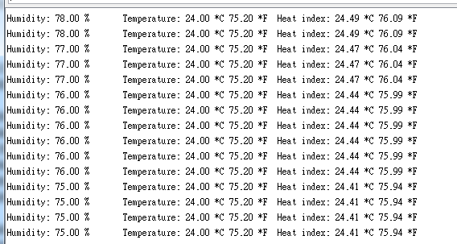
- 心得討論
I2C的接線跟程式真的好難….

