電通二乙微處理器實驗 實驗結報

實驗名稱 | Lab 01
組別 | 26 | 組員 | 楊宏明 05050511  黃璽方 05050616

- 實驗目的
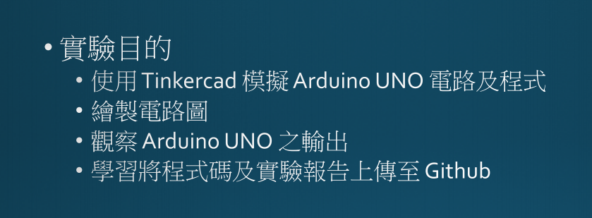

- 實驗步驟
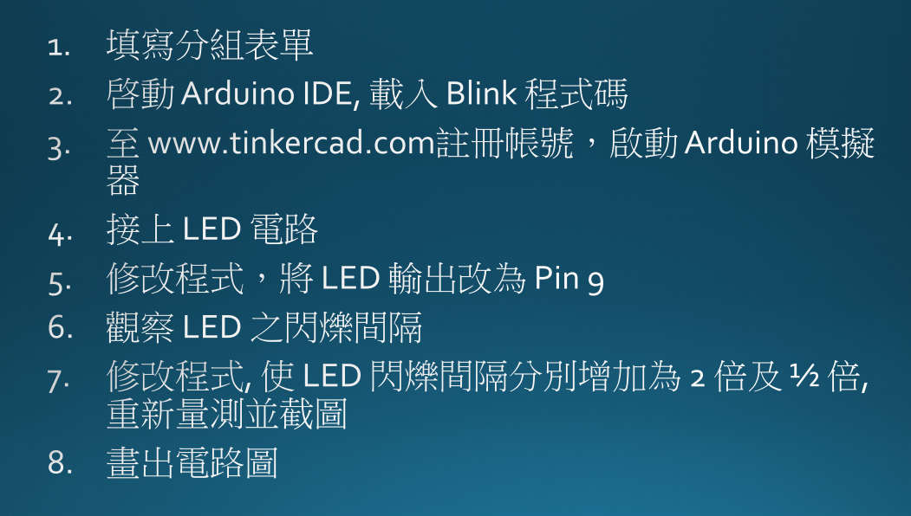

- 程式碼
/*
Blink

Turns an LED on for one second, then off for one second, repeatedly.

Most Arduinos have an on-board LED you can control. On the UNO, MEGA and ZERO
it is attached to digital pin 13, on MKR1000 on pin 6. LED_BUILTIN is set to
the correct LED pin independent of which board is used.
If you want to know what pin the on-board LED is connected to on your Arduino
model, check the Technical Specs of your board at:
https://www.arduino.cc/en/Main/Products

modified 8 May 2014
by Scott Fitzgerald
modified 2 Sep 2016
by Arturo Guadalupi
modified 8 Sep 2016
by Colby Newman

This example code is in the public domain.

http://www.arduino.cc/en/Tutorial/Blink
*/

// the setup function runs once when you press reset or power the board
void setup() {
// initialize digital pin LED_BUILTIN as an output.
pinMode(LED_BUILTIN, OUTPUT);
}

// the loop function runs over and over again forever
void loop() {
digitalWrite(LED_BUILTIN, HIGH); // turn the LED on (HIGH is the voltage level)
delay(1000); // wait for a second
digitalWrite(LED_BUILTIN, LOW); // turn the LED off by making the voltage LOW
delay(1000); // wait for a second
}
- 實驗結果及分析

一閃一閃亮晶晶

- 心得討論

學會使用Tinkercad模擬 受益良多
- 修正電路圖

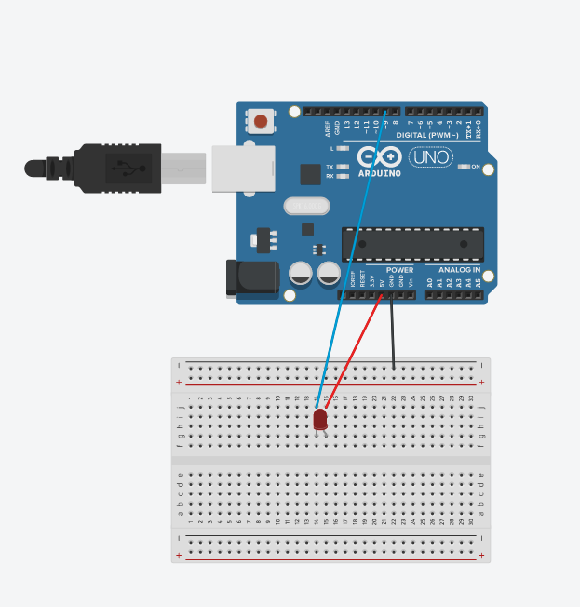

- 修正程式碼
/*
Blink

Turns an LED on for one second, then off for one second, repeatedly.

Most Arduinos have an on-board LED you can control. On the UNO, MEGA and ZERO
it is attached to digital pin 13, on MKR1000 on pin 6. LED_BUILTIN is set to
the correct LED pin independent of which board is used.
If you want to know what pin the on-board LED is connected to on your Arduino
model, check the Technical Specs of your board at:
https://www.arduino.cc/en/Main/Products

modified 8 May 2014
by Scott Fitzgerald
modified 2 Sep 2016
by Arturo Guadalupi
modified 8 Sep 2016
by Colby Newman

This example code is in the public domain.

http://www.arduino.cc/en/Tutorial/Blink
*/

// the setup function runs once when you press reset or power the board
void setup() {
// initialize digital pin LED_BUILTIN as an output.
pinMode(9, OUTPUT);
}

// the loop function runs over and over again forever
void loop() {
digitalWrite(9, HIGH); // turn the LED on (HIGH is the voltage level)
delay(500); // wait for a second
digitalWrite(9, LOW); // turn the LED off by making the voltage LOW
delay(2000); // wait for a second
}

