Engineering Application Software quiz 2 Class: 電通三甲 Name:戴寧 Student ID:04050432

- Write a program that accepts an input string from the user and determines how many times a user-specified character appears within the string without regard to the case of the character (忽略大小寫).

clear all;
close all;
a=input('輸入字串:' , 's');
c=input('輸入欲搜字串:' , 's');
a=upper(a);
c=upper(c);
count=0;
for i=1:length(a)
if strncmp(a(i),c,1);
count=count+1;
end
end
count
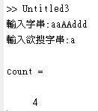

- Plot the function 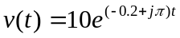for 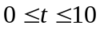using function plot3, where the three dimensions to plot are the real part of the function, the imaginary part of the function, and time.

clear all;close all;
t=0:0/05:10;
y=10*exp((-0.2+j*pi)*t);
plot(t,real(y),'b');
hold on;
plot(t,imag(y),'r');
hold off;
theta = 0:0.05:10;
x= exp(theta)
x= cos(theta) + i*sin(theta)
plot3(real(x),imag(x),theta)
grid on;
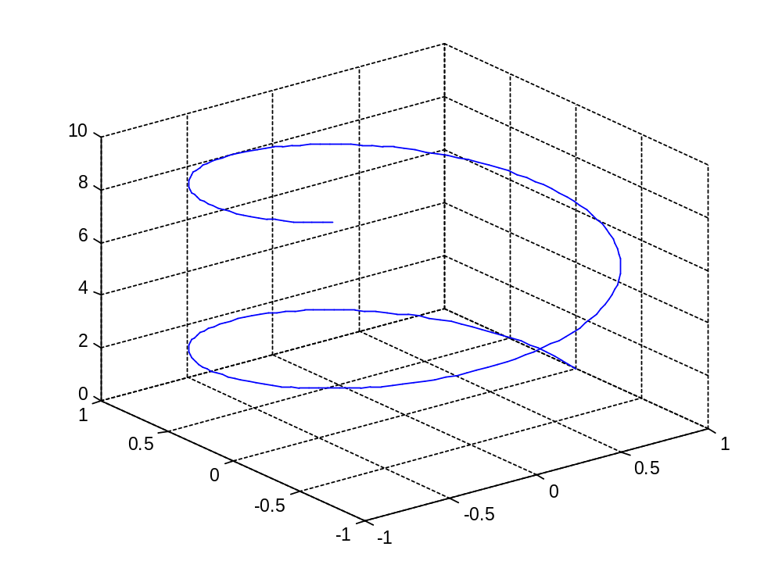

- Create (a) mesh plot, (b) surface plot, and (c) contour plot of the function 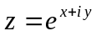for the interval -1<x<1 and -2π<y<2π. In each case, plot the real part of z versus x and y.

clear all;close all;
[x,y] = meshgrid(-1:0.1:1, -2*pi:0.1:2*pi);
i=sqrt(-1);
z=exp(x+i*y);
a=real(z);
mesh(x,y,a);
figure,surf(x,y,a);
figure,contour(x,y,a);
xlabel('\bfx');
ylabel('\bfy');
zlabel('\bfz');
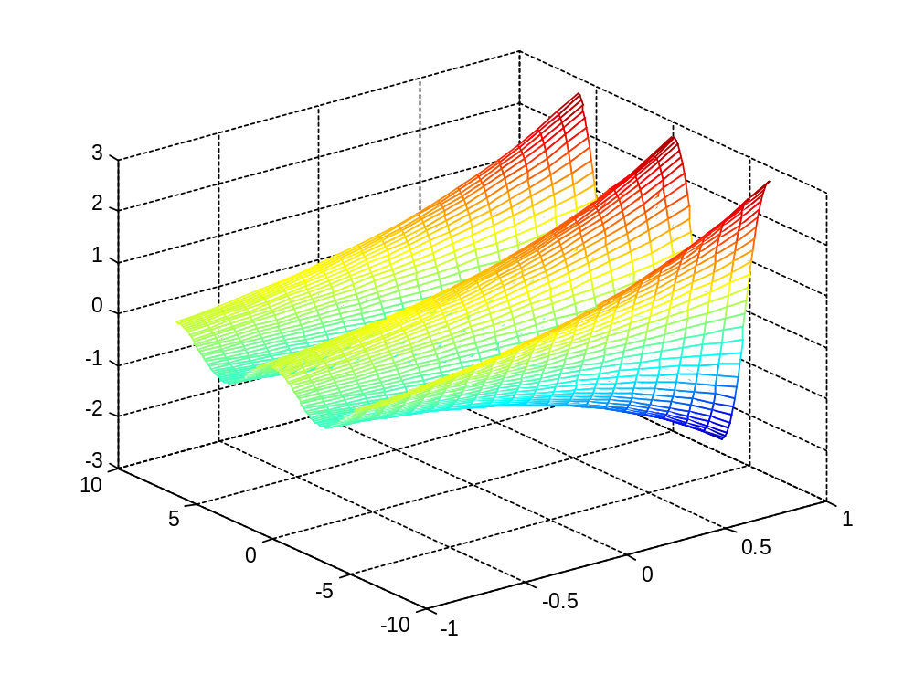
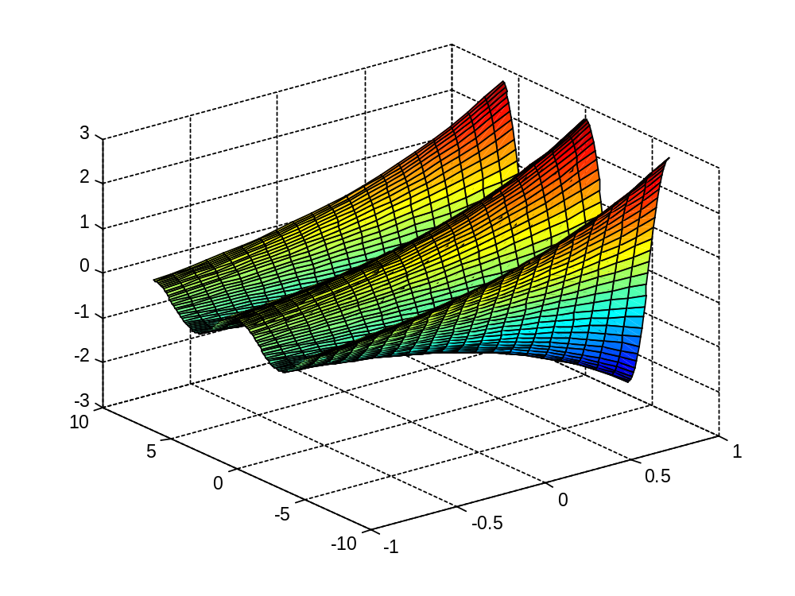
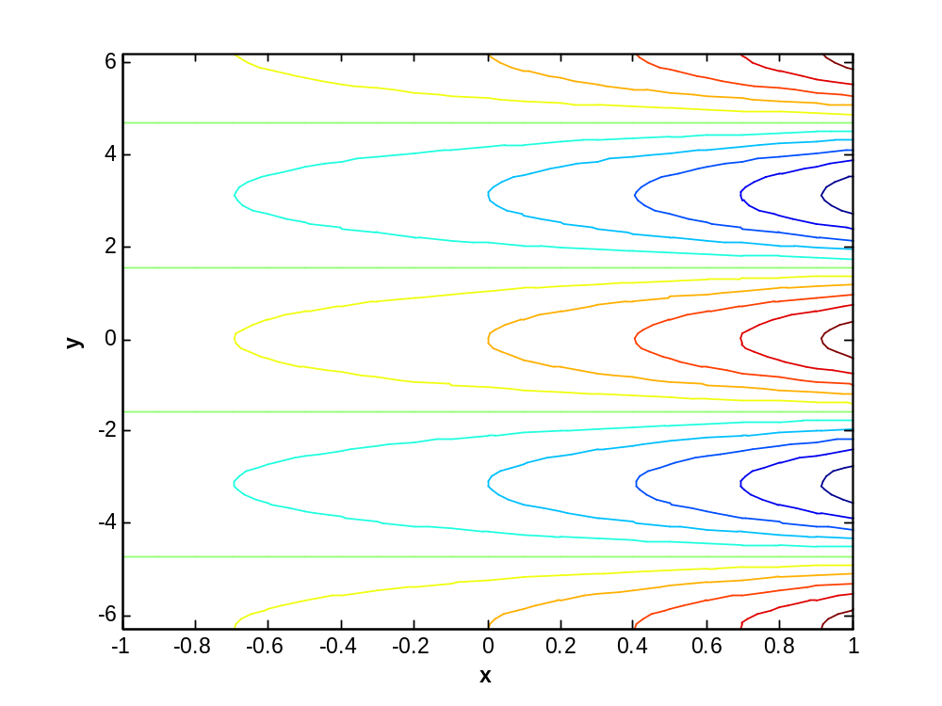

- (a) Create a cell array cell_array with the following structure:

clear all;close all;
a{1,1}=[0];
a{1,2}=[4:-2:2]';
a{2,1}=[1 0 3 ; -5 1 2 ; 1 2 0];
a{2,2}=[1 5 -2]
b=[sum(a{1,1}(:)) sum(a{1,2}(:)) sum(a{2,1}(:)) sum(a{2,2}(:)) ];
%a=cell(1,1);
%b={10, [2:4]; eye(3), [1 4]}
cellplot(a)
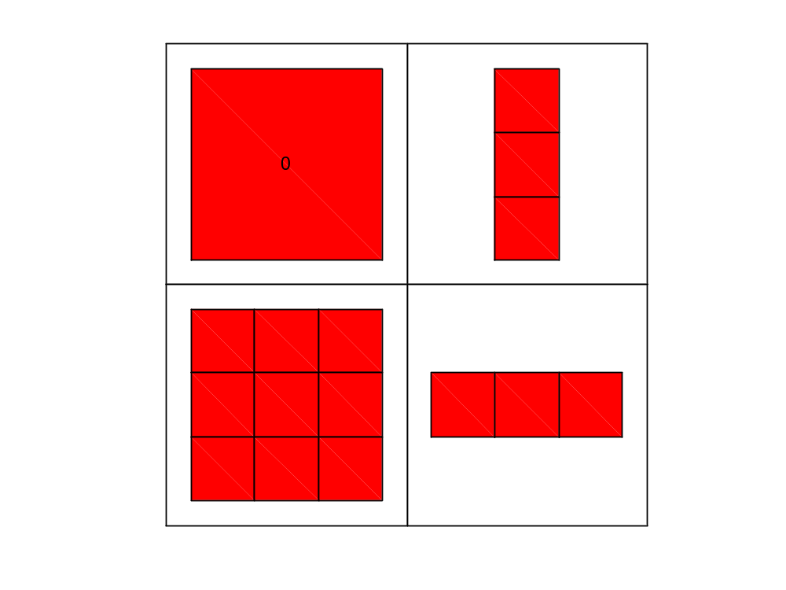

(b) Add 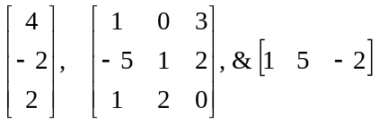 to the cell array cell_array .

(c) Sum up all of individual elements of the array in cell_array and assign the result to an array B. The contents of B will be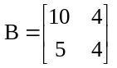. List all the MATLAB codes.

- Function dir returns the contents of a specified directory. The dir command returns a structure array with four fields, as shown here:
>> d=dir(‘chap7’)
d=
36x1 struct array with fields:
name
date
bytes
isdir
where name contains the name of each file, date contains the last modification date for the file, bytes contains the size of the file in bytes, and isdir is 0 for conventional files and 1 for directories.

Write a function that accepts a directory name and path name and returns the total size of all files in the directory in bytes.

函式:
function b=dir_sige(dir_name)
files=dir(dir_name),b=0;
for i=1:length(files)
if ~files(i).isdir
b=b+files(i).bytes;
end
end
end

主程式:
dir_name=input('輸入目錄名:','s');
b=dir_sige(dir_name)

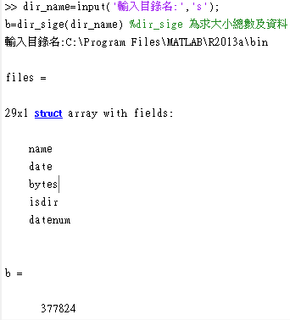

- Calculate and plot the output v of the following differential equation:

