* Talk about your traveling experience.

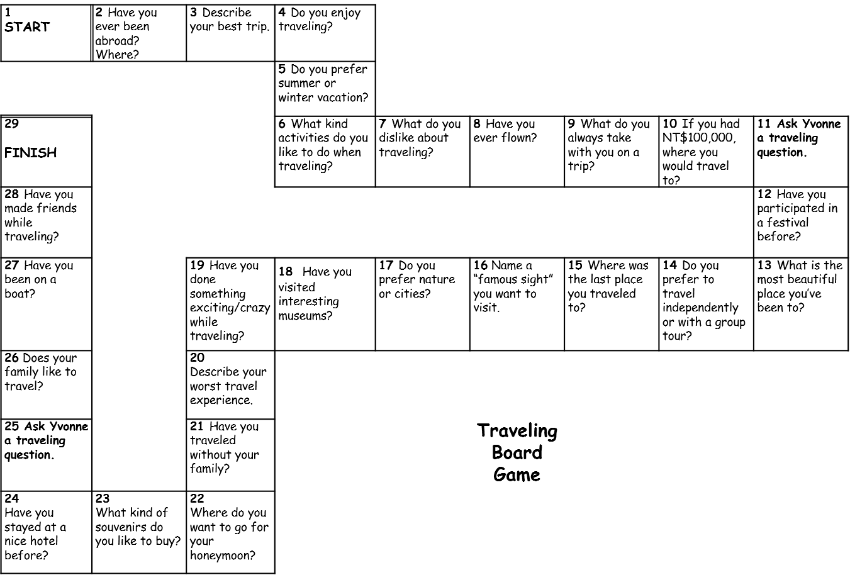

* Talk about your work and interview experience.

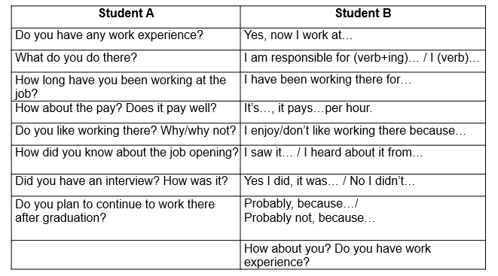

* Define non-verbal communication and talk about how you communicate using NVC .

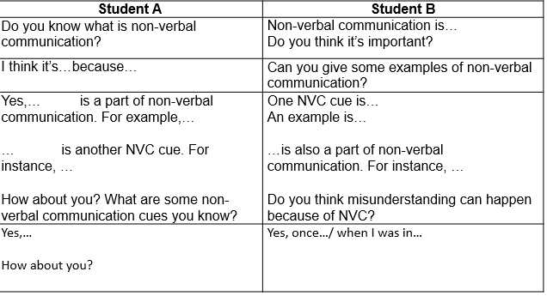

* Give a speech using an outline
* Talk and complain about problems in your life. Understand the situation by asking follow-up questions, than respond with optimism.

