電通二乙微處理器實驗 實驗結報

實驗名稱 | Lab07
組別 | 19 | 組員 | 鄒學緯

- 實驗目的
讀出溫濕度感測器之讀值並傳到PC
- 實驗步驟
接好感測器跟Arduino
- 程式碼

#include "DHT.h"
#define DHTPIN 2
#define DHTTYPE DHT11 // DHT 11
DHT dht(DHTPIN, DHTTYPE);
void setup() {
Serial.begin(9600);
Serial.println("DHTxx test!");
dht.begin();
}

void loop() {

delay(2000);
float h = dht.readHumidity();
float t = dht.readTemperature();
if (isnan(h) || isnan(t)) {
Serial.println("Failed to read from DHT sensor!");
return;
}

float hic = dht.computeHeatIndex(t, h, false);

Serial.print("Humidity: ");
Serial.print(h);
Serial.print(" %\t");
Serial.print("Temperature: ");
Serial.print(t);
Serial.println(" *C ");

}
- 實驗結果及分析
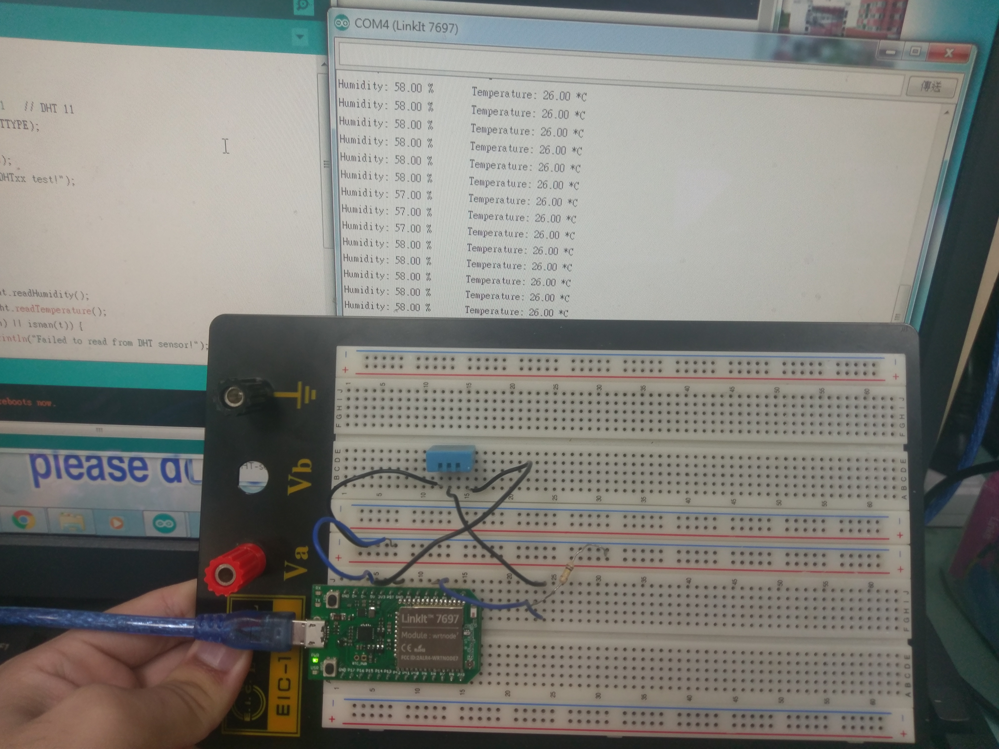
- 心得討論
這次2 3不用做 所以很快就結束了

