電通二乙微處理器實驗 實驗結報

實驗名稱 | Lab11
組別 | 19 | 組員 | 鄒學緯

- 實驗目的
MCS Cloud
- 實驗步驟
修改 MCS_GET code, 加入 MCS Remote
將 A0 電阻值上傳
- 程式碼
程式1:
#include <LWiFi.h>
#include "MCS.h"

char _lwifi_ssid[] = "Hㄒㄈ";
char _lwifi_pass[] = "ja861211";
MCSDevice mcs("DMiMkqqP", "E6Y6nr5Sg2OtqFFo");

MCSControllerOnOff led("05050554");
MCSDisplayOnOff remote("050505544");

void setup()
{
Serial.begin(9600);

Serial.println("Connect to Wifi");
while (WiFi.begin(_lwifi_ssid, _lwifi_pass) != WL_CONNECTED) {
Serial.println("Wifi Reconnecting..");
delay(1000);
}

Serial.println("Connect to MCS...");
while (!mcs.connected()) {
Serial.println("MCS Reconnecting..");
mcs.connect();
}
Serial.println("MCS Connected!");
mcs.addChannel(led);
mcs.addChannel(remote);
pinMode(7, OUTPUT);

}

void loop()
{
while (!mcs.connected()) {
mcs.connect();
if (mcs.connected()) {
Serial.println("MCS Reconnect");
}
}
mcs.process(1000);
while(!led.valid())
{
Serial.println("read LED value from MCS...");
led.value(); //取得MCS數值
}
digitalWrite(7,led.value() ? HIGH : LOW);
if(!remote.set(led.value()))
{
Serial.print("Failed to update remote");
Serial.println(remote.value());
}

if (led.value() == 1) {
digitalWrite(7, HIGH);

} else {
digitalWrite(7, LOW);

}

delay(200);
}

程式2:
#include <LWiFi.h>
#include "MCS.h"

char _lwifi_ssid[] = "Hㄒㄈ";
char _lwifi_pass[] = "ja861211";
MCSDevice mcs("DMiMkqqP", "E6Y6nr5Sg2OtqFFo");

MCSDisplayInteger Temp("0554");

void setup()
{
Serial.begin(9600);

Serial.println("Connect to Wifi");
while (WiFi.begin(_lwifi_ssid, _lwifi_pass) != WL_CONNECTED) {
Serial.println("Wifi Reconnecting..");
delay(1000);
}

Serial.println("Connect to MCS...");
while (!mcs.connected()) {
Serial.println("MCS Reconnecting..");
mcs.connect();
}
Serial.println("MCS Connected!");

mcs.addChannel(Temp);

}

void loop()
{
while (!mcs.connected()) {
mcs.connect();
if (mcs.connected()) {
Serial.println("MCS Reconnect");
}
}
mcs.process(1000);

int sensor = analogRead(A0);

Temp.set(sensor);
delay(200);
}
- 實驗結果及分析
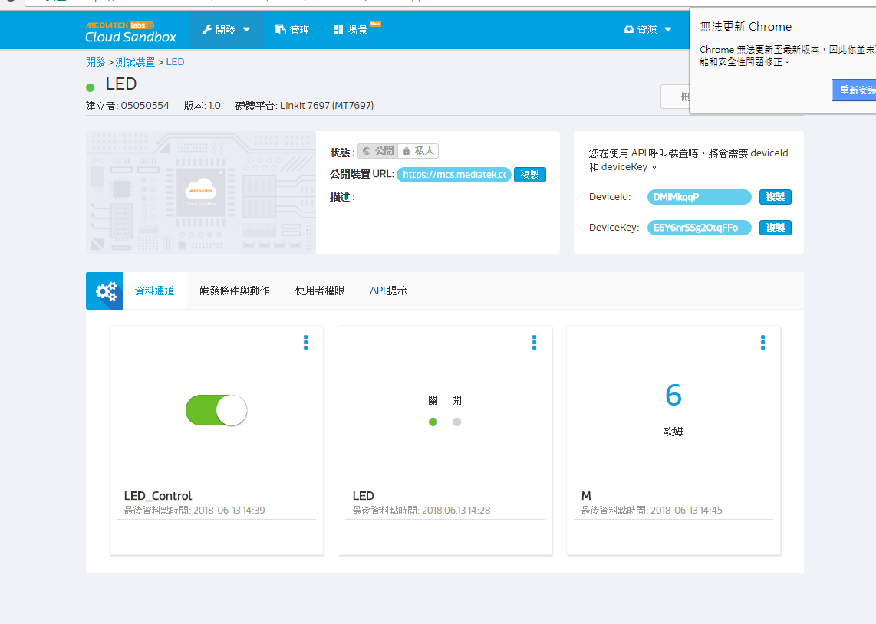

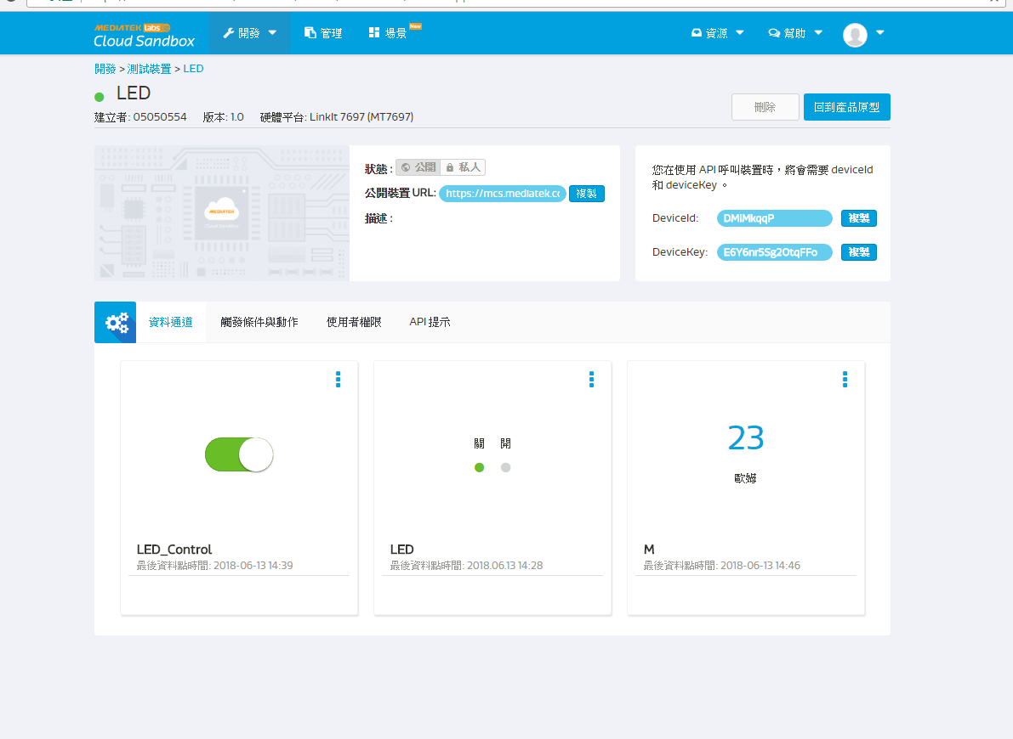
- 心得討論

這次實驗要搞懂要加入什麼東西跟改什麼

