Engineering Application Software Quiz 1 Class:電通四乙 Name:鄒學緯 Student id:05050554

1. The distance traveled by a ball falling in the air is given by the equation



where .

1. Use MATLAB to calculate and plot the position of the ball for the range:  sec.

t=0:1:10;

x0=10e-3;

vo=15e-3;

a=-9.81e-3;

x=x0+vo\*t+1/2\*a\*t.^2;

plot(t,x)

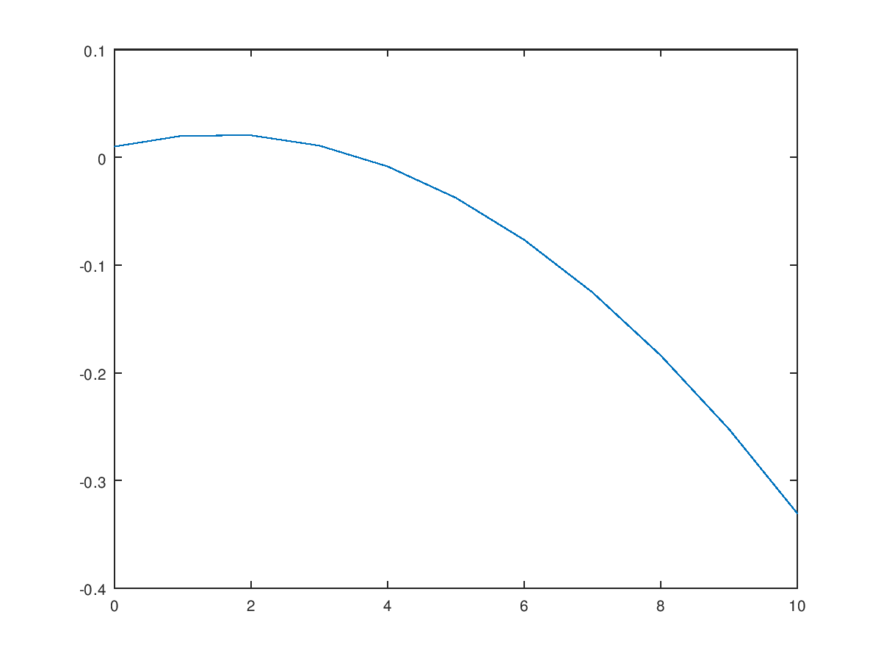

1. From the displayed figure, estimate *x*(5)=?

t=5;

x0=10;

vo=15;

a=-9.81;

x=x0+vo\*t+1/2\*t.^2;

fprintf('x(5)=%f',x)

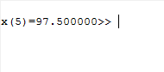

1. Suppose that *u*=1 and *v*=3. Evaluate the following expressions using Octave:

$$\frac{v^{3}}{v^{3}-u^{3}}$$

List your Octave program.

u=1;

v=3;

s=v\*v\*v;

w=s-u\*u\*u;

k=s/w



1. The distance between two pointsandis given by the equation



* 1. Write a program to calculate the distance between two points specified by the user.

fprintf('x1=')

x1=input('');

fprintf('x2=')

x2=input('');

fprintf('y1=')

y1=input('');

fprintf('y1=')

y2=input('');

fprintf('z1=')

z1=input('');

fprintf('z2=')

z2=input('');

a1=(x1-x2)\*(x1-x2);

a2=(y1-y2)\*(y1-y2);

a3=(z1-z2)\*(z1-z2);

a4=(a1+a2+a3)\*\*0.5;

fprintf('d=%f',a4)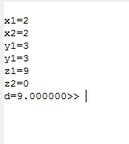

* 1. Use the program to calculate the distance between the points (-3, 2, 5) and (3, -6, -5)

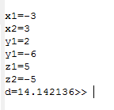

1. The average (rms) voltage across the resistive load varies as a function of frequency according to the following equation.



where and *f* is the frequency in hertz. Assume that L=0.1mH, C=0.25nF, R=50Ω, and =10mV. Plot the (rms) voltage on the resistive load  as a function of frequency *f*. (Create an array of frequencies centered on 1 MHz)

f=1000000;

w=2\*pi\*f;

L=0.1e-3;

C=0.25e-9;

R=50;

Vo=10;

VR=R/sqrt(R^2+(w\*L-1/(w\*C))^2)\*Vo;

fprintf('VR=%f',VR);

fprintf('\n');



1. (a) Write a program to evaluate a function *f* (*x*, *y*) for any two user-specified values *x* and *y*.



(b) Execute the program with the four sets of input values (x, y)=(2, 3), (2, -3), (-2, 3), and (-2, -3).

close all;

clear all;

fprintf('x=')

x=input('');

fprintf('y=')

y=input('');

if x >= 0 && y >= 0

fun = x + y;

elseif x >= 0 && y < 0

fun = x + y^2 ;

elseif x < 0 && y >= 0

fun = x^2+y;

else

fun = x^2+y^2;

end

disp(['f(x,y) = ' num2str(fun)]);

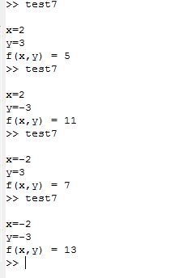

1. The gain G of a certain microwave dish antenna can be expressed as a function of angle by the equation:



whereis measured in radians. Plot this gain function on a polar plot.

a=-pi/2:pi/2;

G=abs(sin(4.\*a)/4.\*a);

plot(a,G)

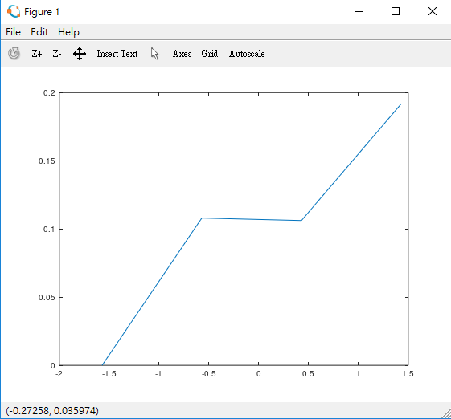

1. A low-pass filter has the following transfer function:



$$\frac{v_{o}}{v_{i}}=\frac{1}{1+j2πfRC}$$

where  and  denote the input and output voltages, respectively; and. Write a program to plot the amplitude and frequency response of this filter (1~1kHz). Note that the plot must include *titles, xlabels,* and *ylabels*.

R=16000;

C=1e-6;

f=1:1:1000;

Vo=1;

Vi=1+j\*2\*pi.\*f\*R\*C;

s=Vo/Vi;

plot(f,s)

