電通二乙微處理器實驗 實驗結報

實驗名稱 | 四合一七段顯示器
組別 | 23 | 組員 | 林宇傑

- 實驗目的

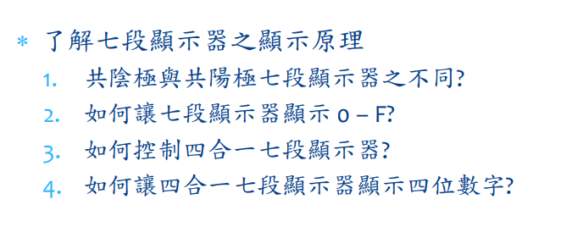
- 實驗步驟
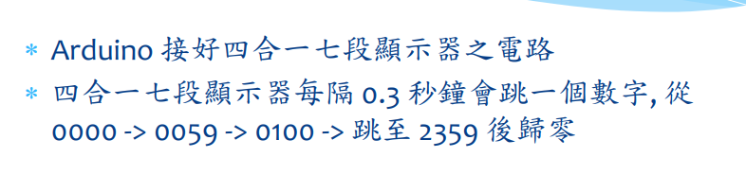
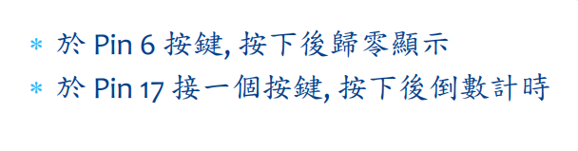
- 程式碼

1.
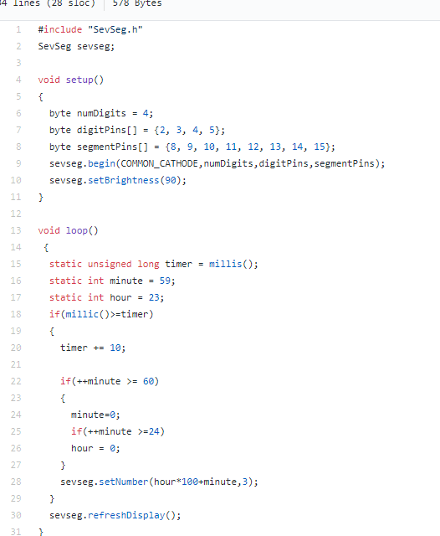

2.

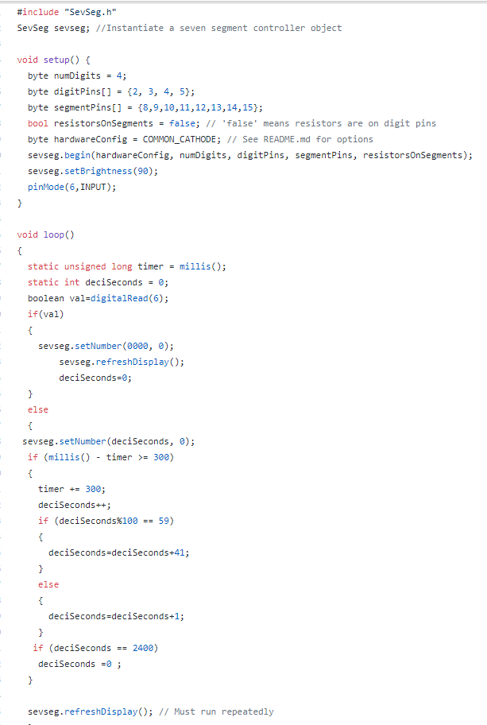

3.

#include "SevSeg.h"
SevSeg sevseg; //Instantiate a seven segment controller object
void setup() {
byte numDigits = 4;
byte digitPins[] = {2, 3, 4, 5};
byte segmentPins[] = {8,9,10,11,12,13,14,15};
bool resistorsOnSegments = false; // 'false' means resistors are on digit pins
byte hardwareConfig = COMMON_CATHODE; // See README.md for options
sevseg.begin(hardwareConfig, numDigits, digitPins, segmentPins, resistorsOnSegments);
sevseg.setBrightness(90);
pinMode(6,INPUT);
pinMode(17,INPUT);
}
void loop()
{
static unsigned long timer = millis();
static int deciSeconds = 0;
boolean val=digitalRead(6);
boolean Pin17=digitalRead(17);
if(val)
{
sevseg.setNumber(0000, 0);
sevseg.refreshDisplay();
if(Pin17==HIGH)
deciSeconds=2400;
else
deciSeconds=0;
}
else if(Pin17==HIGH)
{
sevseg.setNumber(deciSeconds, 0);
if (millis() - timer >= 300)
{
timer += 300;
/*deciSeconds--; */
if (deciSeconds%100 == 0)
{
deciSeconds=deciSeconds-41;
}
else
{
deciSeconds=deciSeconds-1;
}
}
if (deciSeconds == 0)
deciSeconds =2400 ;
sevseg.refreshDisplay(); // Must run repeatedly
}
else
{
sevseg.setNumber(deciSeconds, 0);
if (millis() - timer >= 300)
{
timer += 300;
/*deciSeconds++; */
if (deciSeconds%100 == 59)
{
deciSeconds=deciSeconds+41;
}
else
{
deciSeconds=deciSeconds+1;
}
if (deciSeconds == 2400)
deciSeconds =0 ;
}
sevseg.refreshDisplay(); // Must run repeatedly
}
}

- 實驗結果及分析
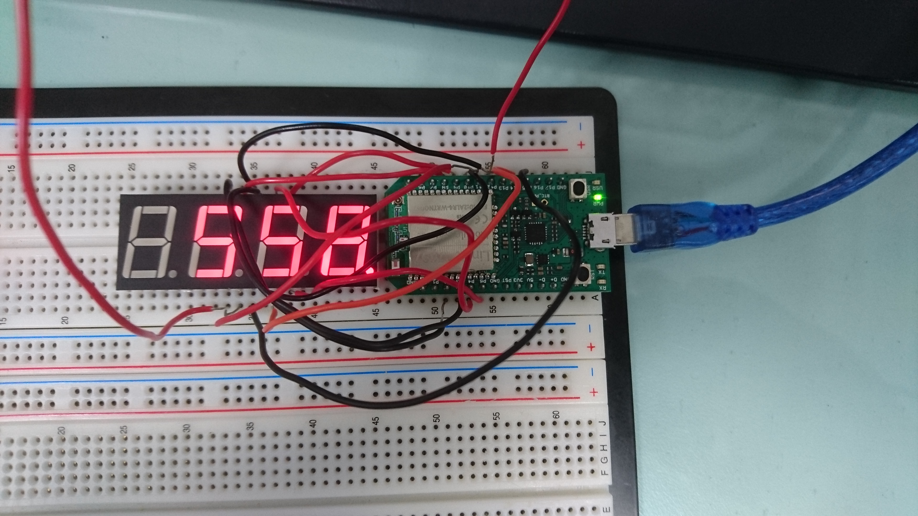

- 心得討論
不能用delay，所以第一題就想很久，後面就輕鬆許多。

- 修正程式碼

