電通二乙微處理器實驗 實驗結報

實驗名稱 | 四合一七段顯示器
組別 | 1 | 組員 | 陳旅涵

- 實驗目的
了解七段顯示器之顯示原理。1.共陰極與供陽極七段顯示器之不同。2.如何讓七段顯示器顯示0~F。3.如何控制四合一七段顯示器。4.如何讓四合一七段顯示器顯示四位數字。
- 實驗步驟
1.Arduino接好四合一七段顯示器之電路，四合一七段顯示器每隔0.3秒鐘會跳一個數字，從0000->0059->0100->跳至2359後歸零。2.於Pin6按鍵，按下後歸零顯示，於Pin17接一個按鍵，按下後倒數計時。
- 程式碼
//CHECK POINT 1
Int number[10][7]={{4,6,7,8,9,10},{7,10},{3,6,7,8,9},{3,6,7,9,10},{3,4,7,10},
{3,4,6,9,10},{3,6,7,8,9,10},{6,7,10},{3,4,6,7,8,9,10},{
3,4,6,7,9,10}};
#include "SevSeg.h"
SevSeg sevseg; //Instantiate a seven segment object
void setup() {
byte numDigits = 4;
byte digitPins[] = {2, 3, 4, 5};
byte segmentPins[] = {8, 9, 10, 11, 12, 13, 14, 15}; sevseg.begin(COMMON_ANODE, numDigits, digitPins, segmentPins);
sevseg.setNumber(3141,3);
sevseg.refreshDisplay();
sevseg.setNumber(Hour * 100 + Min, 0);
Min = Min + 1;
If Min == 60 {
Min = 0;
If (Hour == 23)
Hour=0;
Else
Hour++;
}
sevseg.refreshDisplay();
delay(300);
//CHECK POINT 2
Pin6= DigitalRead (6)
If (Pin6 == LOW)
Min = Hour = 0;
sevseg.setNumber(Hour * 100 + Min, 0) ;
Min = Min + 1;
If (Min == 60)
{
Min = 0;
If (Hour == 23)
Hour=0;
Else
Hour++; }
sevseg.refreshDisplay();
delay(300);
//CHECK POINT 3
Pin6= DigitalRead (6) // Reset
Pin17 = DigitalRead (17) // Reverse
If (Pin6 == LOW)
Min = Hour = 0;
If (Pin17 ==LOW)
{
Min = Min -1; // Reverse
If (Min == -1) {
Min = 59;
If (Hour == -1)
Hour = 23 ;
else
Hour-- } // underflow
}
Else
{
Min = Min +1;
If Min == 60
{…} // overflow
} sevseg.setNumber(Hour * 100 + Min, 0);
sevseg.refreshDisplay();
delay(300);
- 實驗結果及分析
使用到七段顯示器的程式碼，要先引入所需用到的標頭檔，七段顯示器的腳位要接對，數字才會跑對，程式碼經過修改後，可以得到自己想要的目標。
- 心得討論
自己實作一個時鐘真得很有趣，應證了生活上的事物，四合一七段顯示器或許還有許多用途，可以慢慢思考體驗。
- 修正電路圖

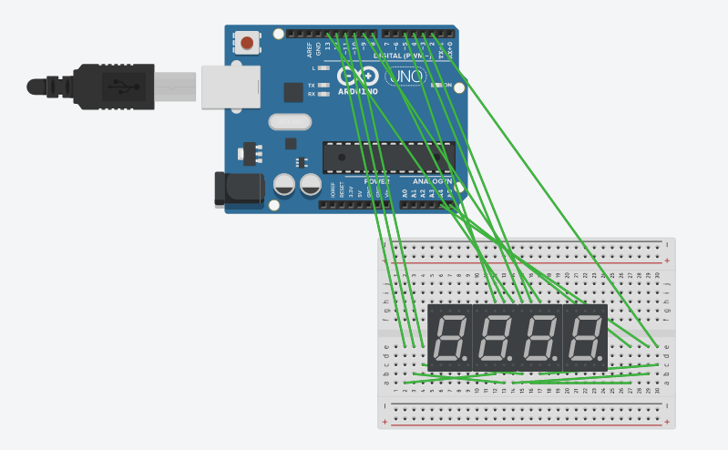
- 修正程式碼

//CHECK POINT 1
#include "SevSeg.h"
SevSeg sevseg;
static unsigned long timer = millis();
static int deciSeconds = 2300;
byte a=0;
byte i;
byte b=0;
void setup()
{
byte numDigits = 4;
byte digitPins[] = {2, 3, 4, 5};
byte segmentPins[] = { 8, 9, 10, 11, 12, 13,14,15};
bool resistorsOnSegments = false; // 'false' means resistors are on digit pins
byte hardwareConfig = COMMON_CATHODE; // See README.md for options
bool updateWithDelays = false; // Default. Recommended
bool leadingZeros = false; // Use 'true' if you'd like to keep the leading zeros

sevseg.begin(hardwareConfig, numDigits, digitPins, segmentPins, resistorsOnSegments, updateWithDelays, leadingZeros);
sevseg.setBrightness(90);
Serial.begin(9600);
}

void loop()
{
if (millis() - timer >= 100)
{
timer += 100;
deciSeconds++; // 100 milliSeconds is equal to 1 deciSecond

b=deciSeconds%100;
if (b % 60 == 0)
{
a++;
deciSeconds=0;
Serial.println(a);
for(i=0;i<a;i++)
deciSeconds+=100;
}
if (deciSeconds == 2359) { // Reset to 0 after counting for 1000 seconds.
deciSeconds=0;
}
sevseg.setNumber(deciSeconds);
}
sevseg.refreshDisplay(); // Must run repeatedly
}
//CHECK POINT 2
#include "SevSeg.h"
SevSeg sevseg;
static unsigned long timer = millis();
static int deciSeconds = 2300;
byte a=0;
byte i;
byte b=0;
const int buttonPin=6;
void setup()
{
pinMode(buttonPin,INPUT);
byte numDigits = 4;
byte digitPins[] = {2, 3, 4, 5};
byte segmentPins[] = { 8, 9, 10, 11, 12, 13,14,15};
bool resistorsOnSegments = false; // 'false' means resistors are on digit pins
byte hardwareConfig = COMMON_CATHODE; // See README.md for options
bool updateWithDelays = false; // Default. Recommended
bool leadingZeros = false; // Use 'true' if you'd like to keep the leading zeros

sevseg.begin(hardwareConfig, numDigits, digitPins, segmentPins, resistorsOnSegments, updateWithDelays, leadingZeros);
sevseg.setBrightness(90);
Serial.begin(9600);
}

void loop()
{
if (millis() - timer >= 100)
{
timer += 100;
deciSeconds++; // 100 milliSeconds is equal to 1 deciSecond

if (digitalRead(buttonPin)==1)
{
deciSeconds=0000;
}
b=deciSeconds%100;
if (b % 60 == 0)
{
a++;
deciSeconds=0;
Serial.println(a);
for(i=0;i<a;i++)
deciSeconds+=100;
}
if (deciSeconds == 2359) { // Reset to 0 after counting for 1000 seconds.
deciSeconds=0;
}
sevseg.setNumber(deciSeconds);
}
sevseg.refreshDisplay(); // Must run repeatedly
}
//CHECK POINT 3
#include "SevSeg.h"
SevSeg sevseg; //Instantiate a seven segment controller object
void setup()
{
byte numDigits = 4;
byte digitPins[] = {2, 3, 4, 5};
byte segmentPins[] = {8,9,10,11,12,13,14,15};
bool resistorsOnSegments = false; // 'false' means resistors are on digit pins
byte hardwareConfig = COMMON_CATHODE; // See README
sevseg.begin(hardwareConfig, numDigits, digitPins, segmentPins, resistorsOnSegments);
sevseg.setBrightness(90);
pinMode(6,INPUT);
pinMode(17,INPUT);
}
void loop()
{
static unsigned long timer = millis();
static int deciSeconds = 0;
boolean val=digitalRead(6);
boolean Pin17=digitalRead(17);
if(val)
{
sevseg.setNumber(0000, 3);
sevseg.refreshDisplay();
if(Pin17==HIGH)
deciSeconds=2400;
else
deciSeconds=0;
}
else if(Pin17==HIGH)
{
sevseg.setNumber(deciSeconds, 3);
if (millis() - timer >= 300)
{
timer += 300; deciSeconds--;
if (deciSeconds%100 == 59)
{
deciSeconds=deciSeconds-59;
}
Else
{
deciSeconds=deciSeconds-1;
}
}
if (deciSeconds == 0)
deciSeconds =2400 ;
sevseg.refreshDisplay(); // Must run repeatedly
}
else
{
sevseg.setNumber(deciSeconds, 3);
if (millis() - timer >= 300)
{
timer += 300;
deciSeconds++;
if (deciSeconds%100 == 59) {
deciSeconds=deciSeconds+41;
}
Else
{
deciSeconds=deciSeconds+1;
}
if (deciSeconds == 2400)
deciSeconds =0 ;
}
sevseg.refreshDisplay(); // Must run repeatedly
}
}

