電通二乙微處理器實驗 實驗結報

實驗名稱 | 跑馬燈
組別 | 1 | 組員 | 陳旅涵

- 實驗目的
8個pin腳接到LED燈,實作跑馬燈。
- 實驗步驟
LED燈向左及向右執行花色展示,加上按鈕,控制LED燈。
- 程式碼
// Lab02_1
// 使用for迴圈的跑馬燈程式
//
// 每個LED 正極接到Pin 0 - 7, 負極接地
const byte startPin = 1;
const byte endPin = 8;
void setup()
{
// 將每個Pin 設定成輸出
for (byte i = startPin; i<= endPin; i++)
{
pinMode(i, OUTPUT);
}
}
void loop()
{
byte i;
byte lightPin = startPin;
// 所有LED OFF
for (i=startPin; i<= endPin; i++)
{
digitalWrite(i,LOW);
}
// 設定要點亮的LED 位置
// 如果點亮的腳位編號小於結束腳位,則腳位編號+1
// 否則從頭開始
if (lightPin < endPin)
{
lightPin ++;
}
else
{
lightPin = startPin;
}
// 點亮LED
digitalWrite(lightPin, HIGH);
delay (100);
}
// Lab02_2
// 使用陣列的跑馬燈程式
// 每個LED 正極接到Pin 0 - 7, 負極接地
const byte LEDs[] = {0,1,2,3,4,5,6,7};
const byte total = sizeof(LEDs);
byte index = 0;
void setup()
{
// 將每個Pin 設定成輸出
for (byte i=0;i<total;i++)
{
pinMode(LEDs[i], OUTPUT);
}
}
void loop()
{
// 所有LED OFF
for (byte i=0;i<total;i++)
{
pinMode(LEDs[i], LOW);
}
// 點亮index 位置之LED
digitalWrite(LEDs[index], HIGH);
// 如果點亮的腳位編號小於結束腳位,則腳位編號+1否則從頭開始
if (index < total)
{
index++;
}
else
{
index = 0;
}
delay(100);
}
// Lab02_3
// 使用使用埠口與位移指令的跑馬燈程式
byte data = B00000001;
byte shift = 0;
byte max = 8;
void setup()
{
// 將Digital Pin 0-7 設定為輸出
DDRD = B11111111;
}
void led_l()
{
PORTD = B00000000; //關閉全部LED
delay(100);
data=B00000001;
for(byte i=0; i<8; i++)
{
PORTD = data;
delay(100);
data=data<<1; //左旋轉
}
}
void led_r()
{
PORTD = B00000000;
delay(100);
data = B10000000;
for(byte i=0; i<8; i++)
{
PORTD = data;
delay(100);
data=data>>1; // 右旋轉
}
}
void loop()
{
led_l();
led_r();
}
// Lab02_4 // 使用花色展示的跑馬燈程式
byte data = 0x01; byte shift = 0;
byte max = 8;
byte led1[]={ 0x80, 0x40, 0x20, 0x10, 0x08, 0x04, 0x02, 0x01}; byte led2[]={ 0x01, 0x02, 0x04, 0x08, 0x10, 0x20, 0x40, 0x80};
byte led3[]={ 0x81, 0xC3, 0xE7, 0xFF, 0xFF, 0xDB, 0xC3, 0x81};
byte led4[]={ 0x80, 0xC0, 0xE0, 0xF0, 0xF8, 0xFC, 0xFE, 0xFF};
void setup()
{ // 將 Digital Pin 0 - 7 設定為輸出
DDRD = 0xFF;
}
void rot(byte *pt)
{
for(byte i=0; i<8;i++)
{
PORTD=pt[i]; delay(200);
}
void loop()
{
rot(led1);
delay(400);
rot(led2);
delay(400);
rot(led3);
delay(400);
rot(led4);
delay(400);
}
- 實驗結果及分析
LED會照著程式碼的要求執行,要注意選擇的pin腳是否可使用。
- 心得討論
把結果做出來很有成就感,之後如果再改編可以看到更美的跑馬燈。
6.修正電路圖
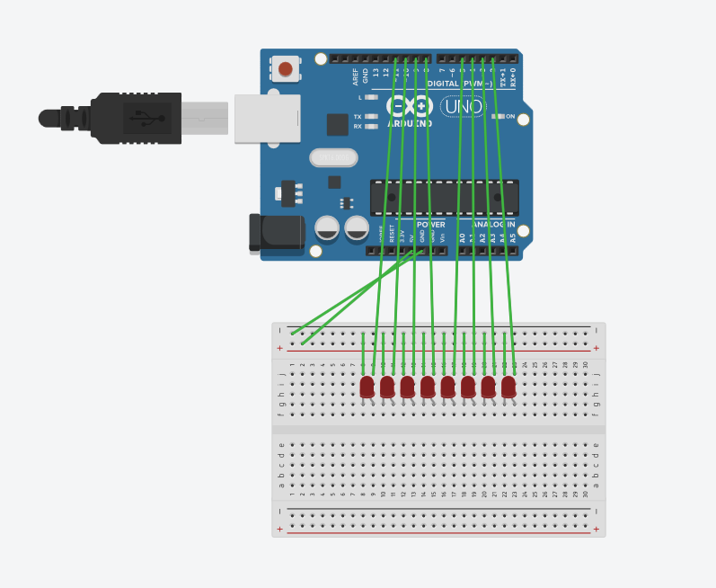
- 修正程式碼
//CHECK POINT 1
byte LED[8]={2,3,4,5,8,9,10,11};
byte i;
byte j;

void setup()
{
pinMode(2,OUTPUT);
pinMode(3,OUTPUT);
pinMode(4,OUTPUT);
pinMode(5,OUTPUT);
pinMode(8,OUTPUT);
pinMode(9,OUTPUT);
pinMode(10,OUTPUT);
pinMode(11,OUTPUT);
}

void loop()
{
for(i=0;i<=7;i++)
{
digitalWrite(LED[i],HIGH);
delay(500);
digitalWrite(LED[i],LOW);
}
for(i=7;i>=0;i--)
{
digitalWrite(LED[i],HIGH);
delay(500);
digitalWrite(LED[i],LOW);
if (i==0)
{
break;
}
}
}
//CHECK POINT 2
byte LED[8]={2,3,4,5,8,9,10,11};
byte i;
byte j;

void setup()
{
pinMode(2,OUTPUT);
pinMode(3,OUTPUT);
pinMode(4,OUTPUT);
pinMode(5,OUTPUT);
pinMode(8,OUTPUT);
pinMode(9,OUTPUT);
pinMode(10,OUTPUT);
pinMode(11,OUTPUT);
}

void loop()
{
digitalWrite(2, HIGH);
digitalWrite(3, HIGH);
digitalWrite(4, HIGH);
digitalWrite(5, HIGH);
digitalWrite(8, HIGH);
digitalWrite(9, HIGH);
digitalWrite(10, HIGH);
digitalWrite(11, HIGH);
delay(500);
digitalWrite(2, LOW);
digitalWrite(3, LOW);
digitalWrite(4, LOW);
digitalWrite(5, LOW);
digitalWrite(8, LOW);
digitalWrite(9, LOW);
digitalWrite(10, LOW);
digitalWrite(11, LOW);
delay(500);
digitalWrite(2, HIGH);
digitalWrite(3, HIGH);
digitalWrite(4, HIGH);
digitalWrite(5, HIGH);
digitalWrite(8, HIGH);
digitalWrite(9, HIGH);
digitalWrite(10, HIGH);
digitalWrite(11, HIGH);
delay(500);
digitalWrite(2, LOW);
digitalWrite(3, LOW);
digitalWrite(4, LOW);
digitalWrite(5, LOW);
digitalWrite(8, LOW);
digitalWrite(9, LOW);
digitalWrite(10, LOW);
digitalWrite(11, LOW);
delay(500);
for(i=0;i<=7;i++)
{
digitalWrite(LED[i],HIGH);
delay(500);
digitalWrite(LED[i],LOW);
}
digitalWrite(2, HIGH);
digitalWrite(3, HIGH);
digitalWrite(4, HIGH);
digitalWrite(5, HIGH);
digitalWrite(8, HIGH);
digitalWrite(9, HIGH);
digitalWrite(10, HIGH);
digitalWrite(11, HIGH);
delay(500);
digitalWrite(2, LOW);
digitalWrite(3, LOW);
digitalWrite(4, LOW);
digitalWrite(5, LOW);
digitalWrite(8, LOW);
digitalWrite(9, LOW);
digitalWrite(10, LOW);
digitalWrite(11, LOW);
delay(500);
digitalWrite(2, HIGH);
digitalWrite(3, HIGH);
digitalWrite(4, HIGH);
digitalWrite(5, HIGH);
digitalWrite(8, HIGH);
digitalWrite(9, HIGH);
digitalWrite(10, HIGH);
digitalWrite(11, HIGH);
delay(500);
digitalWrite(2, LOW);
digitalWrite(3, LOW);
digitalWrite(4, LOW);
digitalWrite(5, LOW);
digitalWrite(8, LOW);
digitalWrite(9, LOW);
digitalWrite(10, LOW);
digitalWrite(11, LOW);
delay(500);
for(i=7;i>=0;i--)
{
digitalWrite(LED[i],HIGH);
delay(500);
digitalWrite(LED[i],LOW);
if (i==0)
{
break;
}
}
}
//CHECK POINT 3
boolean buttonState;
boolean ledState = HIGH;
const int buttonPin=8;
byte LED[8]={3,4,5,7,9,10,11,12};

void setup()
{
pinMode(buttonPin, INPUT);
pinMode(3,OUTPUT);
pinMode(4,OUTPUT);
pinMode(5,OUTPUT);
pinMode(7,OUTPUT);
pinMode(9,OUTPUT);
pinMode(10,OUTPUT);
pinMode(11,OUTPUT);
pinMode(12,OUTPUT);
Serial.begin(9600);
}

int delayandreadbutton(int delaytime)
{
int i;
int buttonState0;
int buttonState1;
buttonState0=digitalRead(buttonPin);
for(i=1;i<=delaytime;i++)
{
delay(1);
buttonState1 = digitalRead(buttonPin);
if (buttonState0!=buttonState1) return 1;
}
return 0;
}

void leda()
{
int i;
int delaytime=100;
int buttonState0;
int buttonState1;

digitalWrite(3, HIGH);
digitalWrite(4, HIGH);
digitalWrite(5, HIGH);
digitalWrite(7, HIGH);
digitalWrite(9, HIGH);
digitalWrite(10, HIGH);
digitalWrite(11, HIGH);
digitalWrite(12, HIGH);
if (delayandreadbutton(delaytime)==1) return;
digitalWrite(3, LOW);
digitalWrite(4, LOW);
digitalWrite(5, LOW);
digitalWrite(7, LOW);
digitalWrite(9, LOW);
digitalWrite(10, LOW);
digitalWrite(11, LOW);
digitalWrite(12, LOW);
if (delayandreadbutton(delaytime)==1) return;
digitalWrite(3, HIGH);
digitalWrite(4, HIGH);
digitalWrite(5, HIGH);
digitalWrite(7, HIGH);
digitalWrite(9, HIGH);
digitalWrite(10, HIGH);
digitalWrite(11, HIGH);
digitalWrite(12, HIGH);
if (delayandreadbutton(delaytime)==1) return;
digitalWrite(3, LOW);
digitalWrite(4, LOW);
digitalWrite(5, LOW);
digitalWrite(7, LOW);
digitalWrite(9, LOW);
digitalWrite(10, LOW);
digitalWrite(11, LOW);
digitalWrite(12, LOW);
if (delayandreadbutton(delaytime)==1) return;
for(i=0;i<=7;i++)
{
digitalWrite(LED[i],HIGH);
if (delayandreadbutton(delaytime)==1) return;
digitalWrite(LED[i],LOW);
}
digitalWrite(3, HIGH);
digitalWrite(4, HIGH);
digitalWrite(5, HIGH);
digitalWrite(7, HIGH);
digitalWrite(9, HIGH);
digitalWrite(10, HIGH);
digitalWrite(11, HIGH);
digitalWrite(12, HIGH);
if (delayandreadbutton(delaytime)==1) return;
digitalWrite(3, LOW);
digitalWrite(4, LOW);
digitalWrite(5, LOW);
digitalWrite(7, LOW);
digitalWrite(9, LOW);
digitalWrite(10, LOW);
digitalWrite(11, LOW);
digitalWrite(12, LOW);
if (delayandreadbutton(delaytime)==1) return;
digitalWrite(3, HIGH);
digitalWrite(4, HIGH);
digitalWrite(5, HIGH);
digitalWrite(7, HIGH);
digitalWrite(9, HIGH);
digitalWrite(10, HIGH);
digitalWrite(11, HIGH);
digitalWrite(12, HIGH);
if (delayandreadbutton(delaytime)==1) return;
digitalWrite(3, LOW);
digitalWrite(4, LOW);
digitalWrite(5, LOW);
digitalWrite(7, LOW);
digitalWrite(9, LOW);
digitalWrite(10, LOW);
digitalWrite(11, LOW);
digitalWrite(12, LOW);
if (delayandreadbutton(delaytime)==1) return;
for(i=7;i>=0;i--)
{
digitalWrite(LED[i],HIGH);
if (delayandreadbutton(delaytime)==1) return;
digitalWrite(LED[i],LOW);
if (i==0)
{
break;
}
}
}
void ledb()
{
int i;
int delaytime=100;
for(i=0;i<=7;i++)
{
digitalWrite(LED[i],HIGH);
if (delayandreadbutton(delaytime)==1) return;
digitalWrite(LED[i],LOW);
}
for(i=7;i>=0;i--)
{
digitalWrite(LED[i],HIGH);
if (delayandreadbutton(delaytime)==1) return;
digitalWrite(LED[i],LOW);
if (i==0)
{
break;
}
}
}
void loop()
{
buttonState = digitalRead(buttonPin);
Serial.println(buttonState);
if (buttonState == HIGH)
{
ledState=!ledState;
if(ledState==LOW)
{
leda();
}
else
{
ledb();
}

delay(20);
while(1)
{
buttonState=digitalRead(buttonPin);
if (buttonState==LOW)
{
break;
}
}
delay(20);
}
else
{
if(ledState==LOW)
leda();
else
ledb();
}
}

