電通二乙微處理器實驗 實驗結報

實驗名稱 | Lab01
組別 |  | 組員 | 余采潔

- 實驗目的
- 使用Tinkercad 模擬 Arduino UNO電路及程式
- 繪製電路圖
- 觀察Arduino UNO 之輸出
- 學習將程式碼及實驗報告上傳至Github
- 實驗步驟
- 啟動Arduino IDE，載入Blink程式碼
- 至Tinker註冊帳號，啟動Arduino 模擬器
- 接上LED電路
- 修改程式，將LED輸出改為Pin 9
- 觀察LED之閃爍間隔
- 修改程式，使閃爍間隔分別為1倍及1/2倍
- 畫出路圖
- 程式碼
//原版
int delaytime = 1000;

// the setup function runs once when you press reset or power the board
void setup() {
// initialize digital pin LED_BUILTIN as an output.
pinMode(9, OUTPUT);
}

// the loop function runs over and over again forever
void loop() {
digitalWrite(9, HIGH); // turn the LED on (HIGH is the voltage level)
delay(delaytime); // wait for a second
digitalWrite(9, LOW); // turn the LED off by making the voltage LOW
delay(delaytime); // wait for a second
}

//1版 間隔X2
int delaytime = 1000*2;

// the setup function runs once when you press reset or power the board
void setup() {
// initialize digital pin LED_BUILTIN as an output.
pinMode(9, OUTPUT);
}

// the loop function runs over and over again forever
void loop() {
digitalWrite(9, HIGH); // turn the LED on (HIGH is the voltage level)
delay(delaytime); // wait for a second
digitalWrite(9, LOW); // turn the LED off by making the voltage LOW
delay(delaytime); // wait for a second
}

//2版 間隔X 1/2
int delaytime = 1000*1/2;

// the setup function runs once when you press reset or power the board
void setup() {
// initialize digital pin LED_BUILTIN as an output.
pinMode(9, OUTPUT);
}

// the loop function runs over and over again forever
void loop() {
digitalWrite(9, HIGH); // turn the LED on (HIGH is the voltage level)
delay(delaytime); // wait for a second
digitalWrite(9, LOW); // turn the LED off by making the voltage LOW
delay(delaytime); // wait for a second
}
- 實驗結果及分析
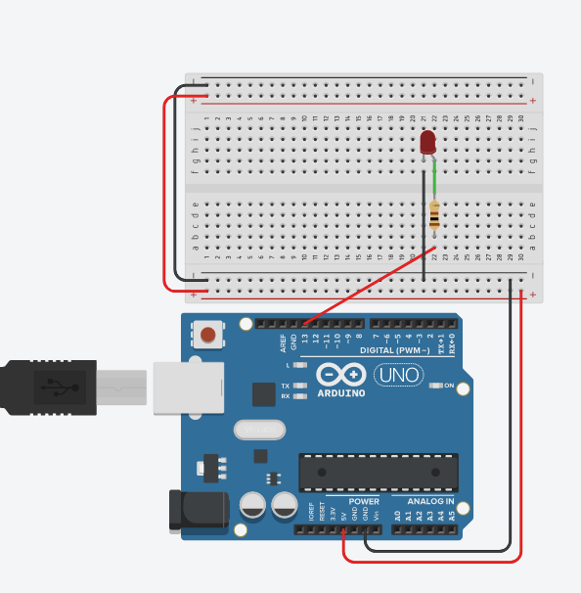
閃爍間隔增加或減少
- 心得討論
Tinkercad模擬電路方便又好用耶

