電通二乙微處理器實驗 實驗結報

實驗名稱 | Arduion_Lab01
組別 | 12 | 組員 | 陳岱德

- 實驗目的
使用tinkercad模擬aruduino電路及程式
畫電路圖
觀察輸出
將程式碼和報告上傳
- 實驗步驟
填分組表單

- 程式碼
// the setup function runs once when you press reset or power the board
void setup() {
// initialize digital pin LED_BUILTIN as an output.
pinMode(LED_BUILTIN, OUTPUT);
}

// the loop function runs over and over again forever
void loop() {
digitalWrite(LED_BUILTIN, HIGH); // turn the LED on (HIGH is the voltage level)
delay(1000); // wait for a second
digitalWrite(LED_BUILTIN, LOW); // turn the LED off by making the voltage LOW
delay(1000); // wait for a second
}
- 實驗結果及分析

- 心得討論

修正電路圖
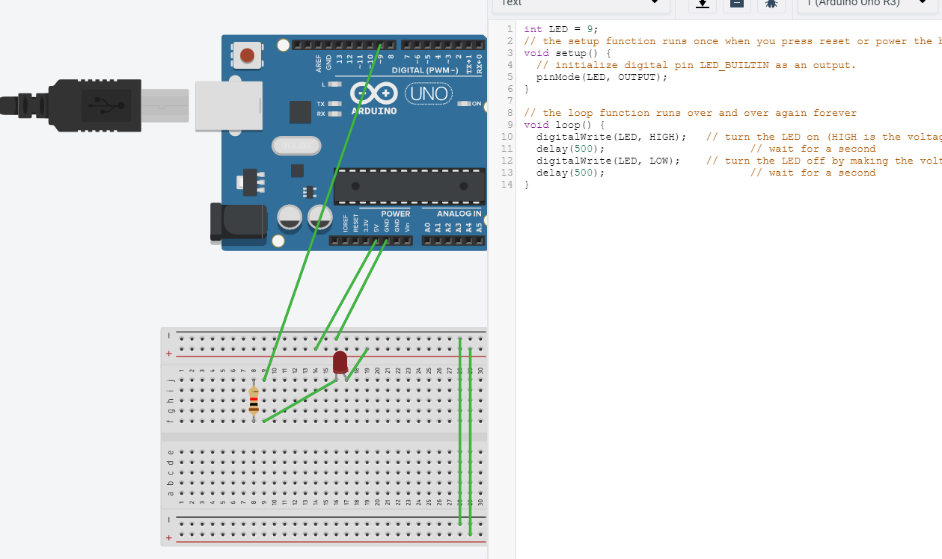
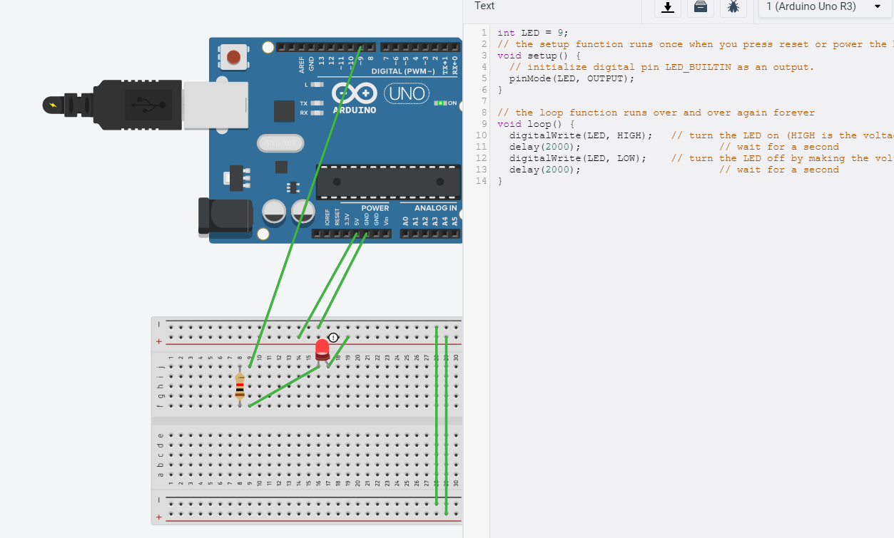
- 修正程式碼
int LED = 9;
// the setup function runs once when you press reset or power the board
void setup() {
// initialize digital pin LED_BUILTIN as an output.
pinMode(LED, OUTPUT);
}

// the loop function runs over and over again forever
void loop() {
digitalWrite(LED, HIGH); // turn the LED on (HIGH is the voltage level)
delay(2000); // wait for a second
digitalWrite(LED, LOW); // turn the LED off by making the voltage LOW
delay(2000); // wait for a second
}

