**電通二乙微處理器實驗 實驗結報**

|  |  |  |  |
| --- | --- | --- | --- |
| **實驗名稱** | **Lab07-LCD顯示器** | | |
| **組別** |  | **組員** | **李嘉誠 05052446** |

1. **實驗目的**

**使用 Arduino LCD程式庫,於16x2LCD顯示器上特殊文字?**

**(1) Arduino與LCD如何接線?**

**(2)如何使用 LCD Liberary?**

**(3) 如何清除螢幕?**

**(4)如何顯示文字?**

1. **實驗步驟: Arduino顯示自己的學號與英文姓名**

**電路圖:**

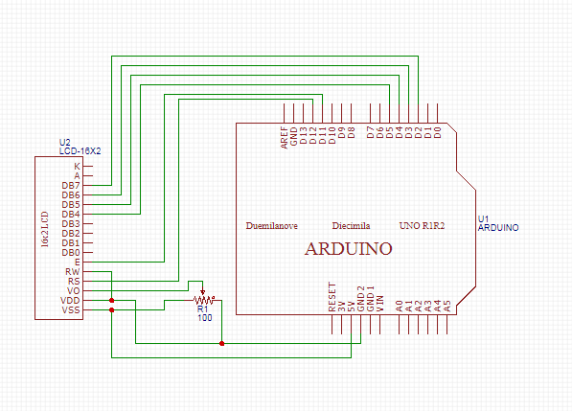

**程式碼:**

**#include <LiquidCrystal.h> // include the library code**

**LiquidCrystal lcd(12, 11, 5, 4, 3, 2); // initialize interface pins**

**void setup()**

**{**

**lcd.begin(20, 2); // set up the LCD's number of columns and rows:**

**lcd.print("05052446");**

**lcd.print("Lee"); // Print a message to the LCD.**

**}**

**void loop()**

**{**

**// set the cursor to column 0, line 1**

**// (note: line 1 is the second row, since counting begins with 0):**

**lcd.setCursor(0, 1);**

**lcd.print(millis()/1000); // print the number of seconds since reset:**

**}**

**實驗結果及分析**

**在LCD上顯示學號與英文名**

1. **實驗步驟: 使用PC串列輸入,所有PC輸入之文字皆顯示在LCD螢幕上**

**電路圖:**



**程式碼:**

**#include <LiquidCrystal.h> // include the library code**

**LiquidCrystal lcd(12, 11, 5, 4, 3, 2); // initialize interface pins**

**void setup()**

**{**

**lcd.begin(20, 2); // set up the LCD's number of columns and rows:**

**Serial.begin(9600);**

**}**

**void loop()**

**{**

**// when characters arrive over the serial port...**

**if (Serial.available()) {**

**// wait a bit for the entire message to arrive**

**delay(100);**

**// clear the screen**

**lcd.clear();**

**// read all the available characters**

**while (Serial.available() > 0) {**

**// display each character to the LCD**

**lcd.write(Serial.read());**

**}**

**}**

**}**

**實驗結果及分析**

**在串列序打文字,而LCD顯示其文字**

1. **心得討論**

**一開始卡了很久才發現自己的杜邦線是壞的，有點懊惱**