**電通二乙微處理器實驗 實驗結報**

|  |  |  |  |
| --- | --- | --- | --- |
| **實驗名稱** | **Lab10-紅外線控制** | | |
| **組別** |  | **組員** | **05052446 李嘉誠** |

1. **實驗目的**

**接收紅外線遙控器編碼**

**發射紅外線編碼並可由另一台正確接收**

1. **實驗步驟**

**接上電路與紅外線接收器,再由遙控制輸出訊號,結果顯示在序列埠**

1. **程式碼**

**#include <IRremote.h>**

**int RECV_PIN = 2;**

**IRrecv irrecv(RECV_PIN);**

**decode_results results;**

**void setup()**

**{**

**Serial.begin(9600);**

**// In case the interrupt driver crashes on setup, give a clue**

**// to the user what's going on.**

**Serial.println("Enabling IRin");**

**irrecv.enableIRIn(); // Start the receiver**

**Serial.println("Enabled IRin");**

**}**

**void loop() {**

**if (irrecv.decode(&results)) {**

**Serial.print("irCode:");**

**Serial.print(results.value, HEX);**

**Serial.print(", bits:");**

**Serial.println(results.bits);**

**irrecv.resume(); // Receive the next value**

**}**

**delay(100);**

**}**

**程式碼2**

**#include <IRremote.h>**

**int RECV_PIN = 2;**

**IRrecv irrecv(RECV_PIN);**

**decode_results results;**

**const int buttonPin=6;**

**int buttonState =0;**

**IRsend irsend;**

**void setup()**

**{**

**Serial.begin(9600);**

**// In case the interrupt driver crashes on setup, give a clue**

**// to the user what's going on.**

**Serial.println("Enabling IRin");**

**irrecv.enableIRIn(); // Start the receiver**

**Serial.println("Enabled IRin");**

**pinMode(buttonPin,INPUT);**

**}**

**void loop() {**

**if (irrecv.decode(&results)) {**

**Serial.print("irCode:");**

**Serial.print(results.value, HEX);**

**Serial.print(", bits:");**

**Serial.println(results.bits);**

**irrecv.resume(); // Receive the next value**

**}**

**buttonState=digitalRead(buttonPin);**

**if(buttonState==HIGH)**

**{**

**irsend.sendNEC(0x4FB48B7, 32);**

**}**

**}**

1. **實驗結果及分析**
2. **接收紅外線遙控器編碼**

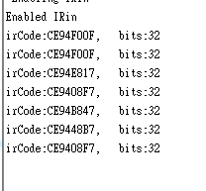

**2.發射紅外線編碼並可由另一台正確接收**

1. **心得討論**

**這次實驗輕鬆好玩，終於擺脫每次做不完的命運。**

1. **修正電路圖**

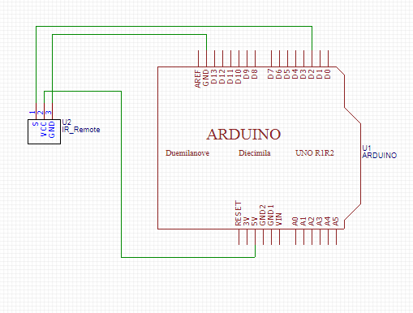

1. **修正程式碼**

**#include <IRremote.h>**

**const int buttonPin=6;**

**int buttonState =0;**

**IRsend irsend;**

**void setup()**

**{**

**pinMode(buttonPin,INPUT);**

**}**

**void loop()**

**{**

**buttonState=digitalRead(buttonPin);**

**if(buttonState==HIGH)**

**{**

**irsend.sendNEC(0x4FB48B7, 32);**

**}**

**}**