OpenPBL: Compiling Pedagogical Authority into Evidence-Gated Human-AI Project Learning
OpenPBL：将教学权威编译为证据门控的人机协同项目学习

Manuscript type: Regular-paper draft; system design and formative evaluation
**稿件类型：** Regular paper 稿件；系统设计与形成性评估
Format note: JCST-inspired section hierarchy and numeric citations; apply the official publisher template after venue confirmation
**格式说明：** 参考 JCST 常规论文的章节层级与数字引文；投稿场次确定后套用官方终稿模板
Author information: Anonymous for peer review
**作者信息：** 匿名审稿版本
Development snapshot: 13 August 2026
**开发快照：** 2026 年 8 月 13 日
Research-status notice: Sections 1-6 report system design and real engineering tests. Section 7 uses seeded synthetic placeholders solely to debug the study protocol and analysis pipeline; approved empirical data must replace them before submission.
研究状态说明： 第 1–6 节报告系统设计与真实工程测试；第 7 节使用固定随机种子的合成占位数据，仅用于调试研究方案和分析流程，正式投稿前必须由经过伦理审批的真实数据完全替换。

Abstract / 摘要
Generative AI can tutor and co-produce, but those capabilities obscure a more basic question: who controls curriculum, adaptation, artifact changes, and consequential judgments? We present OpenPBL, a project-based learning environment that treats pedagogical authority as a typed control plane. Five authority domains—curricular, instructional, adaptive, productive, and evaluative—are allocated across teachers, students, and AI and compiled into executable mechanisms. A role-aware curriculum graph distinguishes authentic prerequisites from lesson targets; instruction follows explanation, example, practice, and feedback before one terminal mastery assessment; diagnostics target only approved prerequisites, route one-to-one remediation, and return every learner to the full lesson; AI may edit whitelisted draft fields only under explicit student delegation with before/after values, provenance, conflict protection, and undo; and progression requires typed test-interpret-revise evidence while students retain submission and teachers retain adjudication. We evaluate implementation fidelity through architecture-decision records, source-level theory-to-mechanism traceability, and 14 targeted test files; all 111 tests passed. To prepare rather than imitate classroom evidence, we also specify a four-condition comparative study and dry-run its pipeline on a seeded synthetic dataset, prominently labelled non-empirical. The synthetic output is not evidence of learning effects. Contributions are an authority topology, a compilation pattern from pedagogical principles to software permissions, an end-to-end auditable implementation, and a falsifiable empirical protocol.
生成式 AI 可以辅导，也可以直接参与作品生产，但这两类能力会遮蔽一个更基础的问题：谁控制课程、适应性支持、作品修改与高后果判断？本文提出 OpenPBL，一个把教学权威视为类型化控制平面的项目式学习环境。系统在教师、学生与 AI 之间分配课程、教学、适应性、生产和评价五类权威，并把分配结果编译为可执行机制：角色感知课程图区分真实先修与课内新授；“解释—示例—练习—反馈”之后只保留一次终结性掌握度测评；诊断仅面向被批准的先修点，按缺口一对一补救，所有学习者随后返回完整主课；AI 只能在学生明确委托下修改白名单草稿字段，并保留前后值、来源、冲突保护和撤销；项目推进依赖类型化的“测试—解释—修订”证据链，学生保留最终提交权，教师保留评价裁决权。我们通过架构决策记录、源码级理论—机制追踪和 14 个定向测试文件评估实现忠实度，111 项测试全部通过。为准备而非伪装课堂证据，本文进一步提出四组比较研究并在固定种子的合成数据上试运行其分析流程；这些数值被显著标注为非实证数据，不构成教育效果证据。本文贡献包括教学权威拓扑、从教育原则到软件权限的编译范式、端到端可审计实现，以及可证伪的实证检验方案。
Keywords: artificial intelligence in education; project-based learning; pedagogical authority; human-AI collaboration; learner agency; evidence gates; reversible delegation; educational design research
关键词： 人工智能教育应用；项目式学习；教学权威；人机协作；学习者能动性；证据门控；可撤销委托；教育设计研究

1. Introduction / 1. 引言
Generative AI has made high-quality-seeming explanation, feedback, planning, and production support available at unprecedented scale. Well-designed AI tutoring can improve learning and engagement in bounded contexts [1], and AI can augment teachers' capacity to provide timely guidance [2]. However, helpfulness is not equivalent to learning. In a large high-school mathematics field experiment, unguarded generative AI improved assisted practice performance but reduced subsequent unaided performance, whereas pedagogical guardrails mitigated the harm [3]. In peer feedback, students tended to rely on rather than learn from AI assistance when the support was removed [4]. These findings shift the design question from whether AI should assist students to which work AI may perform, under whose authority, with what evidence, and with what path back to independent performance.
生成式 AI 使高质量外观的解释、反馈、规划与作品支持以前所未有的规模进入教育。经过审慎设计的 AI 辅导在特定情境中能够促进学习与参与[1]，AI 也可能扩展教师提供及时指导的能力[2]。然而，“帮助学生完成任务”并不等同于“帮助学生发生学习”。一项大规模高中数学现场实验发现，无约束的生成式 AI 虽然提高了有辅助练习的表现，却降低了随后无 AI 条件下的表现；加入由教师设计的提示护栏后，这种损害得到缓解[3]。在同伴反馈情境中，学生也更倾向于依赖 AI，而非从 AI 支持中形成可迁移的调节能力[4]。因此，关键设计问题不再是“是否允许 AI 帮助学生”，而是：AI 可以完成什么工作、由谁授权、依据什么证据，以及学生如何重新回到独立表现。
The problem is acute in PjBL. PjBL organizes learning around sustained inquiry into authentic problems and the creation, testing, and revision of public or inspectable products. Meta-analytic evidence generally supports positive effects, but the magnitude varies by design and context [5], and a recent umbrella review cautions that the methodological quality of available meta-analyses remains low despite a consistently positive direction [6]. PjBL is therefore not a self-executing intervention. Students need calibrated scaffolding for problem framing, knowledge building, inquiry, collaboration, iteration, and reflection [7, 8]. Generative AI can provide such scaffolding, but it can also collapse an inquiry into an answer, a design process into a generated artifact, or reflection into plausible prose.
这一问题在 PjBL 中尤其尖锐。PjBL 围绕对真实问题的持续探究以及可展示、可检验作品的创造、测试与修订来组织学习。元分析总体上支持其积极效果，但效果大小受到设计与情境的显著影响[5]；最新的综述之综述进一步指出，尽管既有结果方向大体积极，相关元分析的方法学质量仍然偏低[6]。因此，PjBL 并不是一种可以自动生效的教学干预。学生需要针对问题界定、知识建构、探究、合作、迭代和反思的适度支架[7, 8]。生成式 AI 可以成为支架，也可能把探究压缩为答案、把设计过程压缩为成品、把反思压缩为流畅却空洞的文字。
Existing AIED research provides important but fragmented responses. Intelligent tutoring research structures hints and feedback around domain models. Learning analytics supports teacher orchestration. Self-regulated learning (SRL) research emphasizes planning, monitoring, and reflection. Human-centred AI calls for meaningful human control. Student-AI collaboration research frames AI as a learning mate rather than a passive tool [9]. Yet educational systems increasingly combine all these functions: they map curriculum, generate courses, diagnose prior knowledge, tutor, collaborate on artifacts, monitor activity, and recommend interventions. When those functions are designed independently, authority can drift. A prerequisite diagnostic may test new lesson content; an adaptive engine may skip core instruction; a collaborator may silently overwrite a student's idea; a dashboard may turn probabilistic inference into a consequential judgment; or multiple agents may optimize local helpfulness while eroding coherence.
既有 AIED 研究提出了重要但相对分散的回应：智能辅导系统围绕领域模型组织提示与反馈；学习分析支持教师进行课堂编排；自我调节学习研究强调计划、监控与反思；人本 AI 强调有意义的人类控制；学生—AI 协作研究则将 AI 视作“学习伙伴”而非被动工具[9]。然而，现实教育系统越来越多地同时承担课程建模、课程生成、先备知识诊断、教学辅导、作品协作、活动监控与干预推荐。如果这些功能相互独立地优化，权威边界就会漂移：先修诊断可能提前测试本应在课堂中新授的内容；适应性引擎可能跳过核心教学；AI 协作者可能悄然覆盖学生的想法；仪表盘可能把概率推断变成高后果裁决；多个智能体则可能在追求局部“有帮助”的同时破坏整体教学一致性。
OpenPBL was redesigned in response to this integration problem. Its earlier architecture treated AI mainly as role-delimited companions that could explain, question, critique, and review but not directly modify a learner's project artifact. The current design adopts a more demanding position: protecting agency does not require prohibiting all AI contribution. Instead, agency can be supported through constrained, inspectable, attributable, and reversible delegation, provided that students retain consequential authority and that progress depends on evidence of learning rather than artifact presence alone.
OpenPBL 的大规模重构正是为了回应这一整合性问题。早期设计主要把 AI 视作角色受限的伴学智能体，可以解释、追问、批评和复核，但不能直接修改学习者的项目作品。新版采取了更具挑战性的立场：保护能动性并不要求一概禁止 AI 参与作品生产。只要委托行为是受约束的、可检查的、可归因的、可撤销的，学生仍保留高后果权威，而且项目推进依赖学习证据而非作品是否存在，AI 就可能参与真实协作而不必然取代学生的认识性工作。
This paper asks:
本文提出以下研究问题：
RQ1. How can an AIED system operationalize curricular boundaries so that personalization diagnoses genuine prerequisites without pretesting or replacing lesson targets?
RQ1： AIED 系统如何将课程边界落实为可执行机制，使个性化诊断聚焦真实先修知识，而不提前测试或替代课内新授目标？
RQ2. How can generative AI participate as both tutor and project teammate while preserving learner epistemic agency and teacher authority across PjBL?
RQ2： 生成式 AI 如何同时作为辅导者与项目队友参与 PjBL，并在全过程中保留学习者的认识性能动性与教师权威？
RQ3. To what extent does the implemented OpenPBL artifact faithfully instantiate these principles?
RQ3： 当前 OpenPBL 制品在多大程度上忠实实现了上述原则？
RQ4. What comparative design can falsify the claim that executable authority boundaries better preserve independent transfer, agency, and teacher judgment than role-based or unrestricted AI?
RQ4： 何种比较设计能够证伪“可执行权威边界比角色型或无限制 AI 更能保护独立迁移、能动性和教师判断”的主张？
The paper makes four contributions. First, it proposes a five-domain topology of curricular, instructional, adaptive, productive, and evaluative authority. Second, it formalizes that topology as a control plane with actors, state preconditions, permitted operations, immutable evidence, reversal paths, and terminal human decisions. Third, it shows how the control plane compiles into a role-aware curriculum graph, prerequisite loop, single terminal assessment, reversible workspace operations, and evidence-gated state transitions. Fourth, it separates implementation fidelity from educational effect and specifies a falsifiable four-condition comparison.
本文的贡献有四点。第一，提出课程、教学、适应性、生产和评价五维教学权威拓扑。第二，把该拓扑形式化为具有行为者、状态前置条件、允许操作、不可变证据、撤销路径和最终人类裁决的控制平面。第三，展示如何把控制平面编译为角色化课程图、先修诊断循环、唯一终结性测评、可撤销工作区操作和证据门控状态转换。第四，严格区分实现忠实度与教育效果，并给出可证伪的四组比较方案。

2. Theoretical and Empirical Background / 2. 理论与实证背景

2.1 PjBL requires scaffolding without appropriation / 2.1 PjBL 需要不夺取任务所有权的支架
PjBL places students in uncertain problem spaces where goals, evidence, methods, and quality criteria must be progressively clarified. This uncertainty is educationally productive but can overwhelm novices. Scaffolding therefore reduces nonproductive complexity while preserving the central intellectual work of the task [7]. Computer-based scaffolding has a small-to-moderate positive effect in problem-based STEM contexts, with effectiveness varying by function and context [8]. The design challenge is not merely to provide more help, but to calibrate help so that it supports participation and then makes learner competence visible.
PjBL 将学生置于目标、证据、方法与质量标准都需要逐步澄清的不确定问题空间。不确定性本身具有教育价值，但也可能使新手不堪重负。支架的作用应当是减少非生产性复杂度，同时保留任务的核心智力工作[7]。计算机支架在 STEM 问题式学习情境中总体具有小到中等的积极作用，但效果随功能和使用情境而变化[8]。因此，设计重点不是提供更多帮助，而是校准帮助，使学生能够参与任务，并最终使其自身能力变得可见。
Generative AI complicates this calibration because the same interface can explain a concept, generate an answer, propose a design, write an artifact, and evaluate the result. Traditional distinctions between a tutor, tool, peer, and assessor become porous. In PjBL, an AI-generated product may be superficially excellent while concealing weak conceptual understanding, limited verification, or minimal student decision-making. Accordingly, the unit of educational design must include not only the product but the sequence of inquiry, evidence, decisions, and revisions that produced it.
生成式 AI 使这种校准更加复杂，因为同一个交互界面既能解释概念，也能给出答案、提出方案、撰写作品并评价结果。传统的“教师—工具—同伴—评价者”边界由此变得模糊。在 PjBL 中，AI 生成的精美产品可能掩盖薄弱的概念理解、不充分的信息核验或极少的学生决策。因此，教育设计的分析单位不能只有最终产品，还必须包含产生该产品的探究序列、证据、选择与修订。

2.2 From student-AI interaction to co-agency / 2.2 从学生—AI 交互走向人机共能动性
Teachers envision productive student-AI collaboration as evolving from learning about AI, to learning from AI, to learning together with AI. They also emphasize authentic tasks, process-oriented assessment, disciplinary knowledge, error analysis, and a safe-to-fail culture [9]. This view treats AI as a participant in activity rather than a neutral delivery channel. Recent work on epistemic co-agency similarly argues that learners must reason with, through, and against AI while retaining responsibility for knowledge claims [11].
教师所设想的有效学生—AI 协作，会经历“学习 AI”“向 AI 学习”和“与 AI 共同学习”三个阶段，并以真实任务、过程性评价、学科知识、错误分析和安全试错文化为支撑[9]。这一观点把 AI 看作活动参与者，而不仅是信息传递通道。最新的认识性共能动性理论同样强调，学习者必须能够与 AI 一起推理、借助 AI 推理，也能反驳 AI，并持续对知识主张负责[11]。
Co-agency is not automatically empowering. Student teachers exhibit distinct agency profiles in AI-supported learning environments, including balanced engagement and uncritical reliance [12]. In collaborative learning, students can imagine AI supporting planning, monitoring, and reflection, but lower domain knowledge may increase the likelihood of adopting AI suggestions without sufficient trial, evaluation, or ownership [13]. Darvishi et al. [4] further show that frequent AI support may produce dependence rather than transferable regulation. These findings imply that agency should be treated as a dynamic relation among people, technologies, tasks, and institutional rules, not as a stable learner trait or a binary “AI/no-AI” property [14].
共能动性并不会天然赋权。师范生在 AI 支持环境中表现出不同的能动性类型，其中既有平衡参与，也有缺乏批判的依赖[12]。在协作学习中，学生能够设想 AI 对计划、监控和反思的支持，但领域知识较弱者更可能直接采用 AI 建议，减少试错、评价和作品所有权[13]。Darvishi 等 [4]也表明，频繁 AI 支持可能产生依赖，而非可迁移的调节能力。这些结果提示：能动性应被理解为人、技术、任务与制度规则之间不断变化的关系，而不是稳定的个人特质，也不是简单的“有 AI/无 AI”属性[14]。
We define human-AI co-agency for learning as the negotiated distribution of initiative and action among learners, teachers, and AI in pursuit of educational goals, where the distribution remains visible, contestable, and accountable. Epistemic agency concerns responsibility for framing questions, judging evidence, and endorsing knowledge claims. Productive agency concerns control over creating and revising artifacts. Evaluative authority concerns consequential judgments about mastery, progression, and quality. The three should not be conflated: a student may delegate a productive action while retaining epistemic and evaluative responsibility.
本文将面向学习的人机共能动性定义为：学习者、教师和 AI 围绕教育目标协商并分配发起权与行动权，而且这种分配始终可见、可质疑并可追责。认识性能动性涉及提出问题、判断证据和认可知识主张；生产性能动性涉及创建和修改作品；评价权威涉及对掌握、进阶与质量作出高后果判断。三者不能混为一谈：学生可以委托某个生产动作，但仍保留认识责任与评价责任。

2.3 Relation to agent-centric online learning environments / 2.3 与智能体中心在线学习环境的关系
Multi-agent course environments such as OpenMAIC [10] show that coordinated LLM roles can connect course authoring with online classroom activity. OpenPBL takes a different unit of design: not the number or coverage of agent roles, but the executable allocation of consequential authority across curriculum, adaptation, artifact production, evidence, and evaluation. Multi-agent organization is therefore an implementation option in this paper; authority boundaries are the object to be designed and tested.
OpenMAIC [10] 等多智能体课程环境说明，协同的 LLM 角色可以连接课程创作与在线课堂活动。OpenPBL 选择了不同的设计单位：重点不是智能体角色的数量或覆盖范围，而是课程、适应性支持、作品生产、证据和评价中高后果权威的可执行分配。多智能体组织在本文中是一种实现选项，权威边界本身才是需要被设计和检验的研究对象。

2.4 Guardrails must be pedagogical, not merely safety filters / 2.4 教育护栏必须是教学性的，而不仅是内容安全过滤
The strongest current evidence suggests that the educational consequences of generative AI depend on interaction design. Broader analyses likewise identify both substantial educational opportunities and risks rather than an inherently beneficial technology [15]. Kestin et al. [1] reported stronger learning in a structured AI-tutoring condition than in an active-learning comparison, while Bastani et al. [3] found that unguarded assistance harmed later unaided performance and that teacher-designed hints mitigated the effect. These studies differ in population, subject, duration, and comparison, but together they reject a capability-only view. An educational guardrail must shape the learning process: it should manage when explanations, prompts, examples, solutions, checks, and production help appear, and what independent performance follows.
当前较强的实证证据说明，生成式 AI 的教育后果取决于交互设计。较广泛的分析同样指出，生成式 AI 同时带来显著教育机会与风险，并非天然有益的技术[15]。Kestin 等 [1]的结构化 AI 辅导条件取得了优于主动学习对照条件的学习结果；Bastani 等 [3]则发现，无护栏帮助会损害后续独立表现，而教师设计的提示能够显著缓解该问题。两项研究在人群、学科、时长与比较条件上并不相同，但共同否定了“模型能力越强，学习越好”的简单观点。教育护栏必须塑造学习过程：它需要控制解释、提示、示例、答案、核验和生产帮助在何时、以何种方式出现，以及之后要求何种独立表现。
OpenPBL therefore treats guardrails as an instructional and governance architecture. Content safety remains necessary, but it is insufficient. A pedagogical guardrail must preserve curricular validity, productive struggle, verification, revision, and human authority. It must also produce records that allow teachers and researchers to inspect whether the intended design was enacted.
因此，OpenPBL 把护栏视为教学与治理架构。内容安全不可或缺，但远远不够。教学性护栏还必须保护课程效度、生产性困难、核验、修订和人类权威，并生成可供教师和研究者检查设计是否得到实际执行的记录。

2.5 Prior knowledge, adaptation, and curricular validity / 2.5 先备知识、适应性与课程效度
Adaptive learning often begins with learner modelling, but personalization can become educationally invalid when a system confuses prerequisite knowledge with the new content that instruction is intended to teach. Prerequisite-aware recommendation demonstrates the value of modelling conceptual dependencies rather than matching only learner preferences or metadata [16]. However, a dependency is not automatically a legitimate pretest target. A construct is a prerequisite only if it is expected prior knowledge, necessary for access to the lesson, and observable through a diagnostic task.
适应性学习通常从学习者建模开始，但如果系统把先修知识与新授内容混为一谈，个性化就可能失去教育效度。先修感知推荐说明，建模概念依赖关系比仅匹配学习偏好或资源元数据更有价值[16]。然而，存在语义依赖并不意味着该概念适合成为前测目标。一个概念只有同时满足“应当已经学过”“进入本课所必需”和“可以通过诊断任务观察”三个条件，才是合格的先修知识。
This distinction matters for fairness and interpretation. Testing new lesson targets before teaching can disadvantage novices and turn personalization into premature tracking. Conversely, omitting genuine prerequisites can cause students to fail core instruction for reasons unrelated to the intended learning goal. OpenPBL addresses this problem through role-labelled curriculum nodes, typed dependency edges, one-to-one diagnostic-remediation mappings, and independent semantic review.
这种区分关系到公平与解释。教学前测试新授目标会惩罚新手，并可能把个性化变成过早分层；忽略真实先修要求，则会让学生因目标无关因素而在核心学习中失败。OpenPBL 通过角色标记课程节点、类型化依赖边、诊断—补救一一对应以及独立语义复核来回应这一问题。

2.6 Regulation, evidence, and teacher orchestration / 2.6 调节、证据与教师课堂编排
SRL comprises cyclical processes of forethought, performance, and reflection; collaborative learning also involves co-regulation and socially shared regulation [17]. A recent mapping review found that AI-SRL research concentrates on cognition and metacognition, underexamines motivation, overrepresents higher education, and often lacks explicit SRL theory [18]. Multimodal and trace data may make regulation more visible, but observed activity is not equivalent to a psychological state or learning [19].
自我调节学习包含前瞻、执行和反思的循环过程；协作学习还涉及共同调节与社会共享调节[17]。一项最新映射综述发现，AI—SRL 研究更关注认知和元认知，较少关注动机，研究对象偏向高等教育，并且大量研究缺乏明确的 SRL 理论基础[18]。多模态和行为轨迹数据可以提高调节过程的可见性，但可观察活动并不等于心理状态或学习结果[19]。
Teachers therefore remain essential interpreters. Classroom orchestration involves managing multiple activities, time constraints, social configurations, and learning goals [20]. Teacher-facing analytics can improve awareness, but effective designs complement rather than replace professional judgment [2, 21]. OpenPBL uses evidence to prioritize attention and gate progression, but does not grant AI final authority over consequential assessment or stage transitions.
教师仍然是不可替代的解释者。课堂编排需要同时协调多种活动、时间约束、社会组织和学习目标[20]。教师仪表盘能够提高情境感知，但有效设计应补充而非替代专业判断[2, 21]。OpenPBL 使用证据进行注意力排序和阶段门控，但不授予 AI 对高后果评价或阶段转换的最终权力。

3. Conceptual Framework: Pedagogical Authority as an Executable Control Plane / 3. 概念框架：作为可执行控制平面的教学权威
An authority topology becomes useful only when it changes what software permits. We therefore model pedagogical authority as a typed control plane: it does not itself generate lessons or artifacts; it specifies which actor may perform which operation under which state, what evidence must be preserved, how a decision can be reversed or contested, and who retains the terminal judgment. An authority rule is compileable only when it declares an actor, state precondition, permitted operation, immutable record, reversal path, and final human decision. Table 1 applies this grammar to five domains.
该框架基于一个简单命题：教育 AI 系统的本质部分取决于谁能够作出哪类高后果决定、依据何种证据，以及决定是否可被质疑或撤销。 本文区分五类权威（表 1）。
Table 1. Distribution of authority in OpenPBL
表 1. OpenPBL 中的权威分配
Authority  权威类型 | Core question  核心问题 | Primary human authority  主要人类权威 | Permitted AI/system role  AI/系统可承担的角色 | Non-delegable boundary  不可委托的边界
Curricular  课程权威 | What knowledge is prior, core, or optional?  哪些知识属于先修、核心或拓展？ | Teacher inspects and may revise goals, roles, and dependencies  教师检查并可修改目标、角色和依赖关系 | Generate and semantically review a draft graph; compile typed relations  生成并语义复核图谱草案，编译类型化关系 | AI cannot silently redefine teacher-approved learning goals  AI 不得悄然改写教师认可的学习目标
Instructional  教学权威 | What sequence constitutes teaching and assessment?  何种序列构成教学与评价？ | Teacher sets course intent and may edit the plan  教师设定课程意图并可修改计划 | Produce explanation, example, guided practice, feedback, and a bounded terminal assessment  生成解释、示例、引导练习、反馈和受限终结性测评 | Practice cannot be relabelled as mastery; enrichment cannot replace core instruction  练习不能被伪装成掌握度评价；拓展不能替代核心教学
Adaptive  适应性权威 | What support follows learner evidence?  学习证据之后提供什么支持？ | Student engages; teacher can inspect or intervene  学生参与；教师可查看或干预 | Diagnose specified prerequisite gaps, route remediation, select time-contingent enrichment  诊断特定先修缺口、路由补救、在有余时选择拓展 | AI cannot use global ability labels to skip the full main lesson  AI 不得以全局能力标签为由跳过完整主课
Productive  生产权威 | Who changes the project artifact?  谁可以修改项目作品？ | Student frames tasks, requests edits, accepts or undoes changes  学生界定任务、请求修改、接受或撤销变化 | Apply whitelisted append/replace operations under explicit delegation  在明确委托下执行白名单内的追加或替换 | AI cannot submit work, complete a stage, or conceal its contribution  AI 不得提交作品、完成阶段或隐藏自身贡献
Evaluative  评价权威 | Who decides readiness, quality, or progression?  谁决定准备度、质量和进阶？ | Student submits; teacher makes consequential judgments  学生提交；教师作出高后果判断 | Validate structural evidence, surface risks, and recommend attention  验证证据结构、提示风险并建议关注对象 | AI cannot confirm teacher decisions or become the final assessor  AI 不得确认教师决定或成为最终评价者

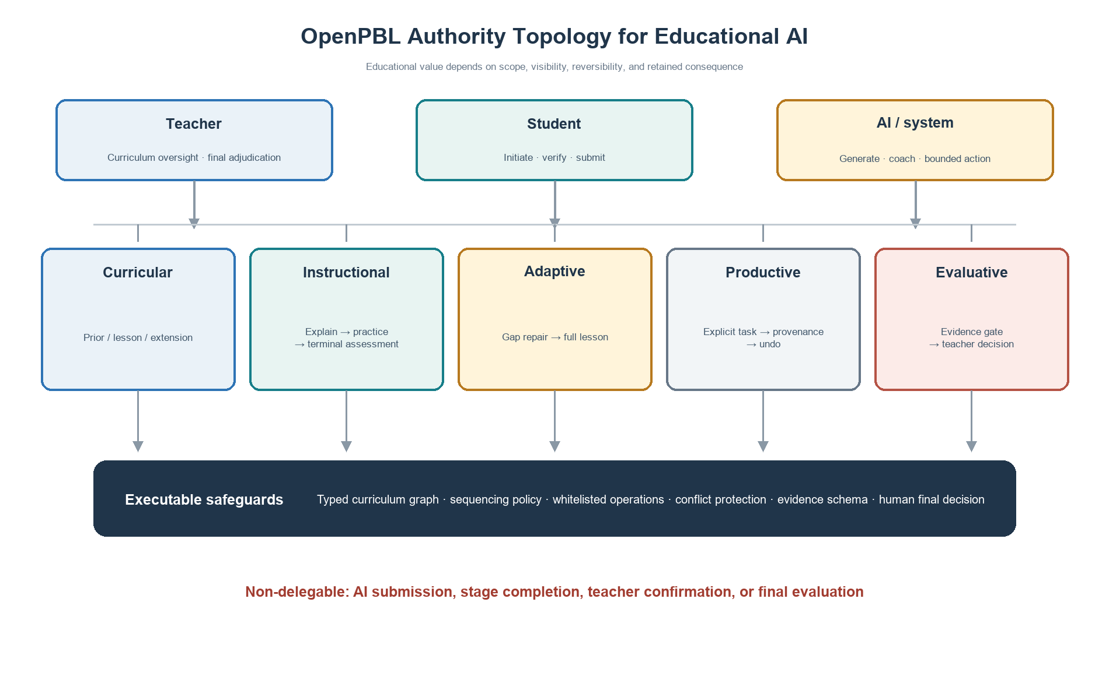
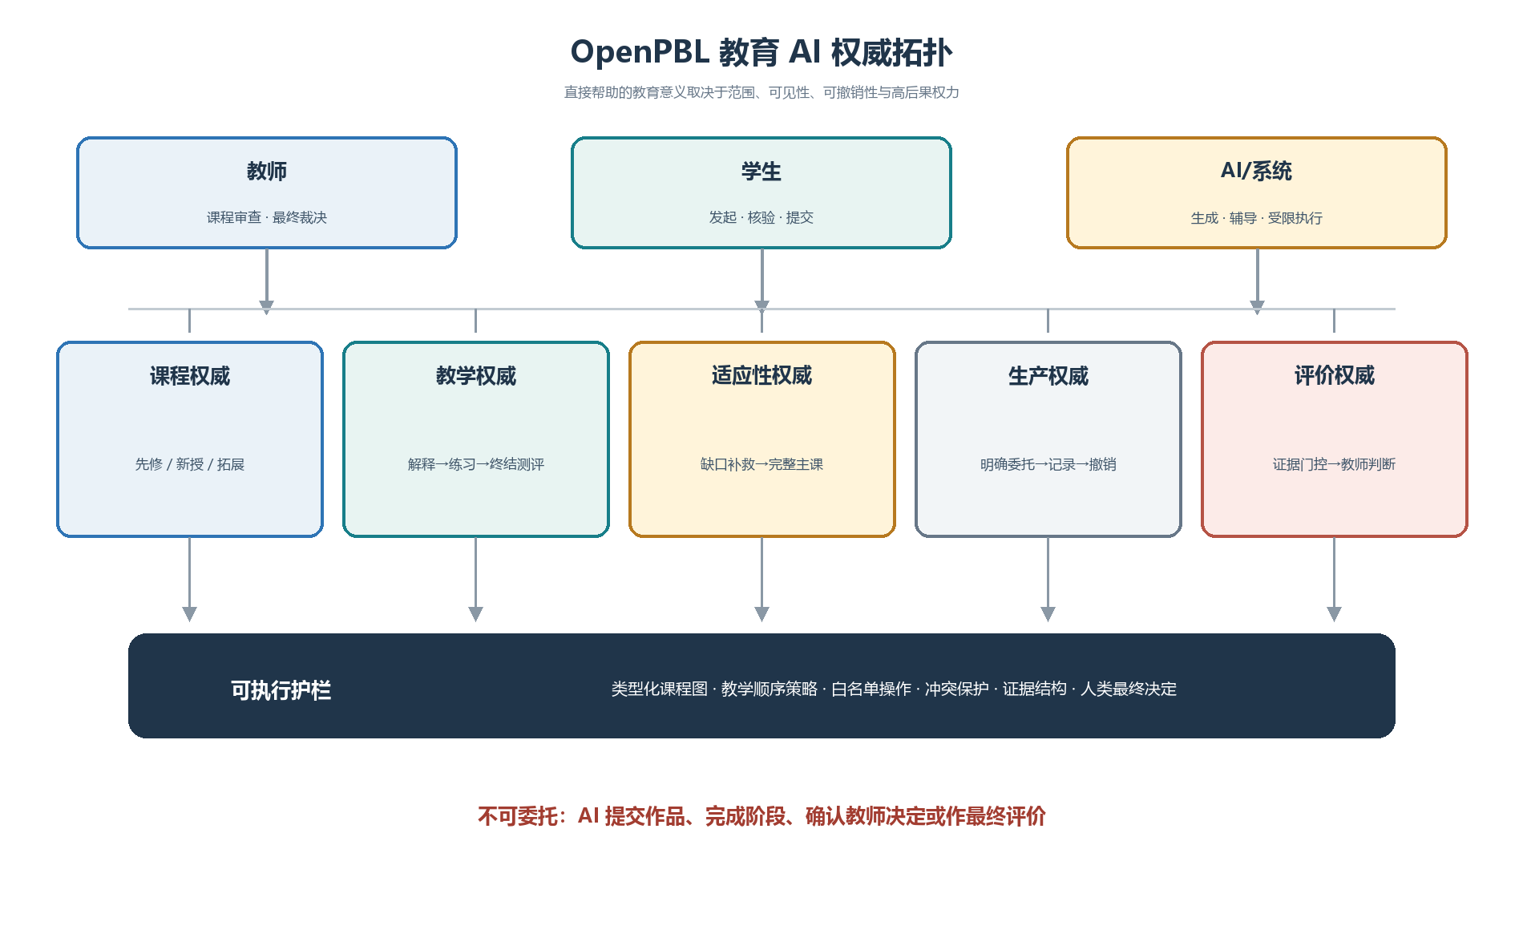
Figure 1. Five-domain authority topology and executable safeguards.
图 1. 五维教学权威拓扑及其可执行护栏。
This topology reframes “human in the loop.” A human click is not meaningful control if the system has already collapsed the decision space or obscured the basis of an action. Conversely, direct AI contribution is not necessarily a loss of agency if the learner initiated a bounded task, can inspect the change, understands its source, can reject or undo it, and must still provide evidence of understanding and revision. Meaningful control depends on scope, visibility, reversibility, and retained consequence.
这一拓扑重新界定了“人在回路”。如果系统已经压缩了决策空间或隐藏了行动依据，一个人类点击并不构成有意义的控制。反之，如果学习者主动发起受限任务，能够检查修改、了解来源、拒绝或撤销，并仍需提供理解和修订证据，那么 AI 的直接贡献也不必然意味着能动性丧失。有意义的控制取决于范围、可见性、可撤销性与高后果权力的保留。
Five design principles follow.
由此形成五项设计原则：
DP1: Curriculum before personalization. Personalization must operate inside an explicit curriculum model that distinguishes expected prior knowledge, lesson targets, and optional extension.
DP1：课程先于个性化。 个性化必须运行在显式课程模型之内，清楚区分应有先备知识、课内新授目标和可选拓展。
DP2: Teach before judging. Core instruction should move through explanation, worked or visible reasoning, ungraded practice, and feedback before a single graded terminal mastery assessment.
DP2：先教学，后判断。 核心教学应经历解释、可见推理或示例、无评分练习与反馈，再进入唯一一次有评分的终结性掌握度测评。
DP3: Remediate evidence-specific gaps, not global learner labels. Adaptive support should respond to identified prerequisite evidence and then return every learner to the full lesson.
DP3：补救证据指向的缺口，而非给学生贴全局标签。 适应性支持只回应被识别的先修证据，并使所有学生回到完整主课。
DP4: Delegate productively, retain agency consequentially. AI changes to learner artifacts must be explicitly requested, narrowly scoped, attributable, conflict-aware, and reversible; students retain submission authority.
DP4：可委托生产动作，但保留高后果能动性。 AI 对作品的修改必须由学生明确请求，范围受限、来源可查、具备冲突感知且可以撤销；提交权属于学生。
DP5: Progress through evidence and human adjudication. Stage completion should depend on evidence of inquiry, testing, interpretation, and revision, with teacher authority over consequential evaluation and intervention.
DP5：依据证据推进，由人完成裁决。 阶段完成应依赖探究、测试、解释和修订证据，教师保留评价与干预权威。
These principles form a conjecture map: if curricular boundaries are explicit, support is sequenced around learning, delegation is reversible, and progression requires evidence, then AI may increase useful assistance without necessarily displacing the learner's epistemic work. The conjecture remains empirical; the present study evaluates only whether the artifact faithfully embodies the hypothesized mechanisms.
这些原则构成一个待检验的推测图：如果课程边界明确，帮助围绕学习过程排序，委托可以撤销，进阶又以证据为条件，那么 AI 可能在增加有效帮助的同时避免替代学习者的认识性工作。该推测仍需要实证检验；本文只评估制品是否忠实体现了假设机制。

4. Research Design / 4. 研究设计

4.1 Educational design research orientation / 4.1 教育设计研究取向
The study follows an educational design research orientation in which theory, design, implementation, and analysis inform one another in iterative cycles [22]. The object of analysis is not a generic software platform but a set of educational conjectures embodied in an executable artifact. The current paper documents the artifact and conducts a formative fidelity evaluation. It does not constitute an effectiveness trial.
本研究采用教育设计研究取向，使理论、设计、实现和分析在迭代中相互修正[22]。分析对象不是一般意义的软件平台，而是一组被写入可执行制品的教育推测。本文记录当前制品，并开展形成性忠实度评估，不构成有效性试验。
Five redesign cycles were consolidated in the August 2026 snapshot:
2026 年 8 月快照整合了五轮关键重构：
1. foundation-first deep-interactive teaching;
1. 基础优先的深度交互教学；
2. managed recovery for course generation while preserving quality checkpoints;
2. 在保留质量检查点的前提下管理课程生成恢复；
3. a strict prerequisite diagnostic-remediation loop;
3. 严格的先修诊断—补救循环；
4. a role-aware curriculum knowledge graph; and
4. 角色感知课程知识图谱；
5. direct but reversible AI collaboration in the student workspace.
5. 学生工作区中的直接但可撤销 AI 协作。
The cycles were documented in architecture-decision records and implemented across course generation, instructional sequencing, adaptation, project workspaces, evidence models, stage gates, and teacher-facing support.
这些周期由架构决策记录明确记载，并实现于课程生成、教学排序、适应性路由、项目工作区、证据模型、阶段门控和教师支持模块。

4.2 Artifact and audit corpus / 4.2 制品与审计语料
The audit corpus comprised five accepted architecture-decision records, their linked implementation modules, the curriculum and learning-evidence data models, and 14 targeted test files selected because they directly exercised the new educational mechanisms. The implementation snapshot contained 58 server API routes and 47 persistent data models. These counts describe artifact scope, not educational quality.
审计语料包括五份已接受的架构决策记录、相应实现模块、课程与学习证据数据模型，以及直接覆盖新版教育机制的 14 个定向测试文件。实现快照包含 58 条服务端 API 路由和 47 个持久化数据模型。这些数字只描述制品范围，并不代表教育质量。
The fidelity audit used a theory-to-mechanism traceability procedure:
忠实度审计采用理论—机制追踪程序：
1. Each design principle was decomposed into observable system obligations.
1. 把每项设计原则分解为可观察的系统义务；
2. Each obligation was mapped to data structures, validation rules, runtime policies, user actions, and tests.
2. 将义务映射到数据结构、验证规则、运行时策略、用户动作与测试；
3. Contradictory permissions were searched for, particularly routes by which AI could bypass teaching, evidence, submission, or teacher authority.
3. 搜索相互矛盾的权限，尤其关注 AI 绕过教学、证据、学生提交或教师权威的路径；
4. Targeted regression tests were executed on the current development snapshot.
4. 在当前开发快照上执行定向回归测试；
5. Deviations were classified as missing mechanisms, implementation defects, or specification-test mismatches.
5. 将偏差分类为机制缺失、实现缺陷或规范—测试不一致。
This procedure establishes whether intended constraints are executable and testable. It does not establish that teachers or students experience the constraints as intended.
该程序能够判断预期约束是否可以执行和测试，却不能证明教师与学生会按照设计者预想的方式体验这些约束。

4.3 Evaluation criteria / 4.3 评价标准
We assessed five dimensions: (a) curricular fidelity, whether prerequisite and lesson roles remain distinguishable; (b) instructional fidelity, whether practice precedes and remains distinct from mastery assessment; (c) adaptive specificity, whether remediation is tied to diagnosed prerequisite evidence; (d) delegation accountability, whether AI artifact changes are explicit, attributable, conflict-aware, and reversible; and (e) human authority, whether submission, consequential evaluation, and progression remain human-governed.
本文评估五个维度：（a）课程忠实度，即先修角色和新授角色是否持续可区分；（b）教学忠实度，即练习是否先于掌握度评价且二者不混淆；（c）适应性特异性，即补救是否直接对应被诊断的先修证据；（d）委托可追责性，即 AI 作品修改是否明确、可归因、具备冲突感知且可以撤销；（e）人类权威，即提交、高后果评价与进阶是否仍受人治理。

4.4 Ethical scope / 4.4 伦理范围
No human participants, classroom data, demographic data, or student work were collected for this study. Tests used synthetic fixtures. Consequently, institutional-review status, consent, and participant protection are not applicable to the reported audit. Any classroom deployment must add informed consent or appropriate educational research authorization, data minimization, age-appropriate transparency, privacy review, accessibility testing, model-risk procedures, and a non-AI participation pathway consistent with local requirements and UNESCO guidance [23].
本研究未收集人类参与者、课堂数据、人口统计信息或学生作品；测试使用合成样例。因此，本文所述审计不涉及知情同意或人类参与者保护。任何课堂部署都必须依据当地要求增加知情同意或适用的教育研究授权、数据最小化、适龄透明度、隐私审查、无障碍测试、模型风险处置和非 AI 参与路径，并参考 UNESCO 指导[23]。

5. OpenPBL System Architecture and Executable Mechanisms / 5. OpenPBL 系统架构与可执行机制

5.1 A unified, inspectable course-entry package / 5.1 统一且可检查的课程入口包
Course authoring begins with a unified generation package rather than disconnected prompts. The package specifies the assumed educational stage, course depth, knowledge ladder, authentic prerequisites, one diagnostic item and one remediation resource per prerequisite, main lesson targets, and optional extensions. A deterministic compiler assigns stable identifiers and constructs a role-aware graph; an independent model review returns a revised complete blueprint rather than isolated comments. Deterministic validation then checks cardinality, identifiers, typed edges, diagnostic-remediation correspondence, and terminal-assessment anchoring before an atomic save.
课程创作从统一生成包开始，而不是多个互不关联的提示。该包同时描述学段假设、课程深度、知识阶梯、真实先修知识、每个先修点的一道诊断题与一项补救资源、主课目标和可选拓展。确定性编译器分配稳定标识并生成角色感知图谱；独立模型复核直接返回一份完整修订蓝图，而不只给出零散意见。随后，确定性验证检查数量范围、标识、类型化边、诊断—补救对应关系与终结性测评锚点，并以原子方式保存。
This architecture separates generative judgment from enforceable structure. A model may propose that concept A is required for lesson target B, but only a typed required-prerequisite relation with required strength may activate a diagnostic. Supportive or helpful relations remain visible without becoming gates. Teachers can inspect and revise the resulting graph and plan.
该架构将生成判断与可强制执行的结构分开。模型可以提出“概念 A 是目标 B 的必要前提”，但只有被标记为必需强度的 required-prerequisite 关系才能触发诊断。支持性或有帮助的关系可以保留可见，但不能成为门槛。教师能够查看并修改图谱和计划。

5.2 Role-aware curriculum knowledge graph / 5.2 角色感知课程知识图谱
Each curriculum node has an instructional role: prerequisite or lesson. Lesson nodes describe intended new learning and mastery boundaries. Prerequisite nodes describe expected prior knowledge, observable evidence, and a diagnostic boundary. Edges include a type, strength, and rationale. This design guards against a common personalization error: using a broad semantic association as if it were a necessary dependency.
每个课程节点具有 prerequisite（先修）或 lesson（新授）角色。新授节点描述本课意图和掌握边界；先修节点描述应有知识、可观察证据与诊断边界。边包含类型、强度和理由。该机制防止系统把宽泛的语义关联误当成必要依赖。
The graph also supports reverse dependency analysis. Teachers can inspect which later stage or knowledge rung depends on a prerequisite and why. The graph is therefore both a machine-readable control structure and a teacher-facing curriculum argument.
图谱还支持反向依赖分析。教师可以查看后续阶段或知识阶梯中的哪些内容依赖某个先修点，以及依赖理由。因此，图谱既是机器可读的控制结构，也是面向教师的课程论证。
The current implementation requires at least one prerequisite. This conservative rule prevents an empty diagnostic plan, but it is not universally valid: some genuinely foundational lessons may have no meaningful content prerequisite beyond general participation skills. We treat this as an identified limitation rather than a settled educational principle. A future revision should permit an audited zero-prerequisite decision and test whether reviewers can distinguish legitimate absence from generation failure.
当前实现要求至少存在一个先修点。这一保守规则能避免空诊断计划，却不具有普遍效度：某些真正的入门课程可能不存在除一般参与能力之外的内容先修要求。本文将其视为已识别局限，而不是成熟原则。后续版本应允许“经审计的零先修”判断，并检验审查者能否区分合理缺省与生成失败。

5.3 Foundation-first deep-interactive instruction / 5.3 基础优先的深度交互教学
The main lesson follows a stable instructional grammar:
主课采用稳定的教学语法：
1. explain the foundational concept;
1. 解释基础概念；
2. show a concrete example or visible reasoning process;
2. 展示具体示例或可见推理过程；
3. provide ungraded guided practice with feedback; and
3. 提供无评分的引导练习与反馈；
4. administer one graded terminal mastery assessment after teaching.
4. 教学完成后实施唯一一次有评分的终结性掌握度测评。
Interactive tools are selected for epistemic function rather than novelty. A whiteboard may expose a worked reasoning path, compare misconceptions, or transform representations. Code, simulation, 3D, game, or diagram widgets are inserted when they support the concept and are paired with guided practice. Earlier quiz-like events are compiled into practice or merged into the terminal assessment. The terminal assessment is bounded to four to eight knowledge-point-tagged questions and a limited share of instructional time.
交互工具依据认识功能而非新奇程度选择。白板可用于呈现推理过程、比较误解或转换表征；代码、模拟、3D、游戏或图示组件只有在确实服务概念时才被插入，并且配套引导练习。早期类似测验的事件会被编译为练习，或合并到终结性测评。终结性测评控制在 4—8 道带知识点标记的问题，并限制其占用的教学时间比例。
The key boundary is that adaptation does not fragment the core lesson. Students who receive prerequisite remediation still complete the full main course. Enrichment occurs only after the sole mastery assessment and only if time remains; it is ungraded and followed by no additional assessment. This prevents personalization from becoming curricular exclusion.
关键边界在于：适应性不会切碎核心课程。接受先修补救的学生仍需完成完整主课；拓展只在唯一掌握度测评结束且仍有时间时出现，不计分，之后也不再安排额外测评。这一设计防止个性化变成课程排除。

5.4 Strict prerequisite diagnosis and remediation / 5.4 严格的先修诊断与补救
For each approved prerequisite, the system provides exactly one diagnostic question and one linked remediation resource. Diagnostic evidence is interpreted per knowledge point. A gap routes the student to the corresponding remediation and then back to the main lesson. The system does not infer a global ability label or a reduced curriculum. The one-to-one mapping also makes adaptation auditable: a teacher can ask what evidence triggered which support.
每个获批先修点严格对应一道诊断题和一项补救资源。诊断证据按知识点解释；发现缺口后，学生进入对应补救，再返回主课。系统不据此形成全局能力标签，也不向学生提供缩减版课程。一一映射使适应性过程可被审计：教师可以追问“哪条证据触发了哪项支持”。
This strictness trades breadth for interpretability. One item cannot provide a reliable psychometric estimate of a complex construct. In the current design, the pretest is a low-stakes routing signal, not a mastery judgment. Classroom research should examine false positives and false negatives, and future versions may use brief adaptive probes where stakes or construct breadth require stronger evidence.
这种严格性以广度换取可解释性。单题无法为复杂构念提供可靠的心理测量估计。当前设计将前测视作低风险路由信号，而非掌握判断。课堂研究应检验假阳性与假阴性；当决策后果较高或构念较宽时，后续版本可采用简短的适应性探测。

5.5 Reversible delegation in the collaborative workspace / 5.5 协作工作区中的可撤销委托
The most substantial redesign concerns productive authority. Students can ask an AI companion to update approved fields in proposal and making workspaces. The operation is allowed only when an explicit task or request exists and only for a whitelist of targets. The AI returns a structured patch specifying target, mode (append or replace), and content. Each applied operation records the target, before value, after value, companion role, task, and time.
最实质的重构发生在生产权威上。学生可以要求 AI 伴学者修改方案与制作工作区中的获批字段。只有存在明确任务或请求、目标属于白名单时，操作才会被允许。AI 返回结构化补丁，包含目标、append（追加）或 replace（替换）模式及内容。每次执行都记录目标、修改前值、修改后值、伴学角色、任务与时间。
Undo is conditional. If the field still contains the AI-produced value, the student can revert it. If the field has since changed, the system blocks automatic undo to avoid erasing later student or peer work. This conflict rule turns reversibility from a cosmetic history button into protection against silent overwrite. AI cannot submit an artifact, confirm a teacher decision, or complete a stage.
撤销具有条件性。如果字段仍保持 AI 写入后的值，学生可以恢复；如果字段后来已被修改，系统会阻止自动撤销，避免删除学生或同伴的后续工作。该冲突规则使“可撤销”不只是装饰性历史按钮，而是防止静默覆盖的保护机制。AI 不得提交作品、确认教师决定或完成项目阶段。
The educational purpose is not to maximize automated production. It is to let students practice delegation itself: specifying a task, evaluating a contribution, deciding whether it fits their intent, revising or rejecting it, and remaining accountable for the submitted work. Provenance makes these decisions available for reflection and process assessment.
其教育目的不是最大化自动生产，而是让学生练习“委托”本身：说明任务、评价贡献、判断是否符合意图、修改或拒绝，并对最终提交负责。来源记录使这些选择能够进入反思和过程性评价。

5.6 Evidence-gated project progression / 5.6 证据门控的项目推进
Project stages require typed evidence rather than generic activity counts. Evidence can represent intent, plans, source checks, artifact versions, test results, revision decisions, presentation materials, reflection, and teacher confirmation. For the making stage, an uploaded artifact is insufficient. Readiness requires linked test and revision evidence for the configured number of iterations. A revision record identifies the interpretation, reason, planned change, and next goal associated with an iteration.
项目阶段依赖类型化证据，而非笼统活动次数。证据可表示意图、计划、来源核验、作品版本、测试结果、修订决定、展示材料、反思与教师确认。在制作阶段，仅上传作品不足以达到准备状态；系统要求为规定次数的迭代提供相互关联的测试证据和修订证据。修订记录需要说明解释、原因、计划变化与下一目标。
The support engine uses structural completeness and submitted or teacher-confirmed evidence before producing process evaluation. Missing or contradictory evidence yields an insufficient-evidence state rather than a confident score. Signals prioritize teacher attention, while consequential decisions remain with teachers. This design aligns the system's data model with PjBL's process orientation: what matters is not only that a product exists, but that students investigated, tested, interpreted, and revised.
支持引擎只有在证据结构完整且已提交或经教师确认时，才生成过程评价。证据缺失或相互矛盾会得到“证据不足”状态，而不是貌似精确的评分。系统信号只用于帮助教师安排注意力，高后果判断仍由教师作出。由此，数据模型与 PjBL 的过程取向保持一致：不仅要有产品，还要看到学生进行了调查、测试、解释和修订。
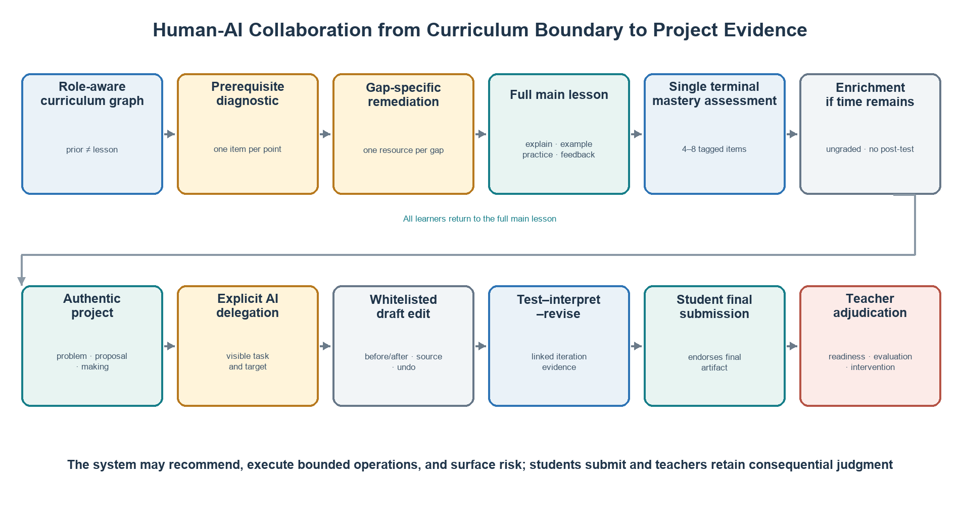
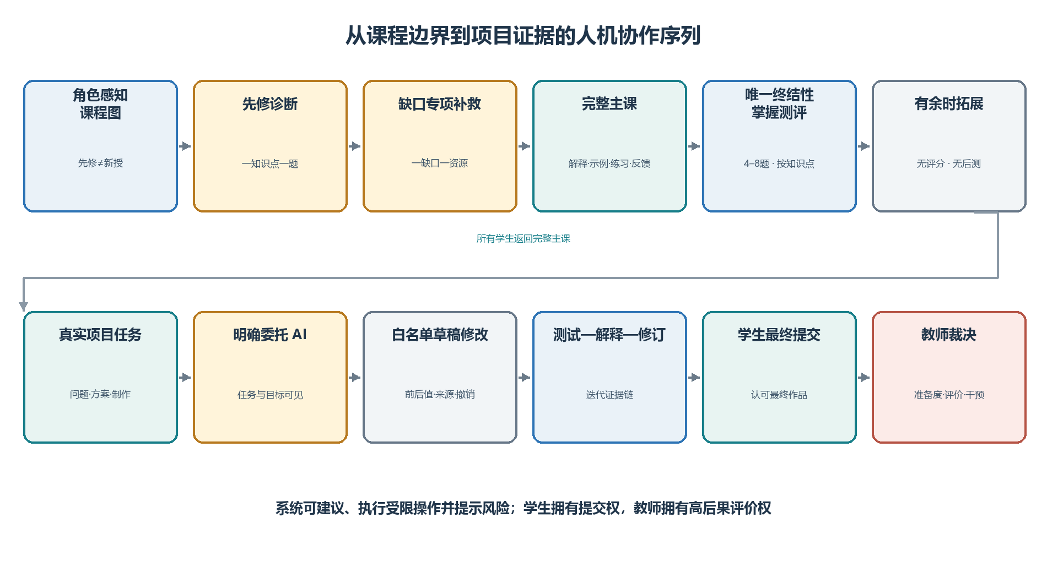
Figure 2. Sequence from curricular boundaries and adaptive teaching to evidence-gated project collaboration.
图 2. 从课程边界和适应性教学到证据门控项目协作的完整序列。

6. Formative Artifact Evaluation / 6. 形成性制品评估

6.1 Traceability from principles to executable mechanisms / 6.1 从原则到可执行机制的追踪
Table 2 summarizes the audit. Every design principle had representation at the levels of data, runtime policy, user action, and test, although strength and empirical validity vary.
表 2 概括了审计结果。每项设计原则都在数据、运行时策略、用户动作和测试层面得到体现，但其强度与实证效度仍不相同。
Table 2. Theory-to-mechanism traceability
表 2. 理论—机制追踪
Principle  原则 | Executable mechanism  可执行机制 | Observable record  可观察记录 | Boundary test  边界测试
DP1 Curriculum before personalization  DP1 课程先于个性化 | Role-labelled nodes; typed and weighted dependency edges; independent semantic review  角色标记节点；类型化、加权依赖边；独立语义复核 | Compiled graph, rationale, diagnostic boundary  编译图谱、关系理由、诊断边界 | Lesson nodes and merely supportive edges cannot trigger prerequisite routing  新授节点和仅具支持性的边不能触发先修路由
DP2 Teach before judging  DP2 先教学后判断 | Foundation-example-practice policy; quiz consolidation; one terminal assessment  基础—示例—练习策略；测验整合；唯一终结性测评 | Ordered course actions and knowledge-point tags  有序课程动作与知识点标记 | Practice remains ungraded; enrichment appears only after terminal assessment  练习保持无评分；拓展只能出现在终结性测评之后
DP3 Evidence-specific remediation  DP3 证据特异性补救 | One question and one resource per prerequisite; per-knowledge-point readiness  每个先修点一题一资源；按知识点计算准备度 | Diagnostic response and remediation selection  诊断回答与补救选择 | Remediation cannot replace or shorten the main lesson  补救不能替代或缩短主课
DP4 Reversible delegation  DP4 可撤销委托 | Explicit request, whitelisted structured patches, provenance, conflict detection, undo  明确请求、白名单结构化补丁、来源记录、冲突检测与撤销 | Before/after operation ledger  前后值操作账本 | AI cannot submit, confirm, complete a stage, or overwrite a diverged field on undo  AI 不得提交、确认、完成阶段，也不能在字段已变化时强制撤销
DP5 Evidence and human adjudication  DP5 证据与人类裁决 | Typed evidence, iteration readiness, insufficient-evidence state, teacher interventions  类型化证据、迭代准备度、证据不足状态、教师干预 | Test-result/revision pairs, submissions, teacher status  测试—修订对、提交和教师状态 | Artifact upload alone cannot satisfy making readiness; AI cannot finalize evaluation  单独上传作品不能满足制作准备度；AI 不得完成最终评价

The traceability audit also found an important conceptual change from the earlier OpenPBL design. The previous prohibition on direct AI editing was simpler to explain but treated all productive assistance as equivalent. The revised design distinguishes an AI action's scope and consequence. Bounded editing can be delegated; epistemic endorsement, final submission, and consequential evaluation cannot.
追踪审计还揭示了 OpenPBL 设计理念的重要转变。早期禁止 AI 直接编辑，规则更容易解释，却把所有生产性帮助视作同一种行为。新版区分 AI 行动的范围和后果：受限编辑可以委托；认识性认可、最终提交与高后果评价不可委托。

6.2 Targeted regression evidence / 6.2 定向回归证据
Fourteen targeted test files covering course-entry generation, knowledge-role validation, adaptive routing, deep-interaction sequencing, terminal assessment, teaching-tool planning, workspace operations, companion guidance, learning-evidence readiness, and stage gates were executed against the development snapshot. The run on 13 August 2026 completed with 14/14 test files and 111/111 tests passing in 14.50 seconds.
本文在开发快照上执行了 14 个定向测试文件，覆盖课程入口生成、知识角色验证、适应性路由、深度交互排序、终结性测评、教学工具规划、工作区操作、伴学指导、学习证据准备度与阶段门控。测试命令于 2026 年 8 月 13 日运行，共 14/14 个测试文件、111/111 项测试通过，耗时 14.50 秒。
The result demonstrates conformance of the tested snapshot to selected pedagogical contracts: lesson nodes cannot trigger prerequisite diagnosis; enrichment cannot precede the terminal assessment; undo cannot overwrite a diverged field; and artifact upload alone cannot satisfy making-stage readiness. It is neither a full-repository verification nor evidence of production reliability or educational effect.
这些结果证明当前快照符合被测试的教学契约，包括新授节点不得触发先修诊断、拓展不得插入终结性测评之前、AI 撤销不得覆盖已发生分歧的字段，以及单独上传作品不能满足制作阶段准备度。它们不代表全仓库验证、生产可靠性或教育效果。

6.3 What the fidelity results do and do not show / 6.3 忠实度结果能够说明什么、不能说明什么
The audit supports three bounded claims. First, the proposed authority topology is technically realizable within a full-stack PjBL environment. Second, the new design principles are represented by enforceable constraints rather than prompt-only intentions. Third, the artifact produces records that could support later process research.
该审计支持三项有限主张。第一，所提出的权威拓扑能够在完整 PjBL 环境中实现。第二，新设计原则体现为可执行约束，而不只是提示词意图。第三，制品生成的记录可以支持后续过程研究。
The audit does not show that students learn more, remain more agentic, feel greater ownership, or become less dependent on AI. It does not show that teachers interpret the graph or dashboard correctly, that one-item prerequisite routing is valid, or that the added evidence burden is acceptable. Passing tests establish conformance to specified behaviour, not the educational value of that behaviour.
审计不能说明学生学得更多、保持了更高能动性、具有更强所有权或减少了 AI 依赖；也不能证明教师能够正确解释图谱或仪表盘，单题先修路由具有充分效度，或新增证据负担可以接受。测试通过只证明行为符合规范，不证明规范本身具有教育价值。

7. Comparative Study Protocol and Synthetic Pipeline Dry Run / 7. 比较研究方案与合成数据流程试运行
SYNTHETIC PLACEHOLDER—NOT EMPIRICAL RESULTS. No participant produced the values in this section. They are seeded simulation records used only to test whether the proposed comparisons, tables, graphics, and analysis code behave coherently. Every value must be replaced with approved human-participant data before submission; none supports a claim that OpenPBL improves learning, agency, or workload.
合成占位数据——不是实证结果。 本节数值并非来自任何参与者，而是仅用于检查比较设计、表格、图形和分析代码能否一致运行的固定种子模拟记录。投稿前必须使用经过审批的人类参与者数据替换全部数值；这些数据不能支持 OpenPBL 改善学习、能动性或教师工作量的结论。

7.1 Falsifiable comparative design / 7.1 可证伪的比较设计
The intended study is a preregistered, cluster-randomized comparison with four conditions: (C1) PjBL without generative AI; (C2) PjBL with an unrestricted general-purpose LLM; (C3) role-based AI tutoring and collaboration without OpenPBL's authority compiler, evidence gates, or reversible artifact operations; and (C4) full OpenPBL. C1 estimates the contribution and cost of AI access, C2 tests whether immediate productivity can diverge from independent learning, C3 separates social-role organization from executable authority governance, and C4 tests the complete design. Randomization should occur at class or team level to limit contamination, with baseline achievement and teacher effects handled in the allocation and model.
拟开展预注册的整群随机研究，设置四种条件：（C1）不使用生成式 AI 的 PjBL；（C2）使用无限制通用 LLM 的 PjBL；（C3）具有角色型辅导与协作、但没有 OpenPBL 权威编译器、证据门控和可撤销作品操作的 AI；（C4）完整 OpenPBL。C1 估计 AI 接入的贡献与成本，C2 检验即时生产力能否与独立学习分离，C3 将社会角色组织与可执行权威治理区分开来，C4 检验完整设计。随机化应在班级或团队层面进行以限制污染，并在分配和模型中处理基线成绩与教师效应。
The primary confirmatory outcome is delayed, unaided transfer aligned with lesson targets. Secondary outcomes are immediate posttest, artifact quality scored blind to condition, epistemic agency, cognitive offloading, evidence-chain integrity, and teacher intervention minutes per team. The critical contrast is C4 versus C3: it tests whether executable authority boundaries add value beyond role-based AI. C4 versus C2 tests whether guardrails preserve transfer and evidence without erasing productive assistance. Artifact quality must never stand alone because fluent AI production can mask weak independent understanding [3, 4].
主要验证性结果是与课程目标一致的延迟、无 AI 迁移表现。次要结果包括即时后测、对条件盲评的作品质量、认识性能动性、认知卸载、证据链完整度和每组教师干预分钟数。关键对比是 C4 对 C3，用于检验可执行权威边界是否超越角色型 AI 产生额外价值；C4 对 C2 则检验护栏能否在不抹去生产性帮助的情况下保护迁移与证据。作品质量不得单独作为结论依据，因为流畅的 AI 生产可能掩盖较弱的独立理解 [3, 4]。

7.2 Analysis and reporting plan / 7.2 分析与报告计划
The confirmatory model should estimate delayed transfer from condition while adjusting for pretest, class clustering, and prespecified teacher and subject factors. Secondary models should use the same contrast matrix, multiplicity control, effect sizes with confidence intervals, missing-data sensitivity analyses, and an intention-to-treat estimand. Process analysis should test preregistered mediation by verification and evidence-chain quality, but mediation would remain associational unless its assumptions are defended. Equity analysis should report heterogeneous effects by prior knowledge and accessibility needs without using small subgroups for automated decisions. Adverse outcomes—false prerequisite routing, unverified AI content, fabricated evidence, inaccessible interaction, privacy incidents, and alert fatigue—must be reported alongside benefits.
验证性模型应以条件预测延迟迁移，同时校正前测、班级聚类以及预先规定的教师和学科因素。次要模型采用同一组对比矩阵，并报告多重性控制、效应量与置信区间、缺失数据敏感性分析及意向治疗估计。过程分析可以按预注册方案检验“核验行为”和“证据链质量”的中介作用，但除非充分论证其假设，中介关系仍应解释为关联。公平性分析应报告先备知识与无障碍需求的异质性效应，但不得利用小样本亚组进行自动裁决。错误先修路由、未核验 AI 内容、伪造证据、不可访问交互、隐私事件和预警疲劳等不良结果，必须与收益一起报告。

7.3 Seeded data-generating scenario / 7.3 固定种子数据生成情景
To debug the pipeline, we generated 240 synthetic records (60 per condition) with NumPy's PCG64 generator and fixed seed 20260813. Baseline scores were drawn from the same distribution. The scenario deliberately encodes overlapping, imperfect trends rather than deterministic superiority: unrestricted LLM access raises immediate posttest and artifact quality but increases offloading and weakens delayed transfer; role-based AI improves productive outcomes but only partly protects agency; full OpenPBL improves delayed transfer and evidence integrity while reducing teacher intervention time. These are assumptions chosen to expose whether the planned measures can distinguish productivity, learning, agency, and orchestration—not observed effects.
为调试分析流程，我们使用 NumPy 的 PCG64 生成器和固定随机种子 20260813 生成 240 条合成记录，每个条件 60 条；各组前测来自同一分布。情景刻意编码相互重叠且并不完美的趋势，而非确定性优势：无限制 LLM 提高即时后测和作品质量，但增加认知卸载并削弱延迟迁移；角色型 AI 改善生产性结果，却只能部分保护能动性；完整 OpenPBL 改善延迟迁移和证据完整度，并减少教师干预时间。这些只是为了检验计划指标能否区分生产力、学习、能动性和课堂编排而设定的假设，并非观察效应。
Table 3. SYNTHETIC PLACEHOLDER descriptive learning outcomes, mean (SD)
表 3. 合成占位数据的学习结果描述统计，均值（标准差）
Condition  条件 | n  n | Pretest  前测 | Posttest  即时后测 | Delayed transfer  延迟迁移 | Project quality  作品质量
PjBL only  仅 PjBL | 60  60 | 67.7 (8.7)  67.7 (8.7) | 72.2 (9.8)  72.2 (9.8) | 68.5 (9.6)  68.5 (9.6) | 69.8 (7.9)  69.8 (7.9)
PjBL + unrestricted LLM  PjBL + 无限制 LLM | 60  60 | 65.5 (7.7)  65.5 (7.7) | 72.3 (8.9)  72.3 (8.9) | 65.4 (8.2)  65.4 (8.2) | 77.8 (7.0)  77.8 (7.0)
Role-based AI  角色型 AI | 60  60 | 68.3 (9.7)  68.3 (9.7) | 77.3 (11.3)  77.3 (11.3) | 71.1 (11.1)  71.1 (11.1) | 79.8 (7.8)  79.8 (7.8)
Full OpenPBL  完整 OpenPBL | 60  60 | 67.7 (8.8)  67.7 (8.8) | 79.1 (9.0)  79.1 (9.0) | 76.8 (9.5)  76.8 (9.5) | 81.8 (7.8)  81.8 (7.8)

Table 4. SYNTHETIC PLACEHOLDER agency, evidence, and orchestration outcomes, mean (SD)
表 4. 合成占位数据的能动性、证据与编排结果，均值（标准差）
Condition  条件 | Agency (1-5)  能动性（1–5） | Offloading (1-5)  认知卸载（1–5） | Evidence integrity (%)  证据完整度（%） | Teacher minutes  教师分钟数
PjBL only  仅 PjBL | 3.7 (0.5)  3.7 (0.5) | 2.4 (0.5)  2.4 (0.5) | 63.6 (8.6)  63.6 (8.6) | 15.3 (2.6)  15.3 (2.6)
PjBL + unrestricted LLM  PjBL + 无限制 LLM | 3.2 (0.4)  3.2 (0.4) | 3.4 (0.5)  3.4 (0.5) | 55.3 (9.8)  55.3 (9.8) | 11.1 (2.5)  11.1 (2.5)
Role-based AI  角色型 AI | 3.7 (0.6)  3.7 (0.6) | 2.9 (0.5)  2.9 (0.5) | 63.6 (8.1)  63.6 (8.1) | 12.1 (2.2)  12.1 (2.2)
Full OpenPBL  完整 OpenPBL | 4.0 (0.4)  4.0 (0.4) | 2.3 (0.5)  2.3 (0.5) | 84.7 (8.6)  84.7 (8.6) | 9.1 (2.2)  9.1 (2.2)

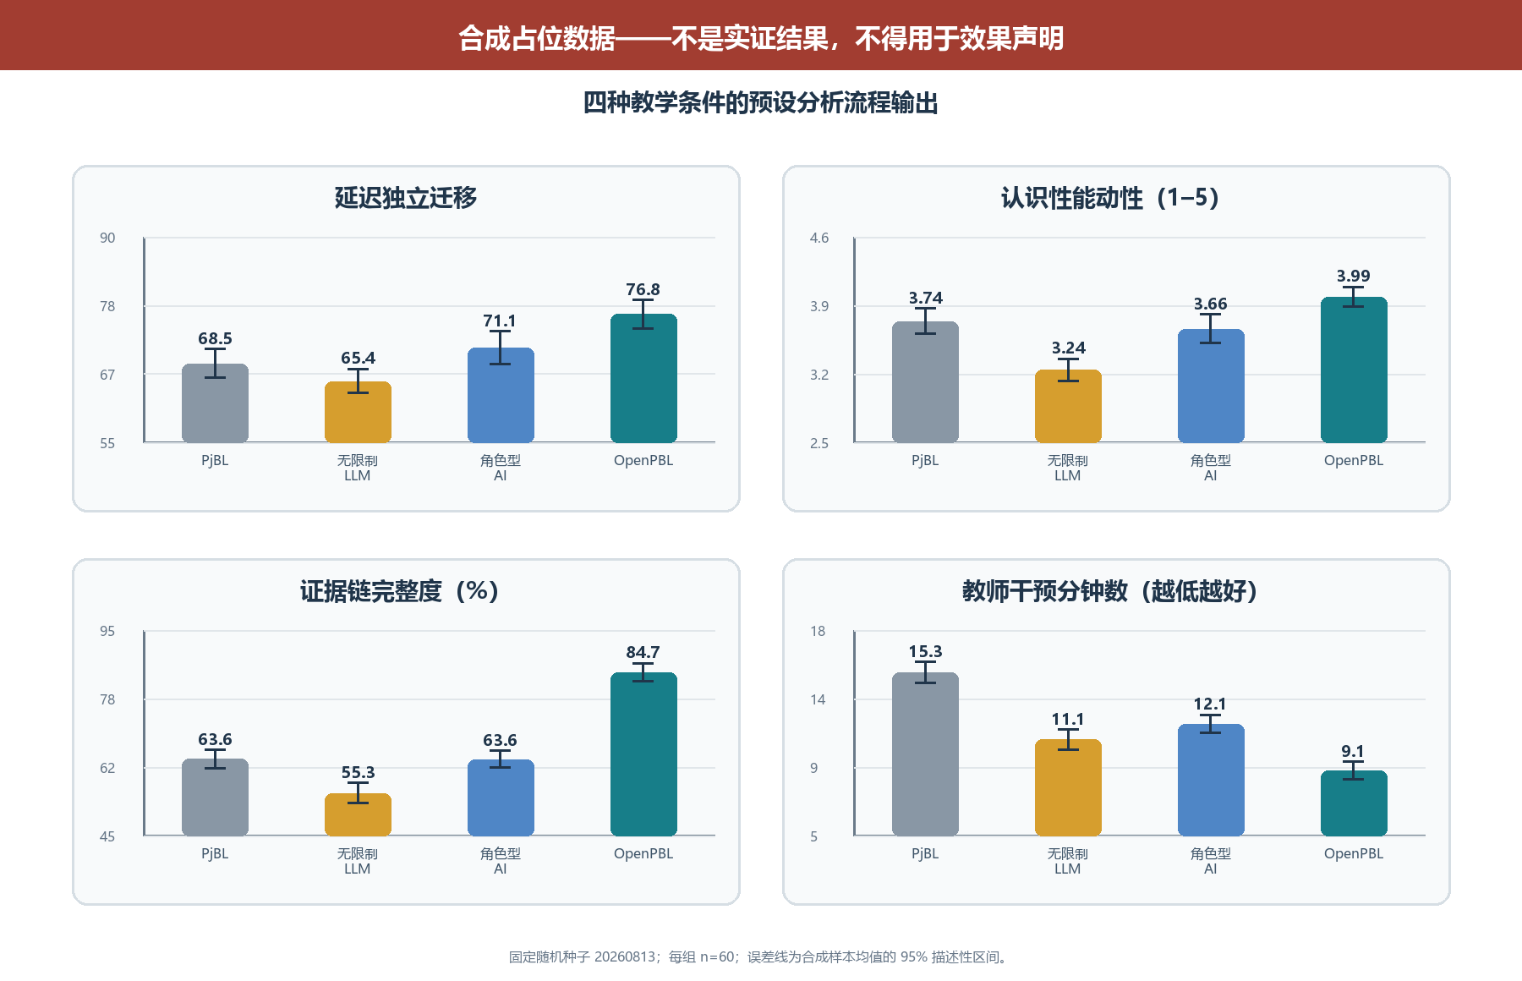
Figure 3. SYNTHETIC PLACEHOLDER scenario used only to dry-run the analysis pipeline.
图 3. 仅用于试运行分析流程的合成占位情景。

7.4 Pipeline interpretation / 7.4 流程输出的解释
In the synthetic dry run, mean delayed transfer was 68.5 (9.6) in C1, 65.4 (8.2) in C2, 71.1 (11.1) in C3, and 76.8 (9.5) in C4. The unrestricted condition produced higher artifact quality than PjBL alone while showing the lowest agency and evidence integrity. Full OpenPBL showed the highest delayed transfer, agency, and evidence integrity and the lowest teacher-intervention time. This joint pattern is useful because it makes the paper's claim falsifiable: real data could show that the controls add friction without learning benefit, that role-based AI is sufficient, or that OpenPBL's advantage is confined to documentation rather than learning.
在合成流程试运行中，C1、C2、C3 和 C4 的延迟迁移均值（标准差）分别为 68.5 (9.6)、65.4 (8.2)、71.1 (11.1) 和 76.8 (9.5)。无限制 LLM 条件的作品质量高于仅 PjBL 条件，却具有最低的能动性和证据完整度；完整 OpenPBL 条件具有最高的延迟迁移、能动性和证据完整度，以及最低的教师干预时间。该联合模式的价值在于使论文主张可以被证伪：真实数据完全可能显示控制机制只增加摩擦而没有学习收益，角色型 AI 已经足够，或 OpenPBL 的优势仅限于记录完整而不是学习。
No p-value is reported because inferential significance on invented observations would be meaningless. The dry run has three legitimate outputs only: a frozen schema and contrast plan, confirmation that the analysis distinguishes the intended constructs, and an explicit replacement checklist. Before submission, researchers must preregister the protocol, obtain ethics approval, replace the CSV, regenerate Tables 3-4 and Figure 3, archive the analytic code, and rewrite Sections 7.3-7.4 and all claims that depend on them.
本文不报告 p 值，因为对虚构观察进行推断显著性检验没有意义。该试运行只有三项正当产出：冻结的数据结构和对比计划、确认分析能够区分预定构念，以及明确的替换清单。正式投稿前，研究者必须预注册方案、获得伦理审批、替换 CSV、重新生成表 3–4 和图 3、归档分析代码，并重写第 7.3–7.4 节及所有依赖占位数据的表述。

8. Discussion / 8. 讨论

8.1 From AI roles to an authority topology / 8.1 从 AI 角色走向权威拓扑
Many educational systems describe AI through social roles such as tutor, peer, critic, or assistant. Roles help users form expectations, but they are under-specified for governance. A “peer” may merely suggest an idea or may rewrite a student's artifact; a “tutor” may ask a question or decide mastery. The authority topology adds a more precise layer: for each consequential domain, it specifies who initiates, who may act, what evidence is required, who can reverse the action, and who decides.
许多教育系统用“导师、同伴、评论者、助手”等社会角色描述 AI。角色有助于用户建立预期，却不足以承担治理功能。“同伴”可能只是提出想法，也可能重写学生作品；“导师”可能提出问题，也可能直接决定掌握度。权威拓扑提供了更精确的描述层：在每个高后果领域中，谁发起、谁可执行、需要何种证据、谁能撤销、谁作最终决定。
This is the paper's primary theoretical contribution. It connects student-AI collaboration to curriculum design, adaptive instruction, PjBL evidence, and teacher orchestration. It also offers a unit for comparative research. Systems that use the same model and interface may create different learning conditions because they allocate productive and evaluative authority differently.
这是本文最主要的理论贡献。它把学生—AI 协作与课程设计、适应性教学、PjBL 证据和教师课堂编排连接起来，也提供了比较研究的分析单位。即使系统使用同一模型和界面，只要生产权威与评价权威的配置不同，就可能形成完全不同的学习条件。

8.2 Reversible delegation as a middle position / 8.2 可撤销委托提供一种中间立场
Debates about generative AI in education often contrast unrestricted use with prohibition. OpenPBL implements a middle position. Students may delegate bounded productive work, but the delegation is explicit, visible, and reversible. This recognizes that learning to work with AI includes learning to specify, inspect, challenge, and integrate machine contributions. At the same time, it prevents a request for help from silently becoming authorship transfer.
教育领域关于生成式 AI 的争论常在“无限制使用”和“全面禁止”之间摇摆。OpenPBL 提供中间路径：学生可以委托受限的生产工作，但委托必须明确、可见并可撤销。这承认与 AI 协作本身也需要学习，包括说明要求、检查结果、质疑机器贡献并将其整合进自身工作。同时，它避免一次求助在无感状态下变成作者身份的转移。
Reversibility alone is insufficient. Students may approve AI text without understanding it, and provenance can become an ignored log. The learning mechanism depends on associated practices: students should explain why a contribution was kept, identify what they verified, link changes to evidence, and demonstrate unaided or differently supported performance. The system's test-result and revision-decision records create opportunities for those practices, but their quality must be studied.
仅有可撤销性仍然不够。学生可能在不理解时保留 AI 文本，来源账本也可能无人查看。教育机制依赖相应实践：学生应说明为何保留某项贡献、核验了什么、如何依据证据修改，并在无 AI 或不同支持条件下展示能力。系统的测试结果与修订决定记录为这些实践创造条件，但证据质量仍需实证研究。

8.3 Curriculum anchoring limits adaptive overreach / 8.3 课程锚定限制适应性越权
OpenPBL's role-aware graph addresses a subtle but consequential failure mode. Personalization is often framed as matching content to a learner, but without an explicit curricular boundary the system may decide that weak prelesson performance justifies removing or simplifying the very content the lesson is meant to teach. By separating prerequisite from lesson nodes and returning every learner to the full main lesson, the design constrains adaptation to access support rather than curricular tracking.
角色感知图谱回应了一个隐蔽但高后果的失败模式。个性化常被描述为“让内容适合学习者”，但如果缺乏明确课程边界，系统可能因为学生课前表现弱，就删减或简化原本应通过本课学习的内容。区分先修与新授节点，并让所有学生返回完整主课，可以把适应性限制为“帮助进入学习”，而不是“按能力分流课程”。
The approach also reveals unresolved measurement questions. A single diagnostic item is interpretable and low burden, but noisy. Required typed edges improve validity only if the generated or teacher-edited dependency is correct. The graph should therefore be treated as a contestable curriculum model, not ground truth.
该方案也暴露出尚未解决的测量问题：单道诊断题负担小且易解释，却噪声较大；类型化必需边只有在关系本身正确时才具有意义。因此，课程图谱应被视作可质疑、可修改的课程模型，而非客观真相。

8.4 Evidence can support agency or become compliance / 8.4 证据既可能支持能动性，也可能退化为合规负担
Evidence-gated progression is intended to protect inquiry from product-only evaluation. Yet additional forms can become bureaucratic compliance, especially if students generate plausible test and reflection records after the fact. Evidence design must balance structure with authenticity. High-quality evidence should be close to the action it represents, connected across iterations, and useful to the learner or teacher rather than collected solely for analytics.
证据门控旨在防止项目评价只看成品，但新增表单也可能变成形式主义，尤其当学生事后生成貌似合理的测试与反思记录时。证据设计必须在结构与真实性之间取得平衡。高质量证据应尽量靠近它所代表的行动，在多轮迭代之间形成连接，并对学生或教师实际有用，而非仅为分析系统采集。
This risk argues for mixed-method evaluation. Log completeness alone cannot establish regulation or agency. Researchers should combine interaction traces with artifact histories, think-aloud or stimulated-recall interviews, independent performance tasks, classroom observation, and teacher interpretation. Multimodal data may add temporal resolution, but inference claims must remain proportional to the evidence [19].
因此，后续评价必须采用混合方法。日志完整度无法单独证明调节或能动性。研究应结合交互轨迹、作品历史、思维外显或刺激回忆访谈、独立表现任务、课堂观察和教师解释。多模态数据可以提升时间分辨率，但推断强度必须与证据强度相称[19]。

8.5 Implications for AIED design and scholarship / 8.5 对 AIED 设计与研究的启示
For designers, the framework suggests that prompts should be the last rather than the only line of defence. Authority boundaries should also live in schemas, validators, operation whitelists, state transitions, audit records, and user-facing controls. For educators, generated curriculum graphs and adaptive paths should be inspectable arguments. For researchers, implementation fidelity should be reported separately from learning effects, and unaided transfer should be measured whenever AI performs substantial task work.
对于设计者，本框架意味着提示词应是最后一道而非唯一一道防线。权威边界还应写入数据结构、验证器、操作白名单、状态转换、审计记录和面向用户的控制。对于教师，生成课程图谱与适应路径应表现为可检查的论证。对于研究者，实现忠实度应与学习效果分开报告；只要 AI 完成了重要任务工作，就应测量无辅助迁移表现。
The framework is relevant beyond PjBL. Writing tutors, inquiry environments, design studios, coding platforms, and collaborative problem-solving systems all distribute the same five forms of authority. The specific evidence types will differ, but the questions of curricular scope, instructional sequence, adaptation, productive delegation, and consequential evaluation remain.
该框架也适用于 PjBL 之外的写作辅导、探究环境、设计工作室、编程平台和协作问题解决系统。具体证据类型会变化，但课程范围、教学顺序、适应性、生产委托与高后果评价五个问题仍然存在。

9. Limitations and Threats to Validity / 9. 局限与效度威胁
The study has substantial limitations.
本研究存在显著局限。
First, it is a design and fidelity study with no human participants. Educational benefits and harms remain hypotheses. Second, the theory-to-mechanism mapping was produced within the development project and was not independently coded; confirmation bias is possible. Third, the targeted regression set is not the entire repository suite; 111 passing tests show only that selected boundaries conform in the current snapshot. The code revision, dependency environment, model versions, prompts, and complete tests must be frozen and independently reproducible before empirical deployment.
第一，这是无参与者的设计与忠实度研究，教育收益与风险都只是待检验假设。第二，理论—机制映射由开发项目内部完成，尚未经过独立编码，可能存在确认偏误。第三，定向回归并非仓库全部测试，而且仍有一项预期失败；在实证部署前必须冻结代码、模型版本、提示和测试，并实现独立复现。
Fourth, the enforced minimum of one prerequisite may manufacture a dependency for genuinely foundational lessons. Fifth, some default knowledge ladders are tailored to common AI topics and may over-prescribe other domains, cultures, or curricula. Sixth, one-question routing has limited reliability and can misclassify students. Seventh, model-generated graphs, explanations, feedback, and edits can be incorrect, biased, age-inappropriate, or homogenizing despite structural controls.
第四，强制至少一个先修点可能为真正入门课程制造虚假依赖。第五，部分默认知识阶梯面向常见 AI 主题，对其他学科、文化或课程可能过度规定。第六，单题路由信度有限，可能错误分类学生。第七，尽管存在结构性控制，模型生成的图谱、解释、反馈和修改仍可能不正确、有偏、年龄不适宜或造成表达同质化。
Eighth, provenance and undo do not guarantee meaningful consent or understanding. Interface defaults, social pressure, or time constraints may still encourage uncritical acceptance. Ninth, typed evidence can privilege what the platform can capture and disadvantage valid offline, embodied, collaborative, or creative work. Tenth, teacher oversight can create workload rather than reduce it if signals are poorly calibrated. Finally, privacy, accessibility, language variation, and unequal access require local evaluation, particularly in K-12 settings.
第八，来源记录和撤销并不自动等于有意义的同意与理解；界面默认、社会压力与时间约束仍可能诱导学生无批判接受。第九，类型化证据可能偏向平台能够捕获的活动，忽略有效的线下、具身、协作或创造性工作。第十，如果信号校准不当，教师监督可能增加而不是减少负担。最后，隐私、无障碍、语言差异与接入不平等在 K-12 环境中尤其需要本地化评估。

10. Empirical Research Agenda / 10. 实证研究议程
The artifact is ready for co-design and feasibility research, not a definitive outcome claim. We propose three stages.
当前制品适合进入共同设计与可行性研究，而不适合直接作出效果结论。本文建议三个阶段。

10.1 Stage 1: Teacher co-design and validity study / 10.1 阶段一：教师共同设计与效度研究
Teachers from the intended grade levels and subject domains should inspect generated curriculum graphs, prerequisite classifications, diagnostic items, remediation resources, terminal assessments, evidence missions, and intervention signals. Measures should include content-validity ratings, disagreement rationales, correction time, perceived decision authority, and workload. Expert review should explicitly test whether the hard minimum of one prerequisite manufactures dependencies, as well as domains outside the current AI-oriented defaults.
邀请目标学段与学科教师审查生成课程图谱、先修分类、诊断题、补救资源、终结性测评、证据任务与干预信号。测量应包括内容效度评分、分歧理由、修订时间、决策权感知与工作负担。专家评审需要专门测试零先修情形，以及当前偏 AI 主题默认结构之外的学科。

10.2 Stage 2: Classroom feasibility and mechanism pilot / 10.2 阶段二：课堂可行性与机制试点
A multi-class pilot should examine whether students understand AI roles, delegation, provenance, undo, evidence requirements, and teacher authority. Data should include system traces, screen and classroom observation, artifact histories, student interviews, teacher stimulated recall, support incidents, accessibility issues, and model errors. Primary feasibility criteria should be defined in advance: completion, integrity of evidence chains, frequency and success of undo, proportion of teacher signals judged useful, latency, and adverse events. No efficacy conclusion should be drawn from convenience comparisons.
多班级试点应考察学生是否理解 AI 角色、委托、来源、撤销、证据要求和教师权威。数据可包含系统轨迹、屏幕与课堂观察、作品历史、学生访谈、教师刺激回忆、支持事件、无障碍问题和模型错误。事先定义主要可行性标准：完成率、证据链完整性、撤销频率与成功率、被教师判断为有用的信号比例、延迟与不良事件。便利样本比较不应被用于效果结论。

10.3 Stage 3: Comparative effectiveness study / 10.3 阶段三：比较效果研究
After co-design and feasibility criteria are met, a preregistered cluster-randomized or carefully matched study can compare four conditions: PjBL without generative AI, PjBL with an unrestricted general-purpose LLM, role-based AI without authority compilation or evidence gates, and full OpenPBL. The primary outcome should be delayed, unaided transfer aligned with lesson targets. Secondary outcomes should include conceptual achievement, artifact quality, verification accuracy, revision quality, persistence after AI withdrawal, epistemic agency, ownership, trust calibration, collaboration quality, equity, and teacher orchestration workload. The C3-versus-C4 contrast is essential because it separates role richness from executable authority governance.
在共同设计和可行性标准达标后，可开展预注册的整群随机或严格匹配研究，比较四种条件：不使用生成式 AI 的 PjBL、使用无限制通用 LLM 的 PjBL、只有角色组织而没有权威编译与证据门控的 AI，以及完整 OpenPBL。主要结果应是与课程目标一致的延迟无 AI 迁移；次要结果包括概念成绩、作品质量、核验准确性、修订质量、AI 撤除后的坚持、认识性能动性、所有权、信任校准、协作质量、公平性与教师编排负担。C3 与 C4 的对比尤其关键，因为它把“角色丰富”与“可执行权威治理”分离开来。
Adverse outcomes should be treated as first-class results: copied but unverified content, reduced unaided performance, false prerequisite routing, evidence fabrication, inaccessible interactions, biased suggestions, privacy incidents, and teacher alert fatigue. The agenda tests a proposition that can fail: bounded authority control may protect learning better than unrestricted assistance, but it may instead add friction, documentation burden, or teacher work.
不良结果必须被视作一等研究发现，包括复制但未核验的内容、独立表现下降、错误先修路由、证据伪造、不可访问的交互、有偏建议与教师预警疲劳。该议程检验的是一个可以失败的命题：有边界的权威控制也许比无限制帮助更能保护学习，但也可能只增加摩擦、文档负担或教师工作量。

11. Conclusion / 11. 结论
OpenPBL addresses more than the addition of another agent role. Once generative AI enters an end-to-end project-learning process, curricular, instructional, adaptive, productive, and evaluative authority must remain visible, executable, and accountable. The system compiles pedagogical principles into a role-aware curriculum graph, strict prerequisite remediation, one post-instruction mastery assessment, whitelisted and reversible artifact operations, typed evidence chains, student submission, and teacher adjudication.
OpenPBL 回应了 AIED 的一个核心问题：生成式 AI 可以同时成为导师、协作者、生产者、监控者与评价者，但教育责任不能在这些角色之间无序扩散。重构后的系统通过五类显式权威来组织人机协作：在课程中锚定个性化，先提供教学支持再判断掌握度，针对具体先修缺口实施补救，只允许明确且可撤销的作品委托，并要求以过程证据与人类裁决支持高后果进阶。
The formative evaluation shows that these boundaries can become inspectable software contracts: all 111 tests across 14 targeted files passed. Engineering conformance is not learning effect. The synthetic values in Section 7 demonstrate only that the proposed data schema and analysis pipeline run; they establish no condition as superior. OpenPBL's warranted status is therefore an original and falsifiable system design organized around a pedagogical-authority control plane. Claims about learning, agency, or workload require teacher co-design, classroom feasibility evidence, and a preregistered comparative trial.
形成性审计表明，这些理念可以实现为可检查、可测试的约束；尚未解决的回归不一致也说明当前仍是开发快照。下一项更重要的检验属于教育研究：学生是否会利用可撤销委托更有效地与 AI 一起推理并质疑 AI，其独立表现与作品所有权是否得到保留，以及教师能否在不失去权威或时间的前提下获得可行动的可见性。在课堂证据回答这些问题之前，OpenPBL 应被理解为一个具有理论基础且可接受实证检验的设计命题，而不是已经得到证明的教育解决方案。

Data and Artifact Availability / 数据与制品可获得性
The analyzed artifact is the OpenPBL development snapshot of 13 August 2026. All 111 tests in 14 targeted files passed. The 240 records in Section 7 were generated with fixed seed 20260813 and carry synthetic_placeholder=true on every row; they exist only to debug the pipeline. Before classroom research, the authors should freeze the source revision, schema, architecture-decision records, prompt and model configuration, dependency environment, test commands, analysis code, and data dictionary. No human-participant data were collected.
本文分析对象为 2026 年 8 月 13 日的 OpenPBL 开发快照。14 个定向测试文件中的 111 项测试全部通过。第 7 节的 240 条记录使用固定种子 20260813 生成，并在每行标记 synthetic_placeholder=true；它们仅用于流程调试。真实课堂研究开始前应冻结代码修订、数据库结构、架构决策记录、提示词与模型配置、测试命令、分析脚本和数据字典。本文未收集人类参与者数据。

Author Contributions, Funding, and Competing Interests / 作者贡献、资助与利益冲突
These statements are withheld for anonymous review. The non-anonymous version should report contributions using the CRediT taxonomy, identify all funding, and disclose relevant financial or non-financial interests.
匿名审稿阶段暂不披露。非匿名版本应按 CRediT 分类报告贡献，列出全部资助，并披露相关财务或非财务利益。

References / 参考文献
[1] Kestin G, Miller K, Klales A, Milbourne T, Ponti G. AI tutoring outperforms in-class active learning: An RCT introducing a novel research-based design in an authentic educational setting. Scientific Reports, 2025, 15: 17458. https://doi.org/10.1038/s41598-025-97652-6
[2] Holstein K, McLaren B M, Aleven V. Co-designing a real-time classroom orchestration tool to support teacher-AI complementarity. Journal of Learning Analytics, 2019, 6(2): 27-52. https://doi.org/10.18608/jla.2019.62.3
[3] Bastani H, Bastani O, Sungu A, Ge H, Kabakcı Ö, Mariman R. Generative AI without guardrails can harm learning: Evidence from high school mathematics. Proceedings of the National Academy of Sciences, 2025, 122(26): e2422633122. https://doi.org/10.1073/pnas.2422633122
[4] Darvishi A, Khosravi H, Sadiq S, Gašević D, Siemens G. Impact of AI assistance on student agency. Computers & Education, 2024, 210: 104967. https://doi.org/10.1016/j.compedu.2023.104967
[5] Chen C-H, Yang Y-C. Revisiting the effects of project-based learning on students' academic achievement: A meta-analysis investigating moderators. Educational Research Review, 2019, 26: 71-81. https://doi.org/10.1016/j.edurev.2018.11.001
[6] Farshad S, Fortin C. An umbrella review of meta-analyses on project-based learning: Effects on academic achievement, higher-order thinking, and 21st-century skills. Educational Research Review, 2026, 52: 100809. https://doi.org/10.1016/j.edurev.2026.100809
[7] Hmelo-Silver C E, Duncan R G, Chinn C A. Scaffolding and achievement in problem-based and inquiry learning: A response to Kirschner, Sweller, and Clark (2006). Educational Psychologist, 2007, 42(2): 99-107. https://doi.org/10.1080/00461520701263368
[8] Kim N J, Belland B R, Walker A E. Effectiveness of computer-based scaffolding in the context of problem-based learning for STEM education: Bayesian meta-analysis. Educational Psychology Review, 2018, 30: 397-429. https://doi.org/10.1007/s10648-017-9419-1
[9] Kim J, Lee H, Cho Y H. Learning design to support student-AI collaboration: Perspectives of leading teachers for AI in education. Education and Information Technologies, 2022, 27: 6069-6104. https://doi.org/10.1007/s10639-021-10831-6
[10] Yu J F, Zhang-Li D, Zhang Z Y, et al. From MOOC to MAIC: Reimagine online teaching and learning through LLM-driven agents. Journal of Computer Science and Technology, 2026, 41(1): 394-414. https://doi.org/10.1007/s11390-025-6000-0
[11] Samuel A. Learning with machines: Toward a theory of epistemic co-agency. Computers and Education: Artificial Intelligence, 2026, 10: 100573. https://doi.org/10.1016/j.caeai.2026.100573
[12] Chaaban Y, Jung S-G, Medina J, Azem J Y, Salminen J, Jansen B J. Examining student teachers' agency in an AI-supported learning environment: Q methodology research. International Journal of Artificial Intelligence in Education, 2025, 35: 4083-4107. https://doi.org/10.1007/s40593-025-00529-y
[13] Kim J, Detrick R, Yu S, Song Y, Bol L, Li N. Socially shared regulation of learning and artificial intelligence: Opportunities to support socially shared regulation. Education and Information Technologies, 2025, 30: 11483-11521. https://doi.org/10.1007/s10639-024-13187-9
[14] Mouta A, Torrecilla-Sánchez E M, Pinto-Llorente A M. Where is agency moving to? Exploring the interplay between AI technologies in education and human agency. Digital Society, 2025, 4: 49. https://doi.org/10.1007/s44206-025-00203-9
[15] Kasneci E, Sessler K, Küchemann S, et al. ChatGPT for good? On opportunities and challenges of large language models for education. Learning and Individual Differences, 2023, 103: 102274. https://doi.org/10.1016/j.lindif.2023.102274
[16] Chanaa A, El Faddouli N. Prerequisites-based course recommendation: Recommending learning objects using concept prerequisites and metadata matching. Smart Learning Environments, 2024, 11: 16. https://doi.org/10.1186/s40561-024-00301-0
[17] Hadwin A F, Järvelä S, Miller M. Self-regulation, co-regulation, and shared regulation in collaborative learning environments. In: Schunk D H, Greene J A, eds. Handbook of Self-Regulation of Learning and Performance, 2nd ed. Routledge, 2018: 83-106. https://doi.org/10.4324/9781315697048-6
[18] Banihashem S K, Bond M, Bergdahl N, Khosravi H, Noroozi O. A systematic mapping review at the intersection of artificial intelligence and self-regulated learning. International Journal of Educational Technology in Higher Education, 2025, 22: 50. https://doi.org/10.1186/s41239-025-00548-8
[19] de Mooij S, Lämsä J, Lim L, et al. A systematic review of self-regulated learning through integration of multimodal data and artificial intelligence. Educational Psychology Review, 2025, 37: 54. https://doi.org/10.1007/s10648-025-10028-0
[20] Dillenbourg P. Design for classroom orchestration. Computers & Education, 2013, 69: 485-492. https://doi.org/10.1016/j.compedu.2013.04.013
[21] Possaghi I, Vesin B, Zhang F, et al. Integrating multi-modal learning analytics dashboard in K-12 education: Insights for enhancing orchestration and teacher decision-making. Smart Learning Environments, 2025, 12: 53. https://doi.org/10.1186/s40561-025-00410-4
[22] Wang F, Hannafin M J. Design-based research and technology-enhanced learning environments. Educational Technology Research and Development, 2005, 53: 5-23. https://doi.org/10.1007/BF02504682
[23] Miao F, Holmes W. Guidance for Generative AI in Education and Research. Paris: UNESCO, 2023.

