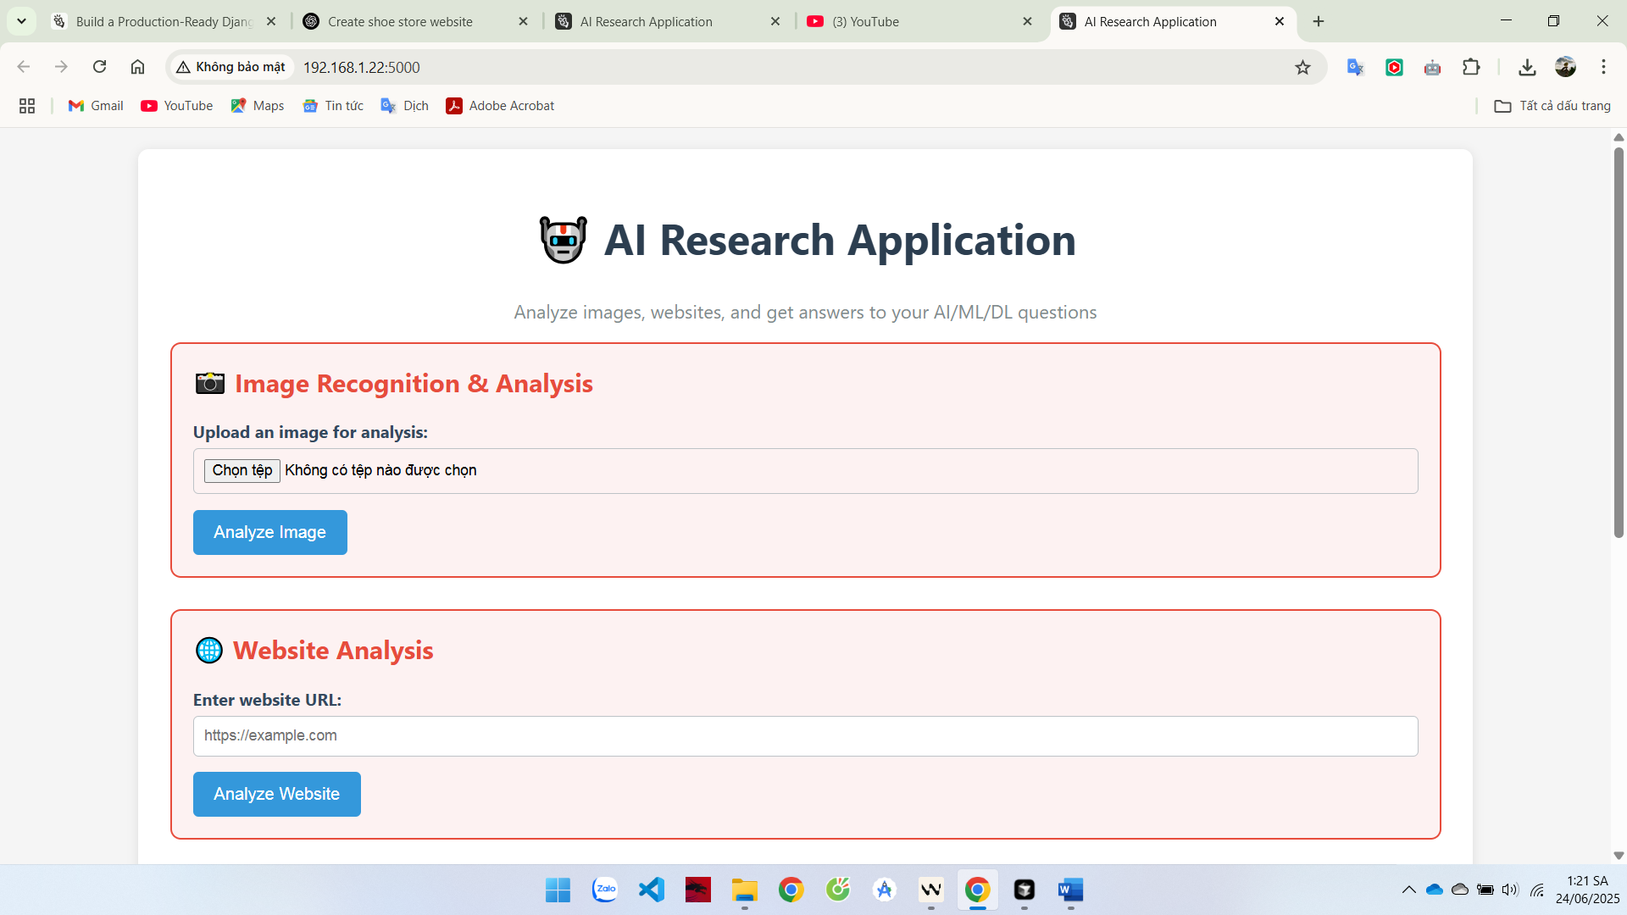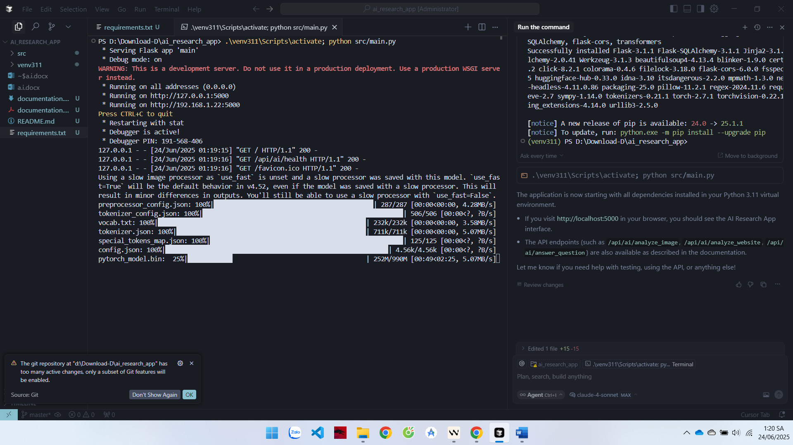{

"analysis_type": "image_recognition",

"caption": "a young man with black hair and a white shirt",

"dimensions": {

"channels": 3,

"height": 906,

"width": 604

},

"edge_density": 0.018436691373185387,

"mean_color": {

"blue": 211.7447133166674,

"green": 211.99737767349384,

"red": 230.0656129848106

}

}

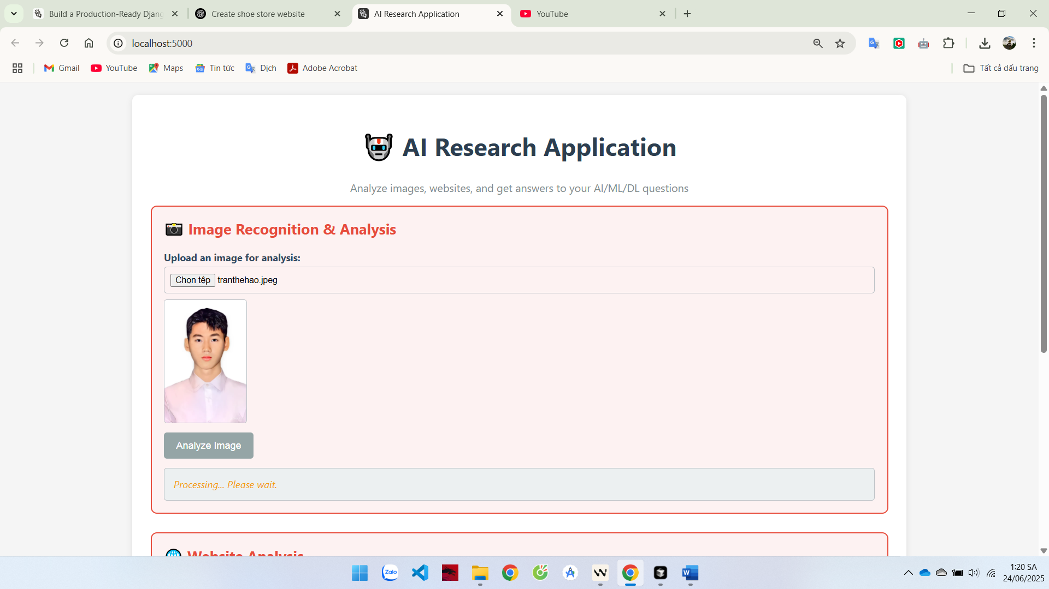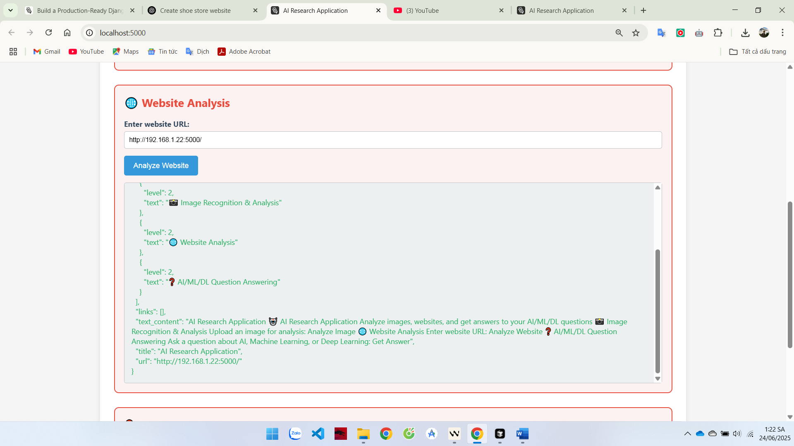

{

"analysis_type": "website_analysis",

"description": "No description found",

"headings": [

{

"level": 1,

"text": "🤖 AI Research Application"

},

{

"level": 2,

"text": "📸 Image Recognition & Analysis"

},

{

"level": 2,

"text": "🌐 Website Analysis"

},

{

"level": 2,

"text": "❓ AI/ML/DL Question Answering"

}

],

"links": [],

"text_content": "AI Research Application 🤖 AI Research Application Analyze images, websites, and get answers to your AI/ML/DL questions 📸 Image Recognition & Analysis Upload an image for analysis: Analyze Image 🌐 Website Analysis Enter website URL: Analyze Website ❓ AI/ML/DL Question Answering Ask a question about AI, Machine Learning, or Deep Learning: Get Answer",

"title": "AI Research Application",

"url": "http://192.168.1.22:5000/"

}