
Surprize
Mini Project Documentation
འཇིགས་མེད་རྣམ་རྒྱལ་བཟོ་རིག་མཐོ་རིམ་སོབ་གྲ།

Royal University of Bhutan
Jigme Namgyel Engineering College, Dewathang
Group Members
Sangay Phuntsho (05250187)
Dechen Pem (05250170)
Yeshi Lhaden (05250202)
DEPARTMENT OF INFORMATION TECHNOLOGY
DIPLOMA IN COMPUTER SYSTEM AND NETWORK
JIGME NAMGYEL ENGINEERING COLLEGE
2nd June 2026

Contents
CHAPTER 1: INTRODUCTION 4
1.1 Current Situation Diagram 4
1.2 Problem Statement 5
1.3 Aim 5
1.4 Objectives 6
1.5 Methodology 6
1.6 Expected Outcome 6
CHAPTER 2: PLANNING PHASE 8
2.1 Project Overview 8
2.2 Scope 8
2.3 Feasibility Summary 10
2.4 Resource Requirements 10
2.5 Schedule 10
2.6 Proposed Solution 11
2.7 System Description 11
2.8 Feasibility Assessment 12
2.9 Management Issues 15
CHAPTER 3: ANALYSIS PHASE 18
3.1 Requirement Determination 18
3.2 Functional Requirements 18
3.3 Non-Functional Requirements 18
3.4 Requirement Structuring 19
3.5 UML-Based Structuring 24
3.6 Data Conceptual Modeling 25
3.7 Normalization 26
CHAPTER 4: DESIGN PHASE 29
4.1 Description 29
4.2 User Interface Design 30
CHAPTER 5: IMPLEMENTATION, TESTING, AND MAINTENANCE 38
5.1 Coding, Verification & Validation 38
5.2 Installation and Documentation 38
5.3 Testing 38
5.4 Maintenance 40
CHAPTER 6: CONCLUSION 42
STATEMENT OF WORK: PROJECT CHARTER 43
List of Figures
Figure 1: Current situation diagram 4
Figure 2: Context diagram 9
Figure 3: Gantt chart 15
Figure 4: DFD level 0 19
Figure 5: DFD level 1 20
Figure 6: DFD level 2 – 1.0 User Management 20
Figure 7: DFD level 2 – 2.0 Event Planning and Gift Suggestion 21
Figure 8: DFD level 2 – 3.0 Order and Delivery Management 22
Figure 9: DFD level 2 – 4.0 Notification Management 23
Figure 10: DFD level 2 – 5.0 Admin Management 24
Figure 11: Use case diagram 25
Figure 12: Entity relationship diagram (ERD) 25
Figure 13: Startup page 30
Figure 14: Login page 31
Figure 15: Home page 32
Figure 16: Plan your surprise page 33
Figure 17: Item page 34
Figure 18: Order page 35
Figure 19: Profile page 36
Figure 20: About us page 37
List of Tables
Table 1: Feasibility assessment 12
Table 2: Schedule feasibility 14
Table 3: Admin / Gift Vendor 26
Table 4: Customer (The Planner) 26
Table 5: Occasion / Event Details 27
Table 6: Occasion Budget 27
Table 7: Gift 27
Table 8: Occasion_Gift (Relationship Table) 27
Table 9: Delivery 28

CHAPTER 1: INTRODUCTION
The desire to celebrate milestones frequently punctuates our relationships; however, the real-world process of planning special events and sourcing meaningful gifts poses serious logistical hurdles. Busy modern routines leave individuals with a severe shortage of personal time to dedicate to detailed event preparation. This deficit often causes frustration, rushed decisions, and stress, which detracts from what should be a joyful experience. Additionally, selecting unique items, staying within a budget, and ensuring prompt delivery are complex tasks that can become overwhelming. When plans fall through or deliveries are delayed, the resulting disappointment highlights the clear need for a centralized, responsive, and dynamic coordinating system.
In response to these challenges, we propose the implementation of the Surprize platform. Surprize is a dedicated service platform designed to simplify and streamline the process of planning surprise gifts and celebrations for friends, partners, and family members. The platform acts as an automated digital replacement for fragmented planning methods, offering users a convenient way to browse creative gift ideas, organize event logistics, and track deliveries smoothly. By establishing clear timelines, organizing arrangements within defined budgets, and automating communication, this system will foster a stress-free environment, transforming gift coordination into an efficient and enjoyable experience.

1.1 Current Situation Diagram
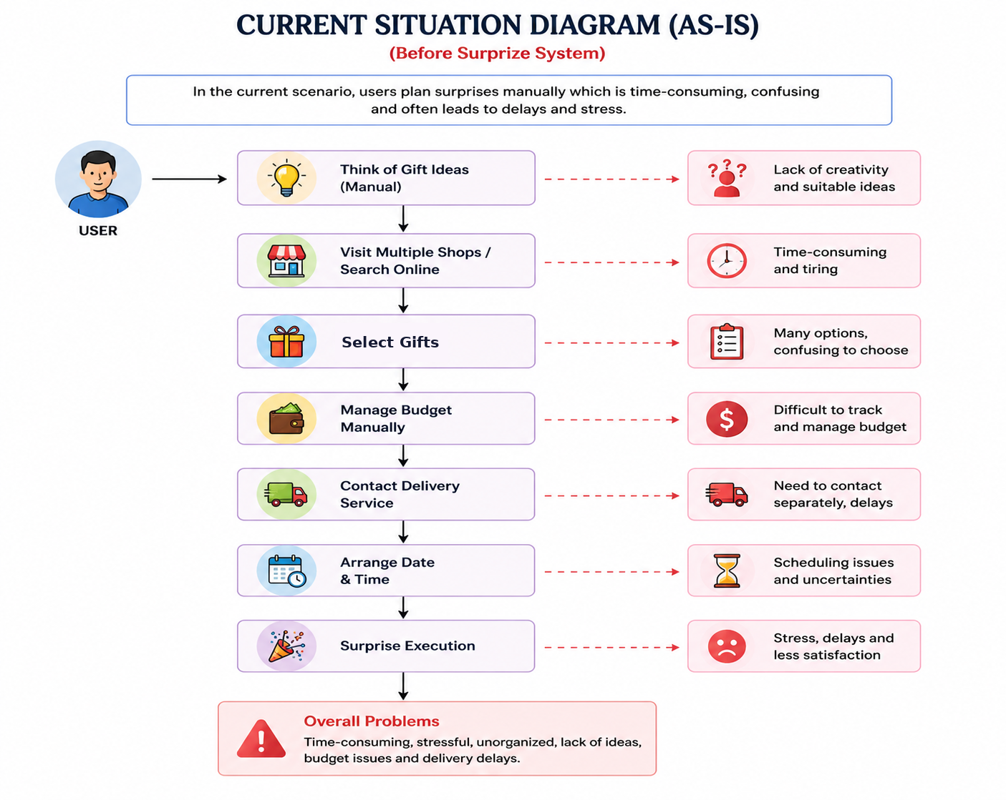
Figure 1: Current situation diagram
This diagram represents the current manual process of planning surprises before the implementation of the Surprize system. It shows that users have to manage every step on their own, which often becomes time-consuming, confusing, and stressful. The process begins with users thinking of gift ideas manually, where they may struggle to find creative and suitable options. They then visit multiple shops or search online, which takes a lot of time and effort.
After that, users select gifts from many available choices, making decision-making difficult and confusing. Budget management is also handled manually, which creates problems in tracking expenses and controlling costs. Users must separately contact delivery services, leading to delays and communication issues. Arranging the delivery date and time can also create scheduling problems and uncertainties.
Finally, during surprise execution, users may experience stress, delays, and dissatisfaction because the entire process is unorganized and difficult to manage. The diagram highlights the major problems of the current system, including lack of creativity, time consumption, budget issues, delivery delays, and poor coordination.

1.2 Problem Statement
In today’s fast-paced world, people often struggle to plan meaningful surprises and select suitable gifts for their loved ones due to busy schedules, lack of creativity, and limited access to organized planning tools. Finding the perfect gift, managing budgets, scheduling deliveries, and ensuring everything is prepared on time can be stressful and time-consuming.
Many individuals find it difficult to come up with unique and personalized surprise ideas for different occasions such as birthdays, anniversaries, graduations, Valentine’s Day, and other special events. Existing solutions often focus only on gift purchasing and do not provide a complete platform for planning and managing the entire surprise experience.
As a result, celebrations may become less memorable, poorly organized, or fail to meet expectations. There is a need for a centralized system that helps users discover creative gift ideas, plan surprise events within their budget, schedule deliveries, receive reminders, and manage all aspects of surprise planning in one place.
The Surprize system aims to address these challenges by providing an easy-to-use platform that assists users in creating personalized, well-organized, and memorable surprise experiences for their friends, family members, partners, and loved ones while reducing the stress and effort involved in planning special occasions.

1.3 Aim
The primary aim of Surprize is to make surprise planning an easy, stress-free, and enjoyable experience. The platform achieves this by providing creative gift and celebration ideas, assisting with the logistics of gifts and timely deliveries, and covering a wide range of occasions including birthdays, anniversaries, and graduations. Ultimately, the overriding goal is to help users plan deeply meaningful, well-organized, and memorable surprises.

1.4 Objectives
- Make surprise planning easy and stress-free: Helps users plan surprises without spending too much time and effort.
- Provide creative gift and celebration ideas: Suggests unique gifts and celebration plans based on the occasion and recipient.
- Assist in organizing gifts and deliveries: Helps users manage all aspects of a surprise, including gifts and delivery schedules.
- Support various special occasions: Covers events such as birthdays, anniversaries, graduations, Valentine’s Day, and other celebrations.
- Ensure timely preparation and execution: Sends reminders and notifications to help users complete preparations on time.
- Enhance user satisfaction: Offers a simple and user-friendly system that improves the overall planning experience.

1.5 Methodology
For this mini project, an Agile Methodology is implemented. This iterative approach builds the platform incrementally through short development cycles, allowing the team to adapt flexibly to evolving software configurations. This framework ensures continuous quality updates, robust security implementations, and early risk reduction during development.
Reasons for choosing Agile
- Flexibility: Allows changes to requirements and features during development.
- Continuous Improvement: Regular testing and feedback help improve the system throughout the project.
- Faster Development: Features are developed and delivered in small, manageable iterations.
- Risk Reduction: Potential issues are identified and resolved early in the development process.
- Better Quality: Continuous monitoring, testing, and updates ensure a reliable and high-quality system.

1.6 Expected Outcome
The Surprize system aims to change how personal milestones are celebrated by making the planning process faster, easier, and less error-prone. It directly tackles common hurdles like creative blocks and time constraints, enhancing real-world operational efficiency. Designed with an intuitive, user-friendly interface, it allows any individual to navigate and use its features with ease. Ultimately, it provides peace of mind, strengthening real-world relationships through well-executed and memorable events.
The platform is expected to provide the following outcomes:
- Easy and hassle-free planning of surprise events and celebrations.
- Personalized gift and celebration recommendations based on user preferences and budget.
- Efficient organization of gifts and delivery schedules.
- Timely reminders and notifications for important events and preparations.
- Reduced time and effort required for planning and managing surprises.
- Improved user experience through a simple and user-friendly interface.
- Better budget management for gifts and celebration activities.
- Successful execution of surprise events with minimal errors and delays.
- Creation of memorable and meaningful experiences for loved ones.

CHAPTER 2: PLANNING PHASE

2.1 Project Overview
Title: Surprize
Surprize is a web-based application designed to simplify the process of planning surprise events. The system provides an interactive and user-friendly interface where users can create accounts, log in, and manage their surprise plans efficiently.
The system works by allowing users to input occasion details such as type of event, preferences, and budget. Based on this information, it suggests appropriate gift ideas and helps users organize their plans. Users can also schedule deliveries and receive notifications about the progress of their event preparation.
The system ensures usability, reliability, and security by protecting user data and providing a smooth and responsive experience. Overall, Surprize acts as a centralized platform that integrates all aspects of surprise planning into one system.

2.2 Scope
The Surprize system is designed to assist users in planning and organizing surprise events in a simple and efficient manner. The scope of this project includes providing users with creative gift ideas, managing event details, and organizing the necessary components such as gifts and deliveries.
The system allows users to enter occasion details like birthdays, anniversaries, and other celebrations, and receive suitable suggestions based on their preferences and budget. It also supports scheduling of surprise deliveries and sending notifications to ensure timely preparation.
This project is mainly focused on individuals who want to plan surprises for their friends, family, and loved ones without facing difficulties in coordination and time management. The system focuses on planning, organizing, and assistance through a digital platform.
Out of Scope
- Online payment processing. The system does not include a payment gateway or any in-app payment page; the order total is shown for budgeting and order confirmation only.
- Physical execution of the surprise event.
User Functions
- Users can create secure accounts and log in to access the system.
- Customers can input specific event parameters, including occasion type (e.g., birthdays, anniversaries, graduations).
- Customers can receive tailored gift recommendations based on their inputs.
- Users can plan and limit their event arrangements strictly within a specified budget.
- Customers can schedule precise surprise deliveries and receive automated progress notifications.
Administrative Functions
- Admins can upload, modify, and manage the central gift recommendation database.
- Admins can view user profile records and monitor platform analytics for performance tracking.
- Admins can dispatch automated system alerts to maintain operational stability.
Context Diagram of the Surprize System
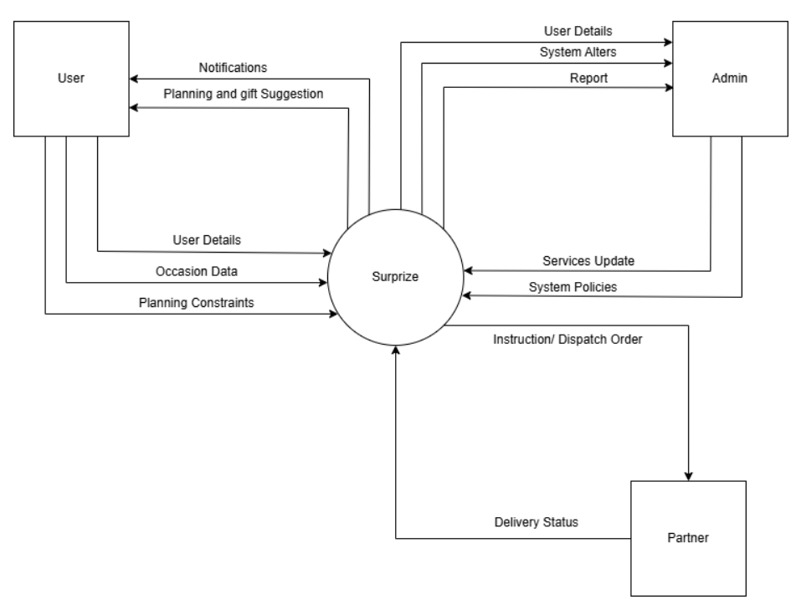
Figure 2: Context diagram
Explanation of the context diagram
This context diagram shows the overall working process of the Surprize system and the interaction between the main entities: User, Admin, Partner, and the Surprize platform. The user provides information such as user details, occasion data, and planning constraints to the Surprize system. Based on this information, the system sends planning suggestions, gift recommendations, and notifications back to the user to help manage the surprise easily.
The admin manages and monitors the system by receiving user details, system alerts, and reports from the Surprize platform. The admin also sends system policies and service updates to the system to ensure smooth operation and proper management. The partner, such as a delivery or gift service provider, receives instructions and dispatch orders from the Surprize system. In return, the partner updates the system with delivery status information to track and manage deliveries effectively.
Overall, the context diagram explains how the Surprize platform connects users, admins, and partners together to provide a smooth, organized, and efficient surprise planning experience.

2.3 Feasibility Summary
The feasibility assessment confirms that the Surprize platform is highly viable across all six evaluated dimensions. Economically, the initial financial inputs—Nu. 50,000–80,000 for core development, Nu. 10,000–20,000 for long-term updates, and Nu. 5,000–10,000 for vendor integrations—are justified by the real-world value, convenience, and time-saving advantages the centralized platform provides to users and local business partners. Operationally and politically, the system is expected to secure widespread stakeholder support and high user adoption because its intuitive interface directly resolves widespread planning issues while smoothly connecting administrators, users, and external vendors with minimal market resistance. Technically and legally, the necessary development tools and skills are readily available to build a secure, compliant, and feature-rich application that safeguards sensitive user information, tracks deliveries, and manages orders within a manageable and realistic 3-to-4-month development schedule.

2.4 Resource Requirements
Technical Resources
- Hardware: Development workstations and testing devices to compile code and evaluate responsiveness.
- Languages & Storage: HTML/CSS and JavaScript for frontend interactivity; PHP/Node.js for server logic; MySQL for secure data storage.
- Hosting: Cloud server infrastructure to guarantee persistent online access.
Human Resources
- Project Manager / Scrum Master: Oversees development sprints and coordinates tasks.
- UI/UX Designer: Architects intuitive, stress-free user interfaces to satisfy usability standards.
- Backend Developer: Constructs database architecture, manages login verification, and programs notification routines.
Financial Resources
The financial layout is organized across specific development and operational allocations:
- Budget Allocation: Maintenance and updates; development tools and hosting.
- Third-Party Service Costs: SMS/email notification systems.

2.5 Schedule
Managing the schedule revolves around automating the timeline from the moment a user inputs their event details to the final surprise delivery. First, users input specific occasion details, such as dates for birthdays or anniversaries, which allows the system to establish a firm deadline. The platform then works within the user’s specified budget to finalize gift ideas. Once the choices are locked in, the core scheduling mechanism takes over to arrange the exact surprise delivery times with local vendors and couriers. To ensure everything runs smoothly and stays on track, the system relies heavily on automated notifications. These updates keep both the organizers and the delivery teams aligned, sending out preparation reminders and real-time status alerts so that the surprise is delivered on time.

2.6 Proposed Solution
To solve the common frustrations of lacking creative gift ideas, running out of time, and struggling with the logistics of event planning, Surprize is a comprehensive digital platform designed to make planning meaningful, well-organized celebrations effortless and stress-free. The solution acts as a personalized, all-in-one celebration assistant that guides users through the entire process, from initial brainstorming to the final delivery.
The journey begins with an intuitive user experience where customers can securely create an account and log in. From there, users input the details of their upcoming event—whether it is a birthday, anniversary, graduation, or another milestone—along with their specified budget. The platform’s core engine then automatically suggests tailored, creative gift and celebration ideas based on those specific inputs. This eliminates the guesswork and decision fatigue that usually comes with finding the perfect present.
Beyond brainstorming, Surprize handles the heavy lifting of execution and logistics. The platform serves as a central hub where users can organize gifts and schedule precise surprise deliveries. To keep the planner stress-free, the system works reliably in the background, providing quick responses and real-time notifications on event preparation milestones. Available anytime and designed with strong data security to protect user information, this solution ensures that friends, partners, and family members receive a memorable and timely celebration without the planner having to manage every detail.

2.7 System Description
The Surprize platform is designed as an all-in-one digital assistant that simplifies the process of planning meaningful, well-organized celebrations for friends, partners, and family members. The system addresses common planning challenges such as a lack of creative ideas, limited time, and complex coordination logistics, and transforms them into a streamlined, automated workflow.
Functionally, the system allows users to securely create an account and log in, where they can input specific event details such as birthdays, anniversaries, or graduations along with a specified budget. The core engine then processes this data to automatically suggest tailored gift and celebration ideas. Beyond brainstorming, the system acts as a logistical hub that allows users to schedule surprise deliveries and receive real-time notifications and updates regarding event preparation.
From a technical standpoint, the system is built to prioritize high usability through an easy-to-use interface, reliability to minimize errors, robust security to protect sensitive user data, rapid performance for quick response times, and constant availability so the service can be accessed anytime. Ultimately, this integrated system ensures that celebrations are executed on time and stress-free for the planner.

2.8 Feasibility Assessment
The project was assessed across six feasibility dimensions, summarized in Table 1 and explained in the sub-sections that follow.
Table 1: Feasibility assessment
Economic Feasibility (Money)  Key Question: Is this project worth the cost?  - The project cost includes development and maintenance.  - Some cost is needed for integrating service providers.  - The system saves users time and effort.  - It provides convenience by organizing everything in one place.  - It creates business opportunities with service providers.  - It improves overall user experience.  - Cost: App/website development = Nu. 50,000 – 80,000  - Updates and bug fixes = Nu. 10,000 – 20,000  - Connecting service providers = Nu. 5,000 – 10,000 | Operational Feasibility (People & Process)  Key Question: Will people actually use it? Will it work in real life?  - The system is easy to use for users.  - Users can easily plan and organize surprises.  - It solves real problems like lack of time and ideas.  - Service providers can easily list and manage their services.  - Admin can manage gifts and service providers efficiently.  - Users are likely to accept and use the system.
Technical Feasibility (Technology and Skills)  Key Question: Do we have the technology and skills?  - Required tools and technologies are available.  - The system can be built as a web or mobile application.  - Skilled developers are available to develop the system.  - The system can connect users with service providers.  - Notifications and delivery tracking can be implemented.  - Integration with services is possible. | Schedule Feasibility (Time)  Key Question: Can we finish it on time?  - The project can be completed within the given time.  - Development will take around 2–3 months.  - Testing will take around 1 month.  - The total time required is 3–4 months.  - The timeline is realistic and manageable.  - Enough time is available to complete all tasks.
Legal and Contractual Feasibility (Rules)  Key Question: Is it allowed legally?  - The system follows legal rules and regulations.  - User data (name, contact details) will be protected.  - Privacy and security of users will be maintained.  - Service providers on the platform will be verified and legitimate.  - No illegal activities are involved. | Political Feasibility (Support & Approval)  Key Question: Will important people support it?  - Users are likely to support the system because it is convenient.  - Service providers are willing to join.  - The system benefits both users and businesses.  - There is minimal resistance from stakeholders.  - The idea is acceptable and useful for everyone involved.

2.8.1 Economic Feasibility
Economic feasibility evaluates whether the Surprize platform is financially practical and beneficial. The development of the system requires costs for software tools, internet access, hosting services, and system maintenance. Since the project uses commonly available technologies such as HTML, CSS, JavaScript, PHP, and MySQL/Firebase, the development cost remains affordable. The expected benefits of the system, such as reducing manual planning effort, saving time, improving budget management, and providing efficient surprise coordination and delivery services, make the project economically feasible.

2.8.2 Technical Feasibility
The Surprize platform is technically feasible because modern technologies and reliable development tools are available for building the system. The project uses secure database systems to manage user data, event details, and budgets safely. Development is supported by the college lab facilities, guidance from lecturers, and IT support, ensuring smooth implementation of features such as notifications and scheduling. These resources help make the system secure, efficient, and scalable.

2.8.3 Operational Feasibility
The Surprize platform is operationally feasible because it is designed to reduce the manual work, stress, and time involved in planning events. The system provides a user-friendly interface that allows users to easily enter event details, manage budgets, and receive gift suggestions. Simple guides and easy navigation help users of all skill levels use the platform effectively, improving overall user satisfaction and efficiency.

2.8.4 Legal and Contractual Feasibility
The project is legally feasible because it follows data protection and privacy regulations to secure user information. Clear agreements will also be maintained with gift vendors and delivery services to ensure reliable operations. Support from the college’s legal and IT departments helps ensure the platform follows all required rules and policies.

2.8.5 Political Feasibility
The Surprize platform is politically feasible because it supports the government’s focus on digitalization and the growth of online services. The project also receives support from college authorities, staff, students, and local vendors who believe the system can make celebration planning easier, faster, and more organized.

2.8.6 Schedule Feasibility
The development of the Surprize platform is scheduled across distinct phases to ensure that all functional and non-functional requirements are met efficiently and without errors. The project timeline is structured into a 12-week schedule, broken down as shown in Table 2 and the Gantt chart in Figure 3.
Table 2: Schedule feasibility
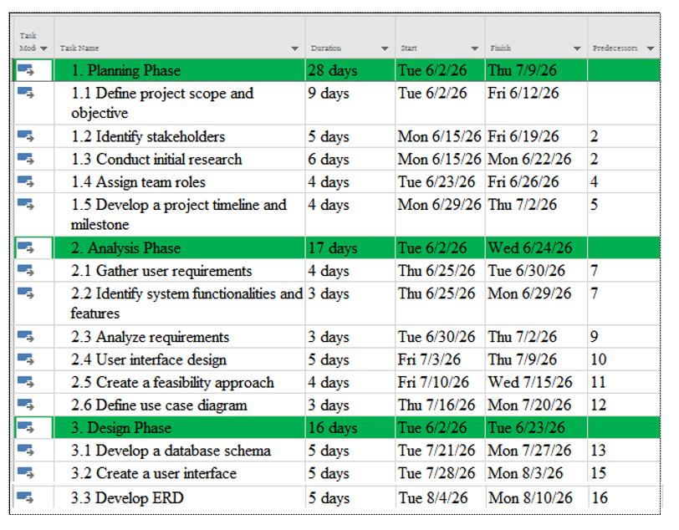
Gantt Chart
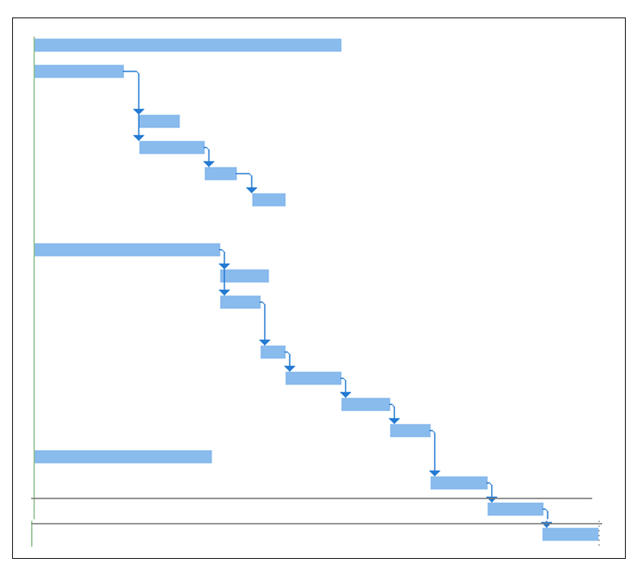
Figure 3: Gantt chart

2.9 Management Issues

2.9.1 Team Configuration and Management
Roles and Responsibilities
Project Manager: Yeshi Lhaden
- Oversee the entire project lifecycle of the Surprize system from planning to deployment.
- Coordinate between team members and stakeholders to ensure project objectives are achieved successfully.
- Monitor project progress, identify potential risks, and implement appropriate mitigation strategies.
- Ensure project deliverables are completed within the scheduled timeline and scope.
UX/UI Designer: Yeshi Lhaden
- Design attractive, user-friendly, and intuitive interfaces for the Surprize platform.
- Create wireframes, prototypes, and visual designs for webpages and mobile screens.
- Ensure consistency in design, branding, and user experience across the platform.
- Collaborate with developers to implement design requirements effectively.
Data Analyst: Sangay Phuntsho
- Analyze user preferences, gift selection trends, and platform usage data.
- Generate insights to improve recommendation accuracy and user satisfaction.
- Monitor platform performance and identify opportunities for enhancement.
- Support data-driven decision-making for future system improvements.
Backend Developers: Sangay Phuntsho, Dechen Pem
- Develop and maintain the backend infrastructure of the Surprize system.
- Manage user authentication, event planning processes, gift recommendation logic, and database management.
- Develop server-side logic and APIs to support frontend functionality.
- Ensure system security, reliability, and efficient data handling.
Frontend Developer: Yeshi Lhaden
- Develop and implement the user interface for the Surprize platform.
- Ensure the website is responsive, user-friendly, and accessible across multiple devices.
- Integrate frontend components with backend services and APIs.
- Implement interactive features such as event planning forms, gift browsing, notifications, and user dashboards.

2.9.2 Communication Plan
Methods and Frequency of Communication
To ensure effective and transparent communication between all stakeholders throughout the development and first deployment of the Surprize platform, the following communication channels will be used:
- Email: The primary channel for formal announcements on project milestones, significant updates on system development (such as the integration of the recommendation engine), deployment schedules, and the publication of critical documents such as user guides and vendor coordination manuals.
- Meetings: Routine team meetings will be held for progress updates, identifying emerging issues (e.g., budget calculation logic or notification delays), resolving them, and brainstorming solutions together as a team. The number and style of meetings will depend on the progress of the project and the needs of the team. Occasional meetings with major stakeholders, such as representatives of the college administration, gift vendors, and delivery partners, will also be scheduled to share experiences and gather suggestions.
- Feedback Mechanisms: Dedicated channels will let users (friends, partners, family planners) and suppliers offer feedback, suggestions, and grievances. These include a feedback form embedded in the web or mobile application, a dedicated email address for support inquiries, and short online questionnaires gathering opinions on platform usability.
- Project Management Tool: A task assignment tool such as Jira will be used for internal task assignment, tracking development progress (e.g., login setup, database schemas, and delivery schedulers), and coordinating due dates, giving transparent visibility of responsibilities and overall project status.
- Collaboration Tools: Platforms such as WhatsApp, Google Meet, and Google Drive will be used for quick communication, instant queries, simple file transfers, and secure data sharing between the development team and key stakeholders.
User Involvement Strategy
This strategy engages users in the development and improvement of the system, so that the platform is highly usable, meets their budget and occasion needs, and is quickly accepted.
- User Testing: Selected users (event planners, friends, family members, and gift suppliers) test new features such as gift tracking, budget filtering tools, and delivery scheduling options before wide release.
- Feedback Forms: Short questionnaires at the end of a scheduled surprise or during application updates collect immediate feedback and satisfaction scores on the planning experience.
Mechanisms for Sharing Ideas
- Suggestion Box: A dedicated section in the app or website where users can suggest improvements, report system bugs, or request new features (e.g., specific event categories or new gift categories).
- Feedback Campaign: Monthly or quarterly email campaigns encouraging users to complete a feedback form (open-ended or rating-based) to improve application performance, data reliability, and delivery services.
- Discussion Forum: Platforms like WhatsApp, Telegram, or a private Facebook group for real-time communication among support staff, delivery courier partners, and admins to share logistics updates and solve coordination issues quickly. Google Drive or shared documents are used for collaborative input on new gift and celebration ideas.
- Verbal Communication: Formal or informal meetings to share and exchange gift curation ideas and ways to improve celebration tracking.

CHAPTER 3: ANALYSIS PHASE

3.1 Requirement Determination
To capture exact user needs, requirement gathering was conducted via interviews and digital questionnaires targeting event planners and retail vendors. This helped identify specific design criteria, such as preferred delivery notifications and budget-tracking constraints, ensuring a data-driven system architecture.

3.2 Functional Requirements
User
- User Registration and Login: Create a verified profile or log in securely using encryption.
- Enter Occasion Details: Input the specific event parameters (e.g., birthday, anniversary, graduation).
- Receive Gift Suggestions: Browse creative ideas dynamically generated by the system.
- Budget Planning: Structure and adjust surprise configurations within a specified financial constraint.
- Schedule Surprise Deliveries: Assign exact delivery timelines and locations for the automated order dispatch.
- Receive Notifications: Acquire real-time updates and status changes regarding event preparation.
Admin
- System Authentication: Securely access back-end data fields via admin credentials.
- Manage Catalog Details: Add, remove, or modify gift items, pricing lists, and recommendation categories.
- Receive Analytics & Alerts: Access system reports, track operational errors, and review user profile safety data.
- Maintain Platform Policies: Update service terms, safety features, and security rules across the network.

3.3 Non-Functional Requirements
- Usability: The interface must be highly intuitive, clean, and easy to use, ensuring stress-free navigation.
- Reliability: The system must function consistently without errors, hanging code, or unexpected crashes.
- Security: User credentials, personal details, and event data must be robustly protected.
- Performance: Core tasks including gift recommendation processing and dashboard updates must respond rapidly under load.
- Availability: The system must remain accessible online 24/7 so users can organize events at any time.

3.4 Requirement Structuring

3.4.1 Process Modeling
Process modeling uses Data Flow Diagrams (DFDs) to show how data moves between the external entities (User, Admin, and Partner), the processes of the Surprize system, and its data stores.
Data Flow Diagram (DFD) Level 0
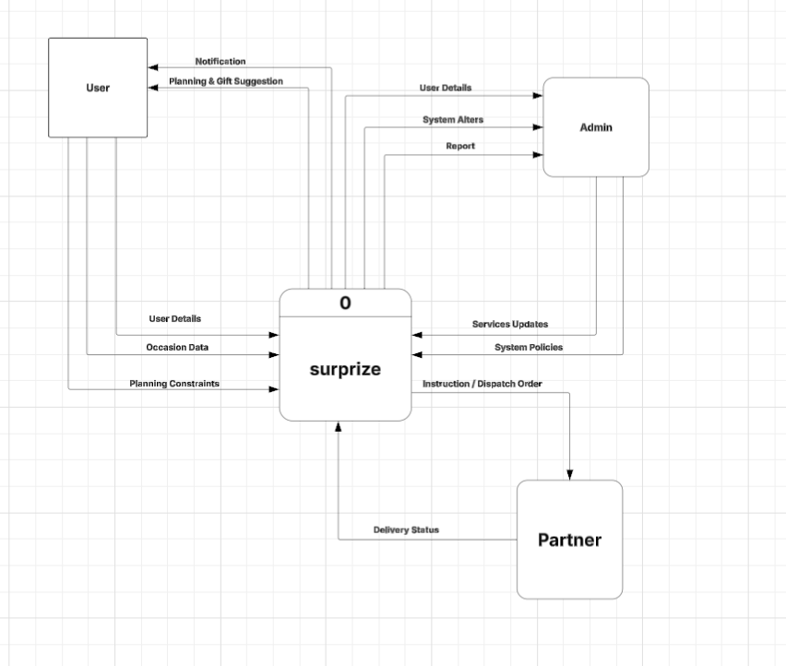
Figure 4: DFD level 0
The level 0 diagram shows Surprize as a single process. The user sends user details, occasion data, and planning constraints, and receives notifications and planning and gift suggestions. The admin receives user details, system alerts, and reports, and sends back service updates and system policies. The partner receives instruction and dispatch orders and returns delivery status.
DFD Level 1
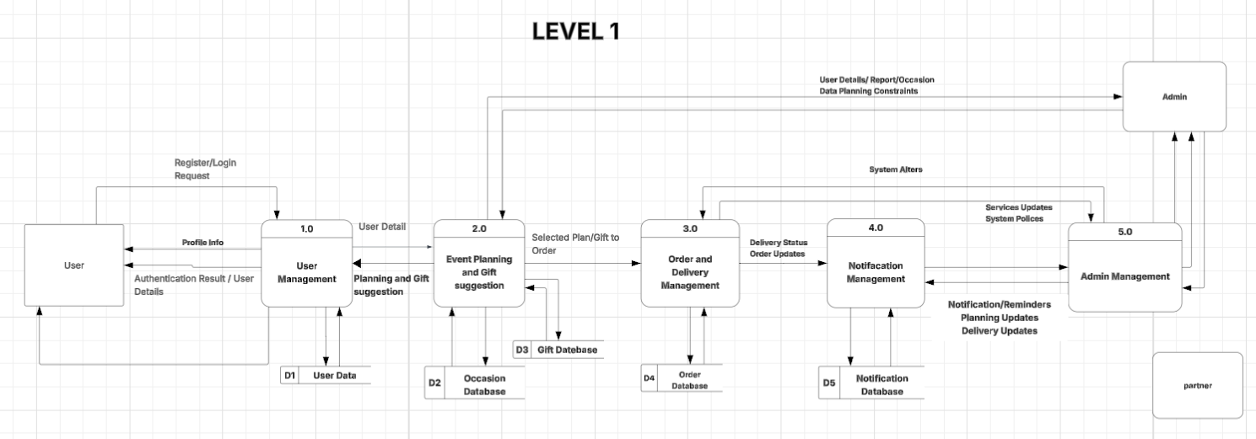
Figure 5: DFD level 1
Level 1 breaks the system into five main processes: 1.0 User Management, 2.0 Event Planning and Gift Suggestion, 3.0 Order and Delivery Management, 4.0 Notification Management, and 5.0 Admin Management. These processes use five data stores: D1 User Data, D2 Occasion Database, D3 Gift Database, D4 Order Database, and D5 Notification Database.
DFD Level 2
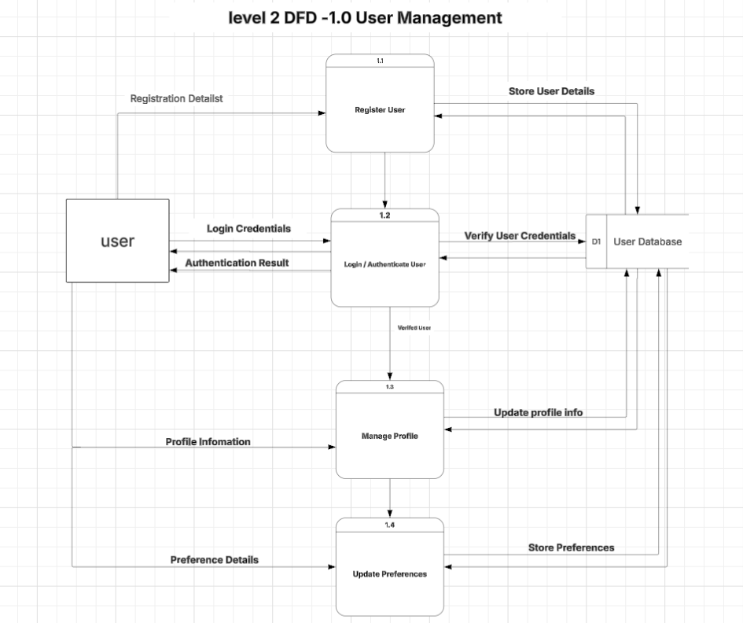
Figure 6: DFD level 2 – 1.0 User Management
Process 1.0 covers registering a user (1.1), logging in and authenticating (1.2), managing the profile (1.3), and updating preferences (1.4). All four steps read from or write to the User Database (D1).
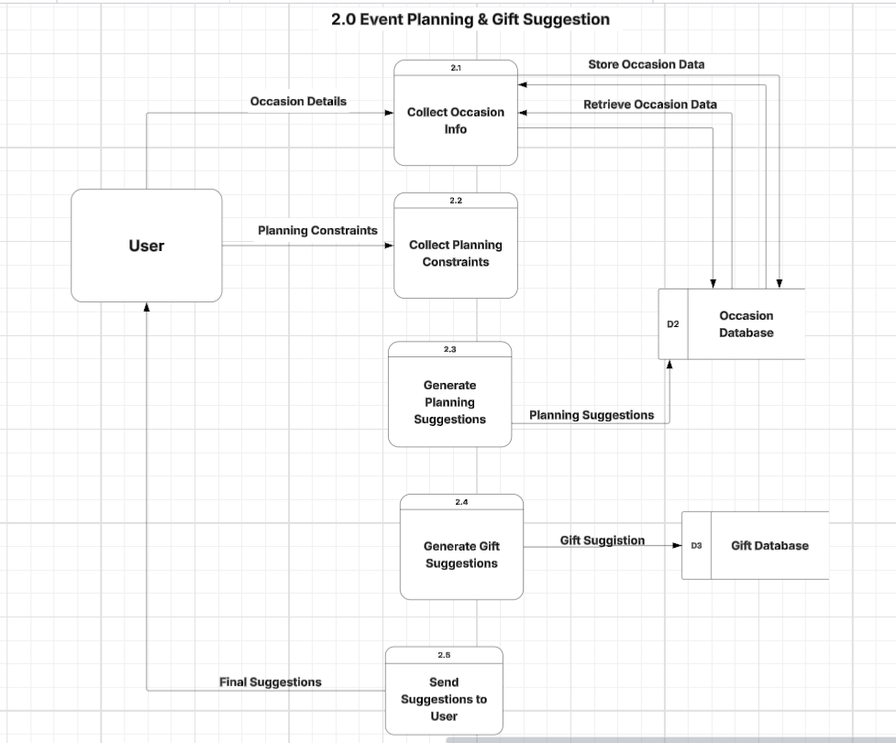
Figure 7: DFD level 2 – 2.0 Event Planning and Gift Suggestion
Process 2.0 collects occasion information (2.1) and planning constraints (2.2), generates planning suggestions (2.3) and gift suggestions (2.4), and sends the final suggestions to the user (2.5). It uses the Occasion Database (D2) and the Gift Database (D3).
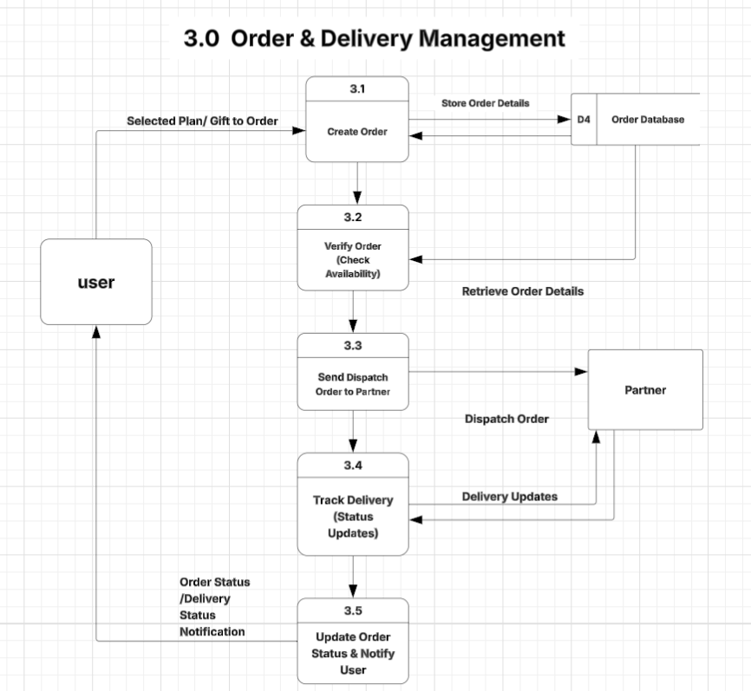
Figure 8: DFD level 2 – 3.0 Order and Delivery Management
Process 3.0 creates an order from the selected plan or gift (3.1), verifies it by checking availability (3.2), sends the dispatch order to the partner (3.3), tracks delivery status updates (3.4), and updates the order status and notifies the user (3.5). Order data is held in the Order Database (D4).
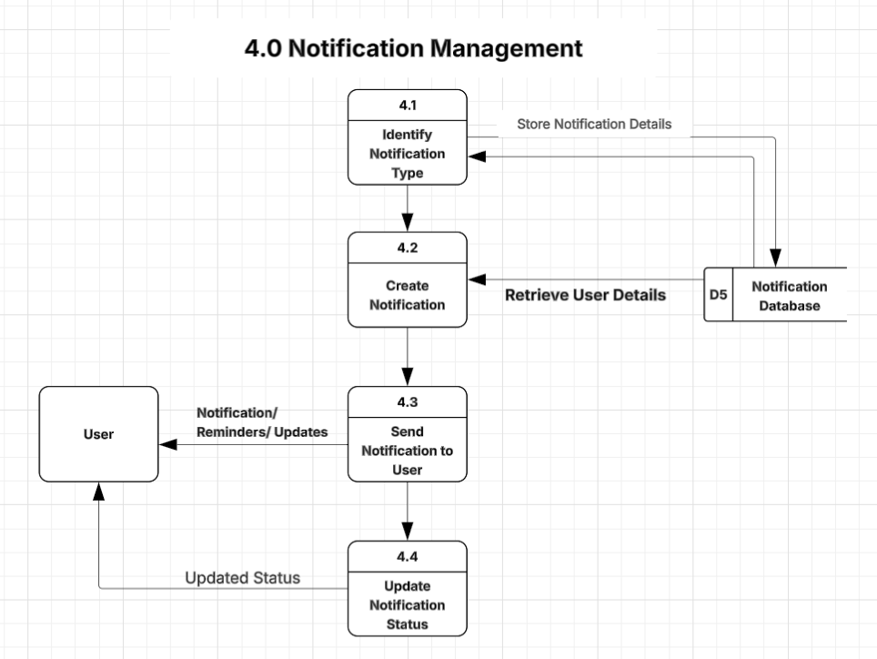
Figure 9: DFD level 2 – 4.0 Notification Management
Process 4.0 identifies the notification type (4.1), creates the notification (4.2), sends it to the user (4.3), and updates the notification status (4.4), using the Notification Database (D5).
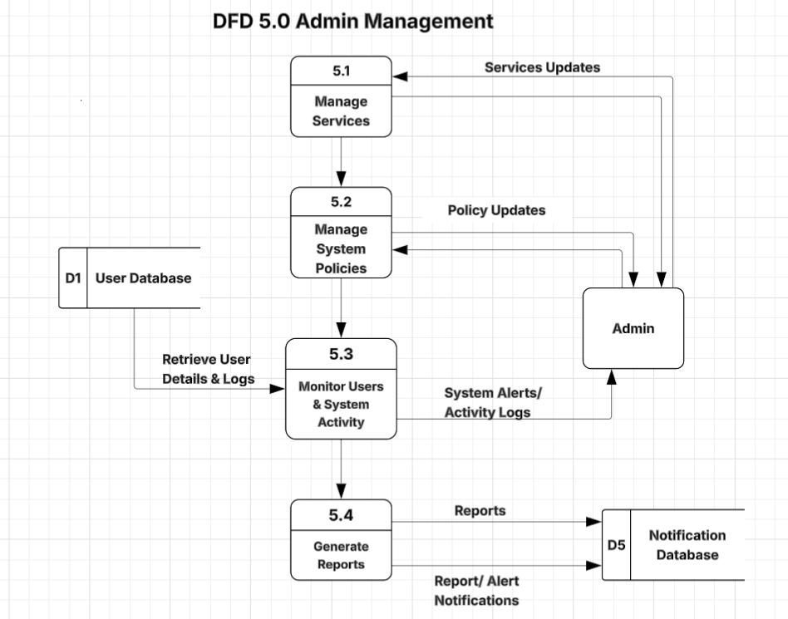
Figure 10: DFD level 2 – 5.0 Admin Management
Process 5.0 lets the admin manage services (5.1) and system policies (5.2), monitor users and system activity (5.3), and generate reports (5.4). It draws on the User Database (D1) and writes alerts and reports to the Notification Database (D5).

3.5 UML-Based Structuring
Use Case Diagram
The use case diagram shows how the main actors—the Users (planners), the Admin, and the Vendor—interact with the system’s main features. Users can explore services, create an account, log in, enter occasion details, add special requests, view automated gift suggestions, and track order and preparation updates so everything stays stress-free. Users can also add, delete, or update their personal profile, keeping their contact and account information correct.
Admins log in and have more control over the backend. They can manage user accounts, view customer event details, organize events, and manage the system inventory by adding, removing, or updating creative gift ideas and celebration packages. They also handle delivery statuses, updating whether a surprise preparation is pending, being packaged, or dispatched, and can adjust delivery schedules as needed to guarantee timely arrivals. The Vendor arranges the gifts and their delivery.
The diagram uses the <<include>> relationship to show that some actions depend on others. For example, entering occasion details includes logging in, and viewing gift suggestions includes entering occasion details. The <<extend>> relationship shows optional behavior: adding special requests extends entering occasion details, and tracking order and preparation extends viewing gift suggestions.
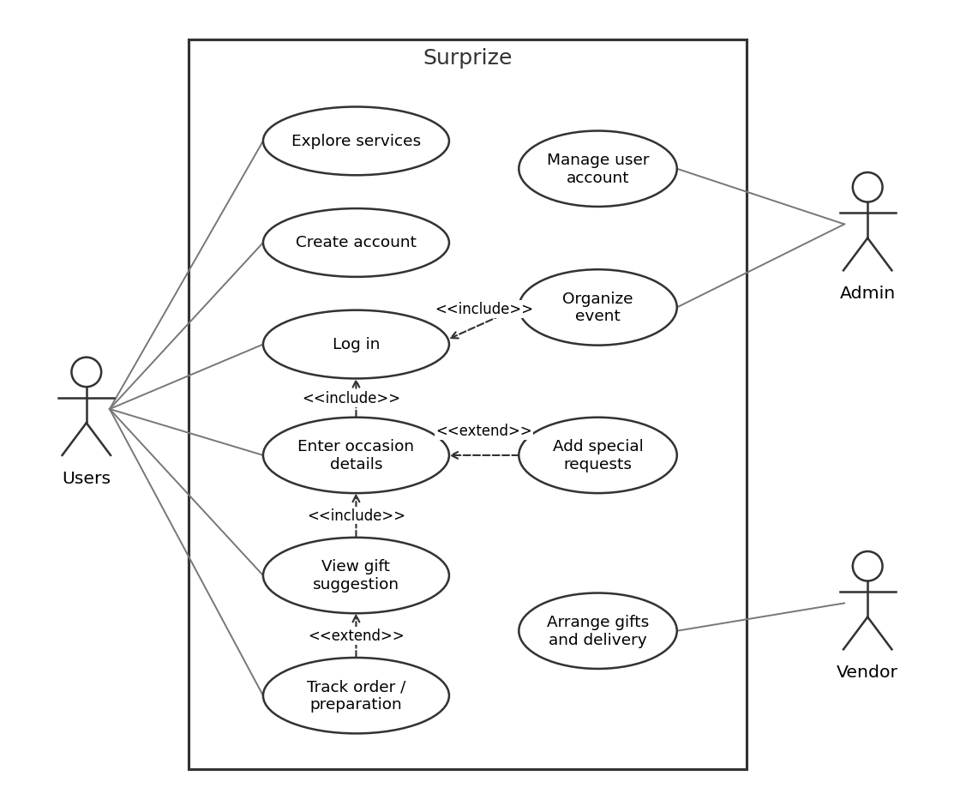
Figure 11: Use case diagram

3.6 Data Conceptual Modeling
Entity Relationship Diagram (ERD)
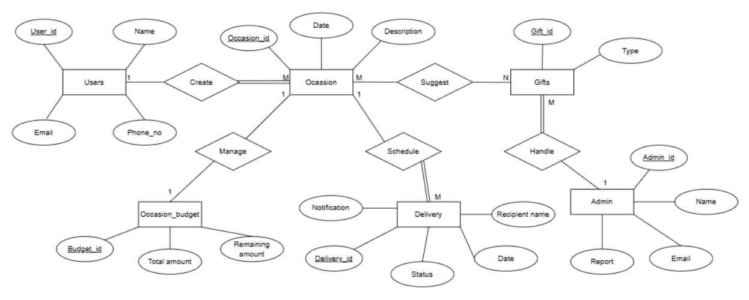
Figure 12: Entity relationship diagram (ERD)
The ERD represents the Surprise Gift Planner system that helps users organize special occasions, manage budgets, select gifts, and schedule deliveries. A user is identified by attributes such as User ID, name, email, and phone number. A user can create multiple occasions, while each occasion is created by only one user. The Occasion entity stores information such as Occasion ID, date, and description. For every occasion, a budget is maintained through the Occasion_Budget entity, which contains the Budget ID, total amount, and remaining amount. This relationship allows users to track and manage expenses for each occasion.
The system also provides gift suggestions for occasions. The Gifts entity contains the Gift ID and gift type. An occasion can have multiple suggested gifts, and a gift may be suggested for multiple occasions, creating a many-to-many relationship. To ensure proper management of gifts, the Admin entity is included. It stores the Admin ID, name, email, and reports. One admin can handle multiple gifts, while each gift is managed by a specific admin.
Additionally, the system supports gift delivery through the Delivery entity, which contains the Delivery ID, recipient name, date, status, and notification. Each occasion can schedule multiple deliveries, but every delivery is associated with a single occasion. Overall, the ERD illustrates how users create occasions, manage budgets, receive gift recommendations, coordinate with administrators, and arrange deliveries.

3.7 Normalization
The tables below are the initial and normalized tables derived from the ERD.
Table 3: Admin / Gift Vendor
Attribute | Data Type | Constraints
Admin_id | INT | Primary Key
Admin_name | VARCHAR (100) | Not Null
Email | VARCHAR (100) | Unique, Not Null
Report | VARCHAR (255) | Null

Table 4: Customer (The Planner)
Attribute | Data Type | Constraints
Customer_id | INT | Primary Key
Name | VARCHAR (100) | Not Null
Email | VARCHAR (100) | Unique, Not Null
Contact_no | VARCHAR (50) | Not Null

Table 5: Occasion / Event Details
Attribute | Data Type | Constraints
Occasion_id | INT | Primary Key
Customer_id | INT | Foreign Key (Customer.Customer_id)
Date | DATE | Not Null
Description | VARCHAR (255) | Null

Table 6: Occasion Budget
Attribute | Data Type | Constraints
Budget_id | INT | Primary Key
Occasion_id | INT | Foreign Key (Occasion.Occasion_id)
Total_amount | DECIMAL (10,2) | Not Null
Remaining_amount | DECIMAL (10,2) | Not Null

Table 7: Gift
Attribute | Data Type | Constraints
Gift_id | INT | Primary Key
Type | VARCHAR (100) | Not Null
Admin_id | INT | Foreign Key (Admin.Admin_id)

Table 8: Occasion_Gift (Relationship Table)
Attribute | Data Type | Constraints
Occasion_id | INT | Primary Key, Foreign Key (Occasion.Occasion_id)
Gift_id | INT | Primary Key, Foreign Key (Gift.Gift_id)

Table 9: Delivery
Attribute | Data Type | Constraints
Delivery_id | INT | Primary Key
Occasion_id | INT | Foreign Key (Occasion.Occasion_id)
Recipient_name | VARCHAR (100) | Not Null
Date | DATE | Not Null
Status | VARCHAR (255) | Not Null
Notification | VARCHAR (255) | Null

CHAPTER 4: DESIGN PHASE

4.1 Description
This chapter presents the design of the Surprize system. The system is developed to make planning and sending surprises easy, fun, and organized. It provides a simple and user-friendly interface for users to select gifts, customize surprises, and schedule delivery for special occasions.
The system design focuses on improving user experience by allowing easy browsing of gift items, planning surprises based on budget, selecting delivery dates, and adding personal messages. It also includes order confirmation and order tracking features.
Each design in this chapter shows how different parts of the system are connected, such as users, orders, gift items, and delivery partners. Special attention is given to features like personalized gift suggestions with AI, multi-item selection, advance ordering, and real-time delivery updates. The system also helps the admin by making it easier to manage orders, update products, and monitor delivery services.
Overall, this design creates a smooth, user-friendly, and modern solution for planning and managing surprises efficiently.

4.2 User Interface Design
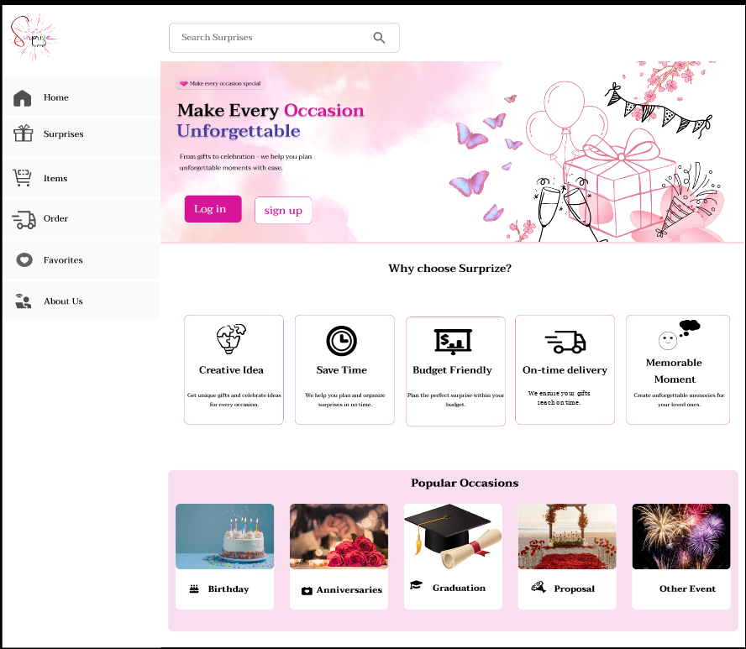
Figure 13: Startup page
The startup page is the home page of the Surprize system. It shows prominent “Log in” and “Sign up” buttons that guide users to begin the surprise process.
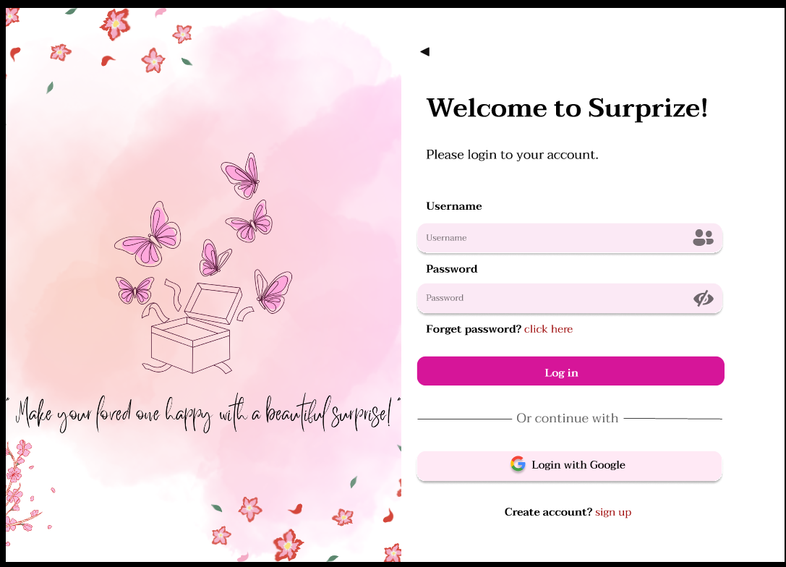
Figure 14: Login page
On the login page, users enter their username and password to log in. Users can also log in with their Google account, and new users can create an account from the same page.
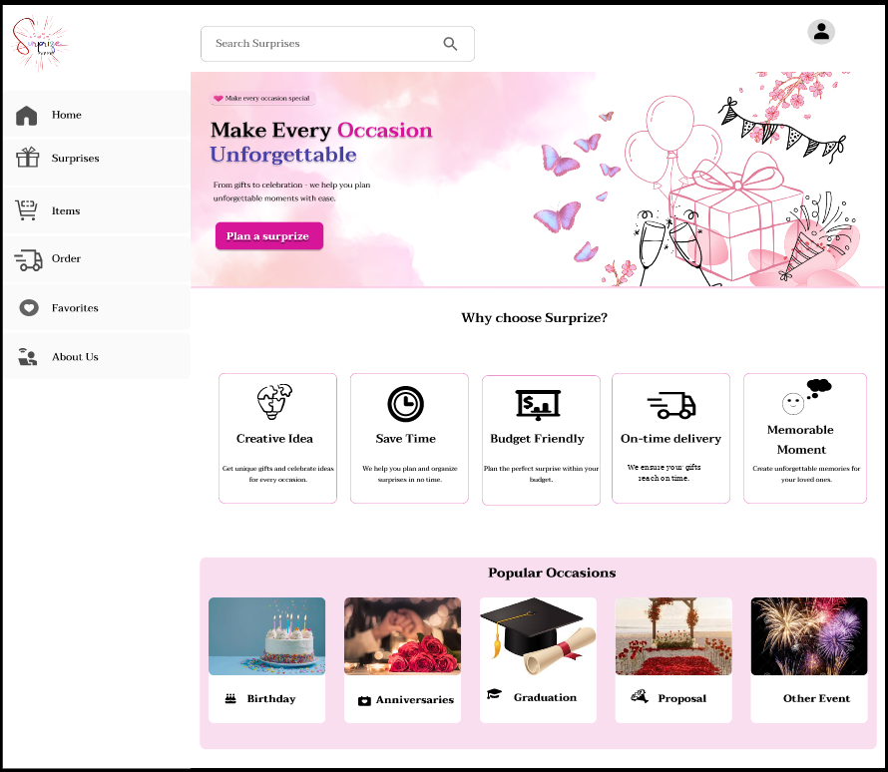
Figure 15: Home page
The home page has a clean and easy-to-use design that shows what the platform offers. At the top there is a profile icon and a search bar, and a “Plan a surprize” button starts the planning process.
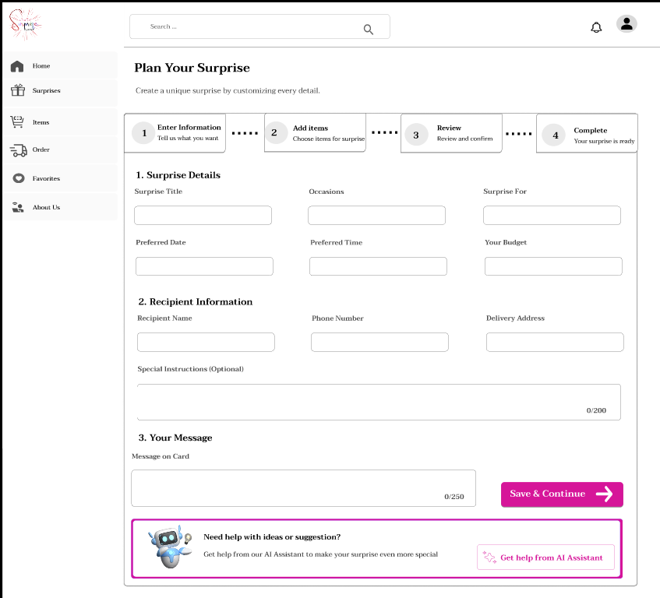
Figure 16: Plan your surprise page
The planning page is a form where users enter surprise details, recipient information, preferred date and time, budget, and a custom message. It also shows the steps for completing the surprise plan and an AI assistant section for help and suggestions.
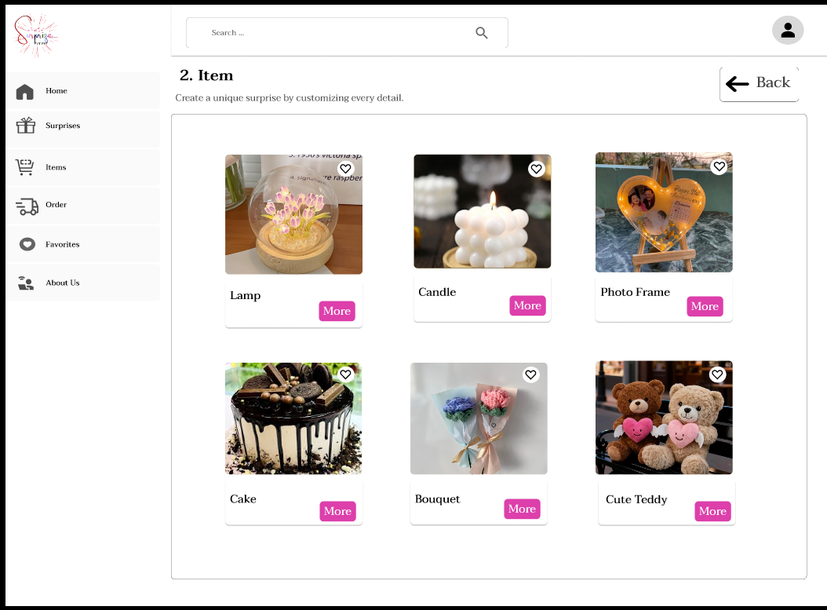
Figure 17: Item page
The item page lets users choose surprise gifts such as lamps, candles, photo frames, cakes, bouquets, and teddy bears. Each item has an image and a “More” button to view details, and a sidebar menu supports navigation.
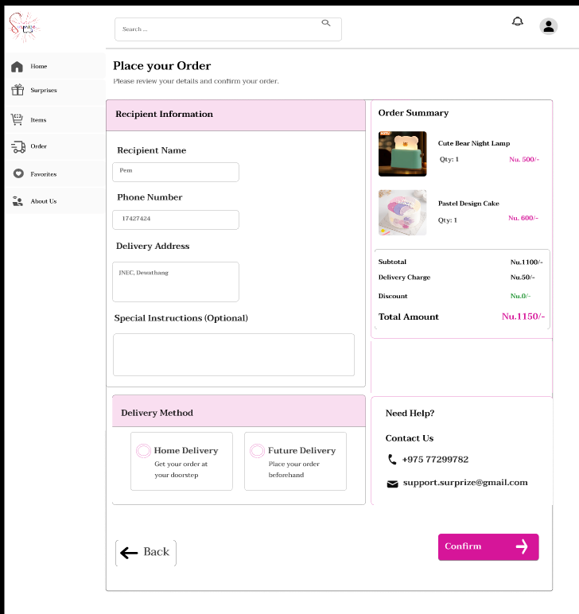
Figure 18: Order page
The order page confirms the order. Users enter recipient details such as name, phone number, address, and special instructions. The page also shows the order summary with the subtotal, delivery charge, discount, and total amount, the delivery options (home delivery or future delivery), and a confirm button to place the order.
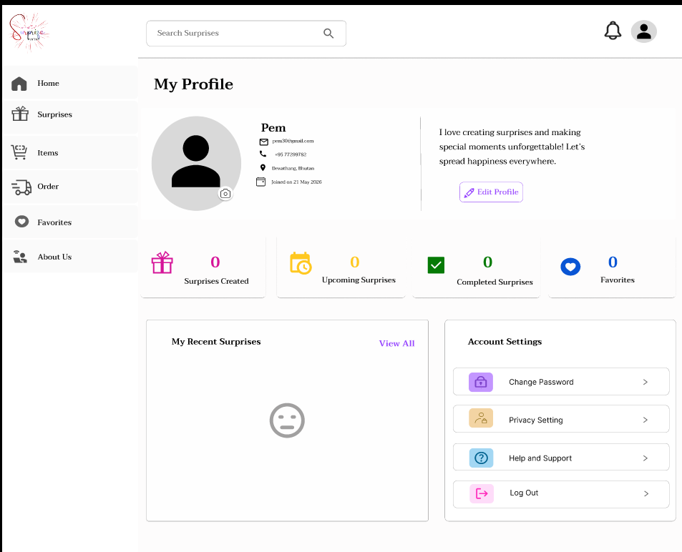
Figure 19: Profile page
The profile page shows personal information, profile editing options, surprise activity statistics, recent surprises, and account settings such as change password, privacy settings, help and support, and log out.
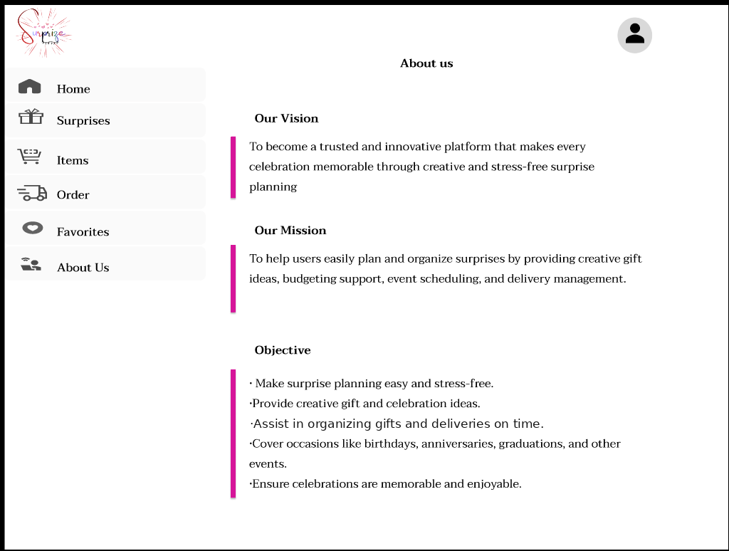
Figure 20: About us page
The About Us page explains the platform’s vision, mission, and objectives. It describes the goal of helping users plan memorable surprises easily through creative ideas, organization, and delivery support.

CHAPTER 5: IMPLEMENTATION, TESTING, AND MAINTENANCE

5.1 Coding, Verification & Validation
Coding is the process of developing the Surprize platform based on the system design and requirements. Developers create features such as user registration and login, event planning forms with budget management, gift recommendation, delivery scheduling, and notification tracking. The frontend is developed using HTML, CSS, JavaScript, or React, while the backend uses technologies like PHP, Node.js, or Python. User data such as account details, event history, and delivery records are stored securely in databases like MySQL or Firebase.
Verification ensures that the system is developed correctly by testing different functions and modules. Developers perform unit testing, integration testing, and code reviews to check the system’s quality, performance, and security. Features like login, delivery scheduling, and gift recommendations are tested to ensure they work properly together.
Validation ensures that the system meets user expectations and provides a smooth user experience. Real users test the platform to check its usability and functionality. Feedback from User Acceptance Testing (UAT) is used to improve the system and ensure users can easily plan and manage surprises.

5.2 Installation and Documentation
Installation is the process of deploying the Surprize platform on a server or cloud environment so users and vendors can access it through web browsers and mobile devices. It includes setting up the backend server, connecting the database, and ensuring the system works smoothly and reliably.
Documentation is divided into two parts:
- User documentation provides simple step-by-step guides for customers to register, plan occasions, manage budgets, select gifts, and track deliveries.
- Technical documentation is prepared for developers and IT staff and includes system architecture, database structure, installation guides, API integration details, and troubleshooting methods to support future maintenance and upgrades.

5.3 Testing
Testing is an important process in developing the Surprize platform to ensure the system works correctly for users and delivery partners. It helps identify and fix errors early, providing a smooth and stress-free user experience.
Black-box testing checks the system from the user’s perspective without looking at the internal code. Testers verify features such as login, budget filtering, milestone setup, and tracking functions to ensure they work properly and are easy to use.
White-box testing focuses on the internal code and system logic. Developers test functions like recommendation algorithms, database operations, and security features to ensure the system is secure, reliable, and free from hidden errors.
By combining black-box and white-box testing, the Surprize platform becomes secure, dependable, and efficient, ensuring a reliable experience for users.

5.3.1 Types of Testing
Different types of testing are used to ensure the platform is reliable, efficient, and user-friendly:
- Unit Testing: The first step, where individual components are isolated and tested separately. For example, we test if the “Schedule Delivery” button correctly captures timestamps or if the login function properly accepts valid credentials.
- Integration Testing: Checks whether different parts of the system work well together. For example, it ensures that once an occasion budget is entered, the recommendation engine updates and filters gift suggestions to match that constraint.
- Functional Testing: Verifies that all key features—like account creation, gift selection, budget organizing, delivery scheduling, and milestone notifications—perform exactly according to the design requirements.
- System Testing: Involves testing the entire application as a whole. A tester acts as a real customer, executing the complete workflow of logging in, entering a birthday milestone, picking a suggested gift package within a budget, placing a test order, and enabling tracking updates to ensure the entire pipeline works smoothly.
- Stress Testing: Checks how the system handles heavy usage, especially during peak holiday or festive seasons, when many users are scheduling surprises simultaneously. The platform must function smoothly without slowing down or crashing.
- Performance Testing: Measures how quickly the application responds to user actions. For example, it tests how fast gift suggestions load when multiple planners are querying the recommendation database concurrently.
- Usability Testing: Focuses on how easy and intuitive the app is for users. It checks whether individuals can quickly browse ideas, plan surprises, and confirm logistics without confusion.
- Acceptance Testing: Conducted to confirm that the platform satisfies all original parameters, verifying that registration, automated gift algorithms, delivery schedulers, and notification alerts are ready for launch.
- Regression Testing: Ensures that new updates or feature additions (such as adding new vendor categories) do not break existing, fully functional modules like user login or budget tracking.
- Beta Testing: Involves releasing the system to a small group of active users and partner vendors to gather practical feedback before the official launch. This helps identify real-world delivery coordination or software issues that might not be caught during internal technical testing.
Among all these methods, Functional Testing, System Testing, Usability Testing, and Beta Testing are the most effective and practical for the Surprize platform, as they directly validate real-world scenarios, improve design navigation, and ensure the system meets daily user needs.

5.4 Maintenance
Maintenance refers to the ongoing process of updating and improving the system after it has been launched. For the Surprize platform, maintenance is essential to ensure that customers can coordinate celebrations smoothly and without technical glitches. Regular maintenance helps the application stay reliable, secure, and user-friendly as technology and user gift preferences evolve.

5.4.1 Types of Maintenance
To keep the Surprize platform in excellent working condition, four types of maintenance are required:
- Corrective Maintenance: Involves fixing bugs or defects that emerge after the platform has been deployed. For example, if a real-time notification alert fails to send or a delivery status does not update correctly, developers must locate and repair the bug immediately to restore full functionality.
- Adaptive Maintenance: Performed when the external operating environment changes. For example, when mobile operating systems (iOS/Android) update, web browsers evolve, or third-party notification (SMS/email) services change their interfaces, the Surprize app must be updated to maintain seamless compatibility.
- Perfective Maintenance: Aimed at enhancing the system based on user and vendor feedback. For instance, customers might suggest a “gift calendar” option to remember annual birthdays, or vendors might request a bulk dashboard for tracking deliveries. These upgrades improve the usability and performance of the application over time.
- Preventive Maintenance: Aims to prevent future problems by regularly checking and updating the platform. Operations include cleaning up old recommendation code, applying security patches, and reviewing data encryption protocols to reduce system crashes, data exposure, or sluggish response times.

5.4.2 Cost of Maintenance
The cost of maintenance refers to the total time, money, and effort required to keep the Surprize system running efficiently and reliably over time. This includes fixing code bugs, updating recommendation databases, improving security, and ensuring the application scales to meet user needs.
In a gift ordering and planning system, maintenance is highly critical due to daily user interactions and time-sensitive milestones. For instance, if the application experiences high latency during holiday peak hours or tracking notifications fail close to a surprise delivery time, these issues need immediate technical resolution to preserve user trust. Without regular validation and technical support, the application could face security vulnerabilities or system crashes, which directly harm user satisfaction and vendor relationships. Additionally, adding new features over time, such as gift ratings or new vendor categories, adds to recurring development and testing costs. To minimize these costs, the system should be regularly monitored, kept secure, and supported with active assistance.

5.4.3 Managing Maintenance
Managing the maintenance of the Surprize platform is essential to ensure smooth operations and a consistently positive user experience. If critical issues like slow gift loading, budget calculation errors, or failed delivery notifications are not addressed promptly, they can lead to customer frustration and reduce overall trust in the system.
To manage this effectively, a clear maintenance plan must be in place. This includes regularly monitoring infrastructure performance, fixing system bugs, and refining features based on user feedback. Communication between system administrators, partner gift vendors, and customers must remain clear—especially regarding package availability, delivery updates, and potential logistical delays. A support system should be permanently accessible within the application for users to report errors or suggest upgrades, ensuring the platform remains reliable, secure, fast, and beneficial for everyone involved.

CHAPTER 6: CONCLUSION
The Surprize system is designed to make planning and sending surprises easy, efficient, and enjoyable. The system provides a user-friendly platform where users can browse gifts, customize their surprises, and schedule deliveries for special occasions. The project integrates key features such as product selection, add to cart, order management, and delivery tracking. It also includes advanced features like AI-based gift suggestions and personalized options, which enhance the overall user experience.
Through proper system design, including DFDs, database normalization, and UI design, the system ensures smooth data flow, reduced redundancy, and efficient performance. The admin side also benefits from simplified management of orders, products, and delivery processes. Overall, the Surprize system offers a modern and reliable solution for surprise planning, making it convenient for users while improving service efficiency. This project demonstrates how technology can be used to create meaningful and memorable experiences.

STATEMENT OF WORK: PROJECT CHARTER
Project Name: Surprize
Project Manager: Yeshi Lhaden
Users: All the people
Project Start/End (Projected):
- Beginning phase of project: Second semester (first year)
- Final phase of project: Second semester (first year)
Project Overview
- An online platform designed to help users plan and send surprises easily.
- Allows users to browse gifts, customize surprises, and schedule deliveries for special occasions.
- Improves the overall experience by providing AI-based gift suggestions and order tracking.
- Supports a simple, user-friendly, and efficient system for managing surprise planning and delivery.
Objective
- Make surprise planning easy and stress-free.
- Provide creative gift and celebration ideas.
- Assist in organizing gifts and deliveries on time.
- Cover occasions like birthdays, anniversaries, graduations, and other events.
- Ensure celebrations are memorable and enjoyable.
Key Assumptions
- Users will actively use the platform to plan and send surprises.
- Accurate product details and user inputs will be provided.
- Real-time updates for orders, delivery status, and notifications.
- Delivery partners will ensure timely and reliable delivery.
Stakeholders and Responsibilities
Stakeholder | Role | Responsibility | Signature
Tashi Yangchen | Module Tutor | Project progress coordinator
Karma Jigme Wangchuk | IT Support Specialist | Support for team members
Yeshi Lhaden | Scrum Master | Manage project and coordinate team and stakeholders | 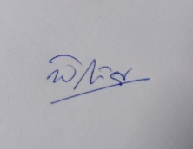
Yeshi Lhaden | Designer | Design user-friendly interfaces and work with frontend developers
Sangay Phuntsho | Data Analyst | Analyzes platform data, improves matching accuracy, and maintains data quality | 
Sangay Phuntsho / Dechen Pem | Backend Developers | Develop backend systems, manage databases and authentication, and support platform functionality | 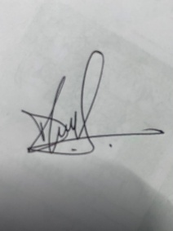
Yeshi Lhaden | Frontend Developer | Design the user interface, ensure responsiveness, and integrate frontend with backend services

