# Objective

This example demonstrates a simple Heart Rate Monitor data logging application.

|  |
| --- |
|  |

# Overview

This example project demonstrates the BLE Heart Rate Monitor data logging application. In this project, the PSoC 4 BLE device implements a simple BLE heart rate sensor and simulates the data for Heart Rate Measurement Characteristic. When the connection is established and notifications are enabled, device transmits the simulated data as notifications and also stores it in an external low-power F-RAM.

# Requirements

**Design Tool:** [PSoC Creator 3.1](http://www.cypress.com/PSoCCreator/) CP1, [CySmart 1.0](http://www.cypress.com/cysmart/)

**Programming Language:** C (GCC 4.8.4 – included with PSoC Creator)

**Associated Devices:** All PSoC 4 BLE devices

**Required Hardware:** [CY8CKIT-042-BLE Bluetooth® Low Energy (BLE) Pioneer Kit](http://www.cypress.com/cy8ckit-042-ble/)

# Hardware Setup

The BLE Pioneer Kit has all of the necessary hardware required for this lab. In this setup, following connections are done in the BLE Pioneer Kit.

* F-RAM is connected port 5 pin 0 and port 5 pin 1.
* The UART RX pin is connected to port 1 pin 4.
* The UART TX pin is connected to port 1 pin 5.
* The red LED (port 2 pin 6) is used to indicate the BLE disconnection state.
* The green LED (port 3 pin 6) is used to indicate the advertising state.
* A mechanical button (port 2 pin 7) is used to wake up the device and start re-advertising.

Figure 1: Block Diagram

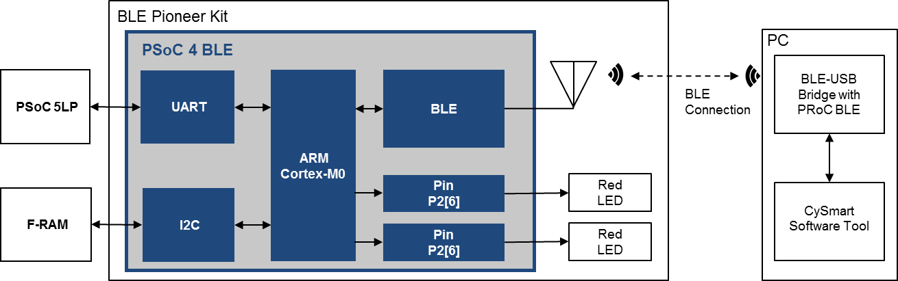

# PSoC Creator Schematic

Figure 3. PSoC Creator Schematic



# Project Description

This project implements a simple BLE Heart Rate Sensor operating as a GAP Peripheral and a GATT Server. On power up, it initializes the BLE stack and and starts advertising, indicated by the blinking green LED. Once a connection request is established, PSoC 4 BLE device initiates the GPA connection procedure and establishes the connection. Device starts simulating the heart rate value, once notifications are enabled. At every notification interval, 1-second, device sends the simulated heart information to the GATT Client and stores the data in F-RAM. This data is also read back and transmitted via UART on the COM port.

Once, the memory gets full device stops logging the data. User can reset the memory by pressing **r** or **R** in the COM port terminal.

# Expected Results

The project sends the Heart Rate and Battery Level notifications to the Central Client device which can show them for user. LEDs are blinking as described in Project Description section. Below figure shows the snapshot with CySmart mobile app.

|  |  |  |
| --- | --- | --- |
| IMG_0010  Figure 3. CySmart iOS app |  | Screenshot_2014-12-05-10-20-32  Figure 4. CySmart Android app |

Simulated heart rate information is also stored in F-RAM. Stored value is read back and sent over UART to PC for debugging.

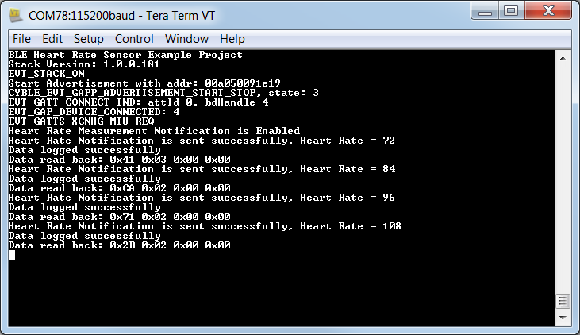

# Related Documents

Table 2 lists all relevant application notes, code examples, knowledge base articles, device datasheets, and Component / user module datasheets.

Table 2. Related Documents

| Document | Title | Comment |
| --- | --- | --- |
| [AN91267](http://www.cypress.com/go/AN91267/) | Getting Started with PSoC 4 BLE | Provides an introduction to PSoC 4 BLE device that integrates a Bluetooth Low Energy radio system along with programmable analog and digital resources. |
| [AN91445](http://www.cypress.com/go/AN91445/) | Antenna Design Guide | Provides guidelines on how to design an antenna for BLE applications. |