SIH 2022 Test Cases

|  |  |  |  |
| --- | --- | --- | --- |
| **Sr No.** | **Name** | **Class** | **Email Id** |
| 1 | User1 | TEIT | user1@sih22.in |
| 2 | User2 | BEIT | user2@sih22.in |
| 3 | User3 | TEIT | user3@sih22.in |

Table 1.1 : Test Table

* This is text with red color
* This is text with green backgroud and black font color
* **This is the text with bold statement**
* This is the text with **partial bold** statement
* This is the text with ALL CAPITAL letter
* This is **mixed** statement with ALL cases.
* This is seperator

-----------------------------------------------------------------------------------------------------------------------

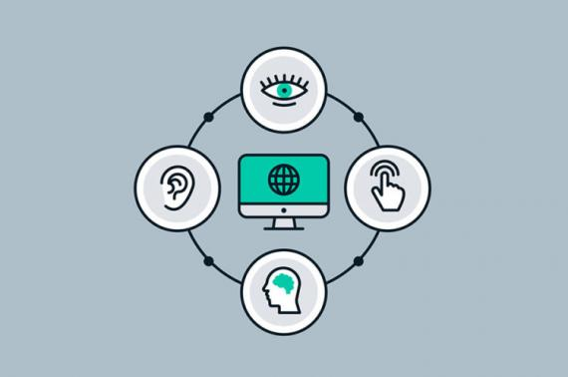

Image : Web Accessibility