**MICROWAVE OVEN:**

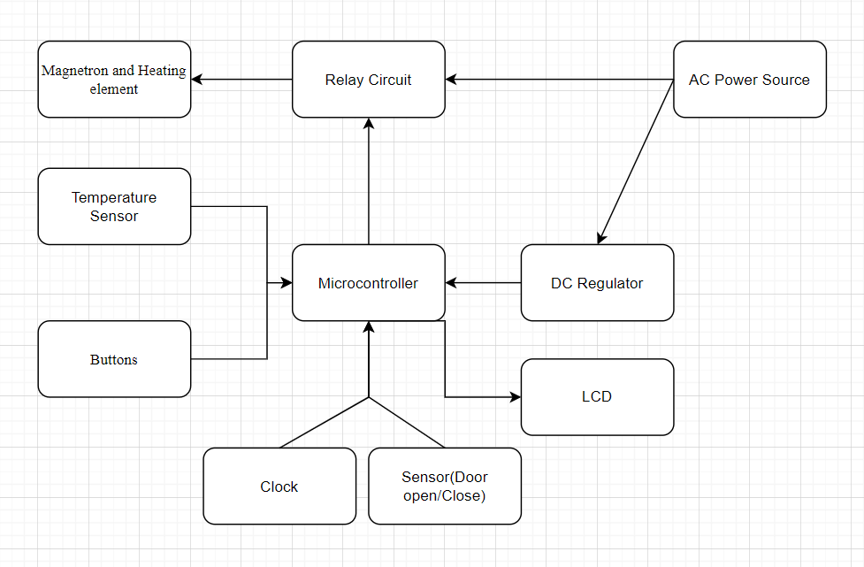

MAGNETRON:

A magnetron is a device that uses the interaction of a stream of electrons, guided by a magnetic field, with cavities within a block of copper to produce microwave radiation (Basically it cooks food).

**LIGHT-EMITTING DIODE:**

A light-emitting diode (LED) is a semiconductor light source that emits light when current flows through it.

TEMPERATURE SENSOR:

Temperature sensor is a device, used to**measure the temperature using an electrical signal.**

MICROCONTROLLER:

It is the brain of the whole system. All the decision making and calculations are done by it.

RELAY:

A **relay** is an electromagnetic switch that opens and closes **circuits.**

SENSOR (DOOR OPEN/CLOSE):

The sensor detects weather door is closed or not, If the door is not closed properly, microwave will not start cooking.

AC POWER SOURCE:

The main source of energy which will provide power to the system.

DC VOLTAGE REGULATOR:

A DC Voltage Regulator is a device which **maintains the output voltage** of an ordinary power supply constant irrespective of load variations or changes in input A.C voltage.

CLOCK:

The micro-controller has a clock simply because it executes **sequential logic.** Microcontrollers need to use a clock because they need to be able to respond to events that may occur at any time.

BUTTONS:

Helps us to set Temp., Time, Mode of cooking and helps the user to operate the microwave oven.