PROJECT : AUTOMATING EMPLOYEE DATA

TEAM MEMBERS
- M.K Baavana
- T. Durga
- M. Kiruthiga
- S. Kiruthiga
PROJECT REPORT

- INTRODUCTION
- IDEATHON PHASE
- REQUIREMENT ANALYSIS
- PROJECT DESIGN PHASE
- PROJECT PLANNING PHASE
- PROJECT DEVELOPMENT PHASE
- ADVANTAGES & DISADVANTAGES
- PROJECT DOCUMENTATION
- CONCLUSION

1. INTRODUCTION

1.1 Project Overview
Automating Employee Data is a system developed to manage and organize employee information efficiently using the ServiceNow platform. In many organizations, employee data such as personal details, department information, and job roles are handled manually, which can lead to errors and delays. This project aims to automate the process of storing and managing employee data using ServiceNow’s workflow automation capabilities. The system allows users to enter employee information through a form, store the data in a database table, and process it automatically using workflows. By automating employee data management, organizations can improve efficiency, reduce manual effort, and maintain accurate records of employee information.

1.2 Purpose
The main purpose of this project is to automate the process of managing employee data in an organization. Instead of manually entering and maintaining records, the system provides an automated platform where employee details can be stored, updated, and managed efficiently. The system also helps HR departments reduce paperwork, minimize errors, and improve data accessibility. Using ServiceNow automation features such as forms, tables, and workflows, the project simplifies employee data management and enhances productivity.

2. IDEATION PHASE

2.1 Brainstorming – Idea Generation – Prioritization
Brainstorming is the process of generating ideas and exploring possible solutions for a problem. In this phase, different ideas were discussed to identify an effective solution for managing employee data in organizations. Initially, several ideas were generated to improve the process of handling employee information. These ideas included developing a digital database for employee records, creating an automated system for employee data entry, implementing workflows for approval processes, and generating automated notifications for updates. After generating multiple ideas, the most suitable solution was selected based on feasibility and efficiency. The idea of Automating Employee Data using ServiceNow was prioritized because it allows organizations to store and manage employee information efficiently through automation. This solution reduces manual work, improves accuracy, and helps organizations maintain organized employee records. Thus, the brainstorming process helped identify automation as the best solution for managing employee data.

2.2 Define Problem Statement
In many organizations, employee data is still managed manually using spreadsheets or paper-based records. This traditional method is time-consuming and prone to errors. Managing a large number of employee records manually becomes difficult for HR departments and can lead to data inconsistencies and delays. Manual data handling also makes it difficult to retrieve employee information quickly when required. Additionally, updating records and maintaining accuracy becomes challenging when the system is not automated. Therefore, there is a need for a system that can automate the process of storing, managing, and updating employee data. The proposed project aims to develop an automated employee data management system using the ServiceNow platform. This system will allow users to enter employee details through a form, store them in a database, and automate the processing of employee information efficiently.

2.3 Empathy Map Canvas
The empathy map canvas is a tool used to understand the needs, thoughts, and challenges of users interacting with the system. In this project, the primary users are HR staff and administrators who manage employee information.
Says: Users say that managing employee data manually is time-consuming and difficult. They need a system that simplifies the process of storing and retrieving employee records.
Thinks: Users think that an automated system would make their work easier and reduce errors in maintaining employee data.
Does: Currently, users store employee details using spreadsheets or manual records. They update employee information manually whenever changes occur.
Feels: Users feel frustrated when managing large amounts of employee data manually because it requires significant effort and time. By understanding the user’s needs and challenges, the proposed system is designed to automate employee data management and provide an efficient and user-friendly solution.

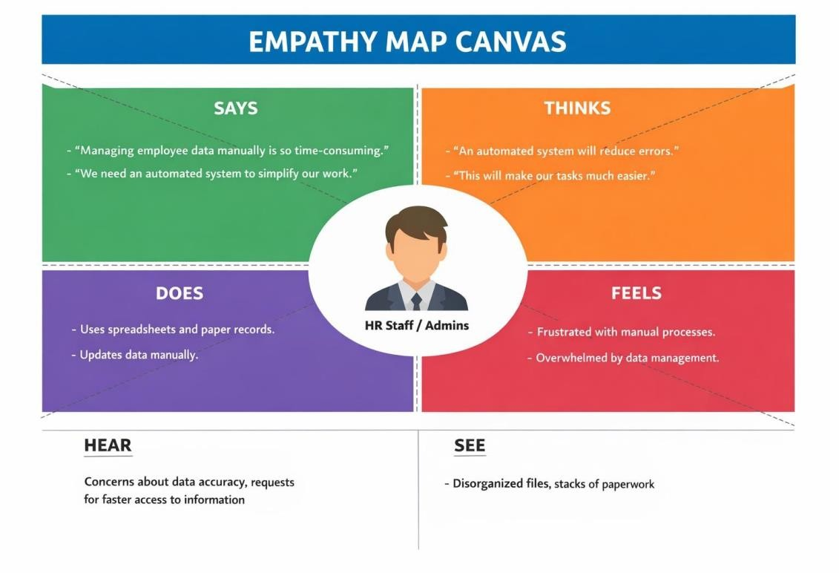

3. REQUIREMENT ANALYSIS

3.1 Data Flow Diagrams and User Stories
A Data Flow Diagram (DFD) is used to represent how data moves through the system. It shows the flow of information from the user to the system and how the data is processed and stored. In the Automating Employee Data system, the process begins when the user enters employee information through a ServiceNow form. The system then processes the entered data using automation workflows. After processing, the employee data is stored in a ServiceNow database table. The system may also generate notifications or updates for administrators when employee data is created or modified. The main components of the Data Flow Diagram include input, process, storage, and output. The input consists of employee details entered by the user. The process involves the automation workflow that manages the employee information. The storage is the ServiceNow database where employee records are stored. The output is the processed employee data and notifications generated by the system. User stories describe how users interact with the system and what they expect from it. In this project, the primary users are HR staff and administrators.
Some user stories for the system include:
- As an HR administrator, I want to enter employee details into the system so that employee information can be stored digitally.
- As an HR manager, I want to view employee records easily so that I can manage employee information efficiently.
- As a user, I want the system to automatically store employee data so that manual record keeping is reduced.
- As an administrator, I want to receive notifications when employee records are created or updated.
These user stories help in understanding the requirements of the system and guide the development process.

3.2 Solution Requirements
Solution requirements describe the functionalities and characteristics that the system must have in order to operate effectively.

Functional Requirements
- The system should allow users to enter employee details through a form.
- The system should store employee information in a ServiceNow database table.
- The system should automatically process employee data using workflow automation.
- The system should allow administrators to view and manage employee records.

Non-Functional Requirements
- The system should be user-friendly and easy to operate.
- The system should ensure data accuracy and reliability.
- The system should provide secure storage for employee information.
- The system should perform efficiently and respond quickly to user requests.
These requirements help ensure that the system meets user needs and performs effectively.

3.3 Technology Stack
The Automating Employee Data system is developed using the ServiceNow platform and its built-in development tools. ServiceNow is a cloud-based platform that allows organizations to automate workflows and manage business processes efficiently. In this project, the ServiceNow Developer Instance is used as the development environment for creating the application. ServiceNow tables are used to store employee information such as employee name, department, designation, and other related details. These tables function as the database for the system. Forms are used to collect employee information from users. Users can enter employee details through these forms, and the data is automatically stored in the database. Workflow automation or Flow Designer is used to automate the processing of employee data. It ensures that the system performs certain actions automatically without manual intervention. Notifications are used to inform users or administrators about updates or changes in employee records. Together, these technologies help create an efficient automated system for managing employee information.
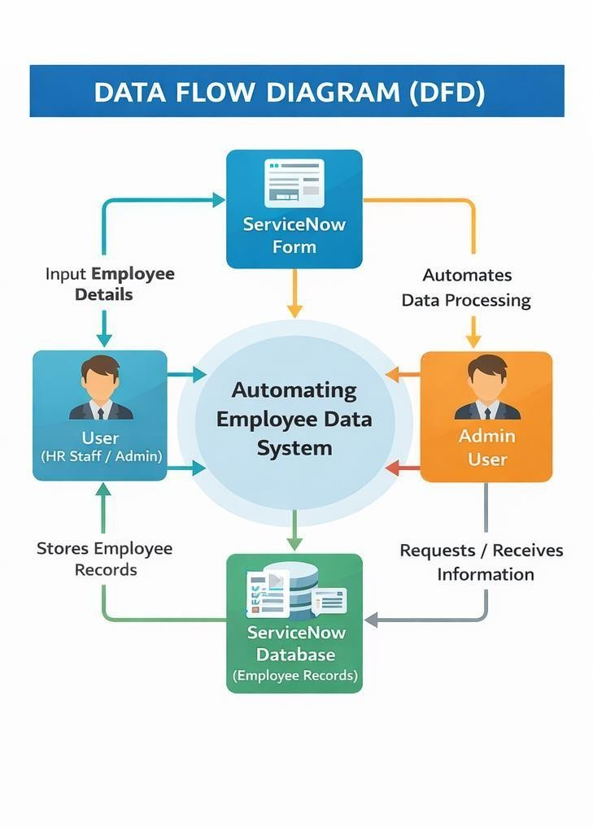

4. PROJECT DESIGN PHASE

4.1 Problem – Solution Fit
Many organizations face challenges in managing employee data manually. HR departments often maintain employee information using spreadsheets or paper-based records. This method is inefficient and can lead to errors, data loss, and difficulty in retrieving information quickly. As the number of employees increases, managing records manually becomes more complicated and time-consuming. It also becomes difficult to update employee details and maintain accurate records. The proposed system addresses this problem by automating the process of managing employee data using the ServiceNow platform. The solution provides a digital system where employee information can be entered through forms and stored in a database automatically. Automation workflows help process the data efficiently and reduce manual work. By implementing this solution, organizations can improve data accuracy, reduce human errors, and manage employee information more effectively.

4.2 Proposed Solution
The proposed solution is to develop an automated employee data management system using the ServiceNow platform. This system allows HR staff or administrators to enter employee details through a user-friendly form. Once the data is entered, it is automatically stored in a ServiceNow database table. Automation workflows process the information and perform required actions such as updating records or sending notifications. The system simplifies employee data management by reducing manual tasks and ensuring that employee information is organized and easily accessible. It also improves efficiency and helps organizations manage their workforce information effectively.

4.3 Solution Architecture
The solution architecture describes how different components of the system interact to perform the required functions. In this system, the user interacts with the ServiceNow application through a form interface where employee details are entered. The entered data is sent to the ServiceNow database table where employee records are stored. The workflow automation component processes the stored data and performs actions such as updating records or generating notifications. Administrators can access the stored employee information whenever needed. The architecture ensures a smooth flow of data from the user interface to the database and automation workflows. This structured design allows the system to manage employee information efficiently and reliably.

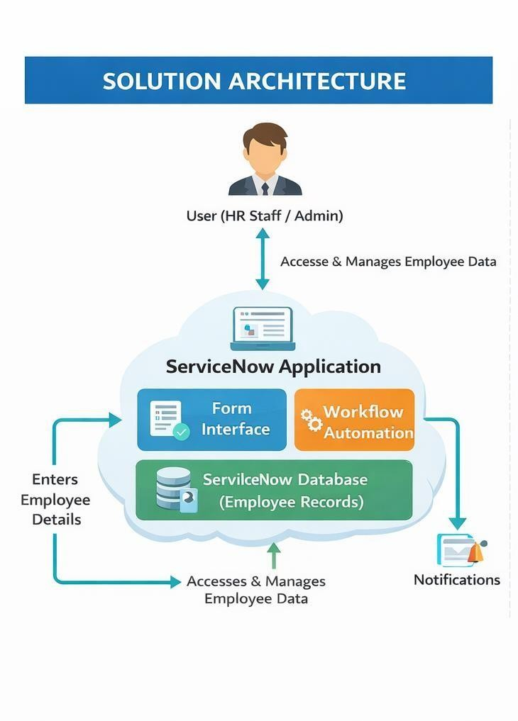

5. PROJECT PLANNING PHASE

5.1 Project Planning
Project planning is an important stage in the development of any system. It involves organizing tasks, identifying resources, and determining the steps required to complete the project successfully. In this project, the planning process began with identifying the problem related to manual management of employee data in organizations. After understanding the problem, the objectives of the project were defined, which included developing an automated system for managing employee information efficiently.
The next step involved selecting the appropriate platform for implementing the solution. The ServiceNow platform was chosen because it provides powerful tools for workflow automation, data management, and application development. After selecting the platform, the system design was planned. This included creating employee data forms, defining database tables, and designing automation workflows for processing employee information. Finally, testing and evaluation were planned to ensure that the system works correctly and meets the requirements. Proper planning helped ensure that the project was developed in an organized and systematic manner.

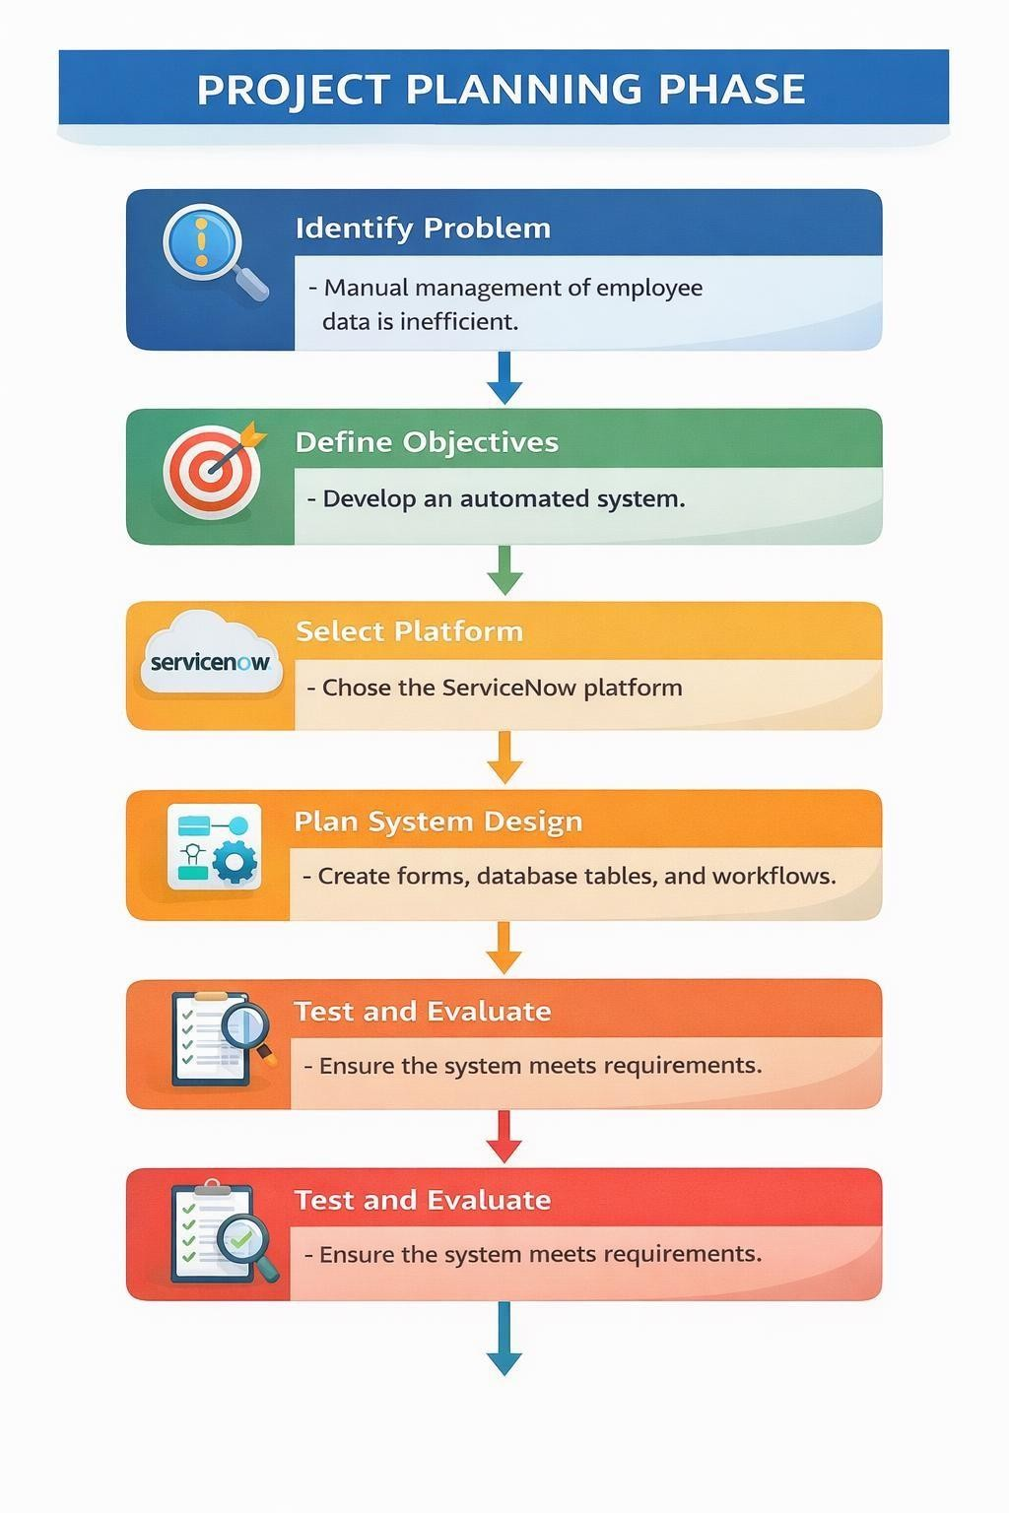

6. PROJECT DEVELOPMENT PHASE

6.1 Performance Testing
Performance testing is conducted to ensure that the system works efficiently and performs its functions without errors. It helps evaluate the system’s reliability, response time, and overall performance when handling employee data. In this project, performance testing was carried out to verify that the employee data entered through the ServiceNow form is correctly processed and stored in the database.
The system was tested by entering different employee details and checking whether the information was saved accurately in the ServiceNow table. The workflow automation was also tested to ensure that the system processes the data properly and performs the required actions without manual intervention. The system’s response time and functionality were observed to confirm that the application operates smoothly. The testing results showed that the system successfully stores employee data and processes it efficiently using automation workflows. This confirms that the automated employee data management system performs reliably and meets the project requirements.

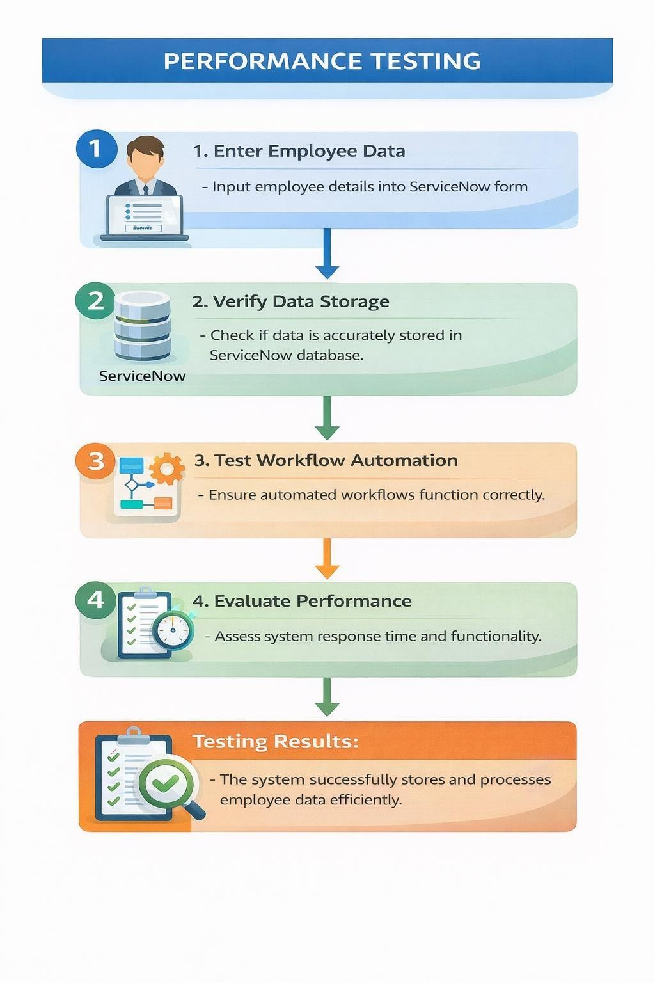

7. ADVANTAGES AND DISADVANTAGES

Advantages
- Reduces manual work in managing employee data
- Improves accuracy and reduces errors
- Provides easy access to employee records
- Automates workflows and processes
- Saves time and increases productivity

Disadvantages
- Requires internet access to use the ServiceNow platform
- Initial setup may require technical knowledge
- System depends on the availability of the ServiceNow platform

8.PROJRCT DOCUMENTATION

8.1 Final Report
The final report provides a complete description of the project Automating Employee Data using ServiceNow. It includes details about the problem identified, the proposed solution, system design, development process, and the results obtained after implementing the system. The project was developed to automate the process of managing employee information in organizations. Manual handling of employee records can lead to errors, data inconsistency, and difficulty in managing large amounts of information. To solve this issue, an automated system was designed using the ServiceNow platform.
The system allows users to enter employee details through a digital form. The entered data is stored in a ServiceNow database table and processed using automation workflows. This reduces manual effort and improves the accuracy of employee data management. The project also includes different phases such as ideation, requirement analysis, project design, project planning, development, and testing. Each phase was carefully implemented to ensure that the system functions correctly and meets the project objectives. The final system successfully demonstrates how automation can simplify employee data management. The project highlights the importance of using modern technology to improve efficiency and reduce manual workload in organizations.

8.2 Screen layout

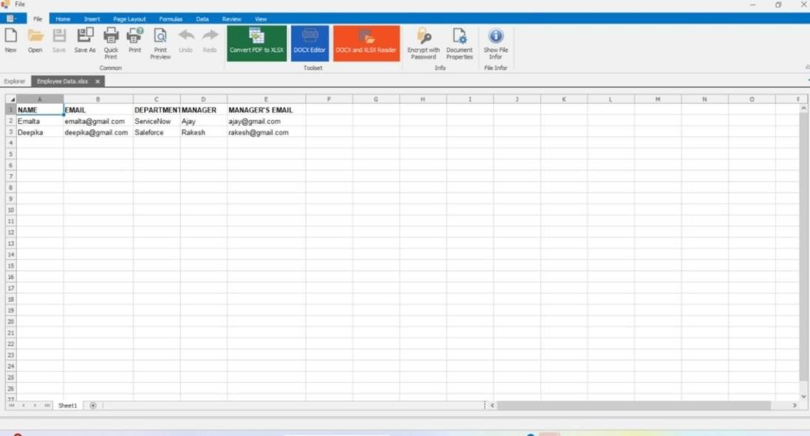

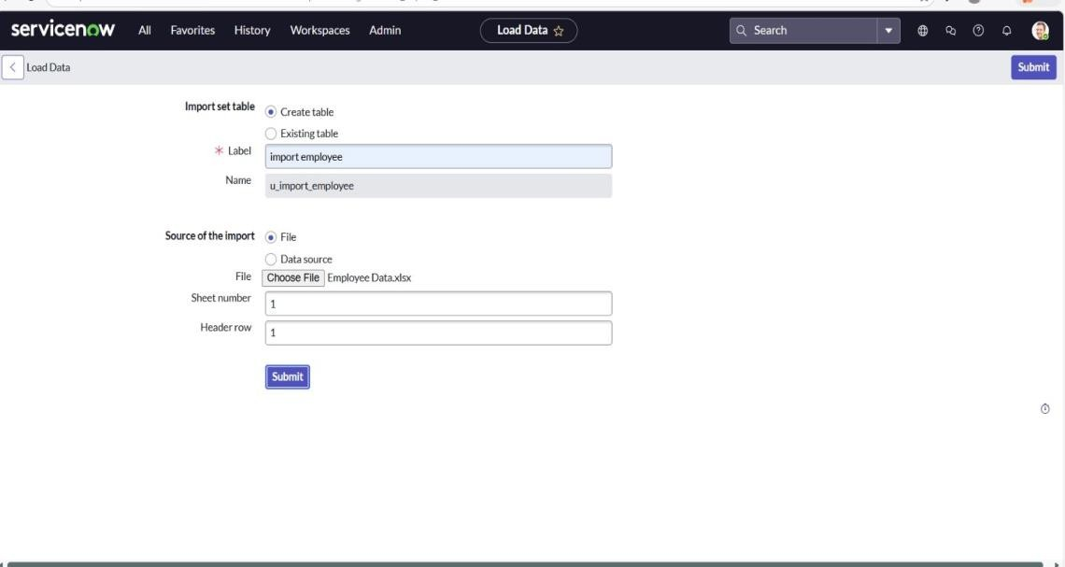

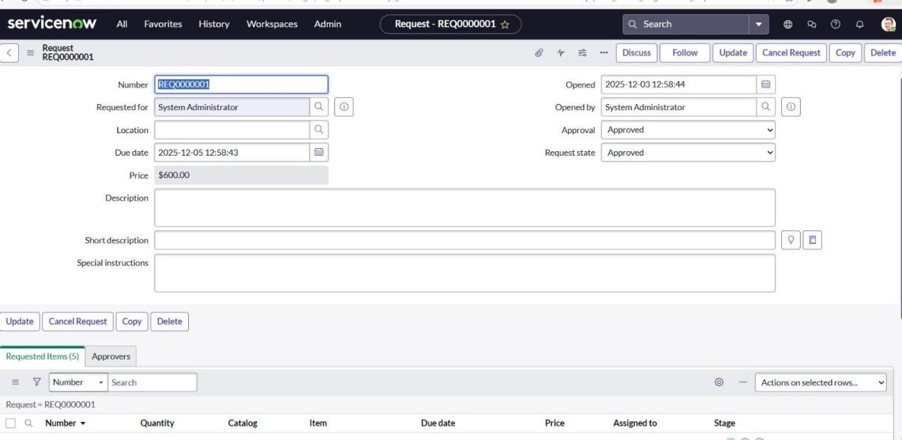

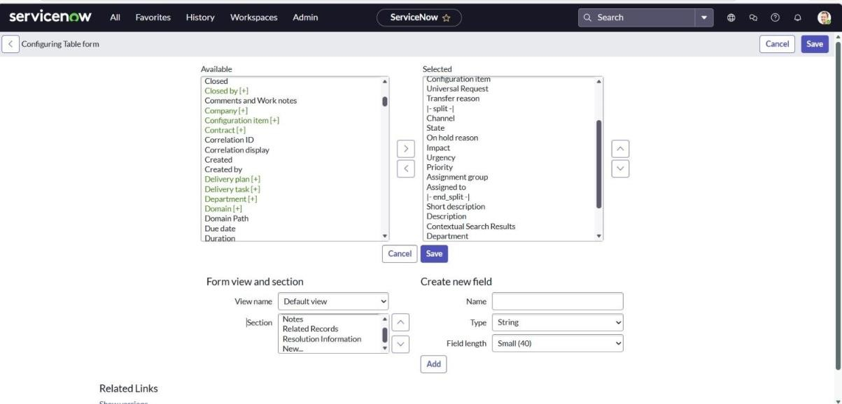

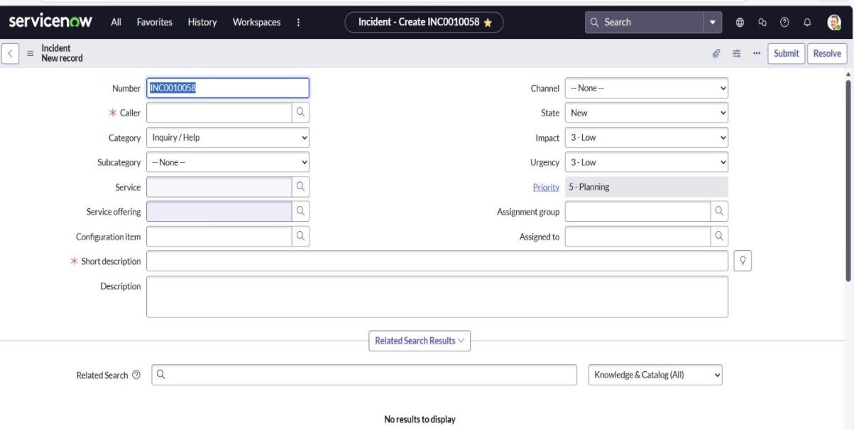

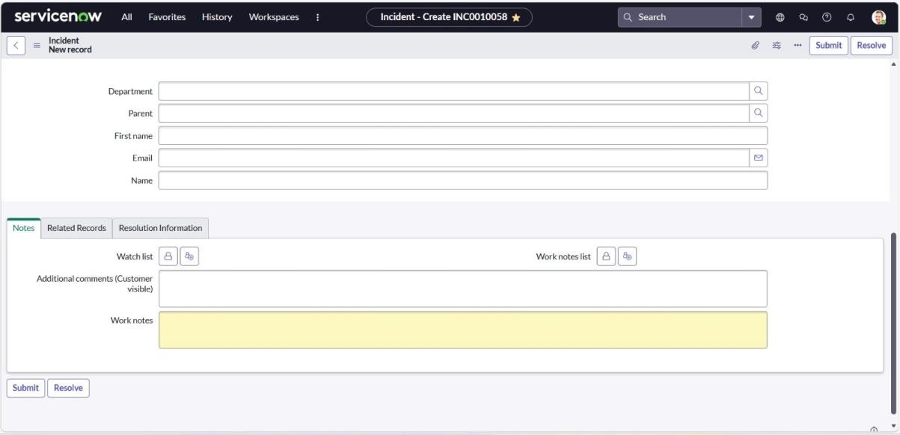

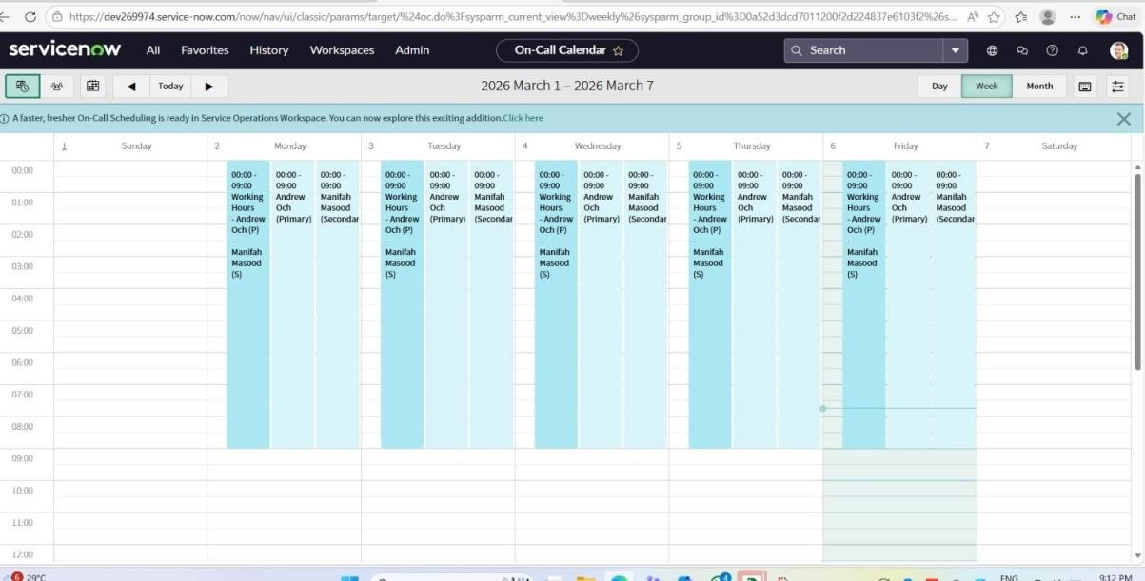

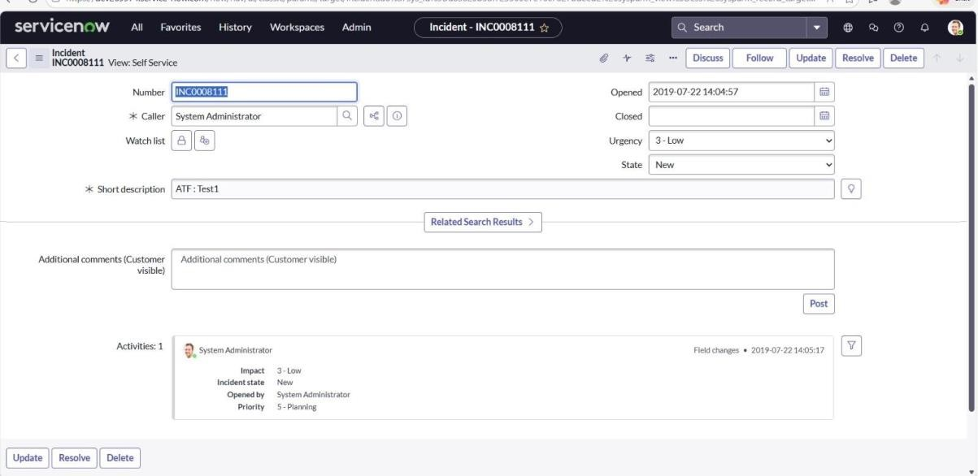

9. CONCLUSION
The Automating Employee Data system successfully demonstrates how automation can improve the management of employee information in organizations. By using the ServiceNow platform, the system provides an efficient way to store, manage, and process employee data. The project reduces manual effort, improves data accuracy, and simplifies the workflow for HR departments. The system ensures that employee records are stored securely and can be accessed easily when needed. Overall, the project highlights the importance of automation in improving organizational efficiency and data management.
