1) Write a program that accepts two numbers and a string from the user. Perform and display:
arithmetic operations (+, -, *, /, //, %, **) on the numbers, and string operations (concatenation,
repetition, slicing, case conversion) on the string.
=>
a = int(input("Enter first number: "))
b = int(input("Enter second number: "))
s = input("Enter a string: ")

# Arithmetic operations
print("Addition:", a + b)
print("Subtraction:", a - b)
print("Multiplication:", a * b)

if b != 0:
print("Division:", a / b)
print("Floor Division:", a // b)
print("Modulus:", a % b)
else:
print("Division by zero not possible")

print("Power:", a ** b)

#String
print("Concatenation:", s + " Assignment")
print("Repetition:", s * 3)
print("Slicing:", s[0:3])
print("Uppercase:", s.upper())
print("Lowercase:", s.lower())

output-
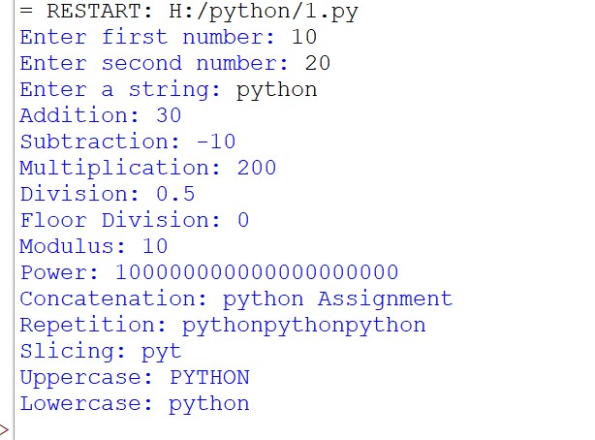
2) Create a list of 10 integers, a tuple of 5 fruit names, a dictionary of 5 student names mapped to
marks, and a set of 6 numbers (with duplicates). Perform: indexing/slicing on the list and tuple,
add/update/delete on the dictionary, and union/intersection/difference on two sets.
ANS =>
# List
L = [10, 20, 30, 40, 50, 60, 70, 80, 90, 100]
print("List:", L)
print("Indexing:", L[2])
print("Slicing:", L[1:5])

# Tuple
T = ("Apple", "Mango", "Banana", "Grapes", "Orange")
print("Tuple:", T)
print("Indexing:", T[1])
print("Slicing:", T[1:4])

# Dictionary
D = {"Amit": 80, "Riya": 90, "Sam": 75,
"Neha": 85, "Raj": 70}
print("Dictionary:", D)

D["Pooja"] = 95 # Add
D["Amit"] = 88 # update
del D["Raj"] #delete
print("Updated Dictionary:", D)

# Sets with duplicates
A = {1, 2, 3, 4, 4, 5, 5, 6}
B = {4, 5, 6, 7, 8}

print("Set A:", A)
print("Set B:", B)
print("Union:", A | B)
print("Intersection:", A & B)
print("Difference:", A - B)

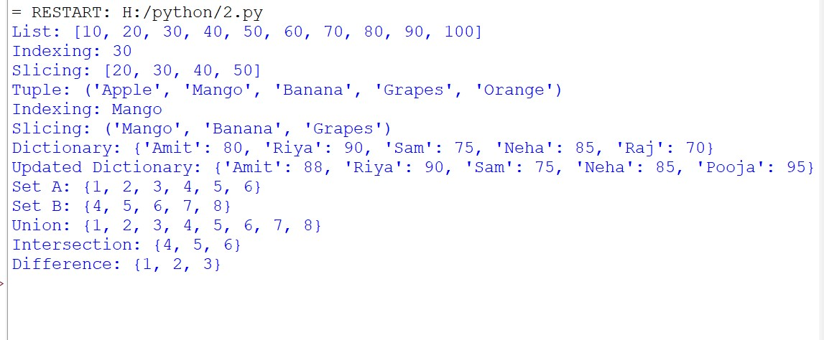
3) Write a program that accepts a student's marks in 5 subjects, computes the average, and
assigns a grade (A/B/C/D/F) using if-elif-else. Also check and display whether the student has
passed all subjects individually (each subject ≥ 35).
=>
#Accept marks in 5 subjects
m1 = int(input("Enter marks in subject 1: "))
m2 = int(input("Enter marks in subject 2: "))
m3 = int(input("Enter marks in subject 3: "))
m4 = int(input("Enter marks in subject 4: "))
m5 = int(input("Enter marks in subject 5: "))

#average
total = m1 + m2 + m3 + m4 + m5
avg = total / 5

print("Average:", avg)

#Assign grade
if avg >= 90:
print("Grade A")
elif avg >= 75:
print("Grade B")
elif avg >= 60:
print("Grade C")
elif avg >= 35:
print("Grade D")
else:
print("Grade F")

#Check individual subject
if m1 >= 35 and m2 >= 35 and m3 >= 35 and m4 >= 35 and m5 >= 35:
print("Passed all subjects")
else:
print("Failed in one or more subjects")

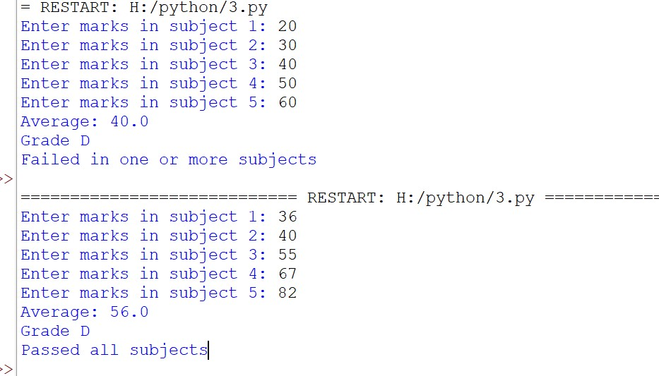
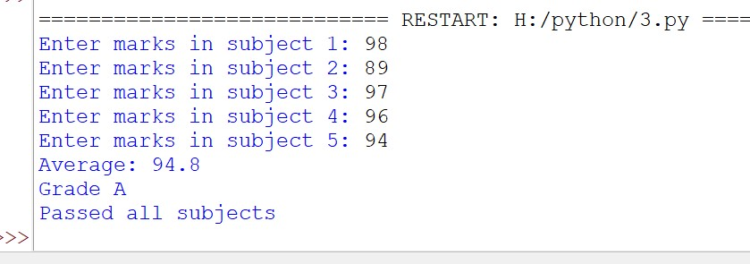

4) Write programs to print:
(a) a right-angled triangle of stars,
=>
#right angle triangle
n = int(input("Enter number of rows: "))

for i in range(1, n + 1):
for j in range(i):
print("*", end=" ")
print()
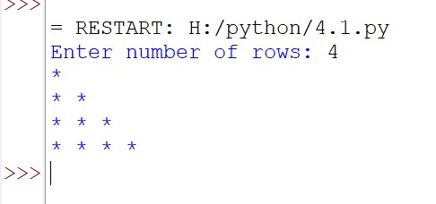
B) a number pyramid
=>
#number pyramid
n = int(input("Enter number of rows: "))

i = 1
while i <= n:
j = 1
while j <= i:
print(j, end=" ")
j += 1
print()
i += 1
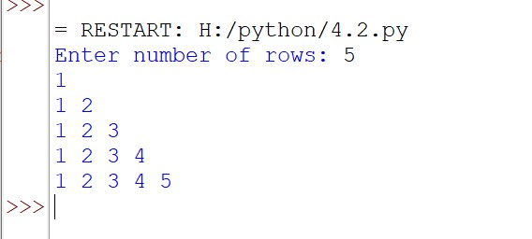
C) Pascal's triangle up to n rows.
#pascal triangle for loop
n = int(input("Enter number of rows: "))

for i in range(n):
num = 1
print(" " * (n - i), end="")

for j in range(i + 1):
print(num, end=" ")
num = num * (i - j) // (j + 1)
print()

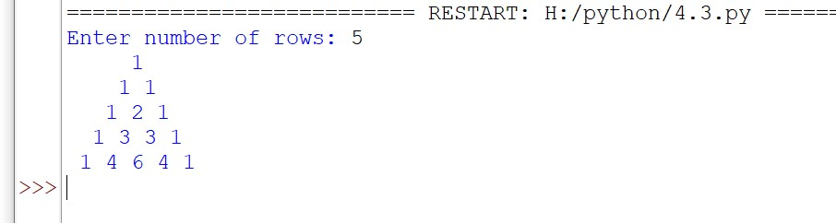
Loop Manipulation — pass, continue, break, else (To understand loop control
statements.)
5) Write a program that iterates through numbers 1-50: skip multiples of 3 using continue, stop
the loop entirely if a number greater than 40 that is also prime is found (break), use pass as a
placeholder for a future feature, and use a for-else block to print "Loop completed without
interruption" when the loop finishes naturally.

for n in range(1, 51):

#skip multiples of 3
if n % 3 == 0:
continue

# Check prime number greater than 40
if n > 40:
prime = True
for i in range(2, n):
if n % i == 0:
prime = False
break

if prime:
print("Prime number found:", n)
break

# Placeholder for future feature
if n == 10:
pass

print(n)

else:
print("Loop completed without interruption")
