动态规划-拼图


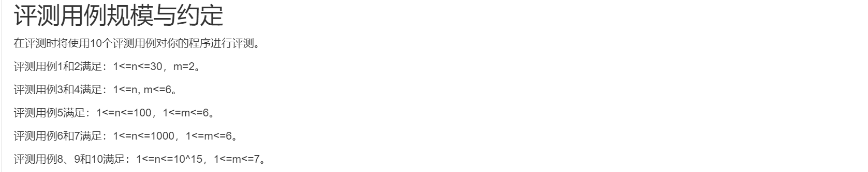
#include <bits/stdc++.h>
using namespace std;

typedef long long ll;
const int mod=1e9+7,o=1<<7;
struct Matrix{
ll ar[o][o];
Matrix () { memset(this->ar,0,sizeof(this->ar)); } //init
};
ll n,m,M; Matrix C;
Matrix M_mul(Matrix A,Matrix B){
Matrix E;
for(int i=0;i<M;i++)
for(int j=0;j<M;j++)
for(int e=0;e<M;e++)
E.ar[i][j]+=A.ar[i][e]*B.ar[e][j],E.ar[i][j]%=mod;
return E;
}
void dfs(int now,int nxt,int from){
if(now==M-1&&nxt<M)
C.ar[nxt][from]++;
for(int i=0;i<m;i++){
if((now&(1<<i))==0){
int fi=0,ti,li; //former i,this i,later i
if(i) fi=1<<(i-1); ti=1<<i; li=1<<(i+1);
if((nxt&ti)==0&&(now&li)==0) dfs(now+ti+li, nxt+ti, from);
if((nxt&ti)==0&&(nxt&li)==0) dfs(now+ti, nxt+ti+li, from);
if((nxt&li)==0&&(now&li)==0) dfs(now+ti+li, nxt+li, from);
if(fi&&(nxt&fi)==0) dfs(now+ti, nxt+fi+ti, from);
break;
}
}
}

int main(){
cin>>n>>m; M=1<<m;
for(int i=0;i<M;i++) dfs(i,0,i); //枚举起点
Matrix B; // E
for(int i=0;i<M;i++) B.ar[i][i]=1;
while(n){
if(n%2) B=M_mul(C,B);
C=M_mul(C,C);
n/=2;
}
cout<<B.ar[0][0]<<endl;
}

