注意力机制-矩阵运算
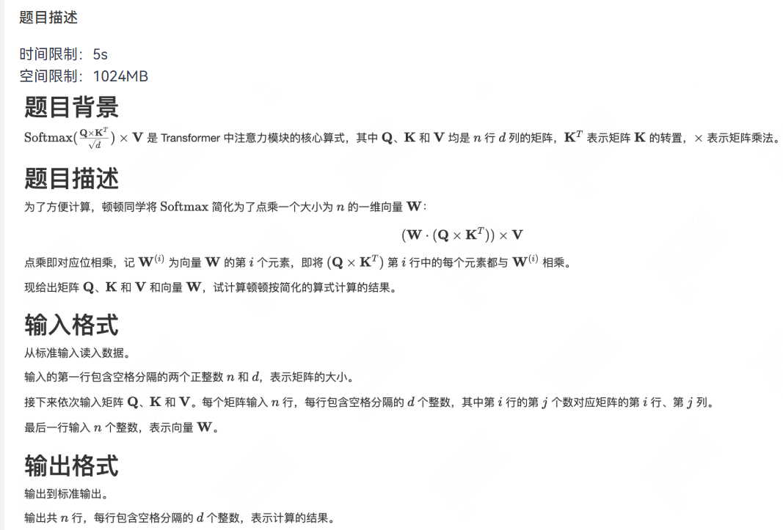
输入：
3 2
1 2
3 4
5 6
10 10
-20 -20
30 30
6 5
4 3
2 1
4 0 -5

输出：
480 240
0 0
-2200 -1100

参考代码：
#include <iostream>
using namespace std;
typedef long long LL;
const int N = 10010, D = 30;
LL tmp[D][D], ans[N][N];
int n, d;
int Q[N][D], K[N][D], V[N][D], W[N];
int main()
{
cin >> n >> d;
for (int i = 1; i <= n; i ++)
for (int j = 1; j <= d; j ++)
cin >> Q[i][j];
for (int i = 1; i <= n; i ++)
for (int j = 1; j <= d; j ++)
cin >> K[i][j];
for (int i = 1; i <= n; i ++)
for (int j = 1; j <= d; j ++)
cin >> V[i][j];
for (int i = 1; i <= n; i ++) cin >> W[i];

// ¼ÆËã KµÄ×ªÖÃ * V = tmp
for (int i = 1; i <= d; i ++)
for (int j = 1; j <= d; j ++)
for (int k = 1; k <= n; k ++)
tmp[i][j] += K[k][i] * V[k][j];

// ¼ÆËã Q * tmp = ans
for (int i = 1; i <= n; i ++)
for (int j = 1; j <= d; j ++)
{
for (int k = 1; k <= d; k ++)
ans[i][j] += Q[i][k] * tmp[k][j];
ans[i][j] *= (LL) W[i];
}

for (int i = 1; i <= n; i ++)
{
for (int j = 1; j <= d; j ++)
cout << ans[i][j] << " ";
cout << endl;
}
return 0;
}

