注意力机制-矩阵运算
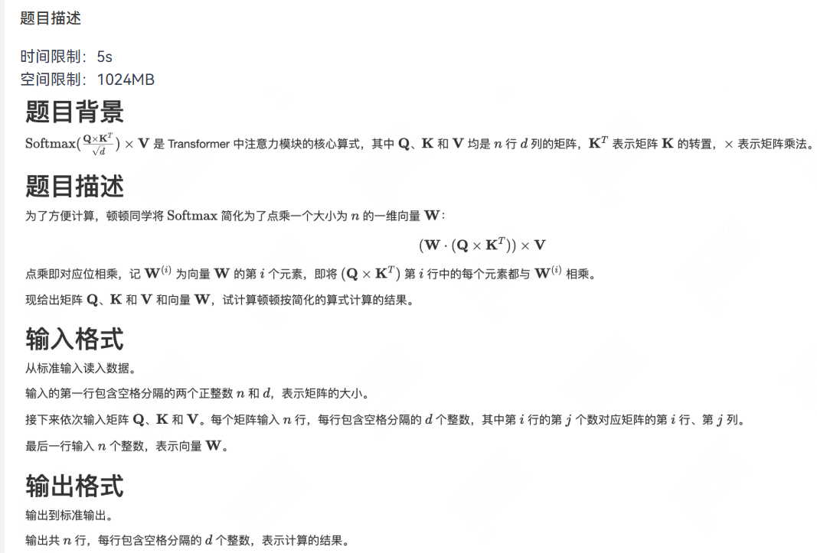
输入：
3 2
1 2
3 4
5 6
10 10
-20 -20
30 30
6 5
4 3
2 1
4 0 -5

输出：
480 240
0 0
-2200 -1100

参考代码：
#include <iostream>
using namespace std;
typedef long long LL;
const int N = 10010, D = 30;
LL tmp[D][D], ans[N][N];
int n, d;
int Q[N][D], K[N][D], V[N][D], W[N];
int main()
{
cin >> n >> d;
for (int i = 1; i <= n; i ++)
for (int j = 1; j <= d; j ++)
cin >> Q[i][j];
for (int i = 1; i <= n; i ++)
for (int j = 1; j <= d; j ++)
cin >> K[i][j];
for (int i = 1; i <= n; i ++)
for (int j = 1; j <= d; j ++)
cin >> V[i][j];
for (int i = 1; i <= n; i ++) cin >> W[i];

// ¼ÆËã KµÄ×ªÖÃ * V = tmp
for (int i = 1; i <= d; i ++)
for (int j = 1; j <= d; j ++)
for (int k = 1; k <= n; k ++)
tmp[i][j] += K[k][i] * V[k][j];

// ¼ÆËã Q * tmp = ans
for (int i = 1; i <= n; i ++)
for (int j = 1; j <= d; j ++)
{
for (int k = 1; k <= d; k ++)
ans[i][j] += Q[i][k] * tmp[k][j];
ans[i][j] *= (LL) W[i];
}

for (int i = 1; i <= n; i ++)
{
for (int j = 1; j <= d; j ++)
cout << ans[i][j] << " ";
cout << endl;
}
return 0;
}

配餐

#pragma GCC optimize("O3,unroll-loops")
#pragma GCC target("avx2,bmi,bmi2,lzcnt,popcnt")
#pragma GCC optimize(2)
#include <iostream>
#include <vector>
#include <map>
#include <set>
#include <stack>
#include <queue>
#include <limits>
#include <string>
#include <array>
#include <sstream>
#include <numeric>
#include <list>
#include <deque>
#include <cstring>
#include <cmath>
#include <cstdlib>
#include <cstdio>
#include <random>
#include <algorithm>
#include <climits>
#include <complex>
#include <cassert>
#include <bitset>

using namespace std;

// Super Idol的笑容
// 都没你的甜
// 八月正午的阳光
// 都没你耀眼
// 热爱105°C的你
// 滴滴清纯的蒸馏水

#define itr(...) begin(__VA_ARGS__), end(__VA_ARGS__)
#define fastIO() ios::sync_with_stdio(false),cin.tie(nullptr),cout.tie(nullptr)
#define debug(x...) do { cout << "\033[32;1m" << #x <<" -> "; rd_debug(x); } while (0)
void rd_debug() { cout << "\033[39;0m" << endl; }
template<class T, class... Ts> void rd_debug(const T& arg,const Ts&... args) { cout << arg << " "; rd_debug(args...); }
#define pb push_back
#define PF(x) ((x) * (x))
#define LF(x) ((x) * PF(x))

typedef long long ll;
typedef unsigned long long ull;
typedef pair<int, int> PII;
typedef pair<ll, ll> PLL;

const double eps = 1e-6;
const int MOD = 1e9 + 7;
const int inf = 0x3f3f3f3f;
const ll infl = 0x3f3f3f3f3f3f3f3fll;
mt19937_64 mrand(random_device{}());
ll rnd(ll x) { return mrand() % x;}
uniform_int_distribution<ll> dist(0, LLONG_MAX);

const int N = 1010;
int n, m, k, d;
int cnt[N][N];
int vis[N][N];
int trace[N][N];
int dis[N][N];
int xx[] = {1, 0, -1, 0};
int yy[] = {0, 1, 0, -1};
bool check(int x, int y){
return (x >= 1 && x <= n && y >= 1 && y <= n);
}
void solve(){
cin >> n >> m >> k >> d;
memset(dis, 0x3f, sizeof dis);
queue<pair<int, int>> q;
for(int i = 1; i <= m; i++){
int x, y;
cin >> x >> y;
q.push({x,y});
dis[x][y] = 0;
vis[x][y] = 1;
}
for(int i = 1; i <= k; i++){
int x, y, c;
cin >> x >> y >> c;
cnt[x][y] += c;
}
for(int i = 1; i <= d; i++){
int x, y;
cin >> x >> y;
trace[x][y] = 1;
}
while(q.size()){
pair<int, int> tmp = q.front();
q.pop();
int x = tmp.first, y = tmp.second;
for(int i = 0; i < 4; i++){
int nx = x + xx[i], ny = y + yy[i];
if(check(nx, ny) && trace[nx][ny] == 0 && vis[nx][ny] == 0){
vis[nx][ny] = 1;
dis[nx][ny] = dis[x][y] + 1;
q.push({nx, ny});
}
}
}
ll ans = 0;
for(int i = 1; i <= n; i++){
for(int j = 1; j <= n; j++){
ans += 1ll * cnt[i][j] * dis[i][j];
}
}
cout << ans << "\n";
}

int main() {
ios::sync_with_stdio(false);
cin.tie(0);
solve();
return 0;
}

