Low Level Design Template

DMT/AD06/TMP

Project Code
Project Name | LOGISTICS MANAGEMENT

Prepared/Modified by | Role | Date of Preparation
Reviewed by | Role | Date of Review
Approved by | Role | Date of Approval
Circulation List |  | Version Number of the template:1.0
Version Number | <version No >

Table of Contents

1. Description Of The Unit 3
2. References 4
3. Dependencies / Assumptions 5
4. Class Diagrams 6
5. Sequence Diagrams 7
6. Design Components 8
6.1 List Of UI Components 8
6.2 List Of Design Classes 8
7. Re-Usable Routines/Components 9
8. Messages 10
9. Configuration Files 11
10. Crud Matrix Table 12
11. Data Mapping Matrix 13
12. Action Flow Matrix 14
13. Stored Procedures 15
14. Program Specification / Pseudo Code 16
REVISION HISTORY OF THE WORK PRODUCT 17

Description Of The Unit

USER-
- User will be able to sign up to his account to order some goods from dealers through logistics.
- If he is not registered, he will be directed to register page where he will enter his details with password and get an autogenerated ID.
- Once he sign up successfully, he will be able to select different options for his functionality.
- He can view and update his account details, he can view his previous orders and transactions and he can view products and can place order.
- In Products Screen, if he wants to select multiple products, then he just has to select product quantity with corresponding product ID and has to press PF4 to continue to select more products.
- If any product is not currently available, then proper message will be showed.
- He can clear all the selected products from products screen and from checkout + bill screen.

ADMIN-
- Admin can login successfully assuming that he already has an ID and password.
- Admin can handle various tasks like updating products, updating dealers and can check status.

- In Update Products screen, admin can add, update and delete products for

References
<Write the relevant References referred to prepare the LLD>

1. Google.com
2.

Dependencies / Assumptions
<describe dependencies and assumptions that are relevant to coding of the unit. Mention the dependencies and assumptions related to FDA regulatory requirements >

Class Diagrams

Sequence Diagrams

Design Components

List Of UI Components

List Of Design Classes

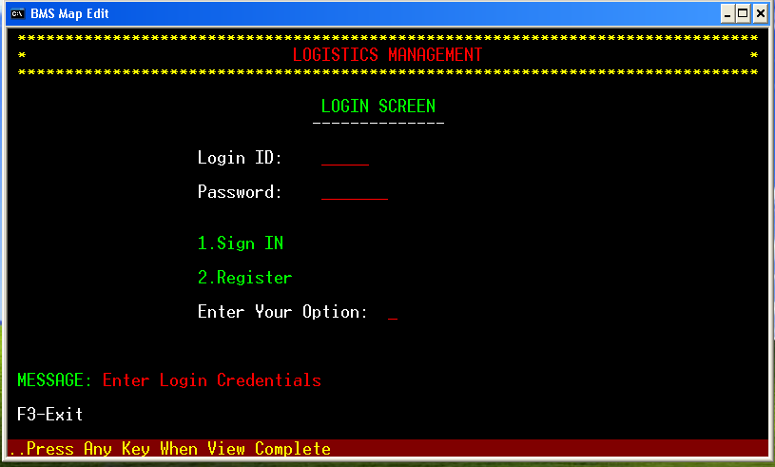
- User Login Screen

- User Register Screen
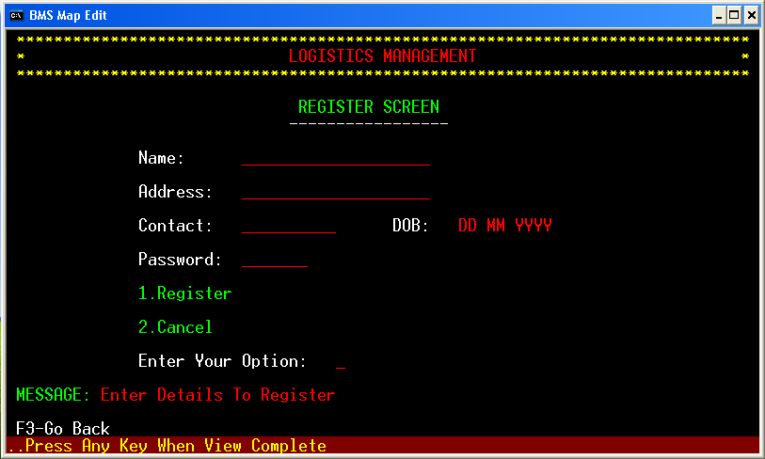

- User Menu Screen
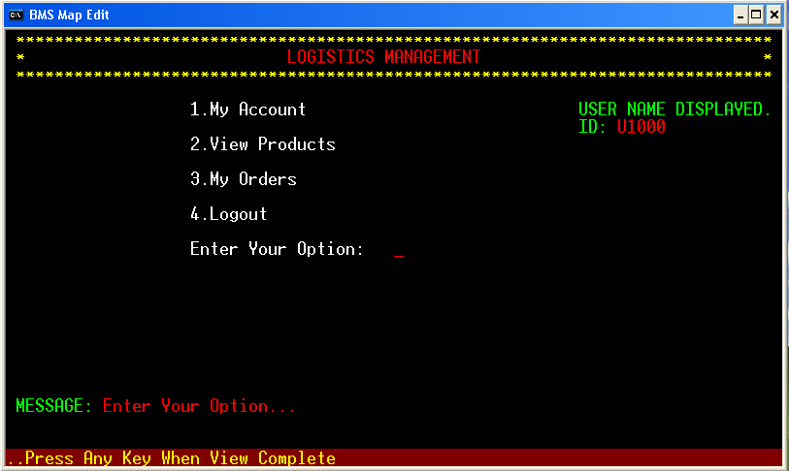
- My Account Screen
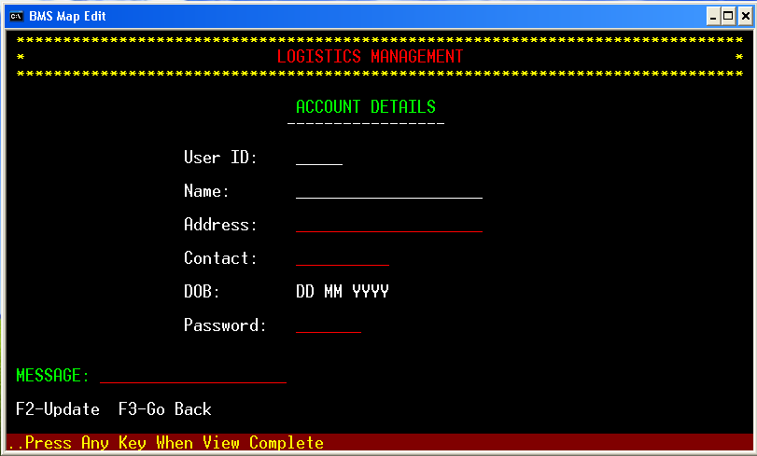

- View Products Screen
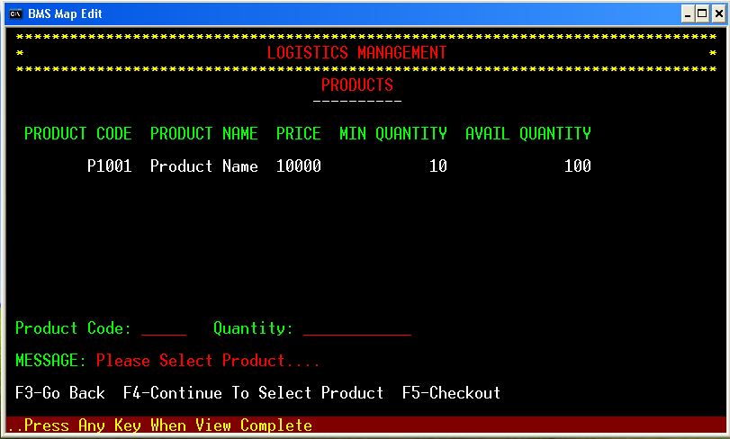
- Checkout + Bill Screen
Not Yet Designed
- View My Orders
Not Yet Designed

- Admin Login Screen
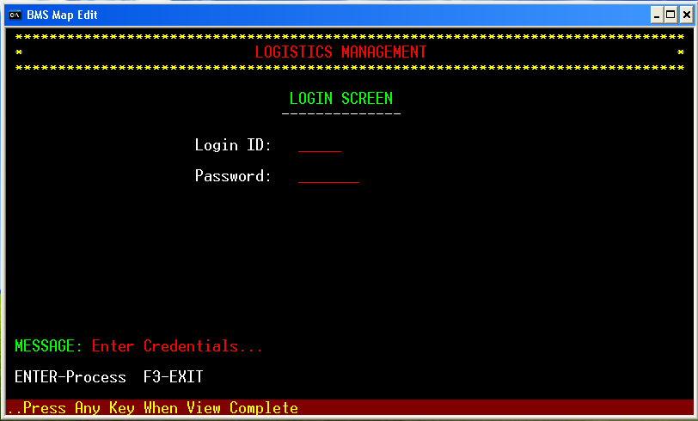

- Admin Menu Screen
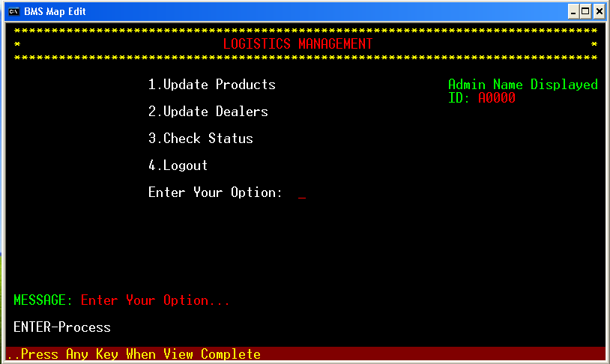

Re-Usable Routines/Components
<provide references to the re-usable routines, copybooks and templates used by the unit>

Messages
<describe what are relevant messages which has to be displayed in this program unit>

#. | Type | Message Text
1. | <Warning/Information/Validation/Error>

Configuration Files
<< Provide complete list of configuration files that will be required during deployment of the application. This list will comprise of all the XML files, resource files packaged within application deployment>>

File Name | Path | Description

Crud Matrix Table

# | Table Name | Create | Read | Update | Delete

Data Mapping Matrix
<identify data-mapping matrix pertinent to screen or report data items. Provide details of the base table or column, screen item name, length, calculations and validations.>

Action Flow Matrix
<identify the action flow matrix detailing all actions and triggers associated with the unit. Provide details of processing and the enabled conditions>

Stored Procedures
<describe what are Stored Procedures Pertaining to this program unit >

# | Stored Procedure Name  (with Description) | Input/Out Parameters | Type | Size
1.

Program Specification / Pseudo Code
<specify processing details of the unit >

REVISION HISTORY OF THE WORK PRODUCT
<to be maintained by projects>

# | Date | Version # | Section Changed | Details of changes made | Approved By
1
2

