a.) How many of these bonds were approved by voters?

**There were 7210 bonds approved by voters.**

b.) how many were defeated?

**There were 1638 bonds disapproved by voters**

c.) Are there any differences in the rates of approved bonds across the four different government types? Calculate the appropriate descriptive statistics to answer these questions.

Carried Defeated

CITY 0.87549519 0.12450481

COUNTY 0.82800000 0.17200000

ISD 0.72434341 0.27565659

WD 0.94521739 0.05478261

**There are differences in the rates of approved bonds but they do not differ greatly. CITY has a 87.55% approval rate, COUNTY has a 82.80% approval rate, ISD has a 72.43% approval rate, and WD has a 94.52% approval rate. WD has the highest approval rate and ISD has the lowest approval rate.**

1. Some of these bonds were on the ballot during presidential elections and therefore had very high voter turnout. Calculate a new variable in the dataframe called “Votes_Total” that is the sum of the votes “for” and “against” the bond measure. When and where did the bond measure with the highest voter turnout occur? What was it for?

**The highest voter turnout occurred in Harris County on 11/8/22 for Road Utilities.**

1. Let’s look at the margins by which the carried bonds were approved, ignoring those with very low voter turnout. Create a subset of this dataset that contains the bond measures that were approved and had at least 100 total votes. Next, create a new variable within the subset data frame that gives the percentage of total votes that were for the bond measure and make a graph of the distribution of this new variable. Describe its distribution with the appropriate statistics.

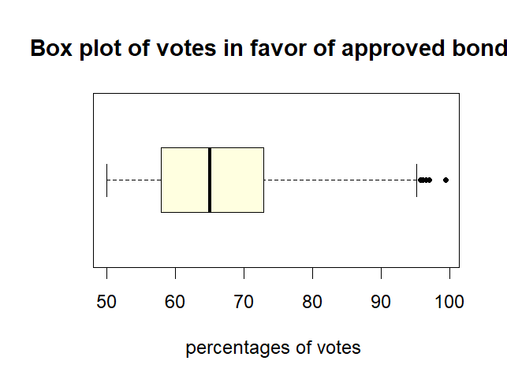

**The minimum number of positive votes for an approved bond was 50%, the Max being 99.44%, and the median being 65.08%. The graph is right skewed with an IQR of 14.94% (1st quartile: 57.96% and 3rd quartile: 72.90%).**

1. Is the margin a bond was approved by related to its cost? Use your subset from #3 to create a graph to display this relationship. Then, answer this question, citing the appropriate descriptive statistic.

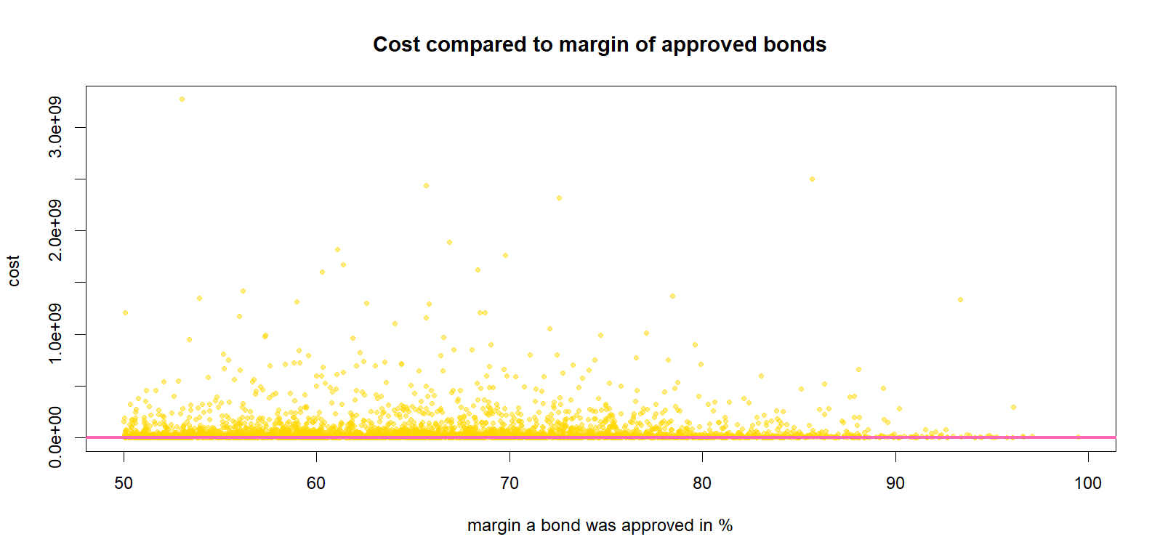

**As shown by the line of best fit, there is no definitive positive or negative relationship/correlation between the margin a bond was approved and the cost as the line is constant. The graph could be described as slightly skewed to the right.**