

**School of Science and Technology**

**BIS3214**

**Data Warehousing and Business Intelligence**

**Autumn/Winter term**

**2014/2015**

|  |
| --- |
| **Date:** 23rd January 2015 |
| **Supervisor:** Dr. Syed Murad |
| **Campus:** Hendon |
| **Group Members:** |

|  |  |  |  |
| --- | --- | --- | --- |
| Cristiano Cardoso Maia  M00322036 | Jade Van Nelson  M00405270 | Kateryna Vyshnyak  M00330646 | Veeraj Bhura  M0041555 |

Table of Contents

Introduction 3

1. Middlesex University 3
2. Objectives, Values and Mission 3
3. Marketing Department 3

Analysis of Operational Systems and Data Sources (20 marks) 4

1. Entity Relationship Diagram description 4
2. Advantages and Disadvantages to Using a Data Warehouse 8

Data mark design 9

ETL process 9

OLAP 9

Conclusion 9

References 9

# Introduction

## Middlesex University

A University in England with roots back to 1878 who has since build up a reputation in London and international as a providing a high level of higher education from its wealth of experience and strategic operational capabilities. Through strengthening our efficiency by employing highly qualified academics, attracting the best ambitious students and strengthening our research reputation we can capitalise internationally on becoming an excellent international tertiary education establishment.

**Van/Veraj**: Mentioned who is in each part of the pyramid. Dean and relatives are on the top and deciding what the values and missions are. Tactical are… not sure, needs to research. And operational are the people providing the service to the students: teachers, librarians and so on…

If you are struggling with it, try [checking this link](http://www.bbc.co.uk/bitesize/higher/business_management/business_enterprise/decision_making_business/revision/1/).

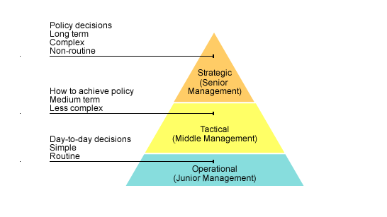

## Objectives, Values and Mission

Our Objectives are to attract students that are determined to succeed and support these students with the correct support and insure student satisfaction by developing policies to maximise their performance. We strive to enhance graduate level employability in an effort to improve our university rankings. We have strategies and policy to organise our schools to enhance excellence.

“Our vision is to become a leading University of choice, recognised internationally for excellence in all that we do.”

## Marketing Department

Middlesex University Marketing department is based at the Middlesex University London campus and from there advertisements are launched and managed. We specialise and focus on each of our five schools across the three different campuses universally. We receive investments for our advertising projects internally as well as from external sources.

**Van/Veraj**: Expand on how the Marketing department works. How they get projects, how they hire contractors to deal with it, why the projects are important. Talk about the list of suppliers and give examples on what they can provide for the projects. Mention that the permanent Middlesex University staff will not be take in consideration for this project. And conclude saying that the objectives of the Marketing department are directly linked with the objective of attracting students that are willing to work hard and succeed.

Use the files below as reference on the appropriate parts of the introduction.

* [University Regulations for the Academic Year 2004/2005](http://www.web.mdx.ac.uk/regulations/archive/regs0405/STS.HTM)
* [Equality and Diversity at Middlesex University](https://www.mdx.ac.uk/__data/assets/pdf_file/0009/58707/Equality-and-Diversity-Strategy-2013.pdf)

# Analysis of Operational Systems and Data Sources (20 marks)

## Entity Relationship Diagram description

**Van/Veraj**: One paragraph introduction starting with a link between the advantages of having an Operational System (done by Kateryna) and finishing by saying that this chapter will be demonstrating how the Marketing department has implemented its own by describing in detail the Entity Relationship Diagram in detail.

Ps: **ERD** stands for **E**ntity **R**elationship **D**iagram, so it is repetitive to say *ERD diagram*. ☺

The different project allows the university to meet its objectives by planning events and managing these events. These projects have cost and they are directly related to the project thus a budget is set by each department as to how much would be spend. Each staff member will also have a cost and this can be requested by filling in a timesheet.

The values are met by taking into consideration the long-term effects these projects will have on staff members, attendees and the different attractions held at these events that could generate positive publicity in line with the values of the university.

The mission is to attract the highest amount of high calibre students and by having different projects like open days, digital and social media events, career events and more traditional events at university like research projects the marketing fulfil its mission.

The ERD that we have displayed below shows all the different entities and their attributes. This will allow us to show relationships across all the entities and compose a data mart that will display relevant information so that Middlesex University at the strategic level can make informed choices in how the budget should be used. The ERD will also show the university a cornucopia of other information like what suppliers are used at certain events and what the turnout of the event was. The Entity Relationship Diagram is vital to the success and longevity of the database and the data mart as if any relationships are missing or any entities have been missed this could result in the error in running queries and retrieving accurate results.

At every event each member of staff plays a crucial role like events management, relations officer from marketing would be there to insure that everything goes according to plan. The member of staff is picked for each event by a few criteria; these criteria are ~~t~~heir expertise as to the role that they are required to fill.

After events and during the course of the year all staff members that are part of the Middlesex University marketing department or are part of an event that the marketing department has held need to be paid for their work.

To keep a track of all the task and how they were accomplished in the past will help us to understand perhaps how to overcome current difficulties but also will be beneficial to justify our expenditure. How we have managed the task indirectly relates to our budget and therefore we could justify requesting more budget for projects as we have x y and z amount of task that was not completed with other projects and therefore we perhaps under performed as a marketing department

Different venues can be held in different countries thus the university fulfils its mission of attracting international attention as well as focusing on the international students who represent a large amount of the university target audience.

Each project would occur at a venue and to organise the events would have different sessions booked in by book therefore being able to ascertain the correct amount of space allocated. This takes care of the logistical matters like seating plan, amounts expected to be catered for and falls under general event management.

**Van/Veraj**: Update the entities and relationship according to the new ERD. Double check if the paragraphs above are updated as well.

1. Staff – Role – Address

One member of staff is only assigned one role at a time. However, there might be many people doing the same role. The staff must provide their home address, which is then validated under address entity.

1. **Staff – School – Department**

Each staff member must register with a school, they can only be registered to one school and one school can have many departments though many departments can only be assigned to one school.

1. **Department – Cost Centre**

Every department has a cost centre; this cost centre will be responsible to set budget codes to be assigned to specific projects and deal with the staff time sheets.

1. Cost Centre – Time Sheet Cost Center – Time Sheet

Every member of staff fills a time sheet form for every day stating how many hours they have worked on each project. A specific cost centre pays each staff member’s time sheet. The cost centre pays only those staff that are registered with that specific cost centre, this is regardless of the project that they have worked on.

1. **Cost Centre – Budget Code – Project – Expense Sheet**

Projects will have budget codes assigned to them (from the Budget Codes entity) by the Cost Center department. They will then use this code to fill out the Expense Sheet’s form describing how the money have been used so far.

1. **Project – Supplier – Company Address**

Each project may have 0 or many suppliers’ representatives but each contact only works for one company, and are working on one project at a time.

1. **Project – Event – Session**

An event can have 0 (if the event is online) or many sessions. Events are optional for each Project but one event can only be related to one Project at time.

1. **Session – Booking – Venue Address**

The marketing department has a list of venues names and locations. These venues are booked by event sessions, each session is part of an event.

1. **Session – Attendees**

At each event attendees must register to be at the event and in turn each session can record who and how many attendees were at that specific session.

1. **Project – Task – Task History – Staff**

A project can have 0 (in case the tasks hasn't be assigned yet) or many tasks but a specific task can only be related to one project. An extra table called Task History is responsible to keep track of all the tasks from any project even if it has been archived. Along with the keeping track of the staff that was part of the task.

**Cristiano**: mention the external data sources!

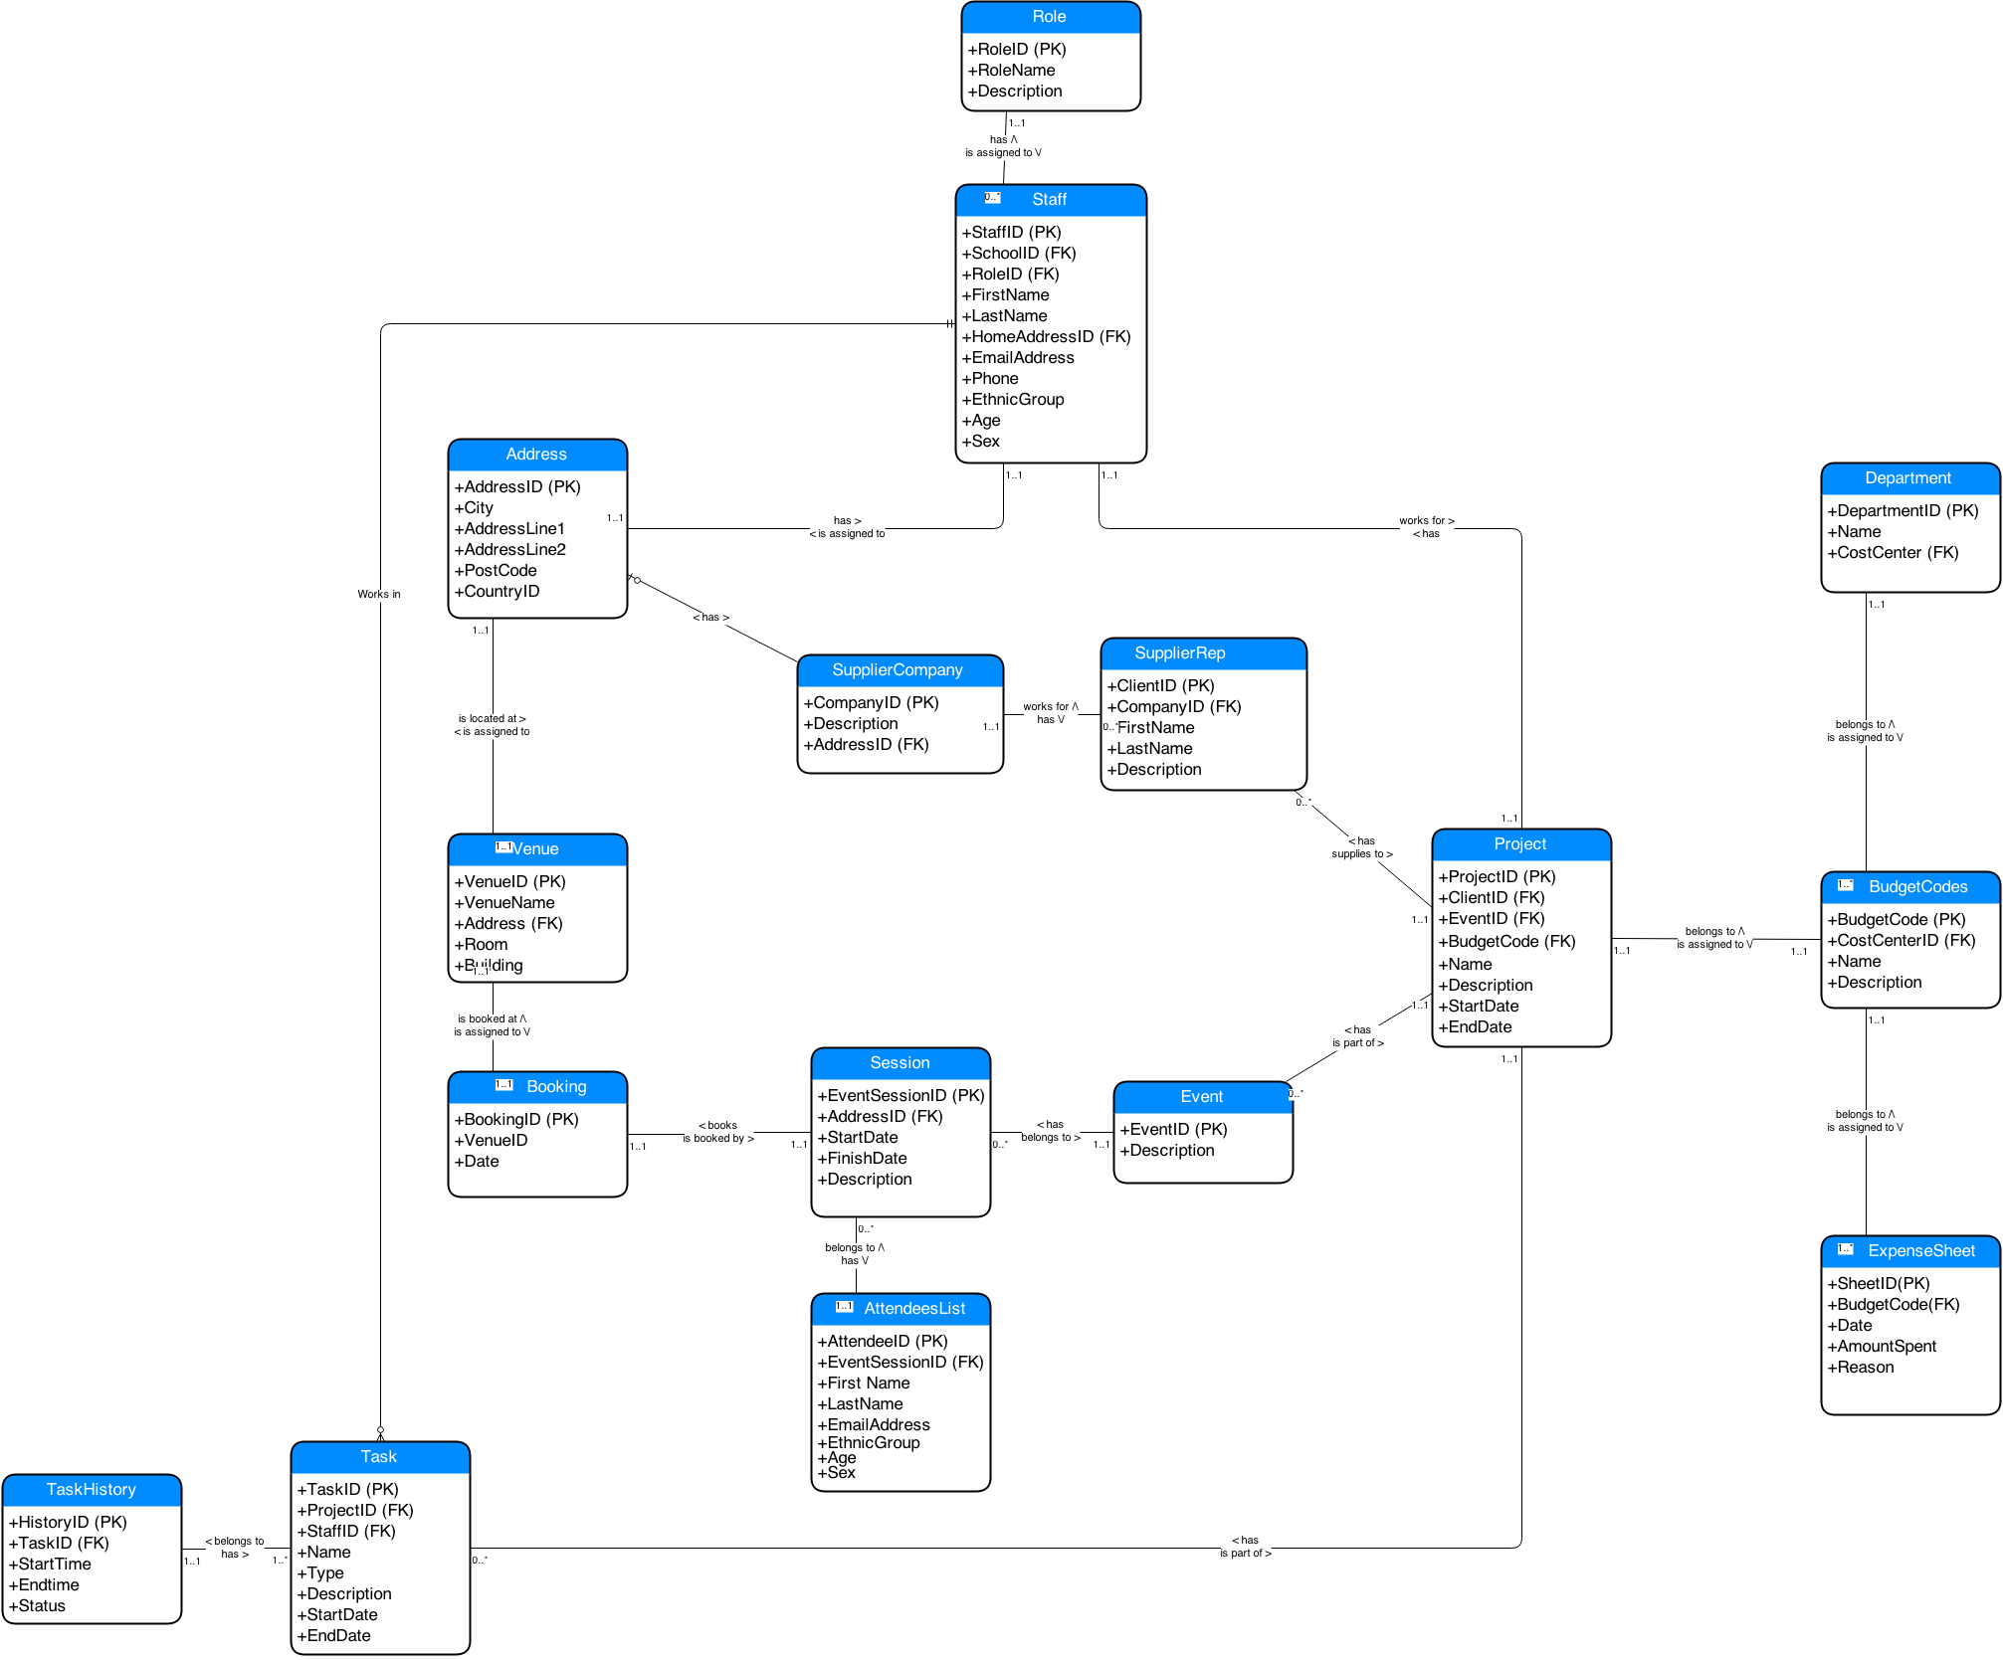

## Advantages and Disadvantages to Using a Data Warehouse

Operational database is designed to process and manage dynamic flow of real-time data. It allows access to the archived data and permits data modification of this data such as deletion, adding or updating. The significant difference between operational and warehouse systems are that operational system designed to assist with transaction process whereas data warehousing oriented for online analytical process (OLAP) (Exforsys). Therefore usage of data is optimized for different purposes, see Table 1 below.

|  |  |
| --- | --- |
| **Operational Database** | **Data Warehouse** |
| Supporting high-volume transaction performance with minimum rear reporting.  Provides process-oriented or process-driven analysis only around defined processes of the business and its tasks. | Supporting high-volume analytical transactions with maximum reporting that promptly used for making strategic decisions.  Provides subject-oriented analysis with main focus on the business area where company requires strategic decisions. The collected information is concise about particular issue and collected from more then one operational sources. The data analysis produce information about short-range strategies its assessment and evaluations. |
| Dealing with current data and this data updated on the regular basis. | Dealing with historical data and this data rarely changed. Data warehouse stores information as non-volatile and read only format. This data is loaded on the regular basis and growing constantly. |
| System optimized for fast data uploading but small content at the time. | System optimized for fast data retrieval and large content at the time. |
| Data is specific to application performance; therefore it is non-integrated or partially integrated causing data redundancy. | Controlling data redundancy problems within DBSM integration layer. |
| Doesn’t require expert level of computing skills to navigate system. | Requires advance computing knowledge to navigate system. |

Table 1 Operational system VS data warehouse (Rensselaer).

Data Warehouse is computerised system for storing information. This information helps organisation to analyse historical patterns and make important business decisions. The advantage of having large repository of information that it helps to solve number of problems, increase company profitability while and reduce cost to access this historical data within external sources. Furthermore, the data is consistent, relevant, structured and combined from various locations into one centralised location. This data centralisation helps to find multiple solutions than where data analysed separately. Data Warehouse allows storing already retrieved data within operational level that improves turn around time of data reporting and analysis (Power).

The advantage of having data warehouse in marketing is that the data is static and provides a "single version" of the truth about enterprise activities. To understand better its customers – students, future prospects on the marketplace and event’s opportunities to attract more students – customers, researchers and funds.

However there are a number of disadvantages that need to be addressed. Firstly, data warehouse is very expensive to maintain, as data itself must be normalised, loaded and extracted. Moreover, company have to train their users, otherwise it could lead to the security problems while conducting any queries via online access. Secondly, there is always a chance that new transaction system may not be compatible with the currently used systems. There are also a numerous ways of storing information in the data warehouse and applying one set of rules might not be beneficial if in the future company decides to change the way it conducts business (Exforsys).

# Data mark design

* The identification of two subject areas, identified during 2, which would be of benefit to the managers your organisation.
* The design of the star schemas associated with both subjects area identified in 3.1
* A discussion of the granularity of dimension and fact tables
* The extension of one of the star schemas into a snowflake schema.

Two subject areas, within the section of the business

Snowflake is normalised! Star schema is not

Add content here

# ETL process

How extract data from operational system?

What do you do with it before storing on the data warehouse?

Implement the prototype of one of the star schema

# OLAP

How to query it?

What would managers be interested at?

# Conclusion

What challenges do we have to keep it up and running?

Performance? Amount of data stored. Flexibility to adapt/include/remove different columns.

# References

Exforsys, Advantages and Disadvantages to Using a Data Warehouse | IT Training and Consulting – Exforsys. Available at: http://www.exforsys.com/tutorials/data-warehousing/advantages-and-disadvantages-to-using-a-data-warehouse.html [Accessed November 14, 2014].

Power, D., Ask Dan! about DSS - What are advantages and disadvantages of data warehouses? Available at: http://dssresources.com/faq/index.php?action=artikel&id=180 [Accessed November 14, 2014].

Rensselaer, Operational Systems vs. Data Warehousing. Available at: http://www.rpi.edu/datawarehouse/dw-about-cmp.html [Accessed November 25, 2014].