# About GSK

## History

GSK started operations when the companies GlaxoWellcome plc and SmithKline Beecham plc merged 13 years ago (on 1st January 2001), but the combined histories go back since 1715 when the Plough Court pharmacy is established. In October 1906 the trademark Glaxo was registered. The origin of the name comes by adding and changing letters from the word Lacto. The first merge occurred in 1989 when SmithKline Beckman and the Beecham Group become SmithKline Beecham plc.

## Overall

GSK is a science-led global healthcare company with the mission to improve the quality of human life by enabling people to do more, feel better, live longer. The company research, manufacture and make available a broad range of innovative healthcare products. One fact that can perfectly illustrate the scale of the company is: 4 billion packs of GSK products are produced each year.

Medicines, vaccines and Consumer Healthcare are the three mains sectors where GSK operates. On the medicines part, GSK develop and make medicines to treat a range of conditions including: respiratory diseases, cancer, heart disease, and epilepsy, bacterial and viral infections such as HIV and lupus, and skin conditions like psoriasis. The vaccines are researched and made for children and adults that protect against infectious diseases, including: influenza, rotavirus, cervical cancer, measles, mumps, rubella, hepatitis, polio, tetanus and meningitis. Finally, the innovative consumer products produced by GSK are divided in four categories of Total Wellness, Skin Health, Oral Care and Nutrition. The portfolio includes well-known brands such as: Horlicks, Panadol and Sensodyne.

GSK is a global company operating in more than 150 markets. There is a network of 86 manufacturing sites in 36 countries and large Research & Development centres in the UK, USA, Spain, Belgium and China. Almost 99,451 people were employed by GSK in 2013, in which 39% was located in Europe, 38% in EMAP, 17% in Japan and 6% in other countries.

## Values and Mission

Good health cannot be undervalued. It enables people to live life to its fullest, allowing them and their communities to prosper. Yet, improving healthcare and making it affordable and accessible to more people is a huge effort. As the world’s population is expanding, the need for both new and existing treatments will continue to grow. People are living longer and modern lifestyles and diet are contributing to a changing and increasing disease burden. Cost can be a significant barrier to healthcare. Around the world there are pressures on how much is spent on improving health. The process of discovering and developing new medicines and vaccines can take up to 15 years, it can cost up to £1 billion and many concepts will fail en route. At the core of GSK business model are the concepts of innovation and access. They create value by researching and manufacturing innovative products and making these available to as many people who need them as possible.

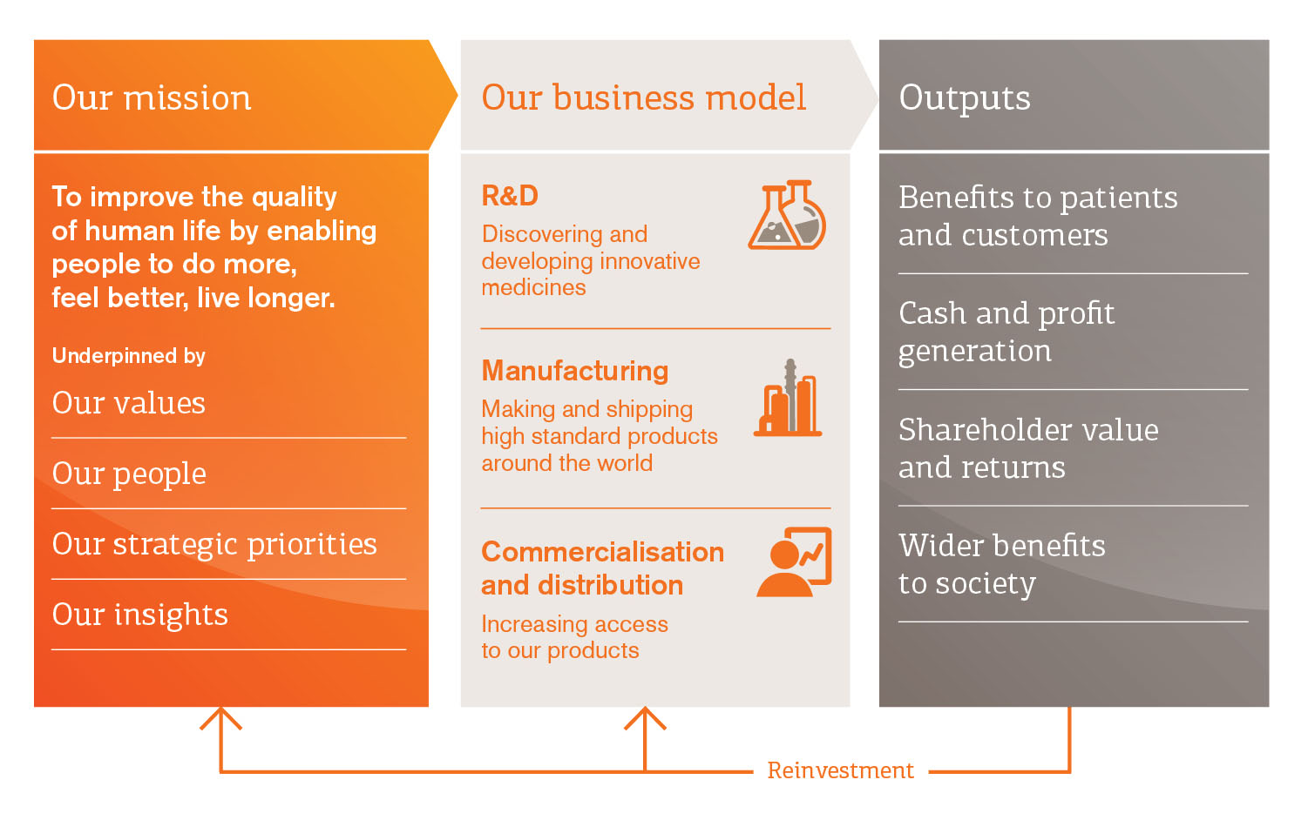

Since 2008, GSK has been implementing a strategy to create a business and culture that can help them succeed in this challenging environment. Investing in innovation; Growing a more balanced business; Improving access to GSK products; Simplifying our operating model; Empowering the employees. In delivering this strategy GSK has been open to challenge, innovation and new ways of working. They have entered into many new partnerships and fundamentally reformed our business model in several areas. £3.4 billion alone was invested in core R&D expenditure in 2013.