# Software Engineering Project Report

**Report :**   
This report shall be submitted in three steps:  
      1.   Part 1 (Section 1 Customer Problem Statement  and   Section 2 System Requirements)  
      2.   Part 2 (Section 3 Functional Requirements Specification  and  Section 4 User Interface Specification )  
      3.   Entire Report

**Software Engineering Project Report**

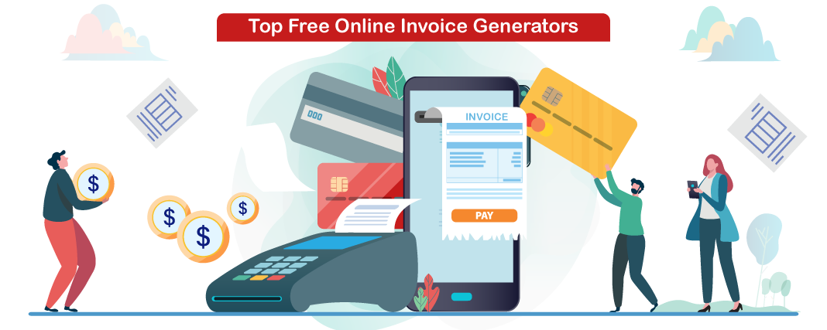

**PREPARED BY-**

**HARSHIT GUPTA**

**ISHIKA JAIN**

**KARTIK GARG**

**ONLINE BILL GENERATOR**

SECTION 1:

**PROBLEM STATEMENT:**

First, waiting for invoice usually takes time and make customer waiting. Therefore, the customer's time gets wasted in waiting. The slowness of traditional bills is one of the important problems. Secondly, the cost of the paper-backed documents is another problem that faces traditional bills .It takes more effort and physical space to keep track of paper documents, to find information and to keep details secure.

* Today a user has to face many problem regarding online shopping and a proper invoice. The merchants dealing in large amount in terms of money has to face problem regarding a proper bill.
* Also customers has to carry the physical bill with them during travelling which becomes a hectic thing to manage.
* Customers cannot have a digital verifiable bill.
* It takes lots of time to generate physical bills.
* Sometimes customer has to go through Readability issues.
* There are chances to get Human error.
* It is more costlier.
* It is not eco-friendly.

**SOLUTION:**

Our software named as digital bill genetator which generates the digital and E-verifiable bill and makes the shopping experience more easy which has the following Advantages:

* This project solve the customer problem of having a proper bill.
* It provides more accurate bill as, there are no chances of human error.
* It is eco-friendly in nature.
* It saves time and provide a more accurate bill in less time.
* It solve the customer problem of carrying a physical bill.
* It provides a more secure and verifiable bill.
* It makes user shopping experience more comfortable.
* It provides a long lasting bill, as customer can download it any time.
* It removes readability issues.
* It is less expensive.

**Four layers of software Engineering are:**

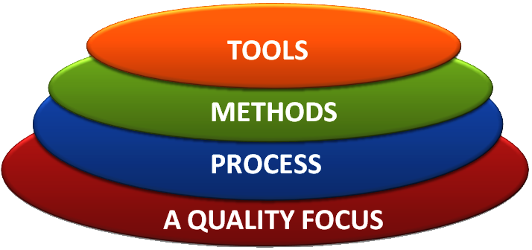

The above four layers of software engineering for our software is described as follows:

* TOOLS: Our software include frontend and backend which are developed using the following technologies.
* For frontend :HTML, CSS, Java script .
* For backend: python 3.
* METHODS:

Our software allows the customer to shop online according to their convenience and after customer successfully purchase an item the software automatically generates a digital verifiable bill and sends the copy of the bill to the customer’s E-mail address.

The software also allows the customer to download the bill in

future also by logging in their respective accounts. The software

also generates a QR code which a customer can keep and on

scanning the QR code the bill will be automatically downloaded to

their system.

***Agile Manifesto:***

Individuals and interactions over processes and tools  
Working software over comprehensive documentation  
Customer collaboration over contract negotiation  
Responding to change over following a plan

***12 Principles behind Agile Manifesto:***

* Our highest priority is to satisfy the customer  
  through early and continuous delivery  
  of valuable software.
* Welcome changing requirements, even late in  
  development. Agile processes harness change for  
  the customer's competitive advantage.
* Deliver working software frequently, from a  
  couple of weeks to a couple of months, with a  
  preference to the shorter timescale.
* Business people and developers must work  
  together daily throughout the project.
* Build projects around motivated individuals.  
  Give them the environment and support they need,  
  and trust them to get the job done.
* The most efficient and effective method of  
  conveying information to and within a development  
  team is face-to-face conversation.
* Working software is the primary measure of progress.
* Agile processes promote sustainable development.  
  The sponsors, developers, and users should be able  
  to maintain a constant pace indefinitely.
* Continuous attention to technical excellence  
  and good design enhances agility.
* Simplicity--the art of maximizing the amount  
  of work not done--is essential.
* The best architectures, requirements, and designs  
  emerge from self-organizing teams.
* At regular intervals, the team reflects on how  
  to become more effective, then tunes and adjusts  
  its behavior accordingly.

**Comparative Study between various Software Process Models:**

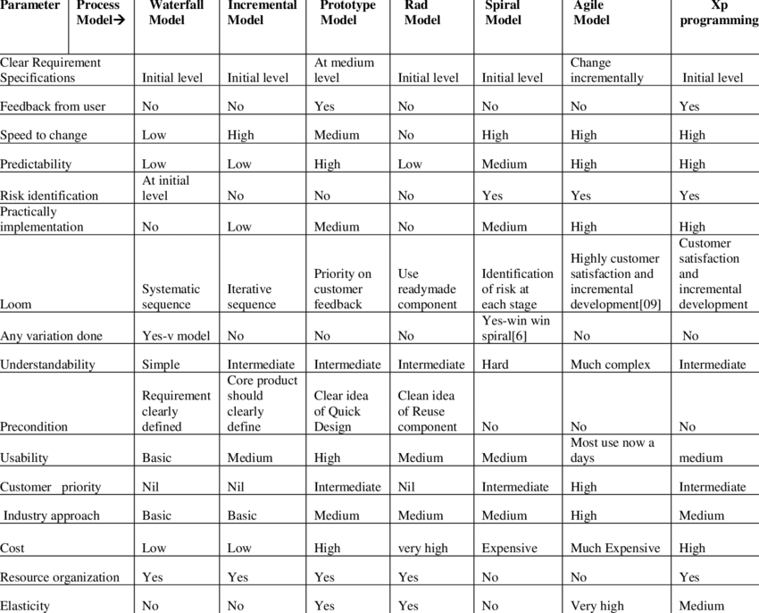

**Rapid Application Development Model (RAD)**

RAD model can be applied successfully to the projects in which clear modularization is possible. If the project cannot be broken into modules, RAD may fail.

The following pointers describe the typical scenarios where RAD can be used −

* RAD should be used only when a system can be modularized to be delivered in an incremental manner.
* It should be used if there is a high availability of designers for modeling.
* It should be used only if the budget permits use of automated code generating tools.
* RAD SDLC model should be chosen only if domain experts are available with relevant business knowledge.
* Should be used where the requirements change during the project and working prototypes are to be presented to customer in small iterations of 2-3 months.

**PROS AND CONS of RAD Model**

RAD model enables rapid delivery as it reduces the overall development time due to the reusability of the components and parallel development. RAD works well only if high skilled engineers are available and the customer is also committed to achieve the targeted prototype in the given time frame. If there is commitment lacking on either side the model may fail.

The advantages of the RAD Model are as follows −

* Changing requirements can be accommodated.
* Progress can be measured.
* Iteration time can be short with use of powerful RAD tools.
* Productivity with fewer people in a short time.
* Reduced development time.
* Increases reusability of components.
* Quick initial reviews occur.
* Encourages customer feedback.
* Integration from very beginning solves a lot of integration issues.

The disadvantages of the RAD Model are as follows −

* Dependency on technically strong team members for identifying business requirements.
* Only system that can be modularized can be built using RAD.
* Requires highly skilled developers/designers.
* High dependency on modeling skills.
* Inapplicable to cheaper projects as cost of modeling and automated code generation is very high.
* Management complexity is more.
* Suitable for systems that are component based and scalable.
* Requires user involvement throughout the life cycle.
* Suitable for project requiring shorter development times.

In our project case we are going to follow the RAD model as it fulfils all the favourable conditions and requirements of RAD model.

**What is a Functional Requirement?**

In software engineering, a functional requirement defines a system or its component. It describes the functions a software must perform. A function is nothing but inputs, its behaviour, and outputs. It can be a calculation, data manipulation, business process, user interaction, or any other specific functionality which defines what function a system is likely to perform.

Functional software requirements help you to capture the intended behaviour of the system. This behaviour may be expressed as functions, services or tasks or which system is required to perform.

**Functional Requirements for Online Bill Generation and shopping system.**

* The system should provide appropriate viewers for user to read the list of items in item store.
* The system should provide user’s unique reference (USER_ID) where customer can have personal account and make payment.
* The user shall choose what item that they want to receive.
* The system should print, for the owner a summary and show the report for who received the item and invoices.
* The system should automatically compute the bills and send the invoices with their items.
* The system should be able to manage some simple geographic info and provide company’s description.
* The system should automatically generate invoices and send a mail to the users with the invoice attached and also generate a QR code which enables the user to verify the bills online.
* The user should choose where they want the item to be delivered.

**What is Non-Functional Requirement?**

A non-functional requirement defines the quality attribute of a software system. They represent a set of standards used to judge the specific operation of a system. Example, how fast does the website load?

A non-functional requirement is essential to ensure the usability and effectiveness of the entire software system. Failing to meet non-functional requirements can result in systems that fail to satisfy user needs.

Non-functional Requirements allows you to impose constraints or restrictions on the design of the system across the various agile backlogs. Example, the site should load in 3 seconds when the number of simultaneous users are > 10000. Description of non-functional requirements is just as critical as a functional requirement.

**Non-Functional Requirements for Online Bill Generation and shopping system.**

* **Product Requirement.**

1. The user interface shall be implemented as simple HTML,CSS,JAVASCRIPT.
2. The list of items should be listed in the order form.
3. The product should be available and updated each day.
4. Proper product details should be present.

* **Owner Requirement.**

1. The owner should provide other services on request by the owner.
2. The owner should communicate with other shop owner or other individual for the services that in the list but not provided.

* **Organizational Requirement.**

1. The system development process and deliverable reports shall conform to the process.
2. The delivery should be made every day.
3. Each item delivered must be reported and recorded each time.
4. The system should automatically generate correct bills.

* **External Requirement.**

1. The system shall not disclose any personal information about customers apart from their name and reference number to the operators of the system.
2. The system should provide geographical attributes and some information about the services.
3. The system must provide safe and secure payment environments

**VARIOUS SOFTWARE UML DIAGRAMS ARE :**

* **USE CASE Diagram:**

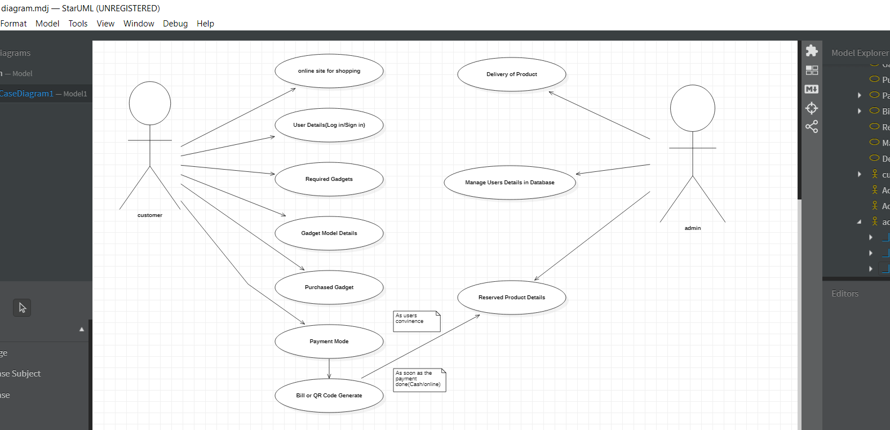

* **ER Diagram**

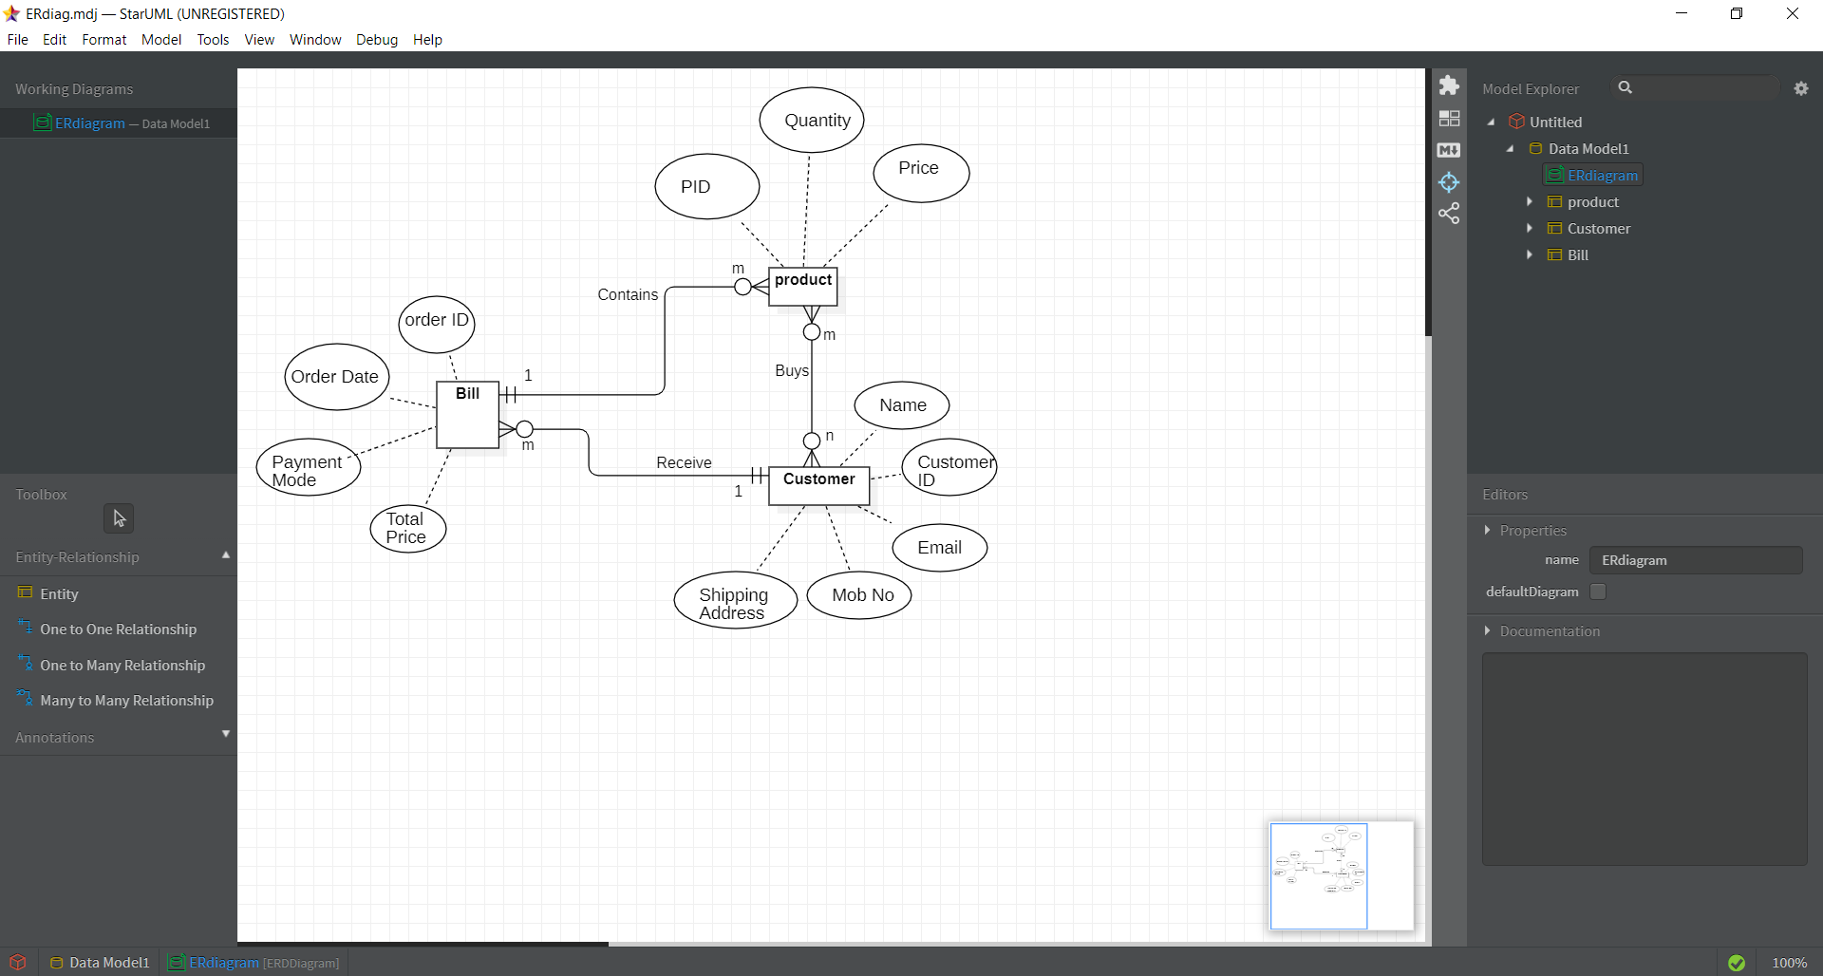

* **CLASS Diagram**

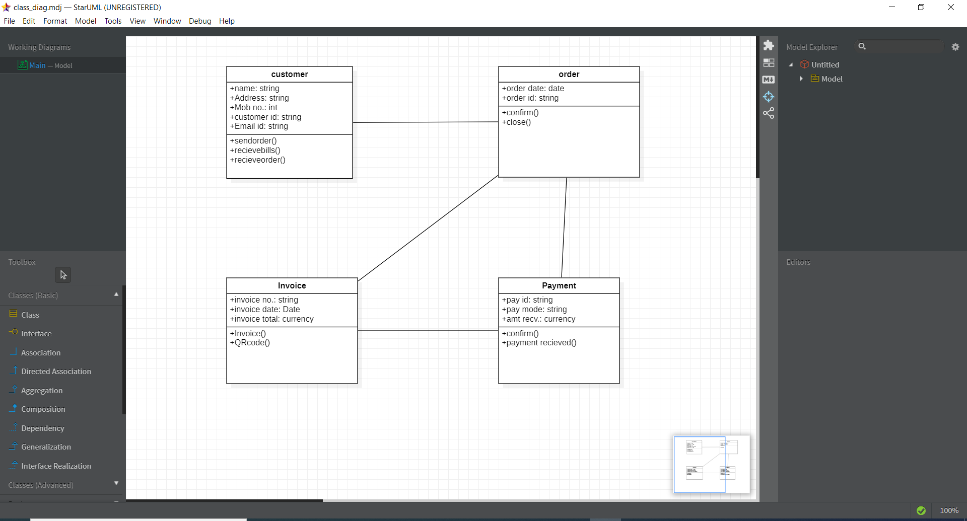

* **ACTIVITY Diagram**

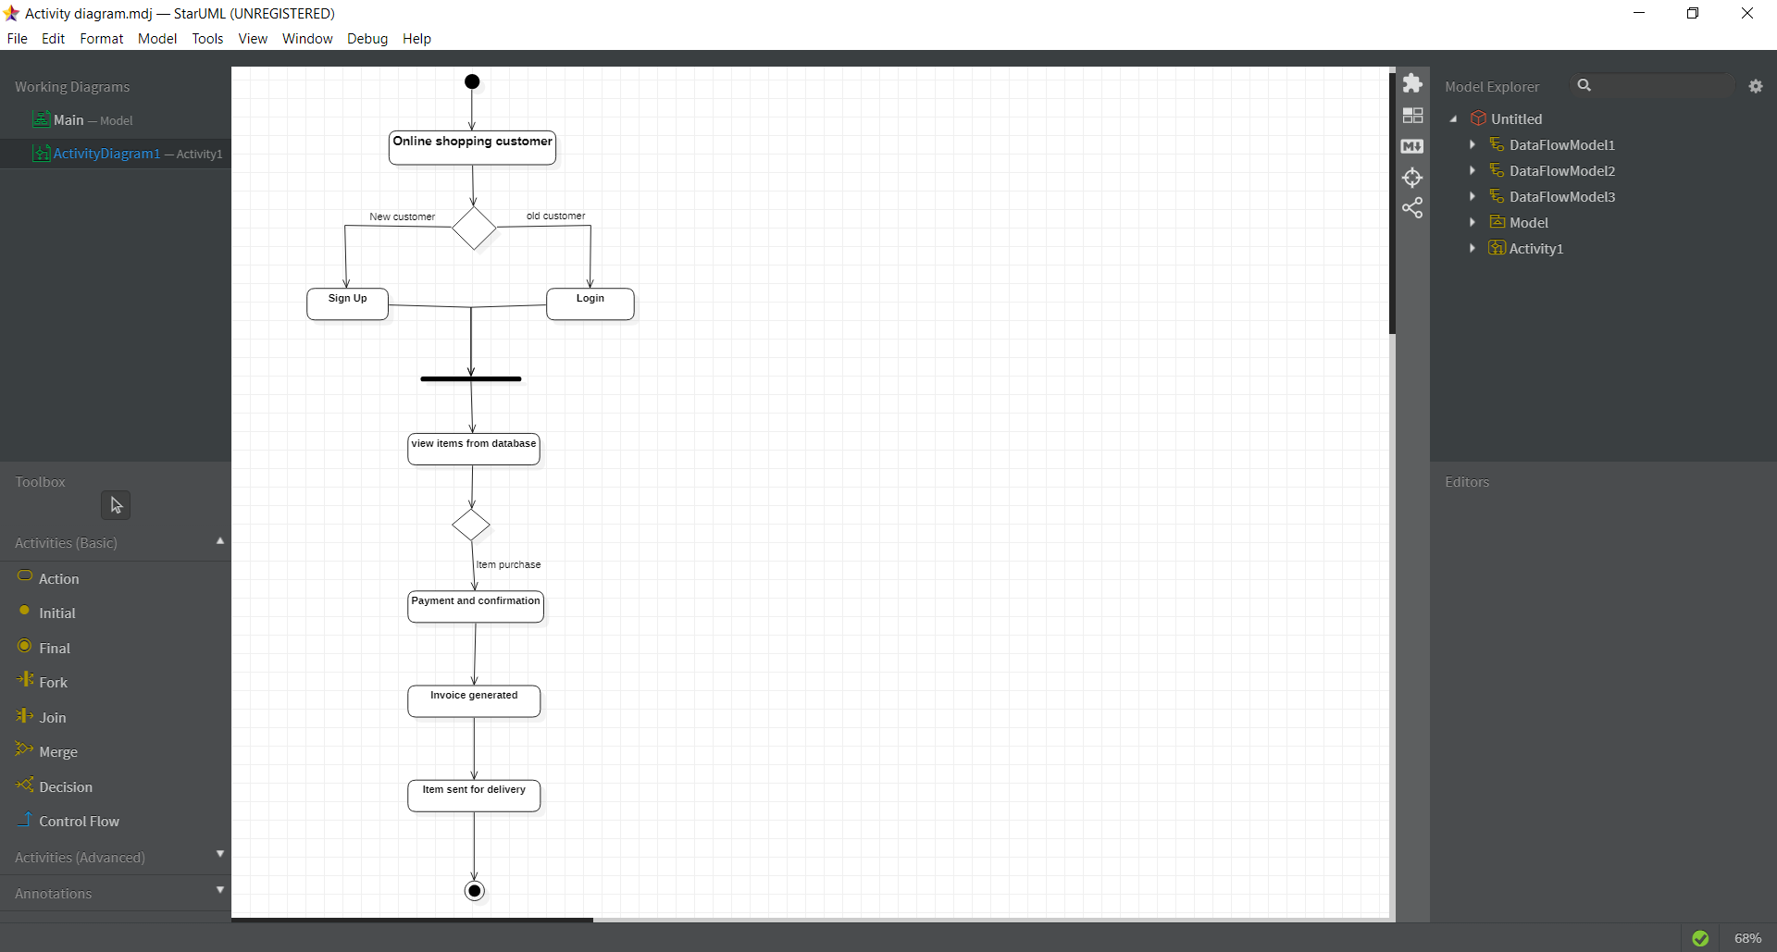

* **DATA FLOW DIAGRAM**

**LEVEL 0:**

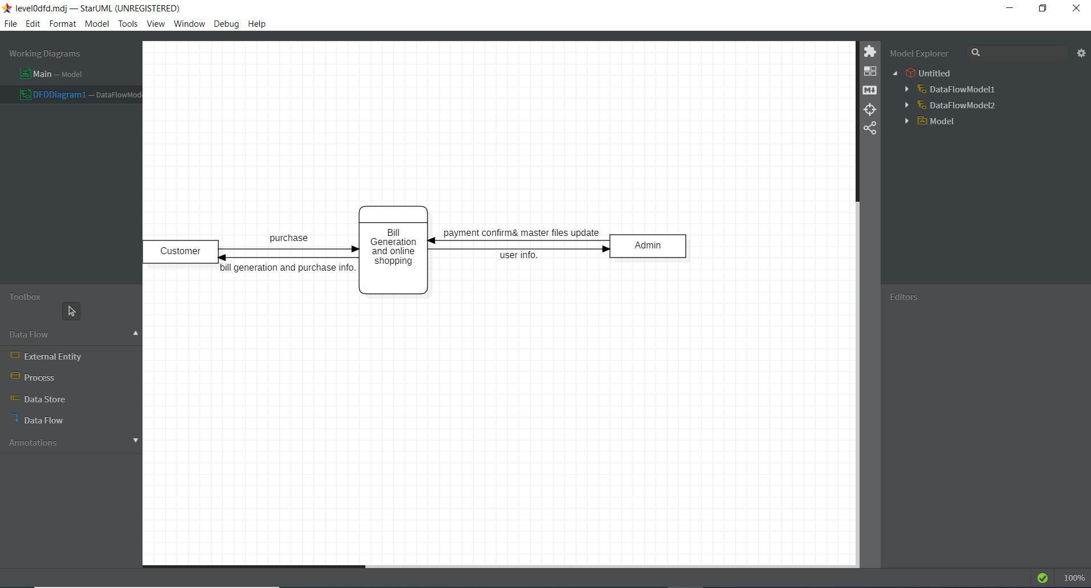

**LEVEL 1:**

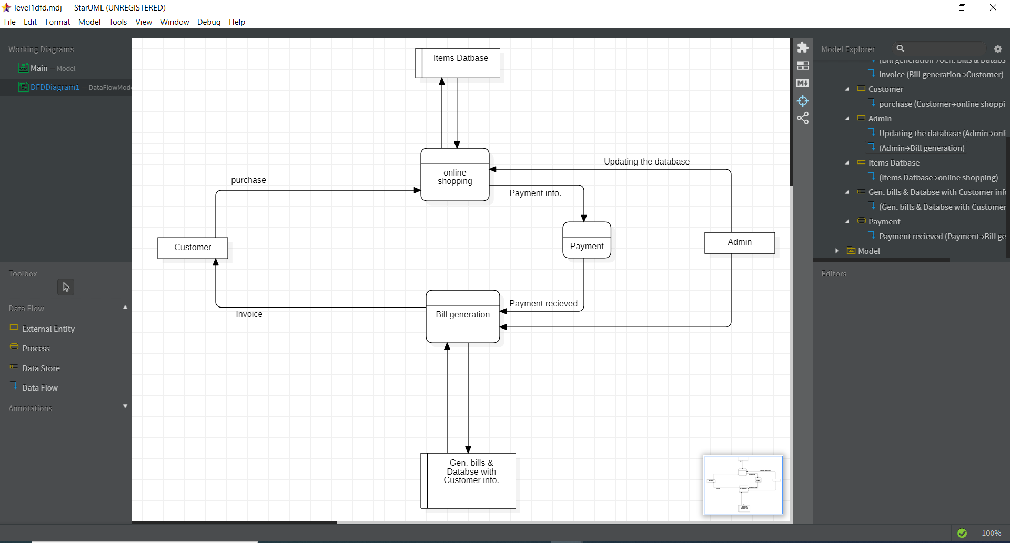

***IMPLEMENTATION:***

For building the online shopping and invoice generator we have a planned implementation process that will include the use of different technologies and the software building process is divided into parts as according to the RAD model the project will be delivered in parts in each iterations.

Some of the technologies and special libraries used in our project are as follows:

* Python 3
* Pyqrcode (for the generation of qrcode.)
* Numpy library.
* Math module
* Validation using python.
* Django used as a server side technology.
* HTML 5, CSS, JavaScript
* MySQL for database management.

In this project the development part consist of frontend which is made using HTML5, CSS and Javascript is used for validation and other purposes.

Python is used as the major technology for the development purpose and Django framework is used to make the website more responsive and user friendly. Where Data bases is handled using MySQL.

Major python libraries used for the development are Numpy for data representation and proper management. And QRCode module from pyqrcode for dealing with the QRCode related work.

In this project two major section that are made :  
first a proper invoice generator that generates the bills that are more reliable than other handmade invoices as soon as after the successful payment.

The other part is to make friendly interface where a customer can search things online and thus according to his/her choice complete the shopping of the products.

The user information such as contact details and login information must be handled securely and appropriately and for that proper system is made here.