PROBLEM STATEMENT:
First, waiting for invoice usually takes time and make customer waiting. Therefore, the customer's time gets wasted in waiting. The slowness of traditional bills is one of the important problems. Secondly, the cost of the paper-backed documents is another problem that faces traditional bills .It takes more effort and physical space to keep track of paper documents, to find information and to keep details secure.
- Today a user has to face many problem regarding online shopping and a proper invoice. The merchants dealing in large amount in terms of money has to face problem regarding a proper bill.
- Also customers has to carry the physical bill with them during travelling which becomes a hectic thing to manage.
- Customers cannot have a digital verifiable bill.
- It takes lots of time to generate physical bills.
- Sometimes customer has to go through Readability issues.
- There are chances to get Human error.
- It is more costilier.
- It is not ecofriendly.

SOLUTION:
Our software named as digital bill genetator which generates the digital and E-verifiable bill and makes the shopping experience more easy which has the following Advantages:
- This project solve the customer problem of having a proper bill.
- It provides more accurate bill as,there are no chances of human error.
- It is ecofriendly in nature.
- It saves time and provide a more accurate bill in less time.
- It solve the customer problem of carrying a physical bill.
- It provides a more secure and verifiable bill.
- It makes user shopping experience more comfortable.
- It provides a long lasting bill,as customer can download it any time.
- It removes readiablity issues.
- It is less expensive.

Four layers of software Engineering are:

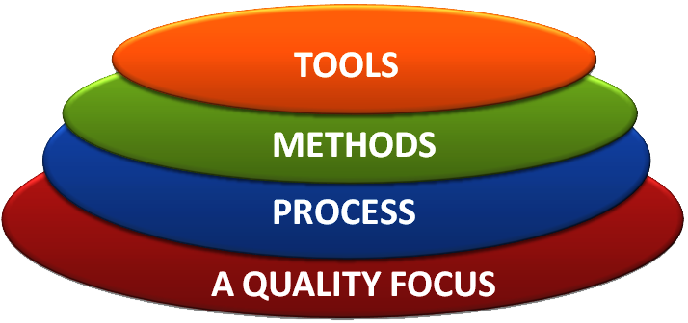
The above four layers of software engineering for our software is described as follows:
- TOOLS: Our software include frontend and backend which are developed using the following technologies.
- For frontend :HTML, CSS, Java script .
- For backend: python 3.
- METHODS:
Our software allows the customer to shop online according to their convenience and after customer successfully purchase an item the software automatically generates a digital verifiable bill and sends the copy of the bill to the customer’s E-mail address.
The software also allows the customer to download the bill in
future also by logging in their respective accounts. The software
also generates a QR code which a customer can keep and on
scanning the QR code the bill will be automatically downloaded to
their system.

Comparative Study between various Software Process Models:

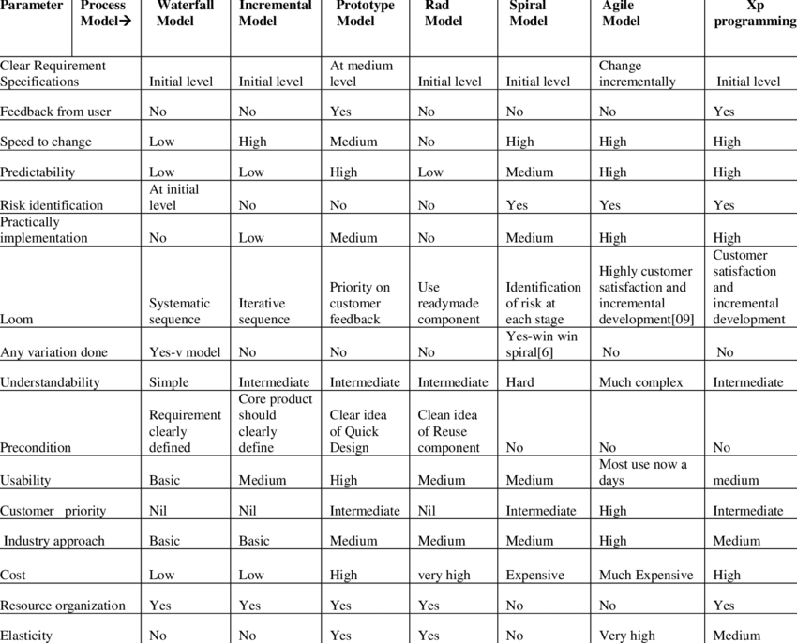

What is a Functional Requirement?
In software engineering, a functional requirement defines a system or its component. It describes the functions a software must perform. A function is nothing but inputs, its behaviour, and outputs. It can be a calculation, data manipulation, business process, user interaction, or any other specific functionality which defines what function a system is likely to perform.
Functional software requirements help you to capture the intended behaviour of the system. This behaviour may be expressed as functions, services or tasks or which system is required to perform.

Functional Requirements for Online Bill Generation and shopping system.
- The system should provide appropriate viewers for user to read the list of items in item store.
- The system should provide user’s unique reference (USER_ID) where customer can have personal account and make payment.
- The user shall choose what item that they want to receive.
- The system should print, for the owner a summary and show the report for who received the item and invoices.
- The system should automatically compute the bills and send the invoices with their items.
- The system should be able to manage some simple geographic info and provide company’s description.
- The system should automatically generate invoices and send a mail to the users with the invoice attached and also generate a QR code which enables the user to verify the bills online.
- The user should choose where they want the item to be delivered.
What is Non-Functional Requirement?
A non-functional requirement defines the quality attribute of a software system. They represent a set of standards used to judge the specific operation of a system. Example, how fast does the website load?
A non-functional requirement is essential to ensure the usability and effectiveness of the entire software system. Failing to meet non-functional requirements can result in systems that fail to satisfy user needs.
Non-functional Requirements allows you to impose constraints or restrictions on the design of the system across the various agile backlogs. Example, the site should load in 3 seconds when the number of simultaneous users are > 10000. Description of non-functional requirements is just as critical as a functional requirement.

Non-Functional Requirements for Online Bill Generation and shopping system.

- Product Requirement.
- The user interface shall be implemented as simple HTML,CSS,JAVASCRIPT.
- The list of items should be listed in the order form.
- The product should be available and updated each day.
- Proper product details should be present.
- Owner Requirement.
- The owner should provide other services on request by the owner.
- The owner should communicate with other shop owner or other individual for the services that in the list but not provided.
- Organizational Requirement.
- The system development process and deliverable reports shall conform to the process.
- The delivery should be made every day.
- Each item delivered must be reported and recorded each time.
- The system should automatically generate correct bills.
- External Requirement.
- The system shall not disclose any personal information about customers apart from their name and reference number to the operators of the system.
- The system should provide geographical attributes and some information about the services.
- The system must provide safe and secure payment environments.

