Revision Guide
Aligning the manuscript with the implemented Web-Based ICT Management and Information System for USTP Balubal Campus. Revised 28 October 2026. Covers the conceptual framework, direct student registration, employment-document review, email OTP, COR matching, bulk account actions, rejected status, and removal of the student-roster interface and request-form uploads.

0. How to use this guide
Line references identify passages in the earlier extracted manuscript (paper.txt); verify headings and current page numbers before pasting. The shaded replacement passages are ready for the manuscript. This guide describes implemented behavior and distinguishes historical database structures from current user-facing features.

1. Verified system facts
Front-end | React 19 with Inertia.js v3, Tailwind CSS v4, and Vite
Back-end | Laravel 13 (PHP 8.5), Laravel Fortify authentication, Laravel Wayfinder
Database | MySQL 8 (automated tests run on in-memory SQLite)
Email | Brevo transactional email API over HTTPS, plus in-app notifications stored in the database
Roles | ict_admin, faculty_staff, student; technicians are non-login assignment records
API | JWT-secured REST API v1. Browser and API registration paths differ; browser OTP and registration-document review must not be described as implemented API requirements.
Registration and files | Direct student registration with COR; faculty/staff registration with employment proof; private document storage; email OTP; ICT Admin approval. No attachment-upload control in the current service-request form; historical downloads remain.
Quality gates | Pest: 384 tests, 380 passed, four skipped; Laravel Pint, ESLint, TypeScript, and production Vite build.

2. Correct copy-paste errors first (Section 3.16)
Line | Problem | Correction
608 | user_id is described as “Unique identifier of the service request”. | “Unique identifier of the user”
611–612 | role_id is described as “References the user who submitted the request”. | “References the assigned user role”
655–658 | The Service Request table lists an attachment column. | Remove attachment as a Service Request column. The separate attachments table and authorized downloads remain for historical data, but the current service-request form has no upload control.
1013–1015 | incident_date is described as “Date and time the incident was reported”. | “Date the incident occurred” (data type DATE; reporting time is created_at)
1042–1045 | The User Liability table lists liability_amount. | Keep the row. The system now records a liability amount (DECIMAL(12,2), nullable) together with the description and settlement status; it still does not process or collect payments.

3. Global replacements
Find (as written) | Replace with
“React.js, PHP, and MySQL” (160, 1180) | “React.js with Inertia.js, the Laravel framework (PHP 8.5), and MySQL”
“PHPMailer with SMTP integration” / “SMTP-based services” / “PHPMailer and SMTP configurations” (487, 1162, 1182, 1219) | “Brevo transactional email API over HTTPS”
“email-based notification” (181, 205) | “email and in-app notification”
“allows administrators to record” (203) | “allows ICT administrators and faculty/staff to record”
“ENUM('Active', 'Inactive')” (634) | ENUM('pending', 'active', 'inactive', 'rejected')
“ENUM('New', 'Good', 'Fair', 'Damaged', 'Defective')” (877) | “ENUM('Working', 'Defective', 'Under Repair')”
“ENUM('Available', 'In Use', 'Damaged', 'Disposed')” (881) | “ENUM('Active', 'For Disposal', 'Retired', 'Disposed')”
“ENUM('Pending', 'Paid', 'Waived')” (1047) | “ENUM('Pending', 'Settled', 'Waived')”
Both statuses are now implemented: keep “Completed” in the Booking status (line 987), “Closed” in the Incident status (line 1017), and “Closed” in the Job Order status (line 785). Approved bookings automatically become Completed after their scheduled date, and administrators may also mark an approved booking as Completed.

4. Section-by-section edits
Section 1.2, Statement of the Problem - replace the situation paragraph
This study aims to address the lack of a centralized web-based system for managing ICT-related operations and information at USTP Balubal Campus. At present, ICT processes are largely manual and supported by disconnected records, making service delivery slow, difficult to monitor, and prone to inconsistency. Faculty and staff still rely on paper-based or fragmented methods when submitting service requests, tracking job orders, monitoring ICT equipment and defective items, recording laboratory incidents and liabilities, and reserving computer laboratories and audio-visual rooms, while students have no direct channel for requesting E-mail accounts and Office 365 access or for monitoring the status of such requests. Registration and document verification are likewise handled manually. Because these functions are not integrated into a single system, delays, overlapping reservations, inconsistent records, unmonitored service deadlines, and difficulty in communicating request updates and approvals frequently arise. In response, the study seeks to develop a Web-Based ICT Management and Information System that centralizes ICT operations, strengthens monitoring and accountability, improves communication through email and in-app notifications, and supports more efficient and accountable service delivery at USTP Balubal Campus.
Section 1.2.1, Conceptual Framework - revised figure and explanation
Replace the original faculty/staff-only framework with the figure below. Include students, faculty/staff, and the ICT Administrator; represent hosting as the application environment and connect the system to the database, private document storage, and email service. Use the manuscript figure number consistently.
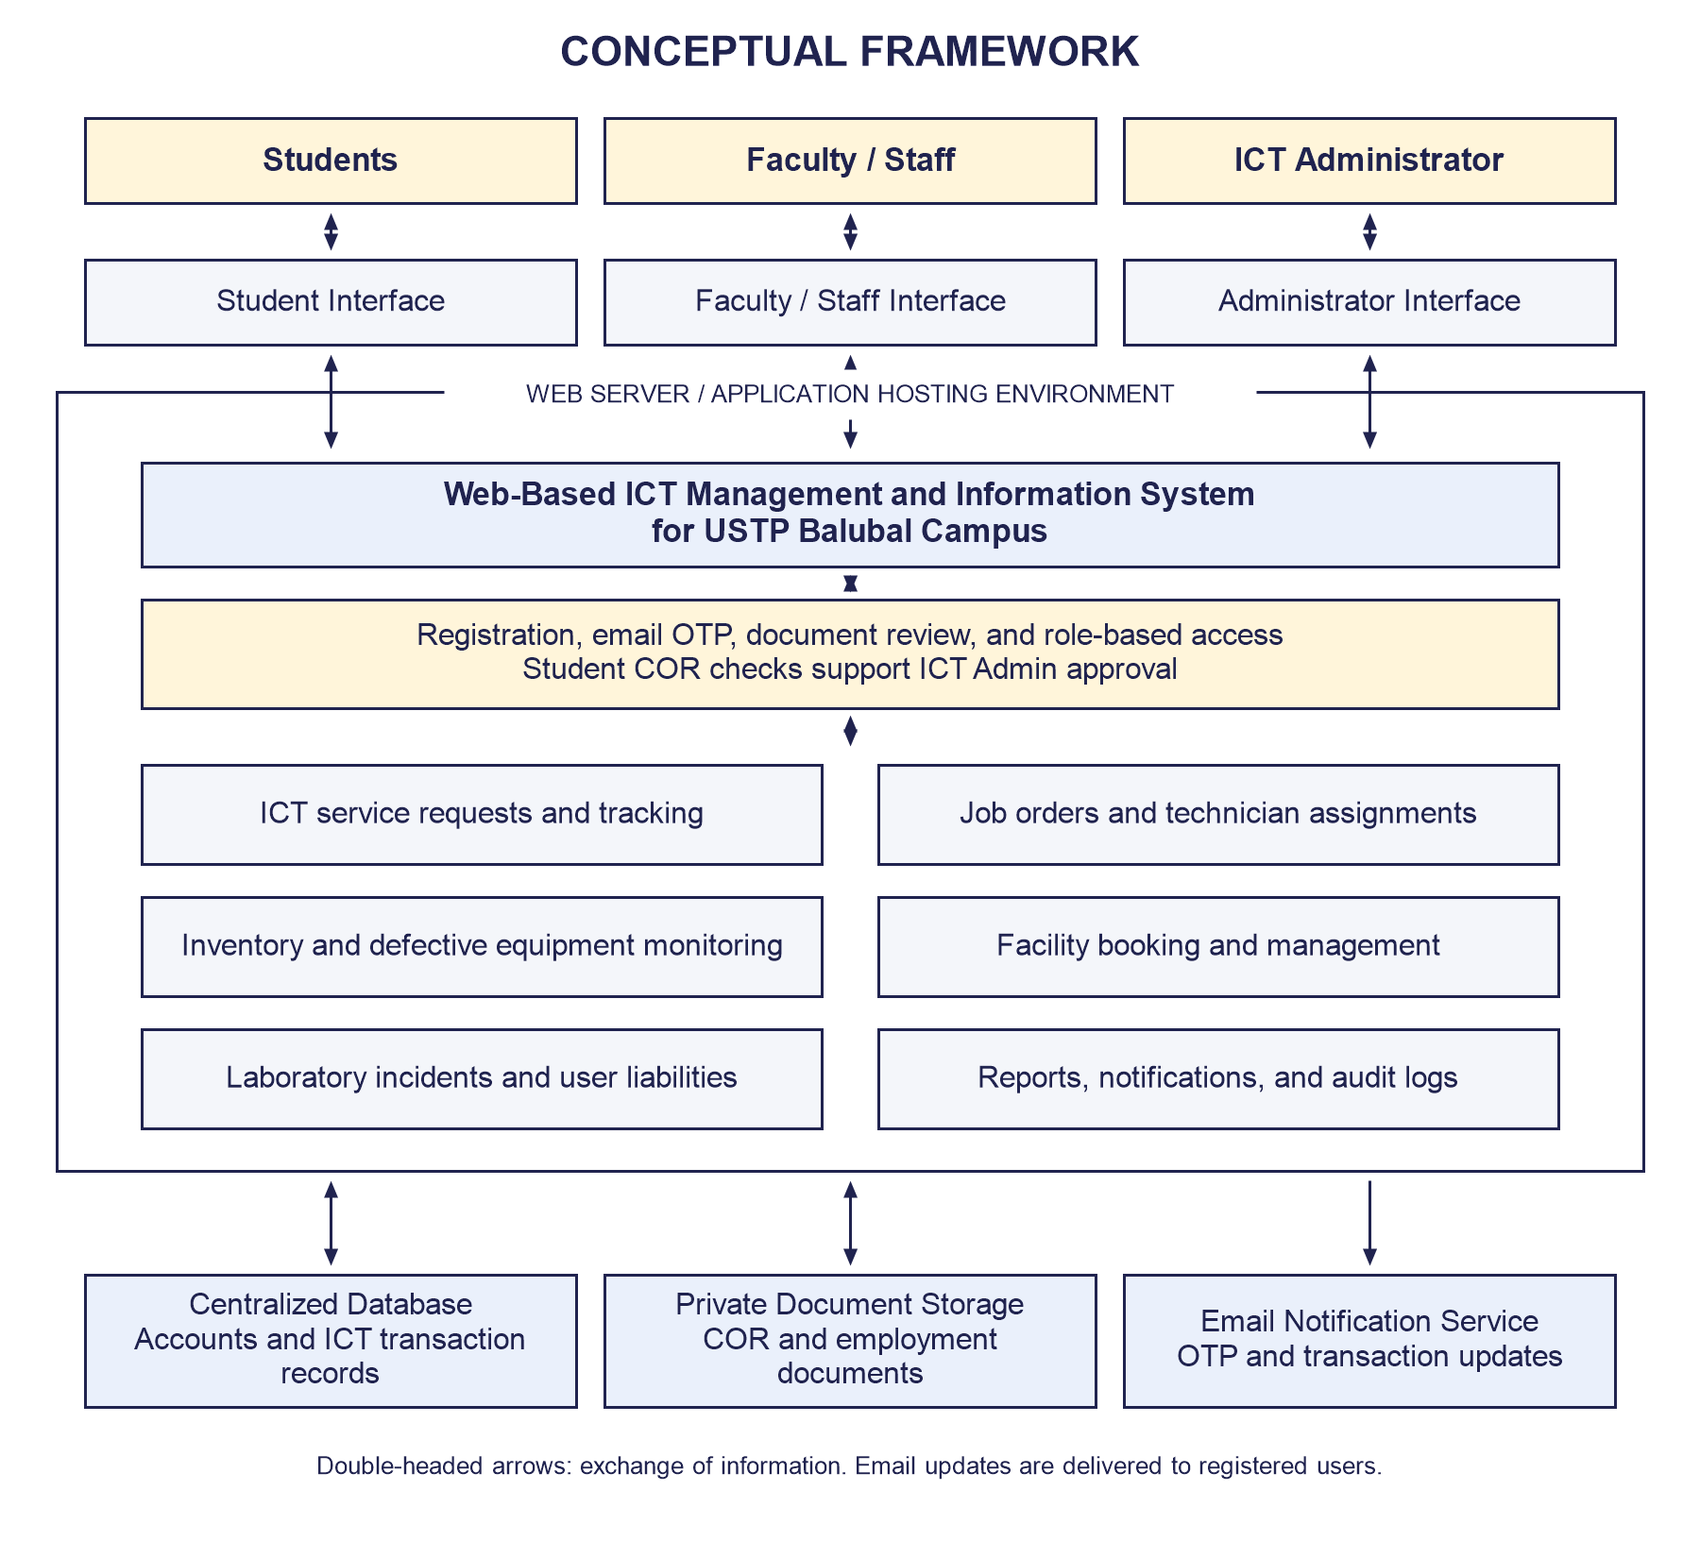
Figure 1. Conceptual Framework of the Web-Based ICT Management and Information System for USTP Balubal Campus.
The conceptual framework illustrates the interaction of students, faculty/staff, and the ICT Administrator with the Web-Based ICT Management and Information System for USTP Balubal Campus through their respective interfaces. The system centralizes ICT service transactions, administrative processes, and information management. Bidirectional arrows represent submissions, decisions, records, and status responses exchanged between the interfaces and the system.
Students submit and monitor permitted E-mail and Office 365 requests. Faculty and staff submit ICT requests, reserve available facilities, and receive transaction updates. The ICT Administrator reviews account applications and documents, approves or rejects registrations and requests, manages job orders and technician assignments, maintains inventory and facility records, monitors incidents and liabilities, and accesses reports and audit logs. Technicians are administrator-managed assignment records rather than a separate authenticated user group.
During browser registration, students enter their own details and submit a COR, while faculty/staff provide employment information and an Employee ID or Certificate of Employment. Applicants verify their email through an OTP and wait for ICT Admin approval. Automatic student COR checks compare readable text with the submitted student ID, name, program, document title, and Balubal Campus. Scanned or unreadable documents require manual review. Academic term and document originality are not automatically validated; verification does not itself activate an account.
The web server hosts the application and provides access to its interfaces and modules. The application exchanges account and transaction data with a centralized database, keeps registration documents in private storage for authorized review, and uses an email service for OTP and relevant notifications. A cloud server may be used as the deployment environment; the framework does not establish that cloud deployment or user acceptance evaluation has already occurred.
Section 1.2.2, Objective of the Study — lines 154–163
Replace the specific objectives with the following list (the current final bullet ends with a duplicated clause that should be removed).
The general objective of this study is to design and develop a Web-Based ICT Management and Information System for USTP Balubal Campus using the Agile Development Methodology to improve the management of ICT-related operations, services, and information.
Specifically, this study aims to:
- Plan the development of the system by gathering and analyzing campus requirements for ICT service requests, job orders, inventory and defective equipment monitoring, laboratory incident reporting and liability tracking, notifications, facility booking and management, document-supported account registration and review, reports, and audit logging;
- Design the system architecture, database structure, workflows, and user interfaces for students, faculty and staff, and ICT administrators to ensure usability, accessibility, security, and efficient management of ICT services;
- Develop the Web-Based ICT Management and Information System using React 19 with Inertia.js v3, Laravel 13 with PHP 8.5, and MySQL, implementing service request processing, automatic job order generation with technician assignment, service-level monitoring, inventory and expiration monitoring, defective equipment monitoring, laboratory incident reports and liabilities, email and in-app notifications, facility booking and management, reports, audit logs, role-based dashboards, document-supported registration with email OTP verification and student COR text matching, and a JWT-secured REST API;
- Test the developed system at the system level to determine its functionality, reliability, performance, and usability, ensuring that all modules operate correctly and satisfy the specified requirements. This objective assesses the quality of the system itself, not its effect on users;
- Deploy the system within the campus environment by configuring the database, server, email service, and application settings to make the platform accessible to authorized users;
- Launch the system and evaluate its user-level impact as perceived by students, faculty, staff, and ICT administrators, determining the extent to which they perceive improvement in ICT service delivery, resource management, communication, and operational efficiency. The Section 3.21 evaluation questionnaire shall operationalize these four dimensions. This objective measures users' perceptions and experiences rather than the technical quality of the system, which is addressed in the fourth objective.
Section 1.3.1, Scope and Limitations — lines 177–185
Replace the entire Scope and Limitations subsection with the text below.
Scope
The system serves students, faculty/staff, and ICT administrators through role-specific interfaces. Students register directly with their name, unique 10-digit student ID, program, personal details, chosen password, and Certificate of Registration (COR); no ICT-maintained roster entry is required. Faculty/staff choose Faculty or Staff and submit employment and personal details with an Employee ID or Certificate of Employment. Web applicants verify their email through an OTP and remain pending until ICT Admin approval. The system supports ICT service requests, job orders and technician assignments, SLA monitoring, inventory and defective equipment monitoring, QR codes, expiration tracking, laboratory incidents and user liabilities, facility booking and management, email and in-app notifications, reports with CSV export, and audit logging. Student requests are limited to E-mail and Office 365 services. The current service-request form does not include an attachment upload. Administrators can review registration documents, run or re-run student COR checks, and approve or reject selected pending accounts individually or in bulk. Rejected registrations are shown separately from deactivated accounts.
Limitations
The system covers only the ICT management operations of USTP Balubal Campus and does not extend to the other campuses of the University of Science and Technology of Southern Philippines. It does not cover hardware procurement, actual repair execution, or financial transaction processing, and it is not integrated with external accounting or payroll systems. It does not process or collect payments for recorded liabilities. It does not provide SMS notifications. It does not perform optical character recognition or verify the authenticity of uploaded registration documents, so scanned or unreadable files are not automatically evaluated. Student access does not extend beyond E-mail and Office 365 requests and the monitoring of their own requests; facility booking, incident recording, inventory management, job-order administration, and other administrative modules are outside student use. The system does not operate offline and requires a stable internet connection, particularly for web-based access and system updates. It does not independently validate the accuracy or completeness of records beyond the input rules applied at data entry.
Section 3.1.7, Data Flow Diagram for Faculty/Staff — lines 507–509
Retain the request and booking flows. Add the registration prerequisite: submit faculty/staff details and employment proof, verify email through OTP, wait for ICT Admin review, then sign in with the registered email and chosen password once approved.
Section 3.1.8, Data Flow Diagram for Students — line 515
Replace the first two sentences.
The diagram shows direct student registration with a unique 10-digit ID, name, program, personal details, chosen password, and COR, followed by email OTP verification and ICT Admin approval. Approved students sign in using their student ID and password, submit E-mail or Office 365 requests, and receive updates on their own requests. Remove roster lookup, roster-based name/program autofill, CSV provisioning, and ID-as-password steps.
Section 3.1.10, System Activity Flowchart — line 526
Replace the sentence beginning “The system also updates inventory records…”.
The system checks role-based access before accepting ICT transactions, records incidents and liabilities when applicable, records audited administrative actions, and generates relevant email and in-app notifications. Web account activation follows email OTP verification and ICT Admin review of the registration and uploaded document.
Section 3.1.11, Use Case Flowchart of Admin — line 543
Replace the sentence beginning “Once the inventory is saved…”.
Once the inventory is saved, the system writes an audit log entry and stores all inventory records in the database.
Section 3.14, Logical Entity Relationship Diagram — line 567
Replace the sentence beginning “Notifications are sent by the Admin…”.
Notifications are generated by the system for relevant account approvals, request updates, bookings, liabilities, and deadlines. The User entity stores student and employment profile fields and registration-document references. Represent rejected registrations separately from inactive accounts. The retained student_rosters table is historical and is no longer a prerequisite for registration.
Section 3.17, Development — line 1160
Append to the module list.
. facility booking and facility management, document-supported student and faculty/staff registration, email OTP verification, automated student COR text matching, administrative account review and bulk actions, SLA monitoring, report generation, and audit logging. Remove student-roster management and service-request upload controls from the current module list.
Section 3.20, Testing — lines 1186–1194
Append a paragraph after the user acceptance testing paragraph.
Automated Pest feature and unit tests verify authentication, OTP registration, direct student registration, required employment documents, private document downloads, COR matching and manual-review outcomes, account approval and rejection, bulk actions, retired roster endpoints, and the ICT transaction and API modules. The verified suite contains 384 tests: 380 passed and four skipped. Code checks include Laravel Pint, ESLint, TypeScript, and a production Vite build. These results do not substitute for documented user acceptance testing or establish that deployment has been completed.
Section 3.22, Deployment — line 1205
Append after the server configuration sentence.
The application was configured for PHP 8.5 and MySQL 8, with the Brevo email API configured for transactional notifications.
Section 4.2.1, User Authentication — line 1257
Append after the description of the entry page.
The system provides separate sign-in interfaces for ICT administrators, faculty/staff, and students. Students enter their own details and upload a COR without roster validation. Faculty/staff select Faculty or Staff, provide employment and personal details, and upload an Employee ID or Certificate of Employment. Web applicants complete email OTP verification before their pending account is created. Successful student OTP verification redirects to Student Sign In with the student ID prefilled; faculty/staff return to Faculty Sign In. Applicants can sign in only after ICT Admin approval. COR checking assists review but does not activate the account automatically. Rejected and deactivated accounts cannot sign in. The current API registration path differs from browser registration and can auto-activate students; do not claim that API registration implements the browser OTP/document flow.
Section 4.2.2, Role Based Dashboard — lines 1262–1276
Add a short Student subsection after the Faculty/Staff dashboard description.
Student. The Student Dashboard provides an overview of the student’s own service requests, including request status, request priority, and recent activity. Students may submit E-mail and Office 365 requests and monitor their progress, but facility booking, incident recording, and administrative modules are not available to them.
Section 4.2.3, Service Request Module — lines 1297–1299
Replace the category paragraph.
Services are grouped into Network Services, Hardware Services, Software Services, and Information System Services. Students are presented only with E-mail and Office 365 under Information System Services. Users provide the request description, contact/location details, and selected services. The current request form does not offer attachment uploads. Previously stored attachment records and authorized download support remain for historical requests.
Section 4.2.4, Job Order Management — lines 1306–1310
Append after the Manage Job Order paragraph.
The interface also displays the job order’s SLA status, priority level, support type, and estimated repair days. After completion, the requester may rate the service and verify the resolution. A printable job order following the FM-USTP-ICT-001 layout is also available.
Section 4.2.5, Inventory Management — lines 1318–1319
Append after the Add Equipment sentence.
Equipment is classified by condition (Working, Defective, Under Repair) and status (Active, For Disposal, Retired, Disposed). The module also supports QR code generation for equipment records, expiration monitoring for consumables and licenses, and marking items defective with repair-status tracking.
Section 4.2.6, Facility Booking — line 1328
Replace the sentence describing the administrator’s options.
The administrator can review the request and approve, reject, or cancel the booking. Users may also cancel their own pending or approved bookings, and the booking form prevents overlapping reservations for the same facility and time slot. Approved bookings become Completed automatically once their scheduled date has passed, and an administrator may also mark an approved booking as Completed.

5. Data dictionary corrections (Section 3.16)
Apply the following changes so the table matches the migrated schema. Only affected rows are listed.
Table | Field | Corrected value / action
Role | role_description | TEXT (nullable)
User | Primary key and name fields | id (PK), name, password — replace user_id, full_name, password_hash
User | status | ENUM('pending', 'active', 'inactive', 'rejected')
User | Add | id_number VARCHAR(20), employment_type VARCHAR(20), email_verified_at DATETIME, avatar VARCHAR(255), plus the registration-profile/document fields in Section 6 of this guide.
Service Request | Note | No attachment column or current request-form upload. Retain the attachments table for historical file records and authorized downloads.
Service Request | Add | form_number VARCHAR(50), location VARCHAR(255), contact_details VARCHAR(255), approved_by INT, date_approved DATETIME, rejection_reason TEXT, sla_deadline DATETIME, sla_status ENUM('On Track','At Risk','Breached')
Job Order | final_remarks | ENUM('Outsource Repair', 'Replacement', 'Disposal', 'Task Completed')
Job Order | action_taken | VARCHAR(150)
Job Order | Add | job_order_number VARCHAR(50), date_in_progress DATETIME, date_closed DATETIME, sla_deadline DATETIME, sla_status, priority_level, support_type ENUM('On Site','Remote'), estimated_repair_days INT, rating INT, requester_comment TEXT
Inventory Item | condition | ENUM('Working', 'Defective', 'Under Repair')
Inventory Item | status | ENUM('Active', 'For Disposal', 'Retired', 'Disposed')
Inventory Item | Add | category VARCHAR(50), specification TEXT, unit_cost DECIMAL(12,2), purchase_order_no VARCHAR(150), end_user VARCHAR(150), department VARCHAR(100), building VARCHAR(100), room VARCHAR(100), expiration_date DATE, expiration_type ENUM('Expiration Date','Shelf Life')
Defective Equipment | recommendation | Delete the row; the column does not exist
Defective Equipment | repair_status | VARCHAR(50), default 'Pending'
Facility | facility_type | ENUM('Computer Laboratory', 'AV Room')
Facility | availability_status | ENUM('Available', 'Unavailable', 'Under Maintenance')
Booking | booking_status | ENUM('Pending', 'Approved', 'Rejected', 'Cancelled', 'Completed')
Booking | Add | approved_by INT (FK users)
Incident Report | status | ENUM('Open', 'Under Review', 'Resolved', 'Closed')
Incident Report | Add | item_id INT (FK inventory_items, nullable)
User Liability | liability_status | ENUM('Pending', 'Settled', 'Waived')
User Liability | liability_description | TEXT (nullable)
User Liability | Add | liability_amount DECIMAL(12,2) (nullable; required when a user is assigned)
Notification | notification_type | VARCHAR(50) (nullable)
Notification | Add | link VARCHAR(255)
Attachment | file_path | VARCHAR(500); retained historical attachment storage reference, not a current upload field
AuditLog | Add | old_values JSON, new_values JSON

6. Registration profile and document fields (User table)
Extend the User data dictionary in Section 3.16 using the following fields. Do not add Student Roster management as an active system module.
Field Name | Data Type | Key | Description
id_number | VARCHAR(20) | Unique for student registration | Student ID; exactly 10 digits in registration validation
educational_level | VARCHAR(50) |  | Automatically submitted as college by the student form
year_level | VARCHAR(20) |  | Student year level
gender | VARCHAR(20) |  | Gender supplied during registration
birth_date | DATE |  | Birth date; must be before today
home_address | VARCHAR(255) |  | Applicant home address
employee_id_number | VARCHAR(50) | Unique; nullable | Faculty/staff employee ID
position | VARCHAR(255) |  | Position or designation
cor_path | VARCHAR(500) |  | Private student COR storage reference
cor_original_name | VARCHAR(255) |  | Original COR filename
cor_verification_status | VARCHAR(255) |  | matched, mismatch, or manual_review; nullable before checking
cor_verification_details | JSON |  | Per-field comparison results and review message
cor_checked_at | TIMESTAMP |  | Most recent automatic COR check time
employment_document_path | VARCHAR(255) |  | Private employment-document storage reference
employment_document_original_name | VARCHAR(255) |  | Original employment-document filename
Historical student_rosters records and their model/table are retained to preserve existing data. The roster page, lookup, import, provisioning, and roster password-reset routes have been removed. Registration reads the submitted name, ID, and program directly. Retained historical tables should be identified as legacy structures rather than presented as current user workflows.

7. Content still missing from the paper
Add one short subsection each under Section 4.2, with a screenshot figure:
- Student Dashboard (student portal)
- Reports module with CSV export
- Facilities Management (add, edit, delete)
- Audit Log viewer
- Notifications (in-app bell, mark as read)
- Registration document review and user-management role filters, pending counts, bulk actions, and separate rejected/deactivated lists
- Settings: profile, password, appearance
- Printable Job Order (FM-USTP-ICT-001)
- Inventory QR code
- Direct student and faculty/staff registration, email OTP verification, private document review, and COR verification results
- Booking completion and incident closure states

8. Remaining consistency checks
- Section 1.3.1 Limitations: the system records liability amounts but still does not process financial transactions or collect payments, so the limitation remains accurate.
- Section 3.1.10 Flowchart: after the edit, the system no longer claims to update inventory automatically when an incident is recorded; incidents merely reference an inventory item.
- Section 3.17 and 3.19: ensure all remaining mentions of PHPMailer/SMTP are replaced; Brevo is the only email transport.
- Section 4.2.6: the paper previously implied a Completed booking state that was not implemented; it now exists, so the description and screenshot may include Completed bookings.
- Section 4.2.3: confirm the screenshot used for Faculty/Staff shows all four service categories, or note that the figure shows a subset.
Prepared from the implemented application and verified automated checks. This revision supersedes the earlier instructions about roster-based student registration, roster CSV provisioning, and service-request attachment uploads. Keep implementation claims separate from planned deployment and user-evaluation activities.

